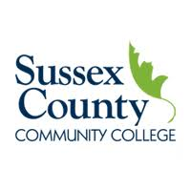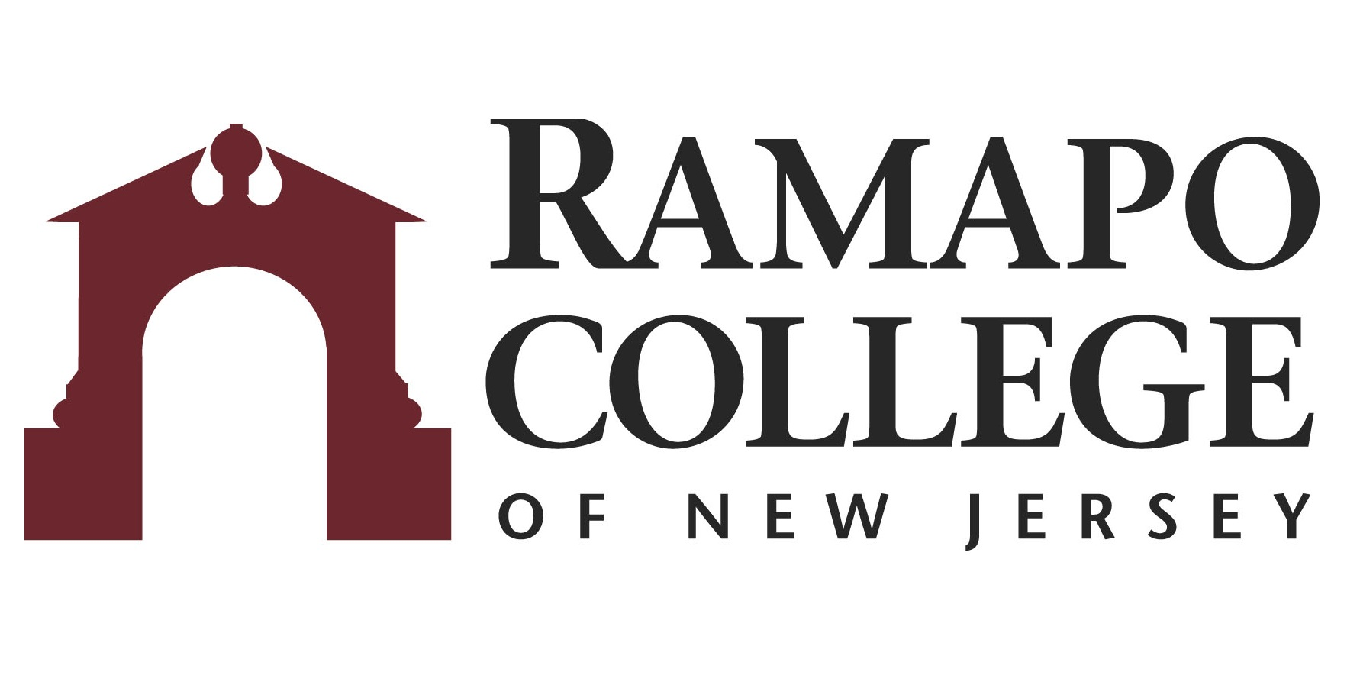
A.S. Business Administration → B.S. Business Administration: Marketing

First Year –SCCC
Fall Semester | HRS |  | Spring Semester | HRS | 
COLL 101: Foundations of Success | 3 |  | COLL 206: Capstone Accounting & Business | 1
ENGL 101: English Composition I | 3 |  | ENGL 102: English Composition II | 3
BUSA 101: Introduction to Business | 3 |  | HUM 100: Humanities Elective | 3
MATH 113: Calculus I | 4 |  | MATH 114: Calculus II | 4
ACCT 101: Accounting Principles I Financial | 3 |  | ACCT 102: Accounting Principles II Managerial | 3
 |  |  | BUSA 205: Business Law I | 3
Total: | 16 |  | Total: | 17

Second Year – SCCC
Fall Semester | HRS |  | Spring Semester | HRS | 
SOC 100: Social Science Elective | 3 |  | ENGL 201: Effective Speaking | 3
BUSA 211: Mgmt & Org Behavior | 3 |  | BUSA 220: Principles of Marketing | 3
SCI 100: Lab Science | 4 |  | SOC 100: Social Science Elective | 3
ECON 101: Macroeconomics | 3 |  | ECON 102: Microeconomics | 3
COMS 110: Computer Concepts & Applications | 3 |  | COMS 120: Computer Software Applications | 3
Total: | 16 |  | Total: | 15

Third Year-RCNJ
Fall Semester | HRS |  | Spring Semester | HRS | 
BADM 225: Management Statistics | 4 |  | FINC 301: Corporate Finance I | 4
INFO 224: Principles of Information Technology | 4 |  | BADM 301: Ethics in Business/INFO 315: Computer Law & Ethics | 4
MGMT 302: Managing Organizational Behavior | 4 |  | MKTG 330: Marketing Research | 4
MKTG 310: Consumer Behavior | 4 |  | MKTG 320: Integrated MKTG Communication | 4
Career Pathways** Module 1: BADM 001  Career Assessment/Advisement Visit ASB Career Services Office in ASB-513 | Grad.  Rqmt. |  | Career Pathways**Module 2: BADM 002  Resume/LinkedIn/Cover Letter Visit ASB Career Services Office in ASB-513 | Grad.  Rqmt.
Total: | 16 |  | Total: | 16

Fourth Year-RCNJ
Fall Semester | HRS |  | Spring Semester | HRS | 
MKTG 430: Marketing Management | 4 |  | BADM 495: Strategic Management | 4
MKTG Elective* | 4 |  | MKTG 400 Level Elective* | 4
MGMT 370: Operations Management | 4 |  | Elective | 4
International Category Course* | 4 |  | Elective | 4
Career Pathways** Module 3: BADM 003  Career Assessment/Advisement Visit ASB Career Services Office in ASB-513 | Grad.  Rqmt.
Total: | 16 |  | Total: | 16
*Course can be chosen from approved list
This plan is based on the completion of an Associate of Arts or Associate of Science Degree at Sussex County Community College encompassing all recommended courses. This plan is subject to change.

