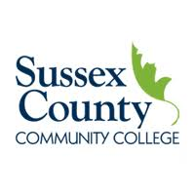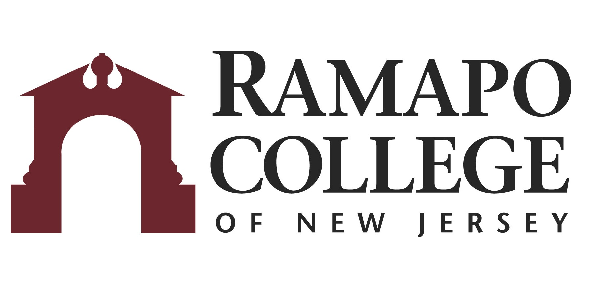
A.A. Liberal Arts: Pre-Law Option → B.A. Law & Society

First Year –SCCC
Fall Semester | HRS |  | Spring Semester | HRS | 
COLL 101: Foundations of Success | 3 |  | ENGL 102: English Composition II | 3
ENGL 101: English Composition I | 3 |  | ENGL 201: Effective Speaking | 3
PHIL 100: Philosophy Elective | 3 |  | MATH 100: Math Elective | 3
HIST 100: History Elective | 3 |  | HIST 100: History Elective | 3
POLS 111: Intro to the American Legal System | 3 |  | HUM 100: Humanities Elective/(WL 101)+ | 3
Total: | 15 |  | Total: | 15

Second Year – SCCC
Fall Semester | HRS |  | Spring Semester | HRS | 
SCI 100: Natural Science Elective | 4 |  | Math/Science Elective | 4
COMS 100: Technology Elective | 3 |  | SOC 100: Social Science Elective | 3
LEGA 105: Legal Research & Writing I | 3 |  | POLS 223: Constitutional Law | 3
Pre-Law Option Elective | 3 |  | Pre-Law Option Elective | 3
PSYC 101: General Psychology/SOCA 101: Introduction to Sociology | 3 |  | LANG 102: World Language II | 3
 |  |  | COLL 201: Capstone for Liberal Arts | 1
Total: | 16 |  | Total: | 17

Third Year-RCNJ
Fall Semester | HRS |  | Spring Semester | HRS | 
LAWS 131: Law & Society | 4 |  | LAWS 201: Global Legal Order | 4
LAWS 233: American Legal History | 4 |  | LAWS 251: Law, Power, & Inequality | 4
SOSC 110: Social Science Inquiry | 4 |  | LAWS 353: Socio-legal Research & Writing | 4
Elective | 4 |  | LAWS Elective: Globalization & Sustainability* | 4
Career Pathways Module 1: SSHS 001  Career Assessment/Advisor Visit SSHS Advisor in Cahill Career (C209) | Grad. Rqmt. |  | Career Pathways Module 1: SSHS 002  Resume/Cover Letter/Personal Statement Visit SSHS Advisor in Cahill Career (C209) | Grad. Rqmt.
Total: | 16 |  | Total: | 16

Fourth Year-RCNJ
Fall Semester | HRS |  | Spring Semester | HRS | 
LAWS 321: Field Studies: Law & Society | 4 |  | LAWS 431: Thesis Supervision # | 4
LAWS 421: Directed Readings # | 4 |  | LAWS Elective: Criminal Justice | 4
LAWS Elective: Culture & Humanities* | 4 |  | SOSC 235: History of Social Thought | 4
Elective | 4 |  | Elective | 4
Career Pathways Module 1: SSHS 003  Interview Practice/Internship Search Visit SSHS Advisor in Cahill Career (C209) | Grad. Rqmt. |  | Elective | 1
Total: | 16 |  | Total: | 17
*Course can be chosen from approved list #Course only offered in corresponding semester
+World Language 101 if needed
This plan is based on the completion of an Associate of Arts or Associate of Science Degree at Sussex County Community College encompassing all recommended courses. This plan is subject to change.

