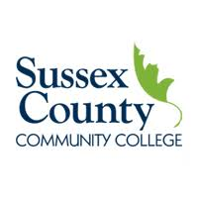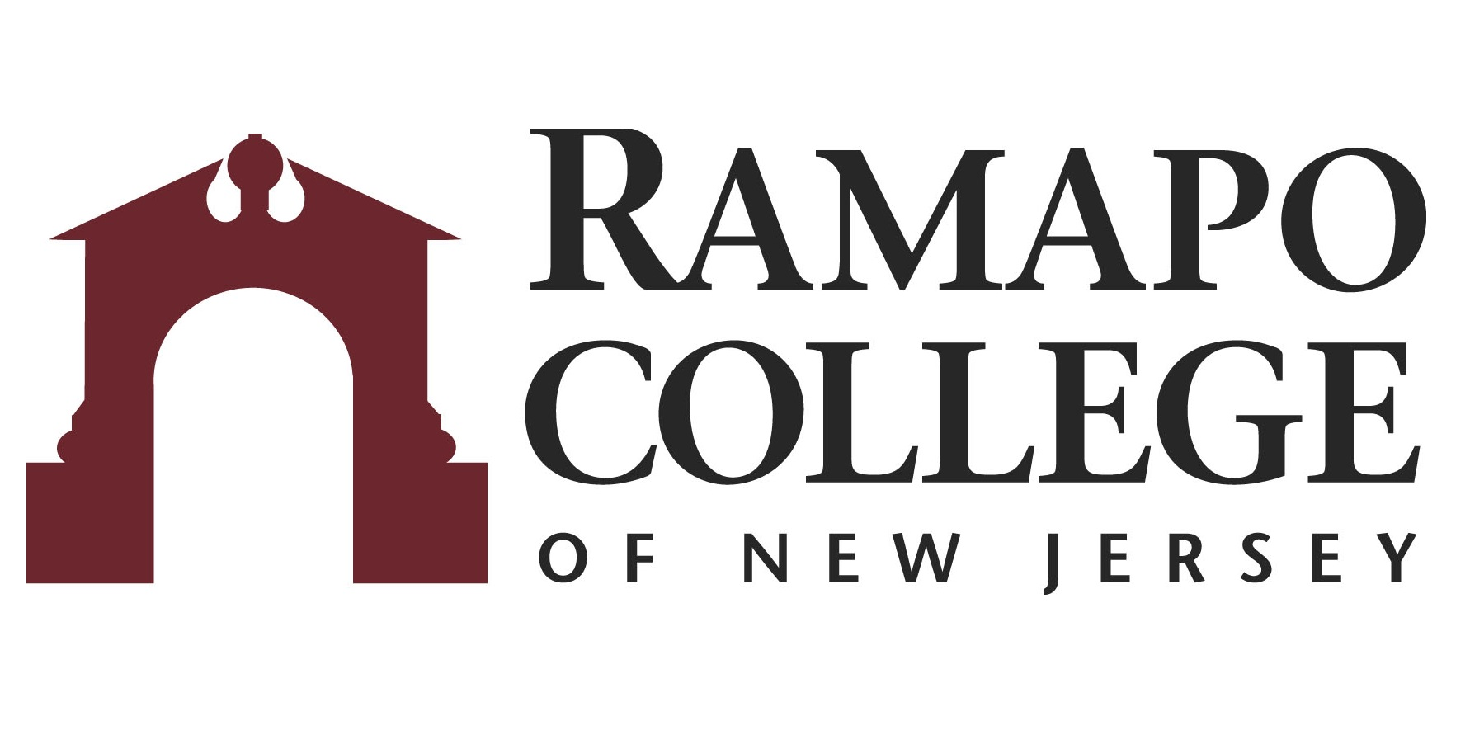
A.S. Science/Math: Computer Science Option → B.S. Computer Science

First Year –SCCC
Fall Semester | HRS |  | Spring Semester | HRS | 
COLL 101: Foundations of Success | 3 |  | ENGL 102: English Composition II | 3
ENGL 101: English Composition I | 3 |  | SOC 100: Social Science Elective | 3
SOC 100: Social Science Elective | 3 |  | HUM 100: Humanities Elective | 3
MATH 113: Calculus I | 4 |  | MATH 114: Calculus II | 4
COMS 114: Intro to Computer Science I | 3 |  | COMS 115: Intro to Computer Science II | 3
Total: | 16 |  | Total: | 16

Second Year – SCCC
Fall Semester | HRS |  | Spring Semester | HRS | 
PHYS 110: Physics I | 4 |  | PHYS 112: Physics II | 4
MATH 201: Discrete Mathematics | 4 |  | MATH 213: Calculus III | 4
COMS 218: Database Management Systems | 3 |  | COMS 223: Data Structures | 3
COMS 221: Operating Systems | 3 |  | COMS 239: Fndmtls of Cmps Architecture | 3
Math/Science Elective | 4 |  | COLL 208: Capstone for Computer Science | 1
Total: | 18 |  | Total: | 15

Third Year-RCNJ
Fall Semester | HRS |  | Spring Semester | HRS | 
CMPS 220: Assembly Language Programming | 4 |  | CMPS 311: Operating Systems | 4
MATH Elective* | 4 |  | CMPS 361: Software Design | 4
Elective | 4 |  | CMPS Elective* | 4
Elective | 4 |  | CMPS Elective* | 4
Total: | 16 |  | Total: | 16

Fourth Year-RCNJ
Fall Semester | HRS |  | Spring Semester | HRS | 
CMPS 366: Org of Programming Languages | 4 |  | CMPS 450: Senior Project | 4
CMPS Elective* | 4 |  | CMPS Elective* | 4
CMPS Elective* | 4 |  | CMPS Elective* | 4
CMPS Elective* | 4 |  | Elective | 4
Total: | 18 |  | Total: | 18
*Course can be chosen from approved list
This plan is based on the completion of an Associate of Arts or Associate of Science Degree at Sussex County Community College encompassing all recommended courses. This plan is subject to change.

