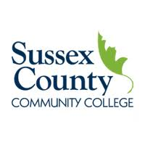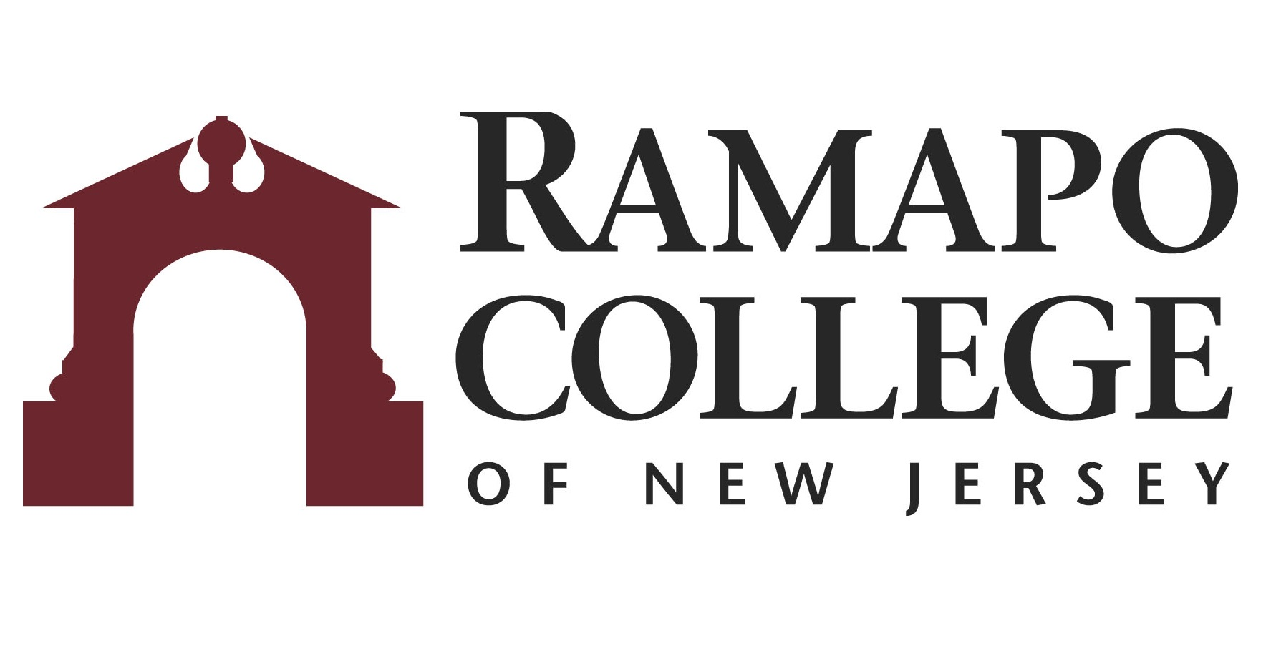
A.S. Science/Math: Chemistry Option → B.S. Chemistry

First Year –SCCC
Fall Semester | HRS |  | Spring Semester | HRS | 
COLL 101: Foundations of Success | 3 |  | ENGL 102: English Composition II | 3
ENGL 101: English Composition I | 3 |  | SOC 100: Social Science Elective | 3
HUM 100: Humanities Elective | 3 |  | COMS 114: Computer Science I | 3
MATH 113: Calculus I | 4 |  | MATH 114: Calculus II | 4
CHEM 110: College Chemistry I | 4 |  | CHEM 112: College Chemistry II | 4
Total: | 17 |  | Total: | 17

Second Year – SCCC
Fall Semester | HRS |  | Spring Semester | HRS | 
CHEM 210: Organic Chemistry I | 5 |  | CHEM 212: Organic Chemistry II | 5
PHYS 120: Physics I w/ Calculus | 4 |  | PHYS 121: Physics II w/ Calculus | 4
MATH 213: Calculus III | 4 |  | SOC 100: Social Science Elective | 3
 |  |  | COLL 210: Capstone for Sciences | 1
Total: | 13 |  | Total: | 13

Third Year-RCNJ
Fall Semester | HRS |  | Spring Semester | HRS | 
CHEM 324/324L: Quantitative Analysis | 5 |  | CHEM 340: Physical Chemistry I Lecture | 4
CHEM Elective* | 4 |  | CHEM 427/427L: Instrumental Analysis | 5.5
Elective | 4 |  | CHEM 425: Biochemistry/CHEM Elective* | 4
Elective | 4 |  | Elective | 4
Total: | 17 |  | Total: | 17.5

Fourth Year-RCNJ
Fall Semester | HRS |  | Spring Semester | HRS | 
CHEM 350: Physical Chemistry I Lab | 1.5 |  | CHEM 352L: Physical Chemistry II Lab | 1
CHEM 352: Physical Chemistry II Lecture | 4 |  | CHEM 451/451L: Adv. Inorganic Chemistry | 5
CHEM 430: Experimental Biochemistry/Elective* | 4 |  | CHEM Elective* | 4
Elective | 4 |  | CHEM Elective* | 4
Elective | 4 |  | Elective | 4
Total: | 17.5 |  | Total: | 18
*Course can be chosen from approved list
This plan is based on the completion of an Associate of Arts or Associate of Science Degree at Sussex County Community College encompassing all recommended courses. This plan is subject to change.

