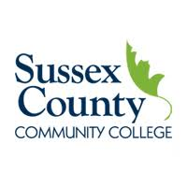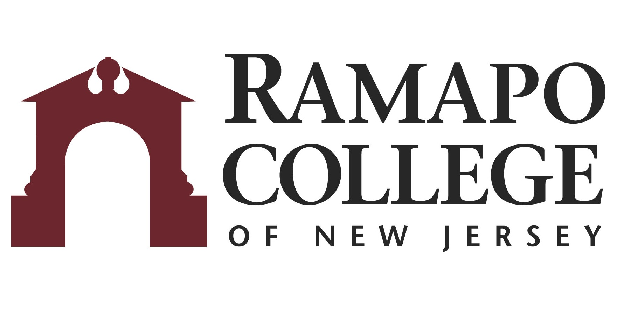
A.S. Accounting → B.S. Accounting

First Year –SCCC
Fall Semester | HRS |  | Spring Semester | HRS | 
COLL 101: Foundations of Success | 3 |  | BUSA 101: Introduction to Business | 3
ENGL 101: English Composition I | 3 |  | ENGL 102: English Composition II | 3
HUM 100: Humanities Elective | 3 |  | GEN 100: General Education Elective | 3
MATH 110: Pre-Calculus I | 3 |  | MATH 111: Business Calculus | 3
ACCT 101: Accounting Principles I Financial | 3 |  | ACCT 102: Accounting Principles II Managerial | 3
Total: | 15 |  | Total: | 15

Second Year – SCCC
Fall Semester | HRS |  | Spring Semester | HRS | 
ACCT 201: Intermediate Accounting I | 3 |  | ACCT 202: Intermediate Accounting II | 3
BUSA 205: Business Law I | 3 |  | BUSA 220: Principles of Marketing | 3
SCI 100: Lab Science | 4 |  | SOC 100: Social Science Elective | 3
ECON 101: Macroeconomics | 3 |  | ECON 102: Microeconomics | 3
COMS 110: Computer Concepts & Applications | 3 |  | MATH 108: Statistics | 3
COLL 206: Capstone Accounting & Business | 1 |  | Approved Accounting Elective | 3
Total: | 17 |  | Total: | 18

Third Year-RCNJ
Fall Semester | HRS |  | Spring Semester | HRS | 
ACCT 321: Intermediate Accounting I | 4 |  | ACCT 322: Intermediate Accounting II | 4
ACCT 329: Federal Tax I | 4 |  | ACCT 332: Federal Tax II | 4
BADM 225: Management Statistics | 4 |  | MGMT 302: Managing Org Behavior | 4
INFO 224: Principles of Information Technology | 4 |  | FINC 301: Corporate Finance I | 4
Career Pathways** Module 1: BADM 001  Career Assessment/Advisement Visit ASB Career Services Office in ASB-513 | Grad.  Rqmt. |  | Career Pathways**Module 2: BADM 002  Resume/LinkedIn/Cover Letter Visit ASB Career Services Office in ASB-513 | Grad.  Rqmt.
Total: | 16 |  | Total: | 16

Fourth Year-RCNJ
Fall Semester | HRS |  | Spring Semester | HRS | 
ACCT 411: Cost Accounting | 4 |  | ACCT 423: Advanced Financial Accounting | 4
ACCT 421: Auditing | 4 |  | BADM 495-Strategic Management | 4
MGMT 370: Operations Management | 4 |  | BADM 301: Ethics in Business/ INFO 315: Computer Law & Ethics | 4
International Category Course* | 4 |  | Elective | 4
Career Pathways** Module 3: BADM 003  Career Assessment/Advisement Visit ASB Career Services Office in ASB-513 | Grad.  Rqmt.
Total: | 16 |  | Total: | 16
*Course can be chosen from approved list
This plan is based on the completion of an Associate of Arts or Associate of Science Degree at Sussex County Community College encompassing all recommended courses. This plan is subject to change.

