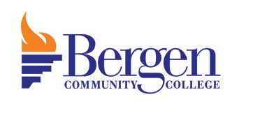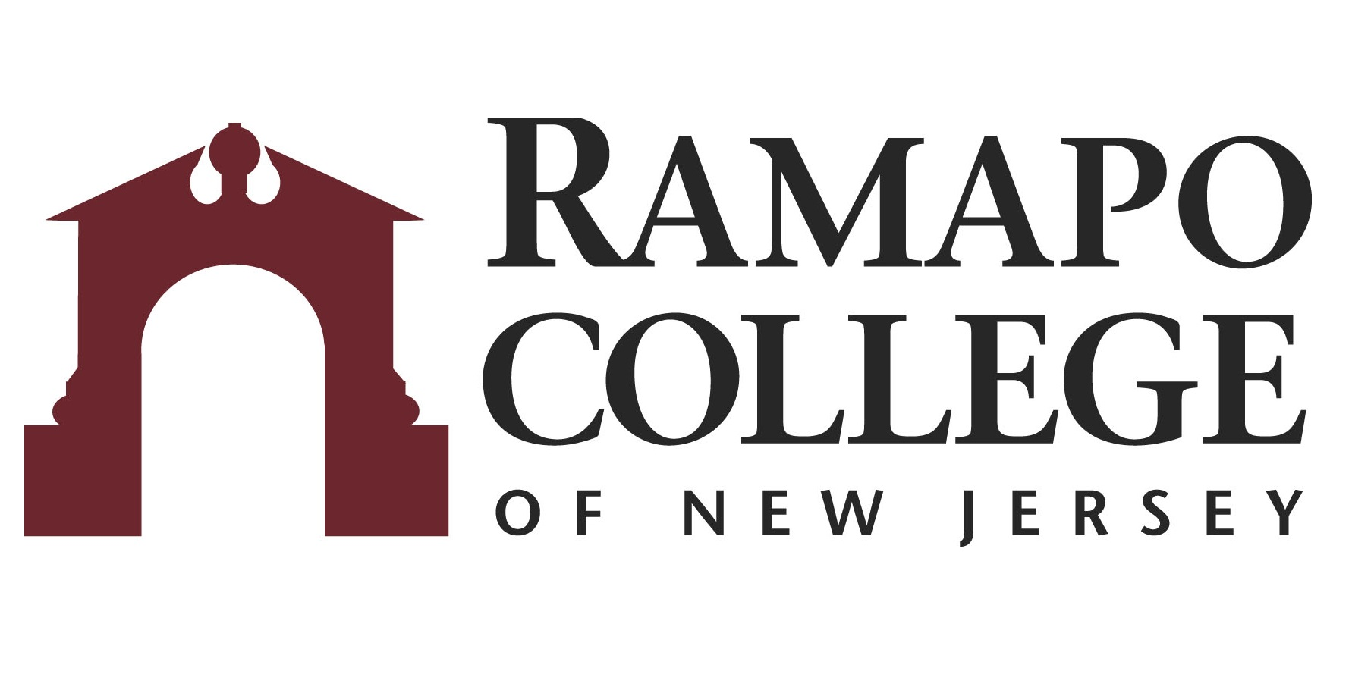
A.S. Business Marketing → B.S Business Administration: Marketing

First Year-BCC
Fall Semester | HRS |  | Spring Semester | HRS | 
WRT 101: English Composition I | 3 |  | WRT 201: English Composition II | 3
COM 100: Speech Communication/COM 102: Public Speaking | 3 |  | HUM 100: Humanities Elective | 3
MAT 150: Statistics | 3 |  | HUM 100: Humanities Elective | 3
ACC 110: Financial Accounting | 3 |  | ACC 210: Managerial Accounting | 3
BUS 101: Introduction to Business | 3 |  | BUS 201: Marketing Principles | 3
 |  |  | ECO 101: Macroeconomics | 3
Total: | 15 |  | Total: | 18

Second Year-BCC
Fall Semester | HRS |  | Spring Semester | HRS | 
BUS 203: Sports Marketing/BUS 210: e-Marketing/BUS 250: Advertising | 3 |  | BUS 233: Business Law I | 3
ECO 102: Microeconomics | 3 |  | INF 101: Principles of Information Technology | 3
SCI 100: Natural Science Elective | 4 |  | SCI 100: Natural Science Elective | 4
HUM 100: Humanities Elective | 3 |  | HUM 100: Humanities Elective | 3
HUM 100: Humanities Elective | 3 |  | FRE 100: Free Elective | 3
Total: | 16 |  | Total: | 16

Third Year-RCNJ
Fall Semester | HRS |  | Spring Semester | HRS | 
BADM 225: Management Statistics | 4 |  | BADM 301: Ethics in Business/INFO 315: Computer Law & Ethics | 4
MGMT 302: Managing Organizational Behavior | 4 |  | FINC 301: Corporate Finance I | 4
MKTG 310: Consumer Behavior | 4 |  | MKTG 330: Marketing Research | 4
MKTG 320:Integrated Marketing Communication | 4 |  | MKTG Elective* | 4
Career Pathways** Module 1: BADM 001  Career Assessment/Advisement Visit ASB Career Services Office in ASB-513 | Grad.  Rqmt. |  | Career Pathways**Module 2: BADM 002  Resume/LinkedIn/Cover Letter Visit ASB Career Services Office in ASB-513 | Grad.  Rqmt.
Total: | 16 |  | Total: | 16

Fourth Year-RCNJ
Fall Semester | HRS |  | Spring Semester | HRS | 
MKTG 430: Marketing Management | 4 |  | BADM 495: Strategic Management | 4
Level 400 MKTG Elective* | 4 |  | International Category Course* | 4
MGMT 370: Operations Management | 4 |  | Elective | 4
Elective | 4 |  | Elective | 4
Career Pathways**Module 3: BADM003  Interview Practice Visit ASB Career Services Office in ASB-513 | Grad.  Rqmt.
Total: | 16 |  | Total: | 16
*Course can be chosen from an approved list
This plan is based on the completion of an Associate of Arts or Associate of Science Degree at Bergen Community College encompassing all recommended courses. This plan is subject to change.

