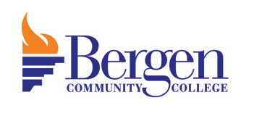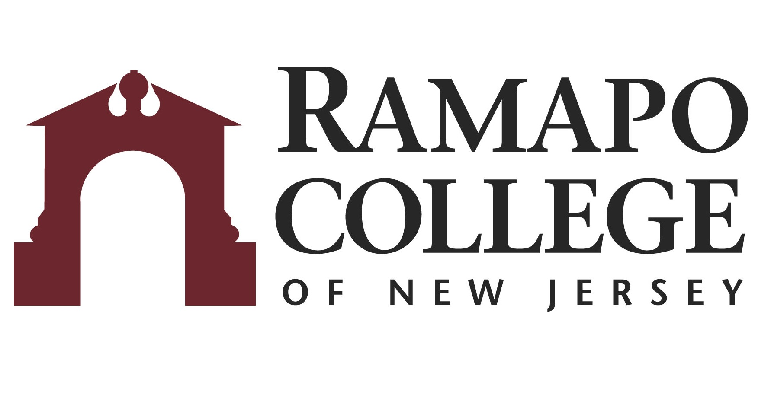
A.S. Natural Science & Math: Chemistry → B.S Chemistry

First Year-BCC
Fall Semester | HRS |  | Spring Semester | HRS | 
WRT 101: English Composition I | 3 |  | WRT 201: English Composition II | 3
COM 100: Speech Communication/COM 102: Public Speaking | 3 |  | MAT 280: Calculus I | 4
MAT 180: Pre-Calculus | 4 |  | HUM 100: Humanities Elective | 3
CHM 140: General Chemistry I | 3 |  | FRE 100: Free Elective | 3
CHM 141: General Chemistry I Lab | 1 |  | CHM 240: General Chemistry II | 3
HUM 100: Humanities Elective | 3 |  | CHM 241: General Chemistry II Lab | 1
Total: | 17 |  | Total: | 17

Second Year-BCC
Fall Semester | HRS |  | Spring Semester | HRS | 
CHM 260: Organic Chemistry I | 4 |  | CHM 262: Organic Chemistry II | 4
PHY 280: Physics I | 4 |  | PHY 290: Physics II | 4
MAT 281: Calculus II | 4 |  | SOC 100: Social Science Elective | 3
SOC 100: Social Science Elective | 3 |  | HUM 100: Humanities Elective | 3
 |  |  | HUM 100: Humanities Elective | 3
Total: | 17 |  | Total: | 17

Third Year-RCNJ
Fall Semester | HRS |  | Spring Semester | HRS | 
CHEM 324: Quantitative Chem Analysis Lecture  CHEM 324L: Quantitative Chem Analysis Lab | 4  1 |  | CHEM 427: Instrumental Analysis Lecture  CHEM 427L: Instrumental Analysis Lab | 4  1.5
CHEM Elective | 4 |  | CHEM 350: Physical Chemistry I Lecture | 4
MATH 225: Multivariable Calculus | 4 |  | CHEM 425: Biochemistry/CHEM Elective* | 4
Elective | 4 |  | Elective | 4
Total: | 17 |  | Total: | 17.5

Fourth Year-RCNJ
Fall Semester | HRS |  | Spring Semester | HRS | 
CHEM 352: Physical Chemistry II Lecture | 4 |  | CHEM 451: Adv Inorganic Chemistry Lecture  CHEM 451L: Adv Inorganic Chemistry Lab | 4  1
CHEM 350L: Physical Chemistry I Lab | 1.5 |  | CHEM Elective* | 4
CHEM Elective* | 4 |  | CHEM 352L: Physical Chemistry II Lab | 4
CHEM 430: Experimental Biochemistry+ | 2 |  | Elective | 4
Elective | 4
Total: | 17.5 |  | Total: | 17

*Course can be chosen from an approved list
+Recommended but not required
This plan is based on the completion of an Associate of Arts or Associate of Science Degree at Bergen Community College encompassing all recommended courses. This plan is subject to change.

