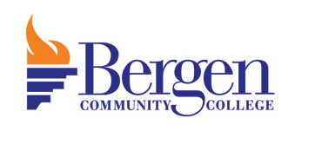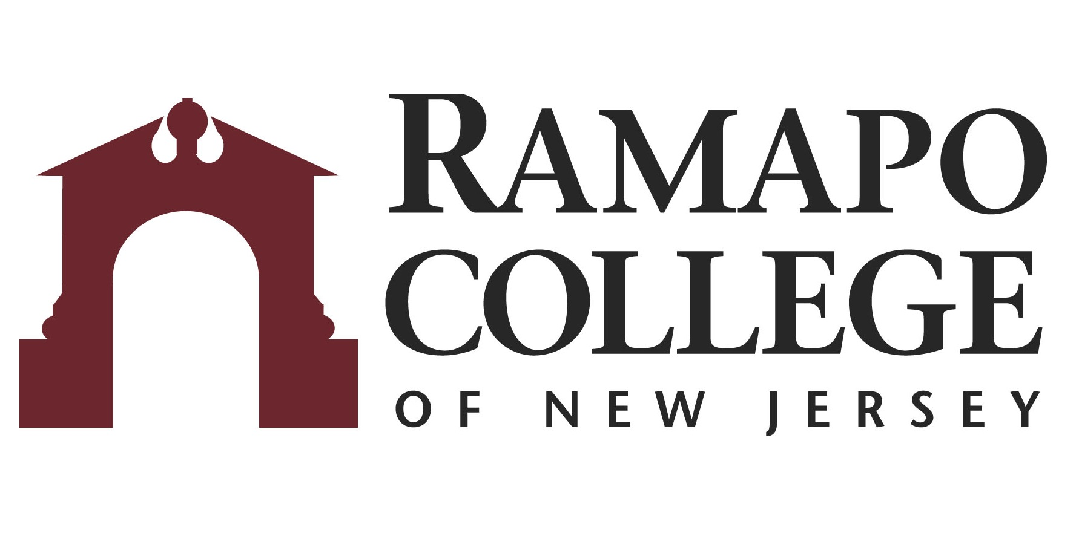
A.A. Fine & Performing Art: Theater Act: → B.A. Theater: Acting

First Year-BCC
Fall Semester | HRS |  | Spring Semester | HRS | 
WRT 101: English Composition I | 3 |  | WRT 201: English Composition II | 3
COM 100: Speech Communication/COM 102: Public Speaking | 3 |  | THR 113: Movement for the Performing Artist/THR 210: Scene Study | 3
THR 110: Basic Act Techniques | 3 |  | HUM 100: Humanities Elective | 3
THR 131: Stagecraft & Lighting | 3 |  | MAT 100: Math Elective | 3
MAT 100: Math Elective | 3 |  | SOC 100: Social Science Elective | 3
HUM 100: Humanities Elective | 3
Total: | 18 |  | Total: | 15

Second Year-BCC
Fall Semester | HRS |  | Spring Semester | HRS | 
HIS 100: History Elective | 3 |  | HIS 100: History Elective | 3
DIV 100: Diversity Elective | 3 |  | SOC 100: Social Science Elective | 3
HUM 100: Humanities Elective | 3 |  | SCI 100: Natural Science Elective | 4
SCI 100: Natural Science Elective | 4 |  | FREE 100: Free Elective | 3
Theater Elective [THR 214/217/232] | 2 |  | THR 215: Directing the Stage | 3
 |  |  | THR 120: Stage Make-up | 1
Total: | 15 |  | Total: | 17

Third Year-RCNJ
Fall Semester | HRS |  | Spring Semester | HRS | 
THR 120: Theater Practicum | 4 |  | THEA 233: Development of Modern Theater | 4
THEA 232: History of Theater | 4 |  | THEA 217: Visual Imagination | 4
THEA 260: Voice & Movement | 4 |  | THEA 315: Clowning & Comedy | 4
THEA 303: Intermediate Acting | 4 |  | Acting Concentration Elective* | 4
Total: | 16 |  | Total: | 16

Fourth Year-RCNJ
Fall Semester | HRS |  | Spring Semester | HRS | 
THEA 435: Advanced Theater Projects/CNTP 388: Internship in Contemporary Arts | 4 |  | THEA 326: Advanced Acting/THEA 427: Scene Studies | 4
THEA 312: Auditioning | 4 |  | THEA 460: Contemporary Theater & Theory | 4
CA Upper Level Interdisciplinary Course* | 4 |  | Elective | 4
Elective | 4 |  | Elective | 4
Total: | 16 |  | Total: | 16

*Course can be chosen from an approved list
This plan is based on the completion of an Associate of Arts or Associate of Science Degree at Bergen Community College encompassing all recommended courses. This plan is subject to change.

