To: ARC & The Faculty
From: General Education Task Force II:
Carol Bowman (SSHS), Chrstina Chung (GECCo), Christina Connor (LIB), Paula Straile-Costa (DAC), Eric Daffron (Provost Office), Lawrence A D’Antonio (TAS), Houda Essafi (SGA), Alex Olbrecht (ASB), Bryan Potts (SGA), Thierry Rakotobe-Joel (ARC), Ed Shannon (SSHGS; Chair), Jackie Skrzynski (CA)
Date: Nov. 18, 2015
Re: Final report in summary
Opening remarks.
The General Education Task Force II thanks the campus community for all of its help and support over the two and a half years of this process.
As a prelude to the report, we would like to clarify significant changes in this report from the previous iterations of the proposal:
- The “Language” requirement has been removed and replaced with a “Global Awareness” requirement.
- The “Distribution” categories have been reconfigured and no longer incorporate a B.A./B.S. division.
- This proposal still calls for a general education program no larger than ten courses. The new general education program, therefore, is no larger than the current curriculum.
Once again, we thank you for your participation and feedback. We have asked you to read many drafts of this proposal, to take survey after survey and to attend many meetings. Your insights were essential for completing this proposal.

SUMMARY INTRODUCTION
We recommend a multi-tiered program that situates the general education in a broader program of graduation requirements. These include experiential components and other activities, like senior presentations.
We wish to “rebrand” the General Education program “The Ramapo Arch Program,” removing any perceived stigma from the term “general education” for both students and faculty engaged in the program. The Arch, as a symbol of Ramapo, is increasingly associated with campus culture and student success (e.g., the Archway database, Arching ceremonies, etc.). We recommend that a visual representation of the arch be associated with materials accompanying the courses and experiences that are part of the Arch program:
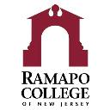
In sketch form, the Ramapo Arch Program includes the following, all of which are more fully described in the report.

Proposed GENERAL EDUCATION CONCEPTUAL FRAMEWORK
The “conceptual framework” is a statement of purpose for the general education program at the college. Composed after weeks of interviews on campus, the conceptual framework is an invitation to students and faculty and a summary statement of the value of a broad liberal education. It also establishes that general education is not a series of “requirements,” but an integral part of an undergraduate education.
From the conceptual framework, the Task Force developed the Learning Outcomes and Goals from which grew The Arch Program. The Task Force recommends that this statement appear on the General Education web page and be part of materials advertising the college and the program.

Conceptual Framework.
As New Jersey’s Public Liberal Arts College, Ramapo invites you to consider new perspectives on the world you’ve known and to prepare you for the next stage of your life. Here, you will be challenged by a variety of educational experiences: our school cores, minors, concentrations, study abroad, and other opportunities. You’ll pursue a major, one suited to your particular interests; at the same time, you will complete a general education curriculum, The Arch Program. Together, these programs ask you to step out from the community where you are now, to join our college community, and prepare you for citizenship in new communities—wherever your passions take you.
In preparation for the specific challenges of your major, The Arch Program curriculum asks you to think of yourself as a member of all of these communities. Drawing on the rich traditions of a liberal arts education, The Arch Program encourages you to see the connections—intellectual, social, economic, cultural, aesthetic, and empirical—we all share in our increasingly linked, increasingly global world.
Today, news, ideas, and wealth can circle the globe at the click of a mouse or the tap of a screen. This world needs citizens who honor where they came from and understand that no individual and no community stands alone. The products in our homes, the books on our shelves and screens, the knowledge in our minds—increasingly link us to hundreds of thousands of others.
The liberal arts teach us to cherish our curiosity and embrace the challenges of the coming world by pursuing a broad education—one that includes both a major and a rigorous general education program that puts that major into context. The student who navigates the channels between Ramapo’s many educational experiences sees the web of ideas, histories, financial links, political bonds, natural systems, and cultural exchange that forms the modern world we share today and links that world to civilizations past.
This world’s citizens must respond quickly to political, technological, and cultural change, be ready to shift careers, or reimagine themselves in an evolving field. A lifetime of learning is the passport to a productive, fulfilling future. The student who takes that path is ready to meet and shape tomorrow.

Proposed GENERAL EDUCATION GOALS AND OUTCOMES
The following goals were developed after extensive investigation on campus. They were further refined with input from AACU colleagues and submitted to GECCo for feedback (See Appendix 1: Proposed Curriculum Map).
- Explore the world: Investigate human cultures and the natural world.
- Critically engage with the products of culture, through interpretation or creative expression.
- Critically interpret history and society.
- Apply methods of scientific inquiry effectively.
- Apply mathematical concepts effectively.

- Engage the world: think critically and convey new understanding.
- Demonstrate logic and reasoning skills.
- Write effectively in scholarly and creative contexts.
- Speak effectively in scholarly and creative contexts.
- Develop the skills necessary to locate, evaluate, and employ information effectively.
- Use technology to communicate information, manage information, or solve problems.

- Experience your world: integrate and apply your new learning.
- Apply disciplinary and interdisciplinary knowledge and skills to address complex problems.
- Practice reflective inter/intra-personal skills.

- Expand our world: develop compassion and ethical understanding across cultures and become an engaged global citizen.
  - Understand diverse communities on local, national, and/or global levels.
  - Analyze ethical implications of the global distribution of power and resources.
  - Question assumptions about individual and group identity.
  - Demonstrate intercultural understanding required to effectively negotiate a diverse global society.

Proposed ARCH PROGRAM IN SKETCH
I. The Keystone courses.
The arch is an apt symbol for a program made of interrelated component parts. We recommend renaming the 100- and 200- level “foundational” courses in the general education program “Keystone Courses” to indicate their significance in holding the arch together.
II. Mid-Career Reflection.
An experience designed by the School or Major that allows us to fully engage both “native” and transfer students at the mid-points of their careers at Ramapo. The Mid-career reflection offers a space for advisement, for students to more fully integrate themselves into the culture of their “home schools,” and for them to learn what resources and opportunities are available to them.
III. Experiential Component.
Learning opportunities embedded into courses within the General Education program.
IV. Distribution Categories.
These courses reinforce Student Learning Outcomes introduced in the Keystone courses and ask students to apply learning outcomes from the keystone courses in new situations.
V. Senior Presentation.
Experience designed by School or Major that is a culmination of General Education and discipline-specific learning.
Notes on COURSES, CATEGORIES, DISTRIBUTION
The Arch Program proposal specifies learning goals will be met in various ways, through distinct courses, small categories (on the “Keystone” level), broader themed distribution categories after Keystones are completed, and experiences such as the Mid-career reflection and Senior Presentation. The following is a key to some of these distinctions as pertaining to the courses and categories:
- Keystone courses:
- First Year Seminar (distinct course)
- Critical Reading and Writing 102 (distinct course)
- Studies in the Arts and Humanities (formerly “Readings in Humanities”; distinct course)
- Historical Perspectives (small category)
- Global Awareness (replacing “Language”; small category)
- Social Science Inquiry (distinct course)
- Quantitative Reasoning (small category)
- Scientific Reasoning (small category)

- Broader themed distribution categories
Students take two of the following. At least one course must be outside of the student’s school.
Culture & Creativity  Populated primarily with Courses from SSHGS and CA | Values & Ethics  Populated with courses from any School | Systems, Sustainability, & Society  Populated primarily with courses from TAS, SSHS, ASB
Courses in this category fulfill the following goals: | Courses in this category fulfill the following goals: | Courses in this category fulfill the following goals:
- Critically engage with the products of culture, through interpretation or creative expression.  - Critically interpret history and society.  - Question assumptions about individual and group identity.  - Demonstrate logic and reasoning skills. | - Analyze ethical implications of the global distribution of power and resources.  - Question assumptions about individual and group identity.  - Practice reflective inter/intra-personal skills.  - Demonstrate logic and reasoning skills. | - Apply methods of scientific* inquiry effectively.  - Analyze ethical implications of the global distribution of power and resources.  - Demonstrate logic and reasoning skills.
 |  | *social science or science
Proposed CURRICULUM MAP

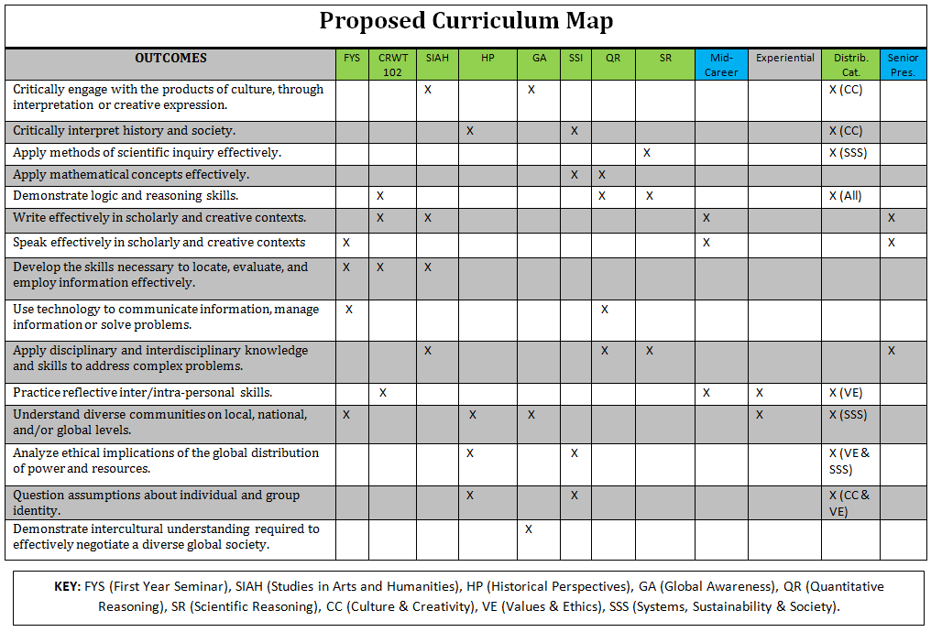
Four-Year ARCH EXPERIENCE

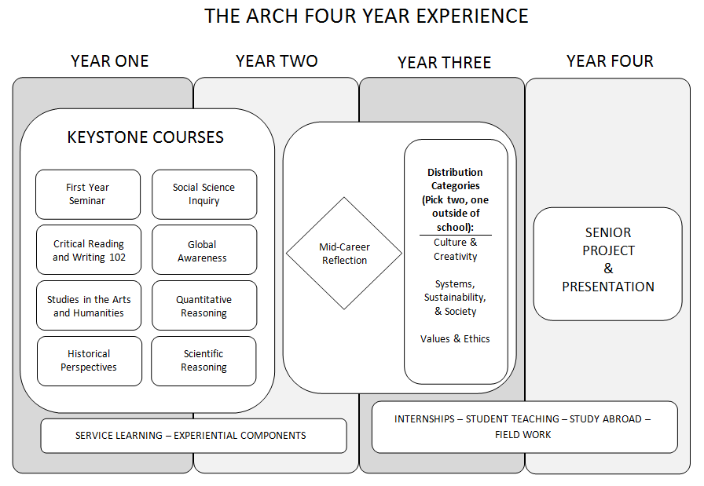

The RAMAPO ARCH

We use verbs like “apply” and “demonstrate” broadly. Students in lower level courses would “apply and demonstrate” knowledge to a lesser degree than students in upper level courses. Also, “apply,” “demonstrate,” and other verbs always imply some level of “understanding.”
We recommend that the implementation committee operationalize this goal in a way that allows courses to achieve EITHER local, national, OR global. See: AAC&U Global Learning VALUE Rubric for further clarification.

