To: ARC & The Faculty
From: General Education Task Force II:
Carol Bowman (SSHS), Seth A Cluett (GECCo), Christina Connor (LIB), Paula Straile-Costa (DAC), Eric Daffron (Provost Office), Lawrence A D’Antonio (TAS), Anthony Darakjy (SGA), Alex Olbrecht (ASB), Bryan Potts (SGA), Thierry Rakotobe-Joel (ARC), Ed Shannon (SSHGS; Chair), Jackie Skrzynski (CA)
Date: May 8, 2015
Re: Final report
Opening remarks.
The General Education Task Force II thanks the campus community for all of its help and support over the two years of this process.
As a prelude to the report, we would also like to clarify two significant changes in this report from the previous iterations of the proposal:
- This proposal calls for a ten-course general education program. The new general education program, therefore, is no larger than the current curriculum. Exemptions and placement testing will reduce it further for some.
- This Proposal does not include clusters. Instead, it recommends distribution categories. Based on feedback from the campus community and data collected from off campus, it became clear that now was not the time to experiment with clusters.
Once again, we thank you for your participation and feedback. We asked you to read many drafts of this proposal, and your comments and insight were essential for completing this proposal.

EXECUTIVE SUMMARY
We recommend a multi-tiered program that situates the general education in a broader program of graduation requirements. These include experiential components and other activities, like senior presentations.
Acting on guidance gleaned from the AACU 2014 Summer Institute on General Education and Assessment, we wish to “rebrand” the General Education program “The Ramapo Arch Program,” removing any perceived stigma from the term “general education” for both students and faculty engaged in the program. The Arch, as a symbol of Ramapo, is increasingly associated with campus culture and student success (e.g., the Archway database, Arching ceremonies, etc.). We recommend that a visual representation of the arch be associated with materials accompanying the courses and experiences that are part of the Arch program (see also Appendix 4, “The Ramapo Arch”):
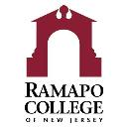
In sketch form, the Ramapo Arch Program includes the following, all of which are more fully described in the report.
A major goal of this proposal is to encourage full-time faculty to teach courses in the general education (especially in the “Keystone” courses). Such faculty engagement enhances both distribution courses and distinct courses, like First Year Seminar and Critical Reading and Writing.
Finally, this report includes two kinds of recommendations: a new general education curriculum and a series of graduation requirements into which that curriculum is woven. The Keystone courses and the Distribution categories comprise the general education curriculum. The Mid-career reflection, experiential component, and senior presentation comprise graduation requirements. The explicit charge of this task force was to develop a general education curriculum. However, we are making recommendations beyond that charge. The graduation requirements serve as a structure supporting the general education curriculum, weaving it into the tapestry of the college experience. We see the two components part of one whole (see Appendix 3: Four-Year Arch Experience).

Proposed ARCH PROGRAM IN SKETCH
I. The Keystone courses.
The arch is an apt symbol for a program made of interrelated component parts. We recommend renaming the 100- and 200- “foundational” courses in the general education program “Keystone Courses” to indicate their significance in holding the arch together.
II. Mid-Career Reflection.
An experience designed by the School or Major that allows us to fully engage both “native” and transfer students at the mid-points of their careers at Ramapo. The Mid-career reflection offers a space for advisement, for students to more fully integrate themselves into the culture of their “home schools,” and for them to learn what resources and opportunities are available to them.
III. Experiential Component.
Learning opportunities embedded into courses within the General Education program.
IV. Distribution Categories.
These courses reinforce Student Learning Outcomes introduced in the Keystone courses and ask students to apply learning outcomes from the keystone courses in new situations.
V. Senior Presentation.
Experience designed by School or Major that is a culmination of General Education and discipline-specific learning.
Proposed GENERAL EDUCATION CONCEPTUAL FRAMEWORK
The “conceptual framework” is a statement of purpose for the general education program at the college. Composed after weeks of interviews on campus, the conceptual framework is an invitation to students and faculty and a summary statement of the value of a broad liberal education. It also establishes that general education is not a series of “requirements,” but an integral part of an undergraduate education.
From the conceptual framework, the Task Force developed the Learning Outcomes and Goals from which grew The Arch Program. The Task Force recommends that this statement appear on the General Education web page and be part of materials advertising the college and the program.

Conceptual Framework.
As New Jersey’s Public Liberal Arts College, Ramapo invites you to consider new perspectives on the world you’ve known and to prepare you for the next stage of your life. Here, you will be challenged by a variety of educational experiences: our school cores, minors, concentrations, study abroad, and other opportunities. You’ll pursue a major, one suited to your particular interests; at the same time, you will complete a general education curriculum, The Arch Program. Together, these programs ask you to step out from the community where you are now, to join our college community, and prepare you for citizenship in new communities—wherever your passions take you.
In preparation for the specific challenges of your major, our general education curriculum asks you to think of yourself as a member of all of these communities. Drawing on the rich traditions of a liberal arts education, The Arch Program encourages you to see the connections—intellectual, social, economic, cultural, aesthetic, and empirical—we all share in our increasingly linked, increasingly global world.
Today, news, ideas, and wealth can circle the globe at the click of a mouse or the tap of a screen. This world needs citizens who honor where they came from and understand that no individual and no community stands alone. The products in our homes, the books on our shelves and screens, the knowledge in our minds—increasingly link us to hundreds of thousands of others.
The liberal arts teach us to cherish our curiosity and embrace the challenges of the coming world by pursuing a broad education—one that includes both a major and a rigorous general education program that puts that major into context. The student who navigates the channels between Ramapo’s many educational experiences sees the web of ideas, histories, financial links, political bonds, natural systems, and cultural exchange that forms the modern world we share today and links that world to civilizations past.
This world’s citizens must respond quickly to political, technological, and cultural change, be ready to shift careers, or reimagine themselves in an evolving field. A lifetime of learning is the passport to a productive, fulfilling future. The student who takes that path is ready to meet and shape tomorrow.

Proposed GENERAL EDUCATION GOALS AND OUTCOMES
The following goals were developed after extensive investigation on campus. They were further refined with input from AACU colleagues and submitted to GECCo for feedback (See Appendix 1: Proposed Curriculum Map).
- Explore the world: Investigate human cultures and the natural world.
- Critically engage with the products of culture, through interpretation or creative expression.
- Critically interpret history and society.
- Apply methods of scientific inquiry effectively.
- Apply mathematical concepts effectively.

- Engage the world: think critically and convey new understanding.
- Demonstrate logic and reasoning skills.
- Write effectively in scholarly and creative contexts.
- Speak effectively in scholarly and creative contexts.
- Develop the skills necessary to locate, evaluate, and employ information effectively.
- Use technology to communicate information, manage information, or solve problems.

- Experience your world: integrate and apply your new learning.
- Apply disciplinary and interdisciplinary knowledge and skills to address complex problems.
- Practice reflective inter/intra-personal skills.

- Expand our world: develop compassion and ethical understanding across cultures and become an engaged global citizen.
  - Engage cooperatively and compassionately with diverse communities locally, nationally and globally.
  - Analyze ethical implications of the global distribution of power and resources.
  - Question assumptions about individual and group identity.
  - Demonstrate skill in a language other than English, while also gaining an understanding of other cultures.
Proposed KEYSTONE COURSES

First Year Seminar

RATIONALE: First Year Seminar serves as the transition from high school to college both academically and developmentally. The Task Force envisions this course fulfilling part of the Experiential component through civic and campus engagement. AACU has also identified First Year Seminar courses as high impact learning experiences. For these reasons, we recommend keeping this course within Ramapo’s general education curriculum.

Recommended Goals:
- Speak effectively in scholarly and creative contexts.
- Develop the skills necessary to locate, evaluate, and employ information effectively.
- Use technology to communicate, manage, or solve problems.
- Engage cooperatively and compassionately with diverse communities locally, nationally and globally

The Task Force Recommends:
- This remains a distinct course.
- Supporting the Writing Across the Curriculum Committee’s review of whether or not this course should remain a Writing Intensive course.
- That Goal #2 above (“Develop skills…”) emphasize the information literacy component “locate.”
- Every First Year Seminar has an experiential component that focuses on citizenship, service learning or campus involvement.
- Encouraging more full-time faculty to teach this course.

Critical Reading and Writing 102

RATIONALE: Middle States requires two important student learning outcomes—written communication and information literacy—with all general education programs. These outcomes are the primary focus of this course. Logic and reasoning have always been embedded into this course, forming the backbone of a liberal arts education. For these reasons we recommend keeping this course within Ramapo’s general education curriculum.

Recommended Goals:
- Demonstrate logic and reasoning skills.
- Write effectively in scholarly and creative contexts.
- Develop the skills necessary to locate, evaluate, and employ information effectively.

The Task Force Recommends:
- This remains a distinct course.
- Critical Reading and Writing 102 continues to be designated Writing Intensive and remain within the General Education Writing Across the Curriculum program.
- Encouraging more full-time faculty, particularly those whose discipline emphasizes rhetoric and critical thinking, to teach this course.
- Supports the CRWT Coordinator’s suggestion to include the term “critical thinking” in the title and course description.
- Maintain the current placement procedures, as well as the current roles for CRWT 101, CRWT 080, and CRWT 090.

Studies in the Arts and Humanities (formerly “AIID 201 Readings in Humanities”; we recommend further title changes—see below)

RATIONALE: Studies in Arts and Humanities is key to a liberal arts education. The strategic plan reinforces the centrality of the arts and humanities to the Ramapo education, calling for “undergraduate enrollment share in the arts and humanities to increase” (Achievement Target 1.4.7).

The strategic plan also calls for a rededication to interdisciplinary education, defining interdisciplinarity as “the interaction, integration, or syntheses of knowledge and learning across disciplines.” Studies in Arts and Humanities successfully recruited full-time faculty from at least two schools in a variety of fields to contribute to the general education program.

Recommended Goals:
- Write effectively in scholarly and creative contexts.
- Critically interpret the products of culture and creative expression.
- Apply disciplinary and interdisciplinary knowledge and skills to address complex problems.
- Develop the skills necessary to locate, evaluate, and employ information effectively.

The Task Force Recommends:
- This remains a distinct course.
- Studies in Arts and Humanities continues to be designated Writing Intensive and remain within the General Education Writing Across the Curriculum program.
- That Goal #4 above (“Develop skills…”) emphasize the information literacy component “evaluate.”
- We recommend a new title and course subject the course. The Task Force suspects faculty teaching the course will be unsatisfied with the title used here, “Studies in Arts and Humanities.” Whatever the new title, it should incorporate “the arts.” We further recommend removing the word “readings” from the title to further invite arts faculty to participate in the course and to signal the interdisciplinary nature of the course to students.
- This course builds on FYS Experiential Component to address the intersection between citizenship, community, and culture. This component would represent students’ second step into the Experiential Component of the Arch Program. We recommend basing this program on Elmira College’s “Encore” program. We recommend expanding this to include Readings at Ramapo, art gallery events, and the like. For more on Elmira’s program: (http://www.elmira.edu/academics/The_EC_Experience/Encore/index.html),
History Category

RATIONALE: While most students arrive having studied history K-12, this category asks them to critically interpret events through historical context. This course also provides context to the topics covered in Studies in the Arts and Humanities. For these reasons we recommend keeping this category within Ramapo’s general education curriculum.

Recommended Goals:
- Critically interpret history and society.
- Analyze ethical implications of the global distribution of power and resources.
- Question assumptions about individual and group identity.

The Task Force Recommends:
- Courses identified in this category must introduce students to concepts like historiography and ask students to learn not only historical content
(events, processes, trends, people) but also to place that learning in historical context
and to think critically about causation, connections to the present, and cultural bias.
- Under the current General Education program, four courses fulfill this requirement (down from a previous six). While we do not recommend expanding this number dramatically, we recommend History faculty work with the implementation committee and reach out to faculty outside the History convening group to explore the possibility of other courses fulfilling the learning outcomes of this category. This would have the effect of bringing more full time faculty into the Keystone courses.
- Regardless, we recommend this distribution category remain close to the current size given the distinct goals and purpose of this category.

Language Category

RATIONALE: A language requirement incorporates College’s International and Intercultural Pillars and is a common part of comparable college’s programs. Ramapo’s International Education student survey registers strong student support for language instruction (http://www.ramapo.edu/international/files/2014/10/Student-Survey-on-International-Education.pdf). Likewise, the Strategic Plan seeks a dramatic increase “successful engagement by graduation in a meaningful international experience (study abroad, service learning abroad, international internship/co-op, foreign language study, intensive specialized international course)” (Achievement Target 1.1.2).

The goal of the language requirement is not proficiency. Its purpose is to sensitize students to language issues and to invite them to think about language, which is at the core of human experience. Language study builds cultural competence, self-awareness, sensitivity to diversity, and respect for others. It also supports writing and oral competency, asking students to engage with their native language from a new context.

For more information on the rationale for the language requirement, please view the General Education Task Force II website: http://www.ramapo.edu/task-force-2/. Also there is a list of conditions under which students would be exempted from this course.
Recommended Goals:
- Demonstrate skill in a language other than English, while also gaining an understanding of other cultures
- Critically engage with the products of culture, through interpretation or creative expression
- Practice reflective inter-intra-personal skills.

The Task Force Recommends:
- Students take a placement test or CLEP test to determine appropriate level.
- Students who test at or below Intermediate I take one course at the appropriate level.
- Students who test above Intermediate I are exempted.
- Students already proficient in a world language other than English are exempted.

Social Science Inquiry

RATIONALE: Major themes outlined in the Conceptual Framework are community, diversity, and citizenship. Incorporating a class emphasizing the social sciences underscores these themes. These disciplines explore society broadly as well as the relationships among individuals within a society. Therefore, we recommend the creation of a new course bringing together these strands.

Framing the course in the context of multiple social science disciplines across schools invites full-time faculty from all five schools to participate in creating and teaching the course.

Recommended Goals:
- Critically interpret history and society.
- Apply mathematical concepts effectively.
- Analyze ethical implications of the global distribution of power and resources.
- Questions assumptions about individual and society.

The Task Force Recommends:
- This is developed as a distinct course.
- This course includes an experiential component. The Task Force encourages the working group developing the course to draw on existing activities on campus. For example, the Civic & Community Engagement Center and the Law & Society Convening Group sponsor the Supreme Court of the US Discussion Series (SCOTUS), which touches on observations and debates of critically important issues facing Americans today, from marriage equality to racial justice. This discussion series may complement topics discussed in this course and lead to further discussion.

Mathematics Category

RATIONALE: We live in a world drowning in data. Citizens lacking the ability to think mathematically cannot fully participate in civic life. Reflecting this reality, both AAC&U and Middle States require quantitative reasoning and literacy.

Recommended Goals:
- Apply mathematical concepts effectively.
- Demonstrate logic and reasoning skills.
- Use technology to communicate, manage, or solve problems.
- Apply disciplinary and interdisciplinary knowledge and skills to address complex problems.

The Task Force Recommends:
- This remains a category.
- Courses in this category give students the opportunity to apply their knowledge of mathematics to topics relevant to their everyday life.
- Maintaining the current courses in place for the Mathematics category. During the implementation phase, the mathematics faculty should work closely with those majors requiring specific mathematics courses to refine those offerings.
- Maintain current placement procedures.

Science Category

RATIONALE: As with mathematical literacy, only citizens with basic scientific sensibility can grapple with the complexity, diversity, and change they will face. Our contemporary culture faces increasing distrust in scientific principles. Middle States’ focus on scientific inquiry reflects the significance of this category.

Recommended Goals:
- Apply methods of scientific inquiry effectively.
- Demonstrate logic and reasoning skills.
- Apply disciplinary and interdisciplinary knowledge and skills to address complex knowledge.
- Engage cooperatively and compassionately with diverse communities locally, nationally, and globally.

The Task Force Recommends:
- This remains a category.
- Courses in this category allow students to connect their understanding of science to topics relevant to society and to areas of knowledge outside of the sciences.
- Students not majoring in the sciences in TAS satisfy the science requirement by completing one of the TAS “Introduction” courses. Students majoring in the sciences in TAS satisfy the science requirement by completing one of the “Fundamentals” courses. Therefore, courses in the Keystone science category (i.e. “Introduction” courses) will be tailored for students new to the sciences.
Proposed MID-CAREER EXPERIENCE

RATIONALE: The Mid-Career Experience integrates Transfer students into the Ramapo experience. It also offers both native and transfer students space to reflect on their academic choices thus far and to seek complementary educational experiences. For instance, students might be counseled to complete a study abroad, or seek an internship, or similar opportunity.

Recommended Goals:
- Practice reflective inter/intra-personal skills.
- Write effectively in scholarly and creative contexts.
- Speak effectively in scholarly and creative contexts.

The Task Force Recommends:
- The Mid-Career experience is specific to Majors or Schools, integrating native students & transfers into their chosen School or major.
- These programs be housed in the schools.
- Each Unit incorporate recommended goals above into the Mid-Career experience.
- The Mid-Career experience dovetails with the sophomore engagement efforts in which the college is already invested. Two schools are already pioneering this effort; we recommend the college build on the efforts of our colleagues in ASB (Career Pathways Program) and SSHGS (Pathways Program). Schools could also choose to weave into the Mid-Career experience other opportunities the college already supports, like retreats and other introspective experiences that contribute to personal growth.
Proposed EXPERIENTIAL COMPONENT

RATIONALE: Experiential Learning is a Pillar of Ramapo College. An enhanced effort to recruit students into the College’s “hands on” learning programs will encourage students to become more active and engaged on campus.

This new effort supports the College’s 2014 Strategic Plan, which calls for the “College [to] offer rigorous curricula and experiential activities that prepare all students for a lifetime of achievement” (OBJECTIVE 1.1.). That report also recommends Ramapo “develop and promote curricular, co-curricular, and extra-curricular programs that demonstrate the value of diversity, self-awareness, examination of multiple perspectives, and respect for others” (OBJECTIVE 4.3).

Recommended Goals:
- Practice reflective inter/intra-personal.
- Engage cooperatively and compassionately with diverse communities locally, nationally and globally.

The Task Force Recommends:
- Experiential learning opportunities be built into as well as encouraged within the General Education program.
- The implementation committee should draw on the conclusions of the Experiential Task Force report (forthcoming).
- Using existing experiential activities already being offered on campus, as well as creating new experiences that address themes outlined in the Conceptual Framework. For example, the First Year and Second Year Engagement Boards create experiential activities specifically geared toward the general education population. The Engagement Boards also have clear academic, personal, social, and civic student learning outcomes that are mapped to specific activities. These activities are assessed each time they are offered. (For more information, please consult the Student Engagement Project’s website: http://www.ramapo.edu/provost/student/.)
- Experiential opportunities purposefully embedded into select courses in addition to stand-alone activities. We offer the following examples:
- First Year Seminar includes the student learning outcome “Engage cooperatively and compassionately with diverse communities locally, nationally, and globally.” We suggest the First Year Seminar program contain some sort of service learning, volunteer, leadership (such as Student Government), or class or individual campus activism component that has the students engage in the College and/or outside community.
- Studies in the Arts and Humanities includes the student learning outcome “Critically engage with the products of culture, through interpretation or creative expression of their own.” We suggest Readings include going to art/ theater /music/ film events on and off campus as part of the class experience.
- Social Science Inquiry includes student learning outcomes focused on questioning assumptions about identity and the distribution of power and resources. The Civic & Community Engagement Center and the Law & Society Convening Group sponsor the Supreme Court of the United States Discussion Series (SCOTUS), which touches on observations and debates of critically important issues facing Americans today, from marriage equality to racial justice. This discussion series may complement topics discussed in this course and lead to further discussion.
Proposed Distribution Categories

RATIONALE: The courses in the following categories build on Keystone learning outcomes.
They provide students an opportunity to reinforce what they have learned in new situations. Well-designed and well-maintained distribution categories invite students to explore new disciplines and make connections within and beyond their own fields of study.

Culture & Creativity | Values & Ethics | Systems, Sustainability, & Society
Courses in this category fulfill the following goals: | Courses in this category fulfill the following goals: | Courses in this category fulfill the following goals:
- Critically engage with the products of culture, through interpretation or creative expression.  - Critically interpret history and society.  - Question assumptions about individual and group identity. | - Analyze ethical implications of the global distribution of power and resources.  - Question assumptions about individual and group identity.  - Practice reflective inter/intra-personal skills.  - Demonstrate logic and reasoning skills. | - Apply methods of scientific* inquiry effectively.  - Analyze ethical implications of the global distribution of power and resources.  - Engage cooperatively and compassionately with diverse communities locally, nationally and globally.
 |  | *social science or science

The Task Force Recommends:
- Students take two of the three distribution categories:
  - Students earning a B.S. degree (See Appendix 2) take a course in the Culture and Creativity category and the Values and Ethics category.
  - Students earning a B.A. degree (See Appendix 2) take a course in the System, Sustainability, and Society category and the Values and Ethics category.
- Courses in these categories can only have prerequisites that are part of the required Keystone courses or based on class standing.
- Criteria for Courses in the distribution categories:
  - Courses will mainly be 200 level. Some 300-level may be allowed under certain circumstances (e.g., class standing or prerequisites drawn only from Keystones).
  - There will be fewer courses in each category, but enough to meet the demand.

Proposed SENIOR PRESENTATION

RATIONALE: This proposal seeks to more fully integrate the general education curriculum into the life of the college. Senior Presentations will serve as evidence that the Arch Program has succeeded. The Senior Presentation is the capstone of the Ramapo College experiences, integrating work from the majors, minors, keystone, and distribution categories.

Among the activities we foresee:
- Oral presentations of capstone work
- Presentation could take many different formats.
- Capstone work includes the diversity of disciplinary work on campus.

Recommended Goals:
- Write and speak effectively in scholarly and creative contexts.
- Apply disciplinary and interdisciplinary knowledge and skills to address complex problems.

The Task Force Recommends:
- Every Spring Ramapo College will designate a full weekday as an Annual Celebration of Student Research, Creativity, and Performance. At the Annual Celebration, seniors (defined by credit range) will give oral presentations of capstone work, ranging from individual or group research projects to visual art, poetry and prose, plays, and more.
- The annual Research Day will expand current programs, like the college-wide Scholars Day. It will also coordinate school- and major- focused programs like Media Collision in CA and student presentations in ASB and TAS. We imagine the inclusion of all existing research/exhibition venues, plus the creation of new ones for programs and schools not currently offering these opportunities.
Proposed GOVERNANCE STRUCTURE FOR THE GENERAL EDUCATION PROGRAM

The Task Force Recommends:
- Courses must address learning outcomes or lose general education/ Arch/ Keystone status.
- Courses submitted for consideration in general education must include in the syllabus specified learning outcomes linked to assignments. GECCo should establish a checklist of requirements for faculty looking to include their course in any of the Keystone or Distribution categories.
- Courses in the categories be revisited and reevaluated every three years, potentially linked with the assessment cycle.
- GECCo periodically audit courses in the distribution categories to see how many students in a particular class are using the class to fulfill a GE requirement. This provides data to faculty overseeing the categories to more effectively choose courses that will more effectively deliver the Arch Program.
- Conduct research to determine the number of courses needed for the distribution categories. There are advantages to keeping the categories manageable, but they need to be able to service the needs of the students. In Spring 2015, the College offered 58 sections in International Issues and 41 sections in Intercultural North America. In Fall 2015, the College has listed 58 sections in International Issues and 32 sections in Intercultural North America. These numbers begin to give us some insight into how many sections need to be offered. Knowing which sections served the most “non-major” students would help GECCo determine how many courses were needed for the Arch Program.
- One member of GECCo should be assigned supervision for each distribution categories with reassign time (3 supervisors in total): Culture & Creativity; Values & Ethics; Systems, Sustainability & Society.
- The coordinator of Social Science Inquiry course should receive reassign time (as is the case with the coordinators of First Year Seminar, Critical Reading and Writing, Studies in the Arts and Humanities).
- The allocation of resources to First Year Seminar has helped that program flourish. Therefore, similar resources should be devoted to Critical Reading and Writing, Social Science Inquiry, and Studies in the Arts and Humanities. Resources such as peer facilitators, a common reading, guest speakers, group activities and support personnel would benefit these courses. Such resources unambiguously signal to both students and faculty that these courses and programs are valued.
- Exploring the possibility for students to choose a limited number of general education courses be taken pass/fail. The pass/fail option may allow students to be more adventurous in their choices and relieve the pressure of learning to navigate new intellectual terrain.

Proposed IMPLEMENTATION PLAN FOR THE GENERAL EDUCATION PROGRAM

The Task Force Recommends:
- Designated members of GECCo spend the AY2015-2016 implementing the new curriculum.
- In AY 2015-16, GECCo suspend regular assessment duties or only assess those outcomes that carry over from the current General Education Student Learning Outcome list (i.e. oral communication, written communication, information literacy, quantitative reasoning, and scientific inquiry).
- As for the General Education Student Learning Outcomes no longer being assessed (i.e. Awareness and The Way the World Works), GECCo should consider the GE revision the “Closing the Loop” on those discontinued outcomes.
- Members of the General Education Task Force II meet with GECCo when needed for clarification on intent of goals/outcomes and other matters.
- An “Arch Program Handbook” be developed, exploring specific iterations and examples of activities and outcomes built on our broad goals.
- A “General Education History/Archive” be developed and maintained on the Ramapo webpage. Knowing what previous efforts have succeeded or failed (and why) will enable future committees and task forces to work more efficiently and effectively.
- With three Keystone courses devoted to experiential components, we have the potential for a cohort model, which the Task Force discussed briefly. For example, cohorts of students might take FYS in the fall and social science in the spring. This recommendation would demand further study, but the model here suggests it as a possibility.
Appendix 1. Proposed Curriculum Map

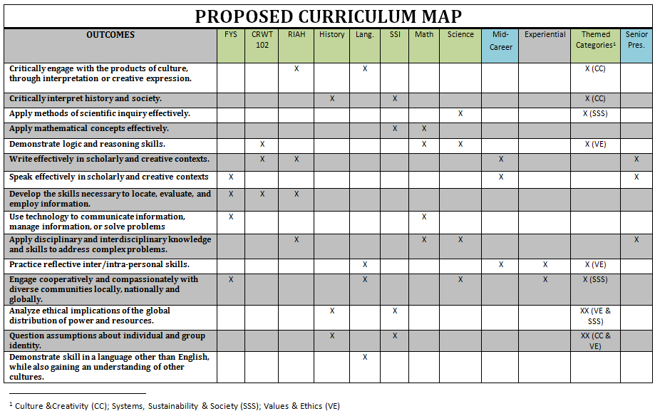
Appendix 2. List of B.S. and B.A. Degrees Currently Offered at Ramapo

UNDERGRADUATE  BACHELOR OF ARTS | UNDERGRADUATE  BACHELOR OF SCIENCE
Africana Studies  American Studies  Communication Arts  Contemporary Arts  Economics  Environmental Studies  History  International Business  International Studies  Law and Society  Liberal Studies -contract major  Literature  Music  Political Science  Psychology  Social Science  Sociology  Spanish Language Studies  Theater  Visual Arts | Accounting  Allied Health  Biochemistry  Bioinformatics  Biology  Business Administration  Chemistry  Clinical Lab Sciences  Computer Science  Engineering Physics  Environmental Science  Information Systems  Integrated Science Studies  Mathematics  Medical Imaging Sciences  Physics  Nursing  Nursing (Earned RN)  Social Work

Appendix 3. Four-Year Arch Experience

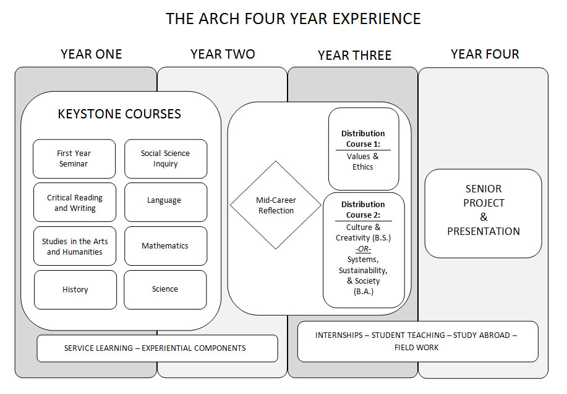

Appendix 4. The Ramapo Arch

We use verbs like “apply” and “demonstrate” broadly. Students in lower level courses would “apply and demonstrate” knowledge to a lesser degree than students in upper level courses. Also, “apply,” “demonstrate,” and other verbs always imply some level of “understanding.”

