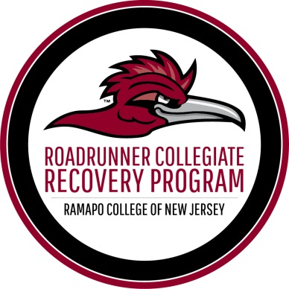

PERSON FIRST - Spoken Here
Recovery Allies Fusion Training Registration

In order to register for "Person First Spoken Here" Recovery Allies Fusion Training, please complete the form below. If you have any questions, please contact Cory Rosenkranz at crosenkr@ramapo.edu or 201-684-7019.
*Required
Name* ____________________________________________________________
Please choose one of the following*:
Faculty
Staff
Graduate Student
Undergraduate Student
Other

Major_____________________________________________________________

Graduation Year____________________________________________________

Cell Phone Number*________________________________________________

Email Address*_____________________________________________________

T-Shirt Size*_______________________________________________________
Are there any accommodations that we can provide for you?
________________________________________________________________________________________________________________________________________________________________________________________________________________________________________________________________________

SUBMIT TO CORY ROSENKRANZ:
(D-216 or by e-mail: crosenkr@ramapo.edu)

