Dropping a Course in Web Self Service 9
- Visit the Following Website:
  - https://ssba.ramapo.edu:8443/myssb/twbkwbis.P_WWWLogin
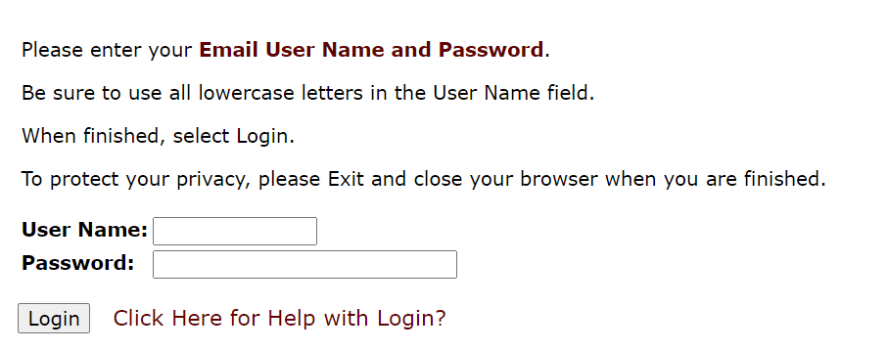
- Enter Username
  - IE: jramapo
- Enter Password
  - Enter your Email Password
- Click Login

- Click on Student Services and Financial Aid Tab 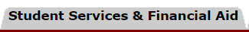
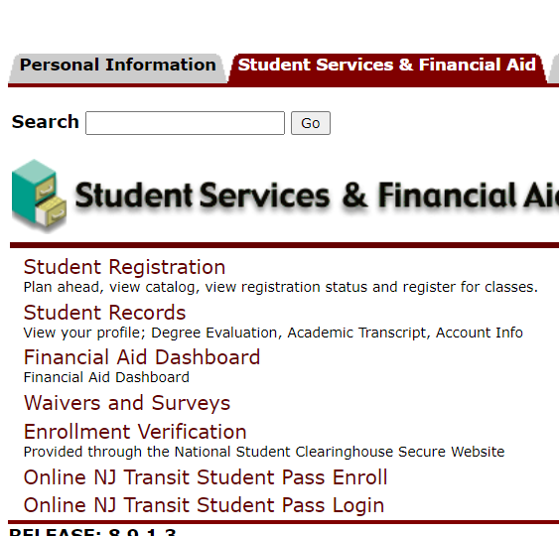
- Click Student Registration

- Click on Register for Classes
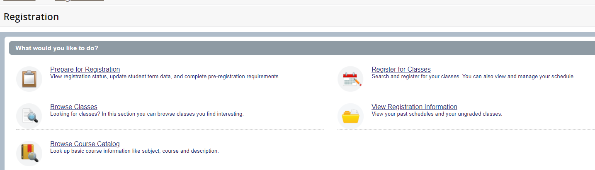
- Select Term 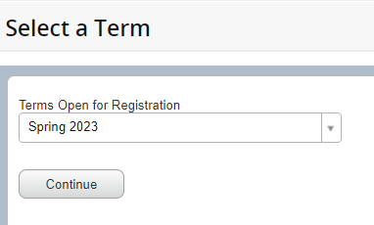
Use Pull Down Arrow to Select Term
- Click Continue 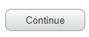
- In the Summary Panel (Located in the Lower Right Corner) you will find a list of registered courses
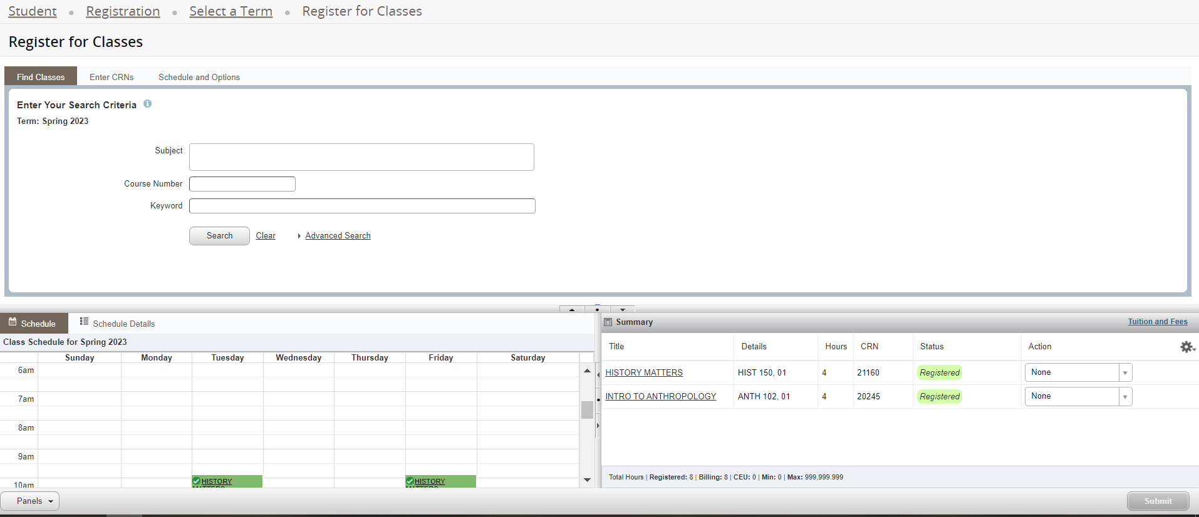
- Next to each course there is an Action Pull Down Option.
- Click on the Pulldown Arrow next to the course you want to drop from
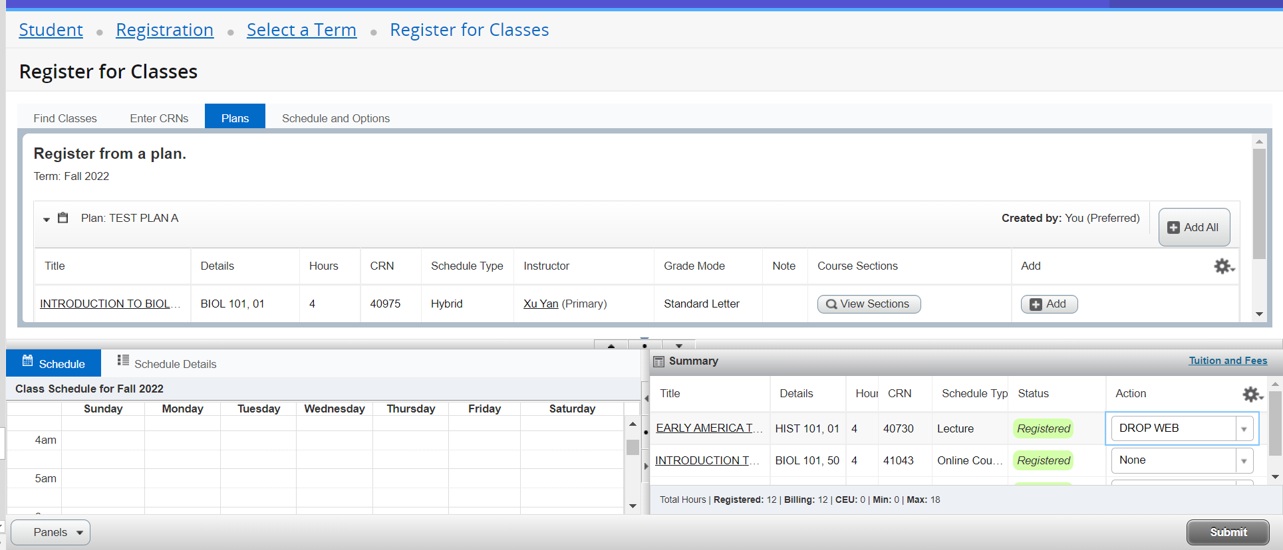
Select Drop Web from Drop Menu
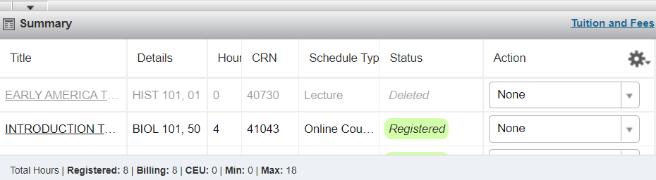
Dropped Course is gray.
Status is Deleted. (Red Circle)

- Click Submit
- The Status will be deleted.
- The course is removed from the calendar
- Review Course Credit. If you dropped a course the number of registered credits will be reduced.

