Self Service 9 EPAF for Special Payments and Steps
Table of Contents
Self Service 9 EPAF for Special Payments and Steps 1
Prerequisites/ Notes 1
Starting an EPAF as an Originator 1
Approving the EPAF as part of the Routing Queue (VP, Budget, HR Reps) 9
Applying the EPAF (Payroll) 12
Common Errors 16

Prerequisites/ Notes
- ITS – Users must have access to EPAF under user roles in GUAUSRL
- One EPAF cannot be used to make two separate payments
- Always click Save before clicking Submit
- Always add a comment before saving, otherwise a workflow notifying the next user in the routing queue will not be triggered

Starting an EPAF as an Originator
Prior to originating an EPAF, be sure to notify POER via email stating you are looking to enter an EPAF for a special payment. EPAFs should not be submitted prior to receiving POER approval.
- In Web Self Service, go to the Employee Dashboard

- Under My Activities, click Electronic Personnel Action Forms (EPAF)
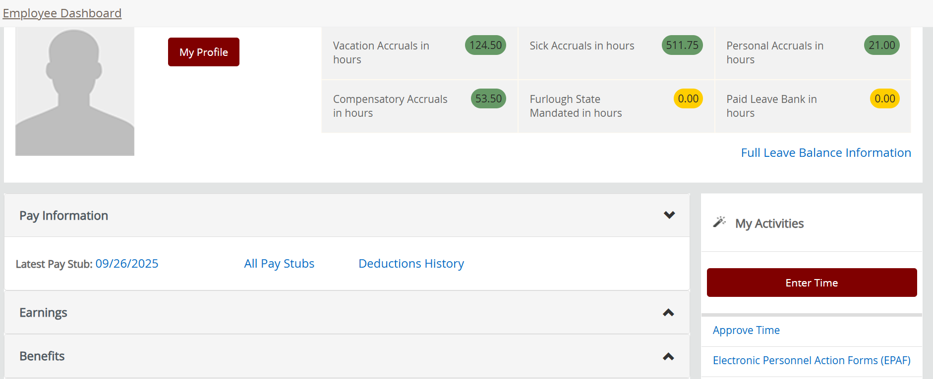

- Click New EPAF
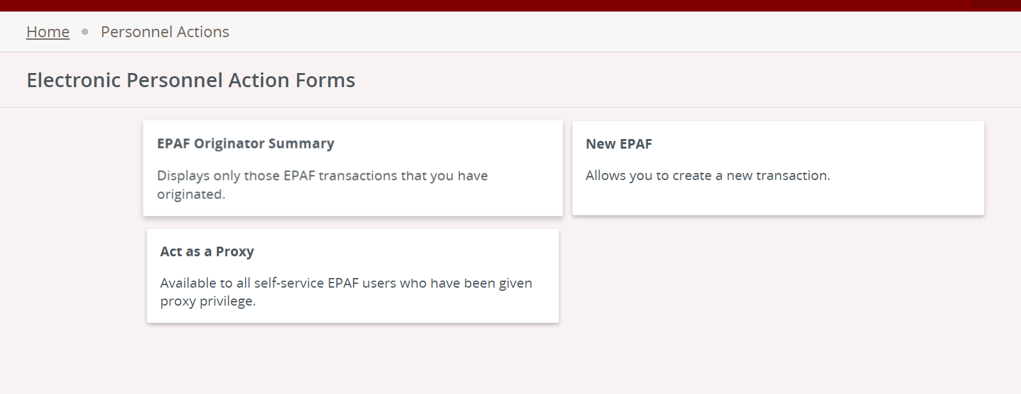

- Enter R Number in ID field of person who will be receiving the special payment
  - If you do not know their R number, please contact Payroll to retrieve this information
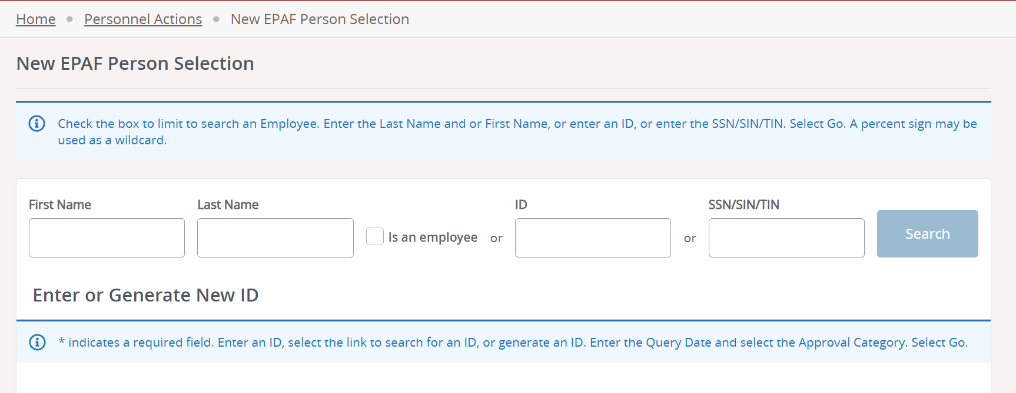

- Click on the ID Number linked in blue to select the correct user, then scroll down. This will populate the ID in the next section.
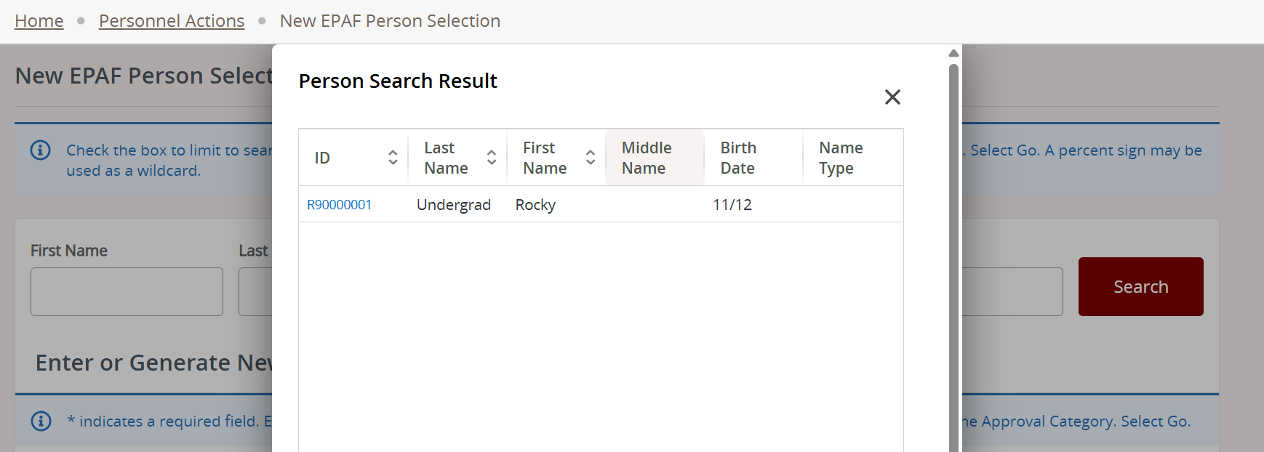

- Query date should be the first day of the pay period. Example - Work begins 5/15/20XX: enter Query Date 5/01/20XX, Job Begin Date populates 5/01/20XX and Jobs Effective Date populates 5/01/20XX. For reference, see the regular EPAF schedule for employees at the following site: https://www.ramapo.edu/payroll/regular-epaf/
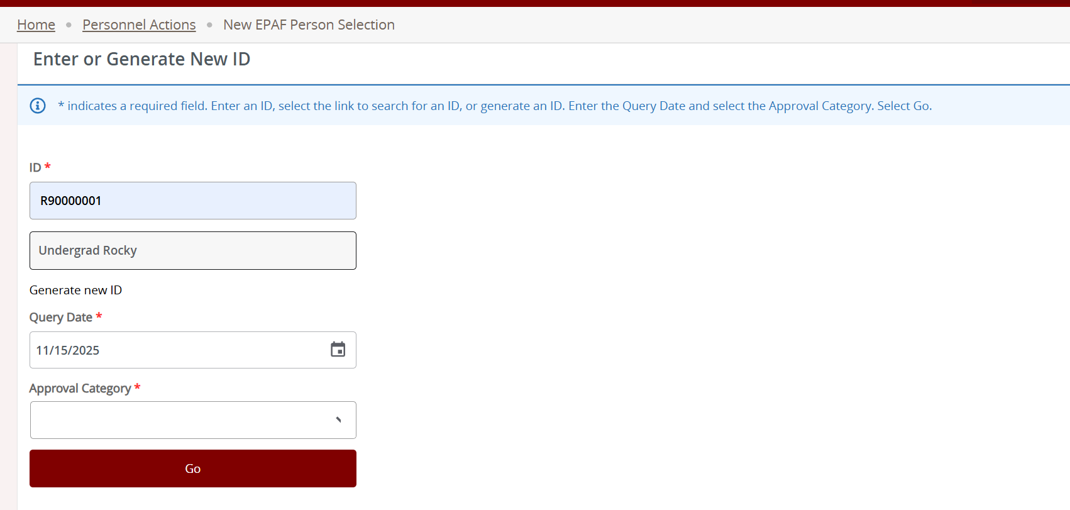

- For special payments the approval category is SPLPAY
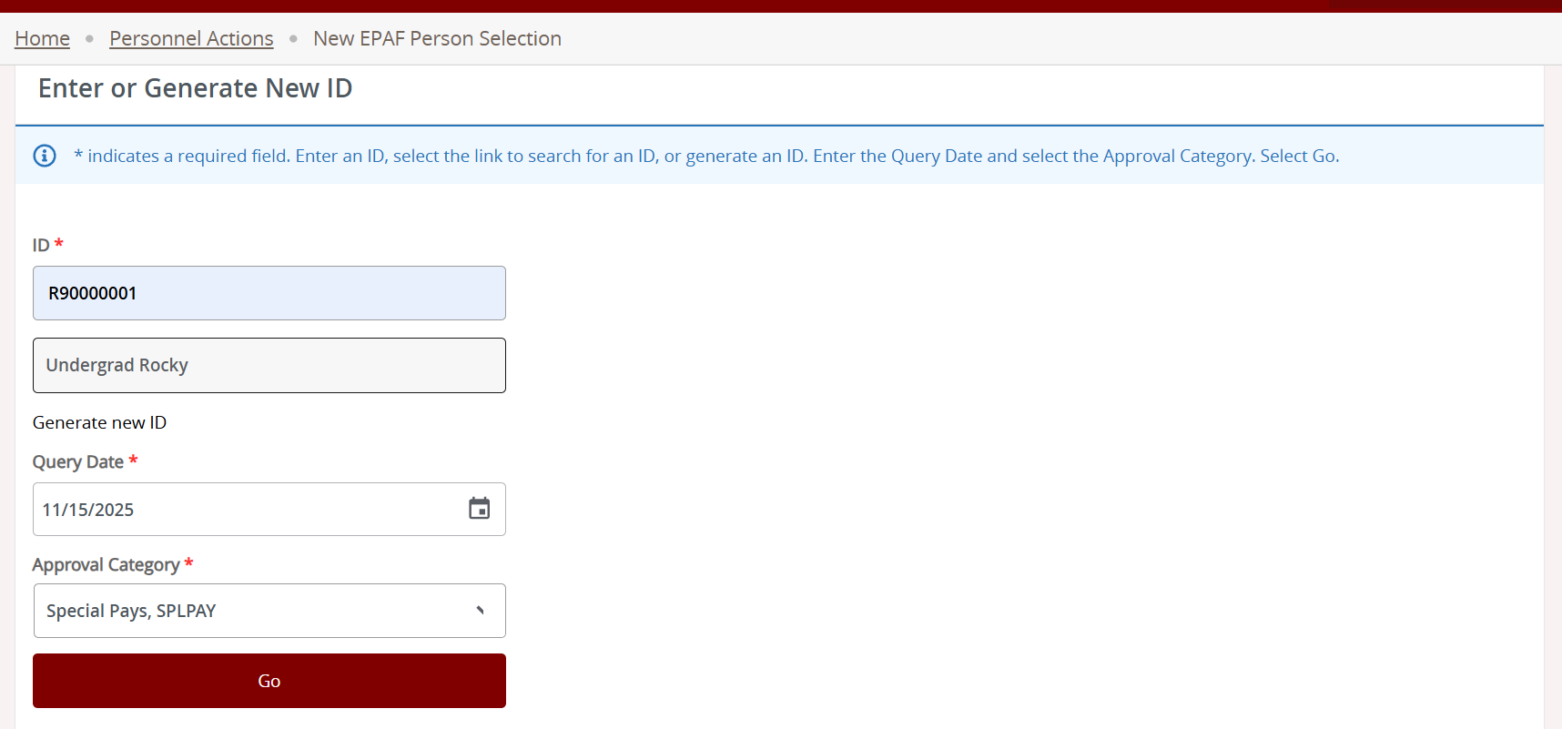

- Click Go. This will redirect you to a Job Selection page. Scroll down to the Special Payments, SPLPAY section where you will see the available jobs associated with this R Number.
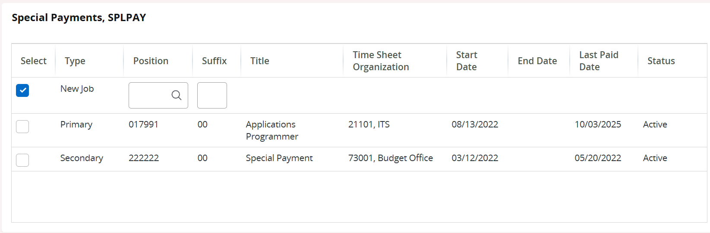

- For special payments, select the secondary position #222222 by checking the checkbox all the way to the left of that line. If you do not see this position listed, reach out to Payroll to get this set up. Once you select the position, click Go.
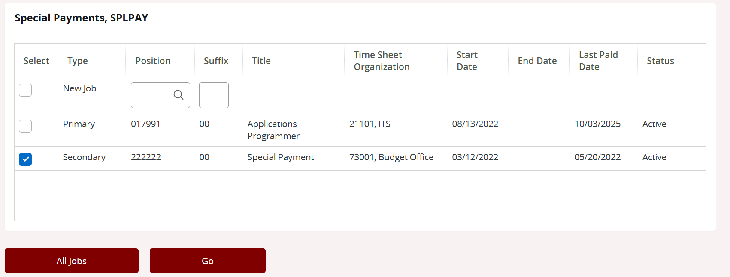

- Under the “New” section, make sure that the FOAP that appears is correct. Note: If the values for any of the columns are cut off, change the zoom settings in your browser to be less than the current setting until the values appear.
  - The org is usually the department for which the employee completed the job.
  - The account for special payments for internal employees is always 6078.
  - The percent is only to be changed if the payment is split between FOAPs. Otherwise, leave it at 100%
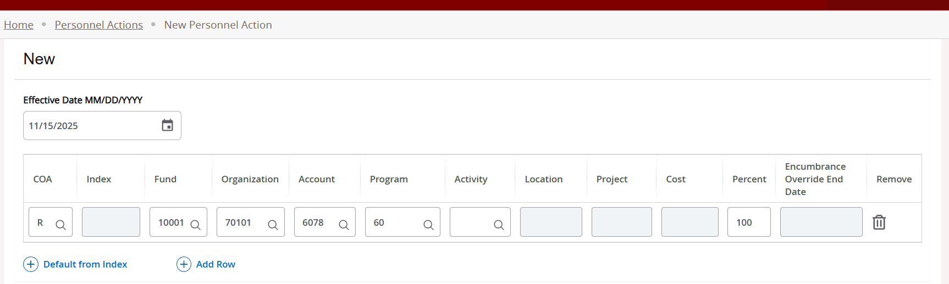

- Under the “New Value” section, click Add Row. Then:
  - Enter the effective date. Be sure to check with Payroll for accuracy. The effective date should be the first day of the pay period you want this special payment paid out to the employee.
  - Enter SPR for Earnings
  - Hours will always be 1. This is how Banner processes EPAFs. Be sure the supporting documentation and any comments against the EPAF explain the actual hours worked and hourly rate.
  - Special Rate will be the total payment of the special payment.
  - Shift should also be 1 unless otherwise noted by Payroll
  - End Date is the first day of the next pay period. Refer to EPAF schedule back in step 7
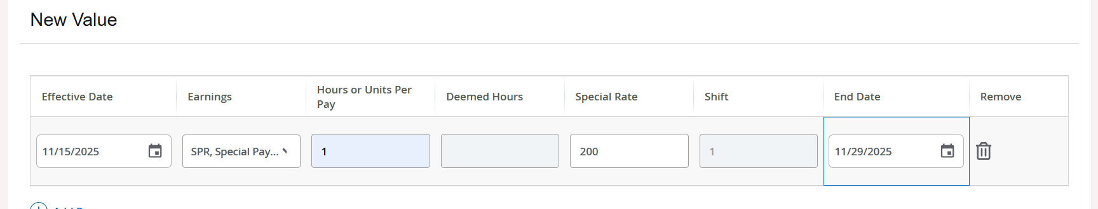

- Under the Routing Queue section, here is the default for Special Payments:
  - This queue will default to the following
    - VP Approval
    - Budget Approval
    - POER/HR Approval
    - Payroll Approval/Application
  - The user for each role can be edited by selecting the dropdown menu next to the user name field.
  - Note for Admins: Approval Groups are set and created in NTRALVL in Banner pages. Default Routing Queues are set in Self Service by POER under Employee > EPAF Originator Summary > Default Routing Queue.
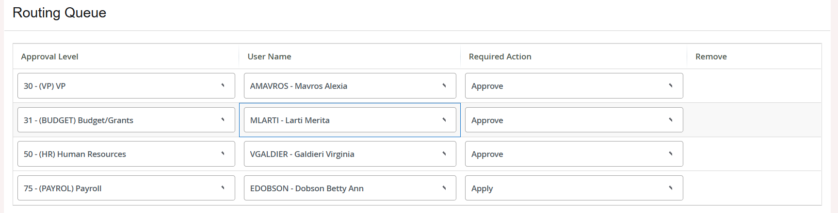

- ***REQUIRED**** Add a comment regarding what the payment is for and how the EPAF will be paid. Also note the location of the supporting documentation and who in POER approved the origination of this EPAF prior to creating the EPAF in Self Service ex – “Prior Approval of origination this EPAF received by POER, V Galdieri.” Any dates of work completed will be helpful as well. Below is an example of the routing queue and part of a comment:
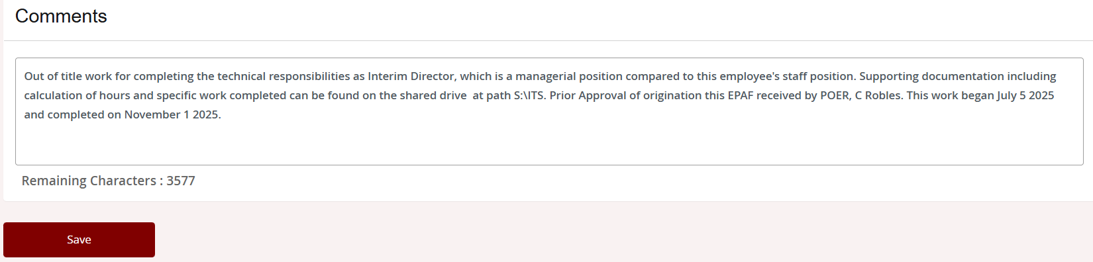
  - If you fail to add a comment, the next approver will not be notified of an EPAF requiring their attention.

- After entering the comment, Click Save. The page may reload. Scroll down to the bottom and click Submit
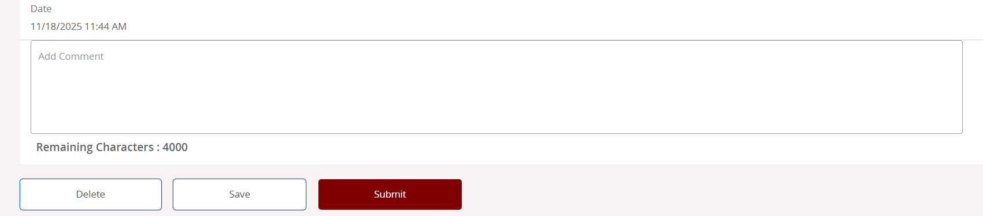
  - If you receive an ORA-06502 error about funds not available, please send one email to both the Budget Office at budget@ramapo.edu and Payroll payroll@ramapo.edu in the “To” field. In the body of the email, state that there are no funds available to process an EPAF and include the following information:
    - the FOAP of the EPAF
    - The POER approver of the EPAF
  - Once funds are available, you may refer back to the transaction via the EPAF Originator Summary.

- Once you submit the EPAF, you will need to review the EPAF in your Originator Summary. To get there, return back to the Personnel Actions screen (by clicking the “Personnel Actions” breadcrumb trail at the top left) and click EPAF Originator Summary.

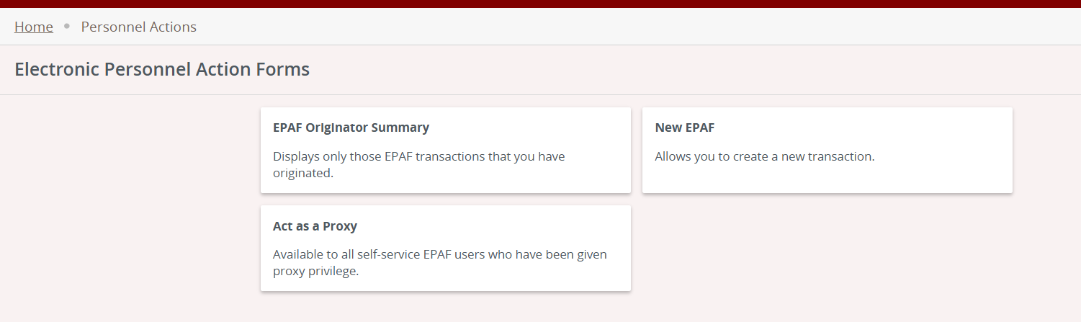

- From there, open the EPAF by clicking the most recent transaction number.
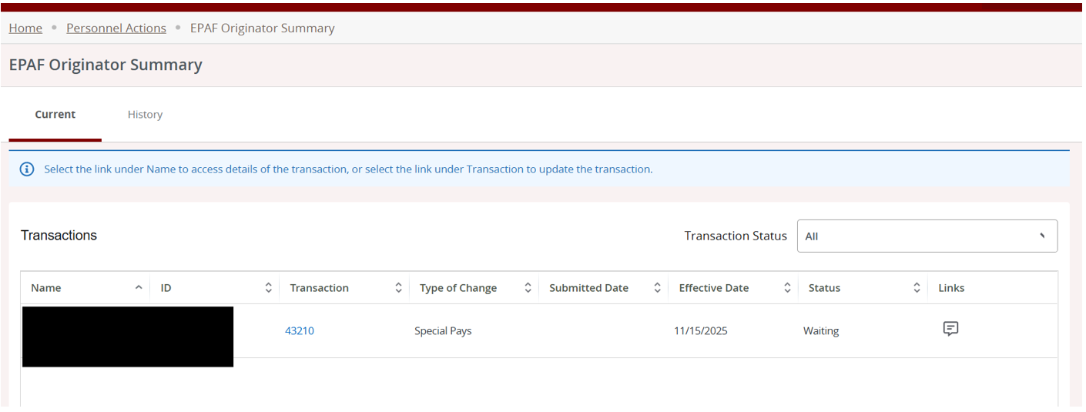
- Review the Information provided. Scroll down, add another comment (required), example – “Submitting for VP Review”, and click Save. Then, click Submit.
The EPAF will now go into the VP’s queue as the first step of the routing queue for approvals. Just in case the system fails to send an email to POER, it is recommended to send your own email noting that you successfully submitted the EPAF and also indicating who the first approval should come from.

Approving the EPAF as part of the Routing Queue (VP, Budget, HR Reps)
- In Web Self Service, go to the Employee Dashboard

- Under My Activities, click Electronic Personnel Action Forms (EPAF)

- Click EPAF Approver Summary
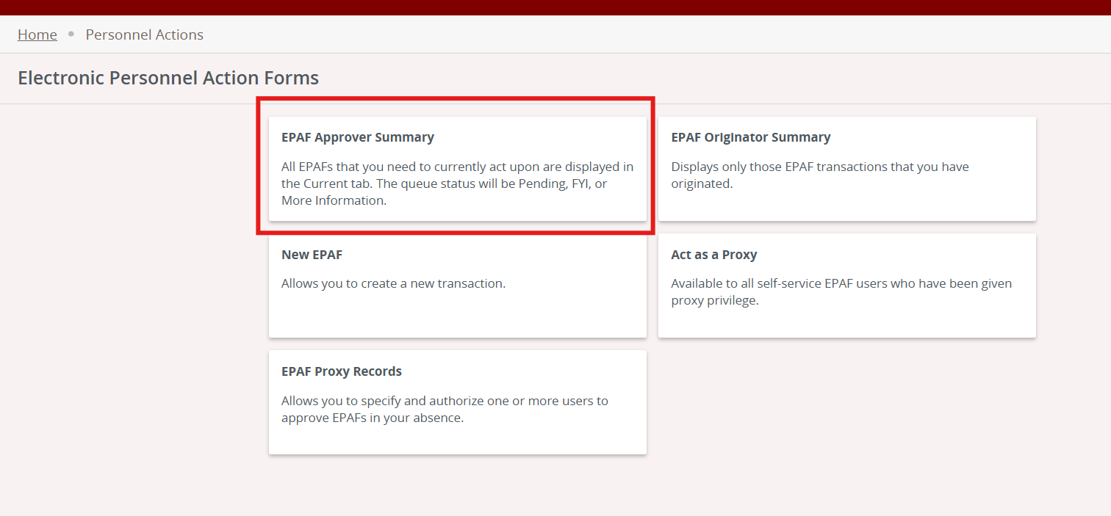

- Click on the Current tab if not shown by default, then click on the recipient’s name linked in blue.
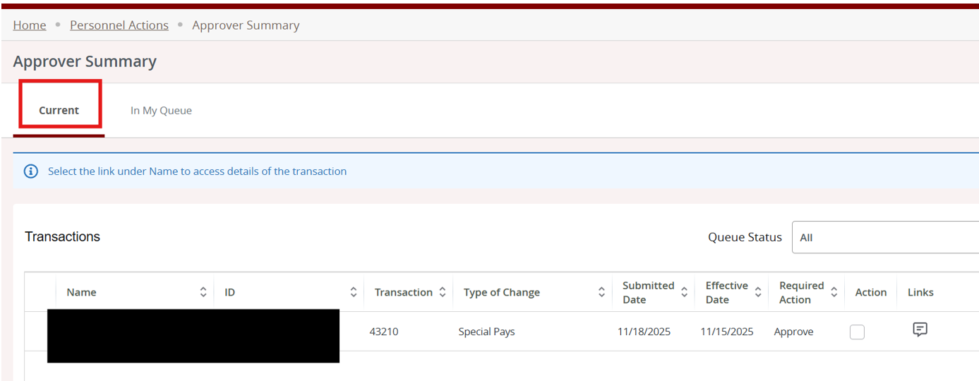
- Review the details of the EPAF, including any comments.
- Scroll all the way down. Click Add Comment (required), enter text, then click save.
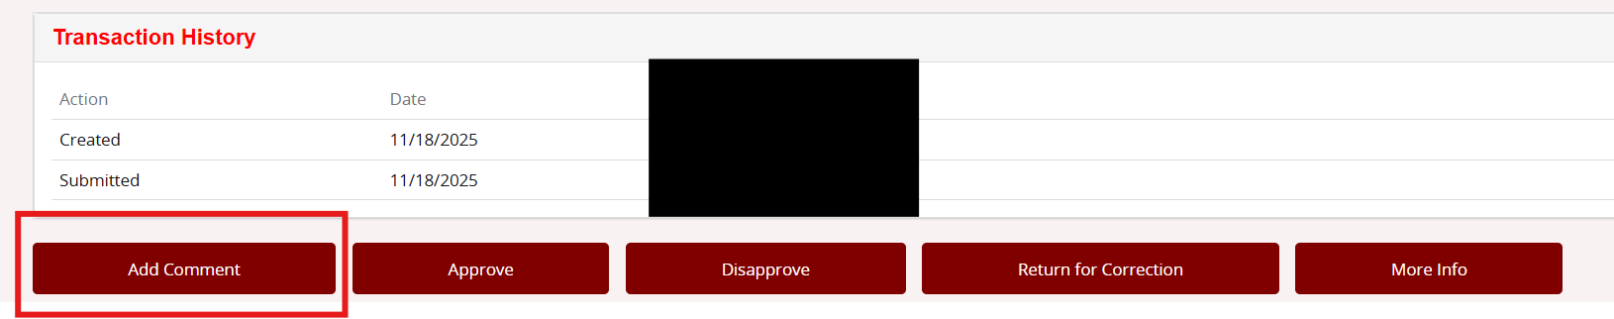
- Go back to the EPAF Preview via the breadcrumb trail at the top left and scroll all the way to the bottom.
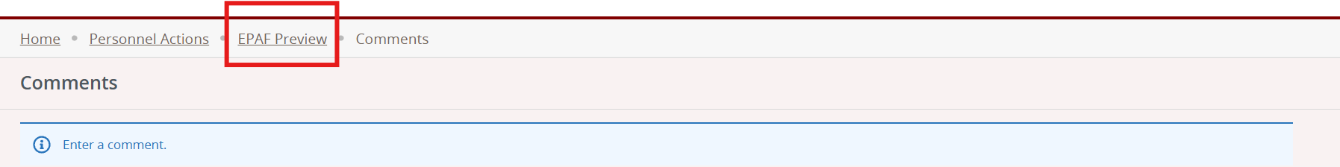
- Click Approve if information is accurate. Click Return for Correction if there is an error. Click Disapprove if the EPAF should not go through at all
  - Return for Correction will send the EPAF back to the originator (unit head) for changes. From there, the approval routing queue restarts. The unit head will need to make sure the EPAF is not sitting in the Originator Summary after updating the EPAF. If so, the unit head will need to approve/submit the EPAF from the originator summary before it can move forward again.
- Once you click approve, the EPAF will go to the next representative in the routing queue and will put their action in a “Pending” state. This is how you know the transaction successfully went to the next reviewer of the EPAF. These steps should be repeated by each approver until the EPAF requires Payroll’s action.
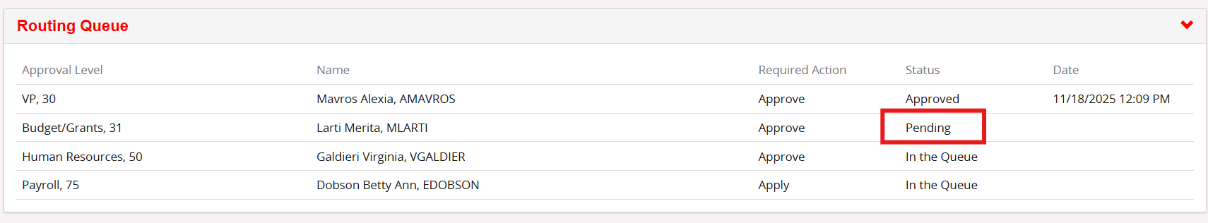

Applying the EPAF (Payroll)
- In Web Self Service, go to the Employee Dashboard

- Under My Activities, click Electronic Personnel Action Forms (EPAF)

- Click EPAF Approver Summary

- Click on the Current tab if not shown by default, then click on the recipient’s name linked in blue.
- Review the details of the EPAF, including any comments.
- If the information is accurate, log into Banner Admin Pages (AppNav)
- Go to NOAAPSM
- You will see a notification regarding an EPAF – click yes
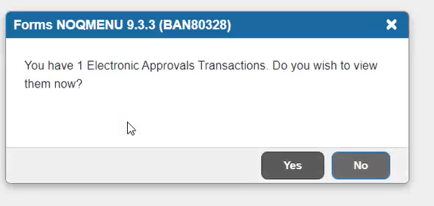
- You will then be asked if you want to be notified of new transactions during the current session, choose Yes

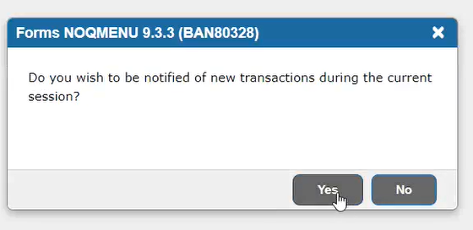

- Under Transaction Status, choose Approved
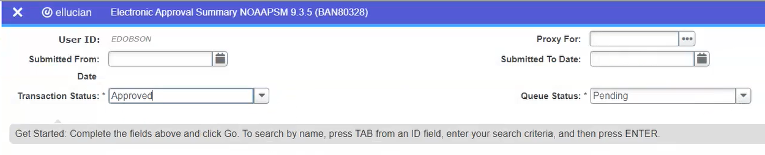
- Under Queue Status, choose All
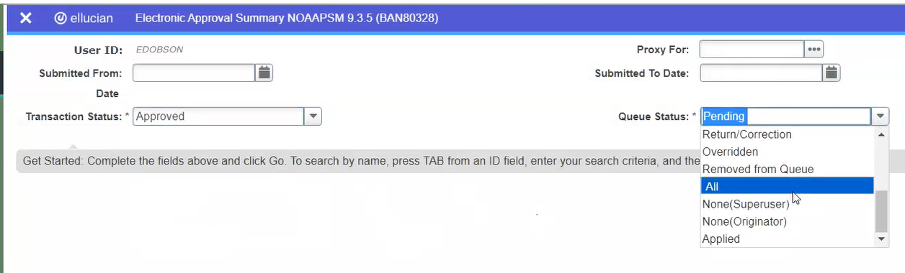
- Click Go and enter your password/pin

- The screen will show blank results – this is normal
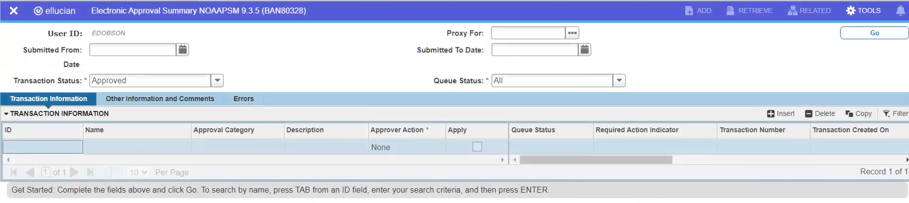
- Go to Tools from the upper right corner and click Refresh, then click Go.

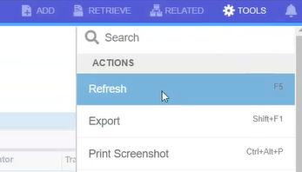
- The transaction will show. Click the Apply checkbox
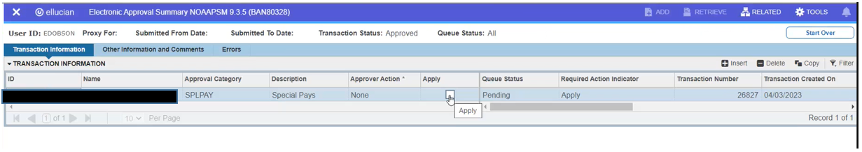

- Go to Tools from the upper right corner and click Apply Changes
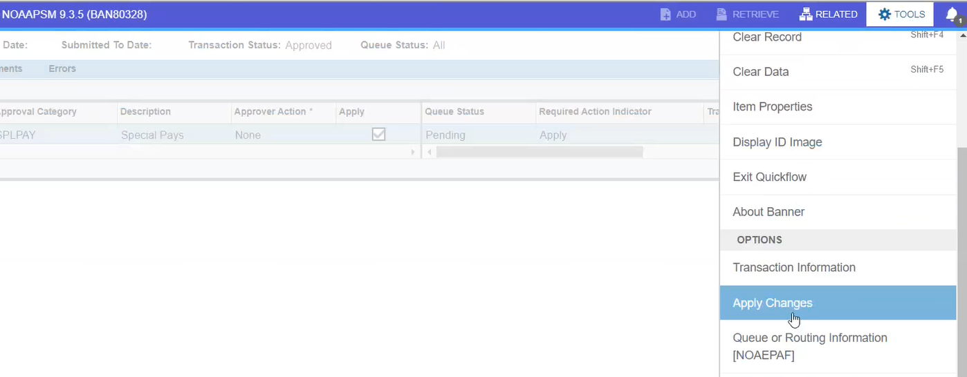

- The transaction will apply and save successfully. The transaction will fully be applied once Payroll opens the next payroll period and runs PHATIME and PHAHOUR.

Common Errors
- ORA-06502 Error – means there is no budget available at the FOAP provided and you cannot process an EPAF unless there is budget available. Reach out to the Budget Office via email, CC’ing Payroll, for assistance.
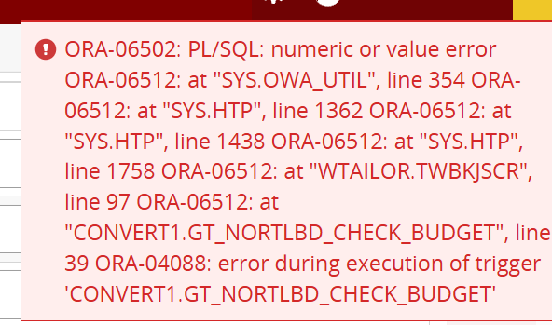
- ORA-01400 Error – This error may show, but then the transaction actually does go through successfully. Check in the Originator Summary if the transaction now has a “Waiting” status – that means it did actually submit.
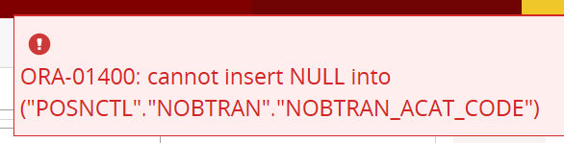
- *ERROR* Begin date must equal the first Jobs Detail Effective Date The individual on this EPAF has been in this position before. The Job Begin Date in the new value column must be blank or the same as the job begin date in the Current value column.
- *ERROR* First Jobs Detail Effective Date must equal the Job Begin Date. The individual on this EPAF has not been in this position before. Fill in Job Begin Date with the same date as the PAF Effective Date.
- *ERROR* New Effective Date cannot be after Employee's Termination Date Employee has been terminated since the last time he/she taught. Send an email to POER to reactivate the employee.
- *ERROR* Effective Date must be greater than Last Paid Date - The individual on this EPAF has been paid since this EPAF was originated and before all the approvals were completed. The EPAF needs to be returned for correction to the originator who must void it and re-enter an EPAF with an effective date greater than the date the employee was last paid.
- *ERROR* Labor Distribution Percentage must equal 100% - The total of all the percentages on the FOAPS to which this assignment is being charged must be 100%.
- *ERROR* User ID’s Must be Entered for Routing Queue – At least one individual has not been identified by selecting their BSU ID in the appropriate approval level of the EPAF.
- *ERROR* Job Detail Record must Exist to Create a New Job or *ERROR* Base Job Record must Exist to Create a New Job - The EPAF is trying to add earnings to a position that does not have an initial job record. Additional earnings are only valid when the job already exists such as the primary assignment for an individual employee.
- *ERROR* This Employee already has a Primary Job - The employee’s primary job is still active for the dates shown on the EPAF. Contact POER to either end the primary job with another EPAF or make this job secondary.
- *ERROR* The Future Dated Job Record must be Deleted before Ending Job There is already an end date on this job beyond the one this EPAF is trying to add. The future end date must be removed by POER before this EPAF can be submitted.

Revised 2/2026

