Stages of EPAF for Special Payments and Steps
Table of Contents
Stages of EPAF for Special Payments and Steps 1
Prerequisites/ Notes 1
Starting an EPAF as a Unit Head (Originator) 1
Approving the EPAF as part of the Routing Queue (VP, Budget, HR Reps) 6
Applying the EPAF (Payroll) 8

Prerequisites/ Notes
- ITS – In Self Service Webtailor Administration, users must have access to EPAF under user roles
- One EPAF cannot be used to make two separate payments
- Always click Save before clicking Submit
- Always add a comment before saving

Starting an EPAF as a Unit Head (Originator)
Prior to originating an EPAF, be sure to notify POER via email stating you are looking to enter an EPAF for a special payment. EPAFs should not be submitted prior to receiving POER approval.
- Log into Self Service
- Go to Employee
- Click EPAF: Employee Personnel Action Forms
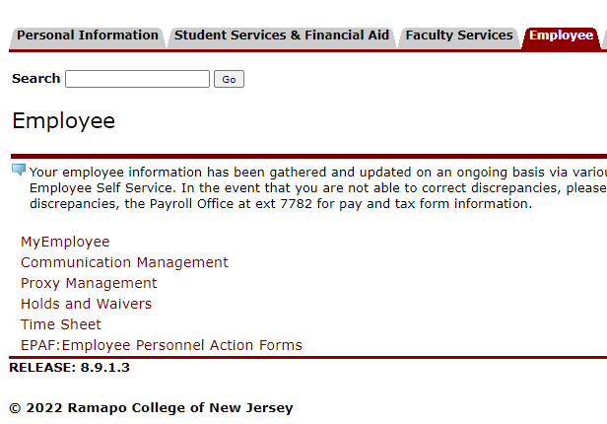
- Click New EPAF
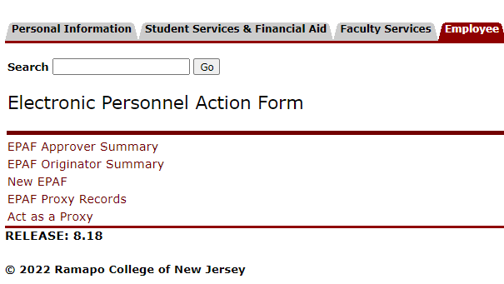

- Enter password, then click Submit. Note to ITS: If pin is needed instead, this is done through GOATPAD
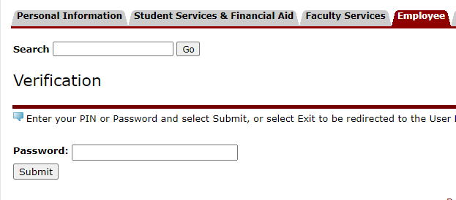

- Enter R Number in ID field of person who will be receiving the special payment
  - If you do not know their R number, you can enter their name and click on the magnifying glass to search for that person
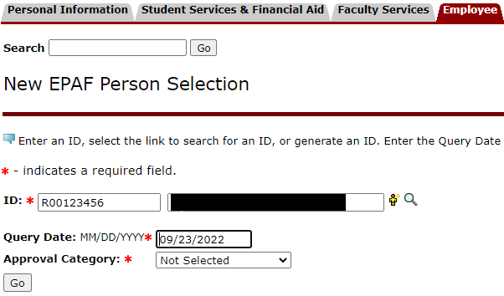

- Query date should be the first day of the pay period. Example - Work begins 5/15/20XX: enter Query Date 5/01/20XX, Job Begin Date populates 5/01/20XX and Jobs Effective Date populates 5/01/20XX
- For special payments the approval category is SPLPAY
- Click Go
- For special payments, select the secondary position #222222 by checking the radio button all the way to the right of that line. If you do not see this position listed, reach out to Payroll to get this set up.
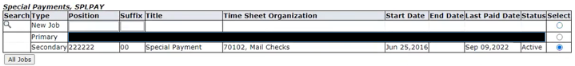
- Under the “New” section, make sure that the FOAP that appears is correct.
  - The org is usually the org for which the employee completed the job.
  - Account for special payments for internal employees is always 6078.
  - The percent is only to be changed if the payment is split between FOAPs. Otherwise, leave it at 100%
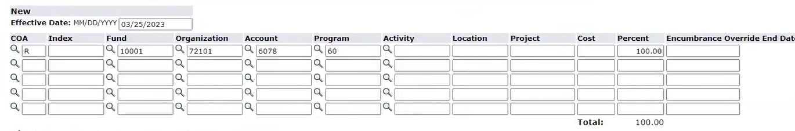
- Under the “New Value” section,
  - Enter the effective date. Be sure to check with Payroll for accuracy.
  - Enter SPR for Earnings
  - Hours will always be 1. This is how Banner processes EPAFs. Be sure the supporting documentation and any comments against the EPAF explain the actual hours worked and hourly rate.
  - Special Rate will be the total payment of the special payment.
  - Shift should also be 1 unless otherwise noted by Payroll
  - End Date is the first day of the next pay period.
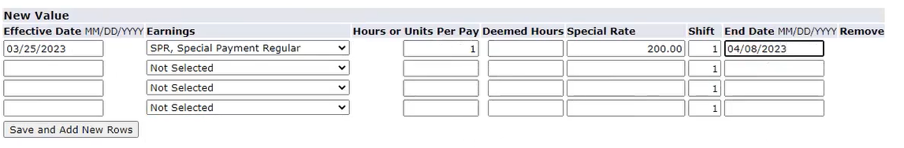
- Under the Routing Queue section, here is the default for Special Payments:
  - This queue will default to the following
    - VP Approval
    - Budget Approval
    - POER/HR Approval
    - Payroll Approval/Application
  - The user for each role can be edited by selecting the magnifying glass next to the user name field.
  - Note: Approval Groups are set and created in NTRALVL in Banner pages.

- Add a comment regarding what the payment is for and how the EPAF will be paid. Also note the location of the supporting documentation and who in POER approved the origination of this EPAF prior to creating the EPAF in Self Service ex – “Prior Approval of origination this EPAF received by POER, V Galdieri.” Any dates of work completed will be helpful as well. Below is an example of the routing queue and part of a comment:
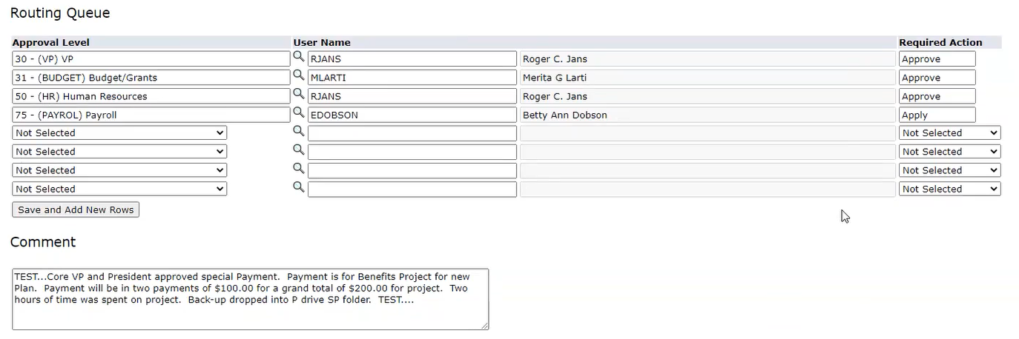
  - Note: Default Routing Queues are set in Self Service by POER under Employee > EPAF Originator Summary > Default Routing Queue
- After entering the comment, Click Save, then click Submit. It is important to click save before clicking submit.
  - If you receive an error about funds not available, please send one email to both the Budget Office at budget@ramapo.edu and Payroll payroll@ramapo.edu in the “To” field. In the body of the email, state that there are no funds available to process an EPAF and include the following information:
    - the FOAP of the EPAF
    - The POER approver of the EPAF
  - If you do receive an error, the EPAF will go into a cancelled state and will need to be re-entered starting at step 1.
- Once you complete the EPAF, you must return back to the Employee > EPAF screen and click EPAF Originator Summary

- From there, open the EPAF by clicking the employee’s name. Scroll down, click save, then click submit
The EPAF will now go into the VP’s queue as the first step of the routing queue for approvals. Just in case the system fails to send an email to POER, it is recommended to send your own email noting that you successfully submitted the EPAF and also indicating who the first approval should come from.

Approving the EPAF as part of the Routing Queue (VP, Budget, HR Reps)
- Go to Employee
- Click EPAF: Employee Personnel Action Forms

- Click EPAF Approver Summary

- Click on the Current tab if not shown by default
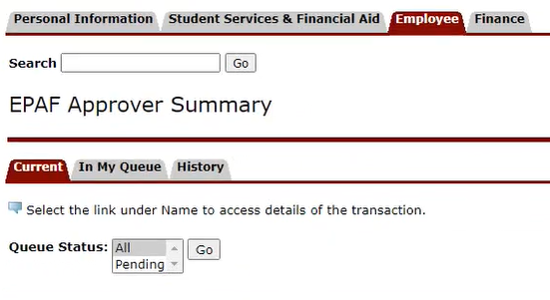
- Select All, and click Go
- Under EPAF Transactions, select the name of the employee
- Review the details of the EPAF, including any comments.
- Scroll all the way down. Add a comment (required), then click save.
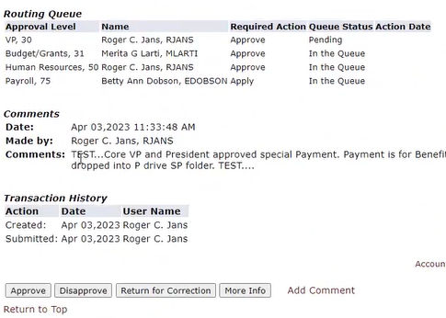
- Click Approve if information is accurate. Click Return for Correction if there is an error. Click disapprove if the EPAF should not go through at all
  - Return for Correction will send the EPAF back to the originator (unit head) for changes. From there, the approval routing queue restarts. The unit head will need to make sure the EPAF is not sitting in the Originator Summary after updating the EPAF. If so, the unit head will need to approve/submit the EPAF from the originator summary before it can move forward again.
- Once you click approve, the EPAF will go to the next representative in the routing queue. These steps should be repeated by each approver until the EPAF requires Payroll’s action.

Applying the EPAF (Payroll)
- Go to Employee
- Click EPAF: Employee Personnel Action Forms

- Click EPAF Approver Summary

- Click on the Current tab if not shown by default
- Select All, then click Go
- Under EPAF Transactions, select the name of the employee
- Review the details of the EPAF, including any comments.
- If the information is accurate, log into Banner Pages
- Go to NOAAPSM
- You will see a notification regarding an EPAF – click yes
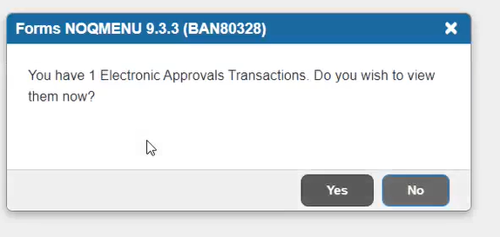
- You will then be asked if you want to be notified of new transactions during the current session, choose Yes

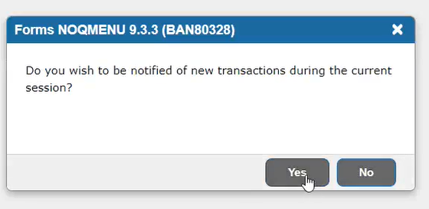
- Under Transaction Status, choose Approved
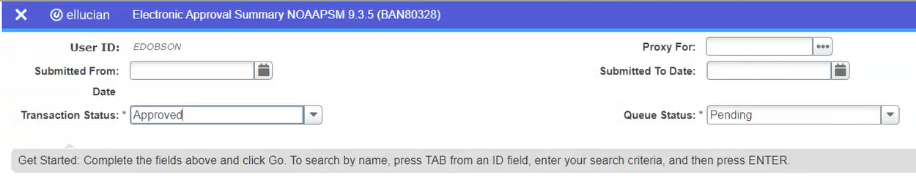
- Under Queue Status, choose All
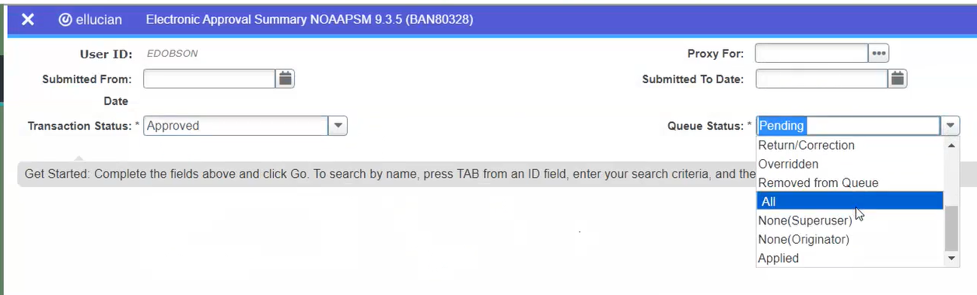
- Click Go and enter your password/pin

- The screen will show blank results – this is normal
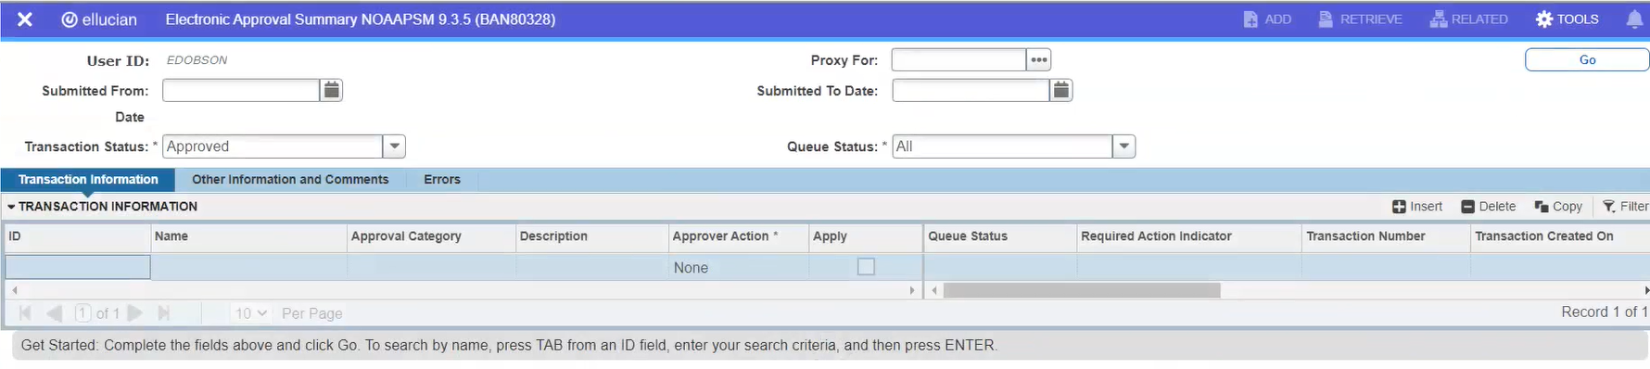
- Go to Tools from the upper right corner and click Refresh, then click Go.

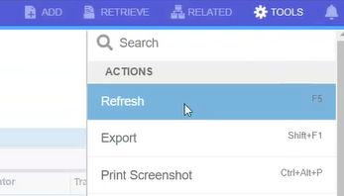
- The transaction will show. Click the Apply checkbox
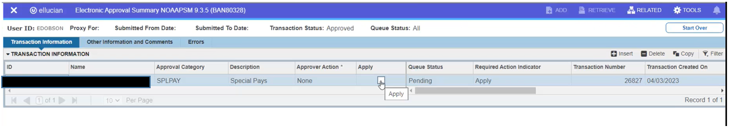

- Go to Tools from the upper right corner and click Apply Changes
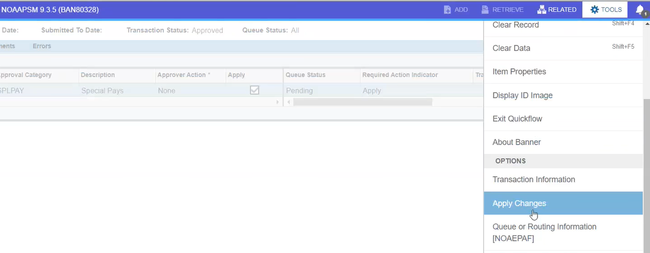

- The transaction will apply and save successfully. The transaction will fully be applied once Payroll opens the next payroll period and runs PHATIME and PHAHOUR.

