Applicant Tracking System
NeoED
Search Committee Training Manual
April 2023
Website:

https://idp.ramapo.edu/idp/profile/SAML2/Redirect/SSO?execution=e1s2

Step 1: Log On:

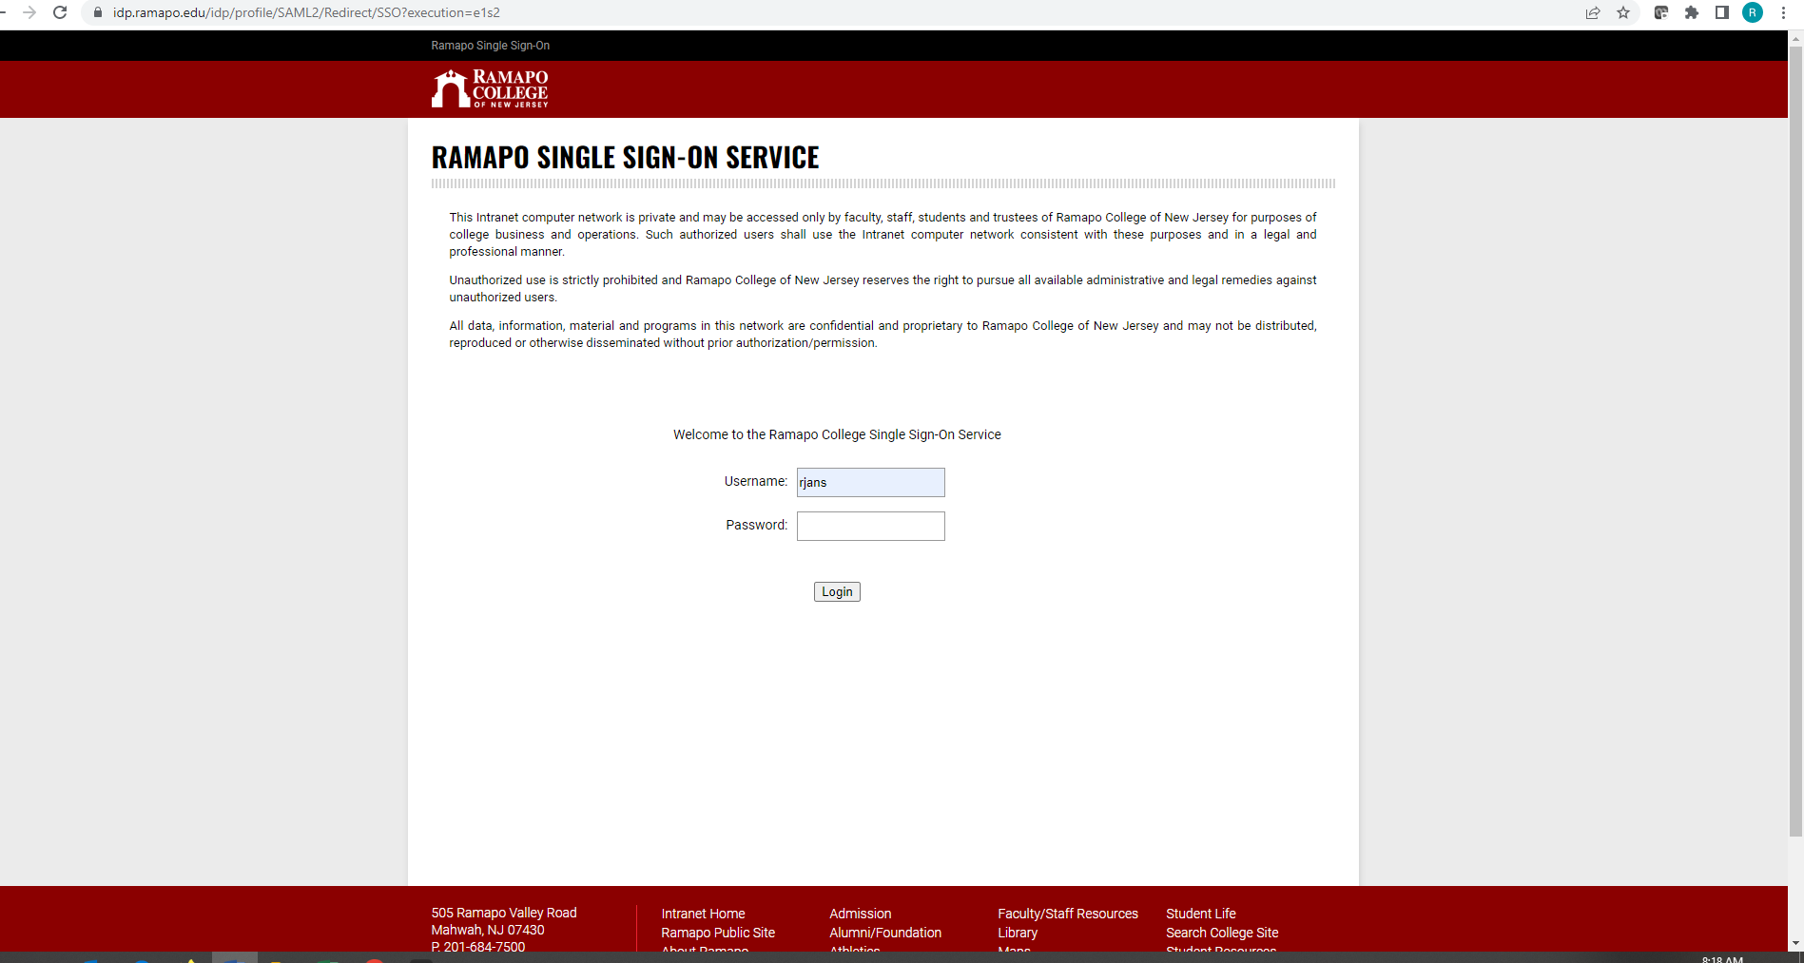
Click Login with SSO

Step 1 Continued:

Step 2:
Your Dashboard will appear
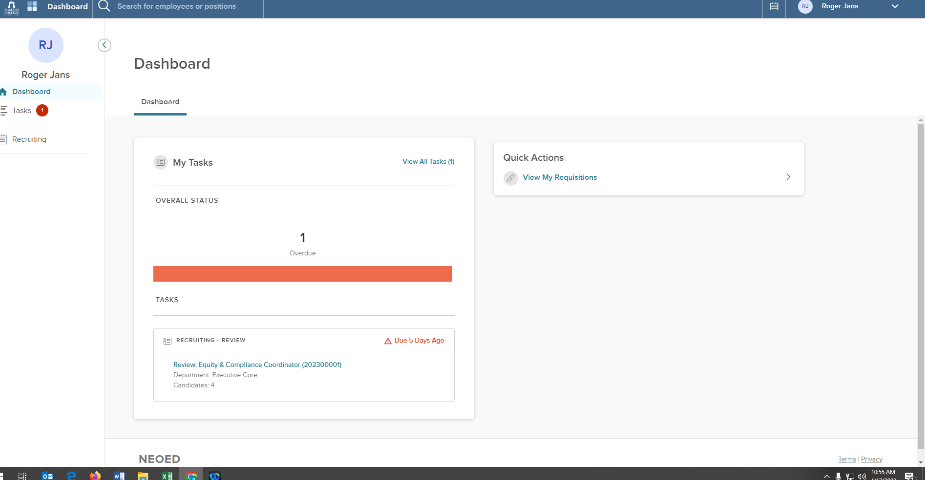
Your search will appear here. Click to view Applicants

Step 3:

Review and rate the applicants

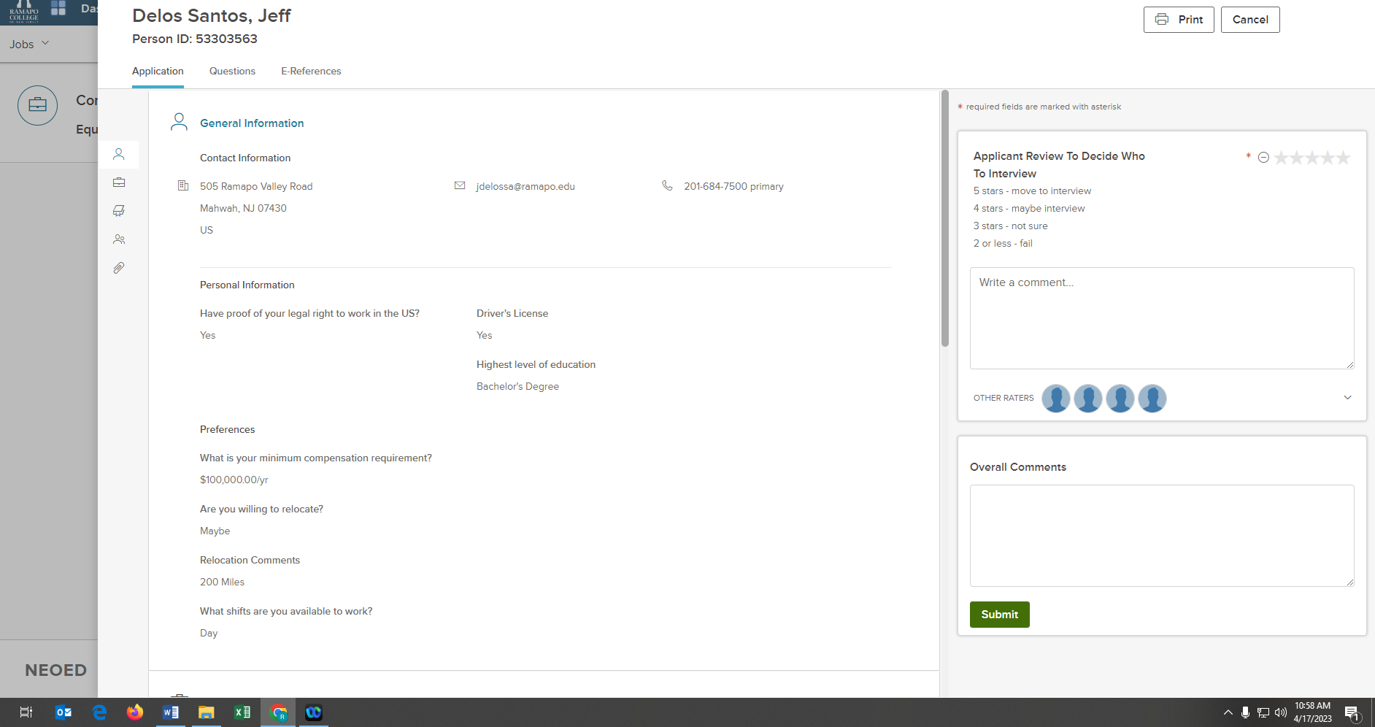
Add comments
And Submit

Rate

