Applicant Tracking System
NeoED
Search Committee Training Manual
April 2023
Website:

https://login.neoed.com/authentication/saml/login/ramapo

Step 1: Log On:

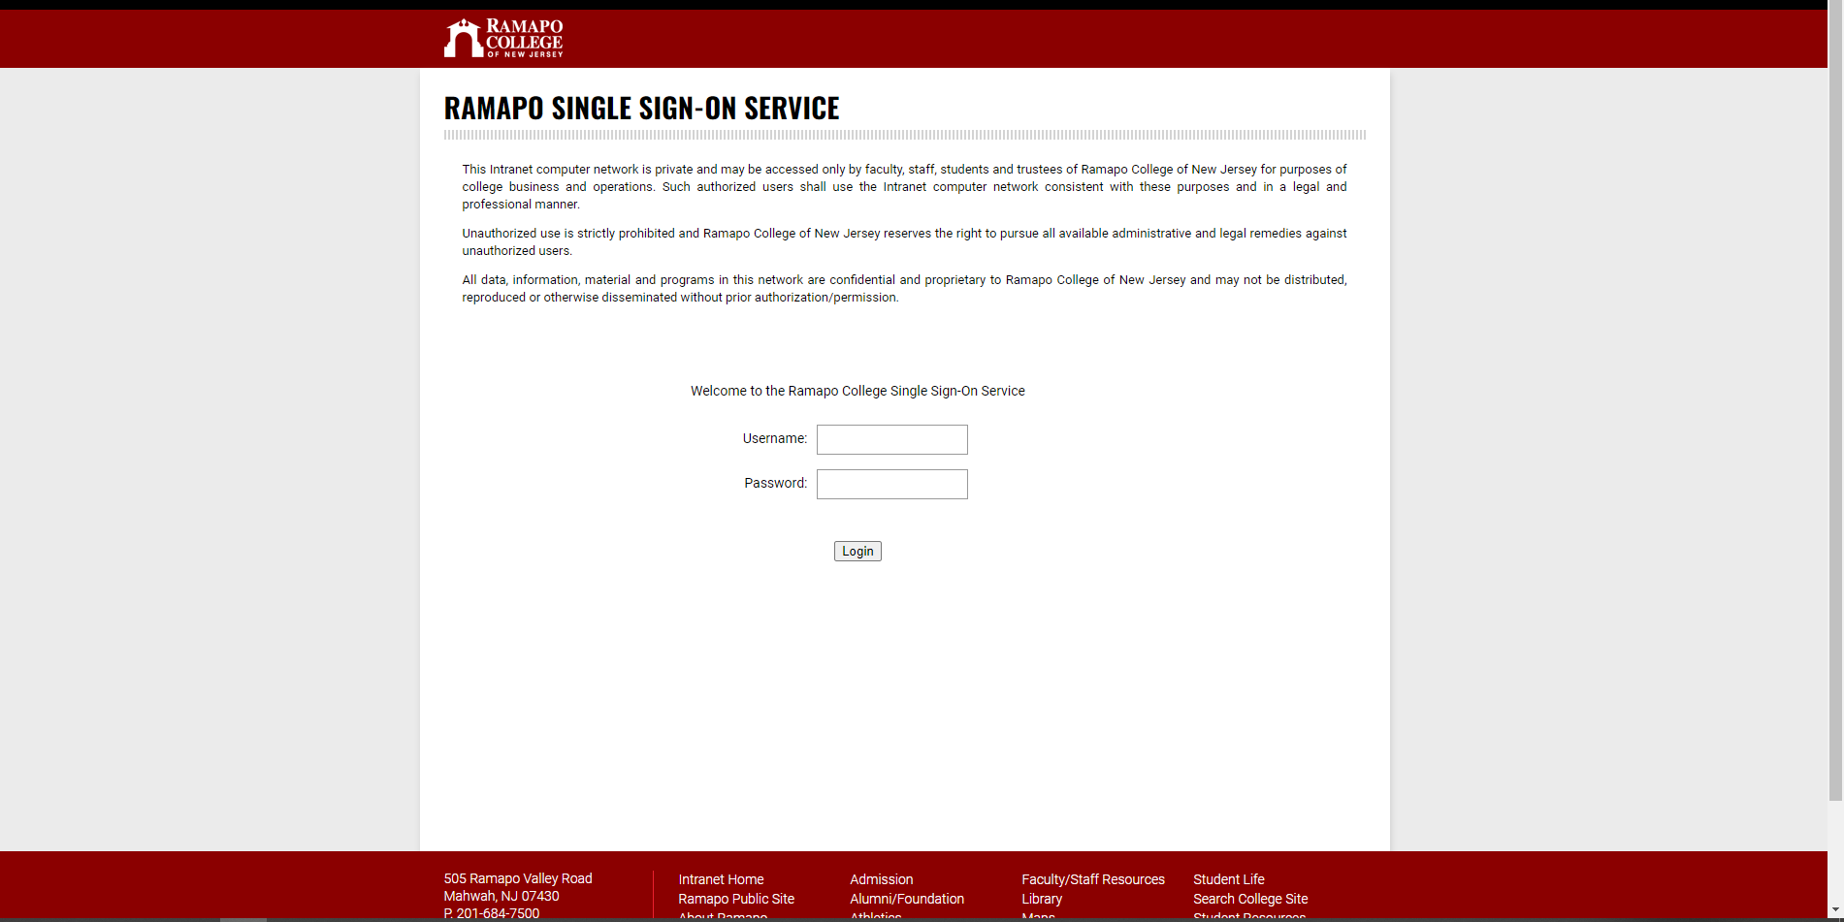
Enter your RCNJ sign on credentials

Step 2:
Your Dashboard will appear

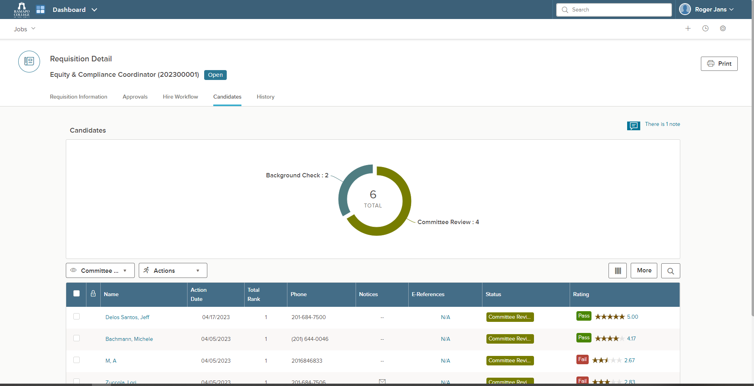
Applicants
Navigation Buttons
Here you can see the applicants as well as navigation buttons. You can perform all your actions from this page and move applicants along in the search process. As Search chair, you are the initiator of moving applicants through the search process.

Step 3:
Using the Navigation Buttons

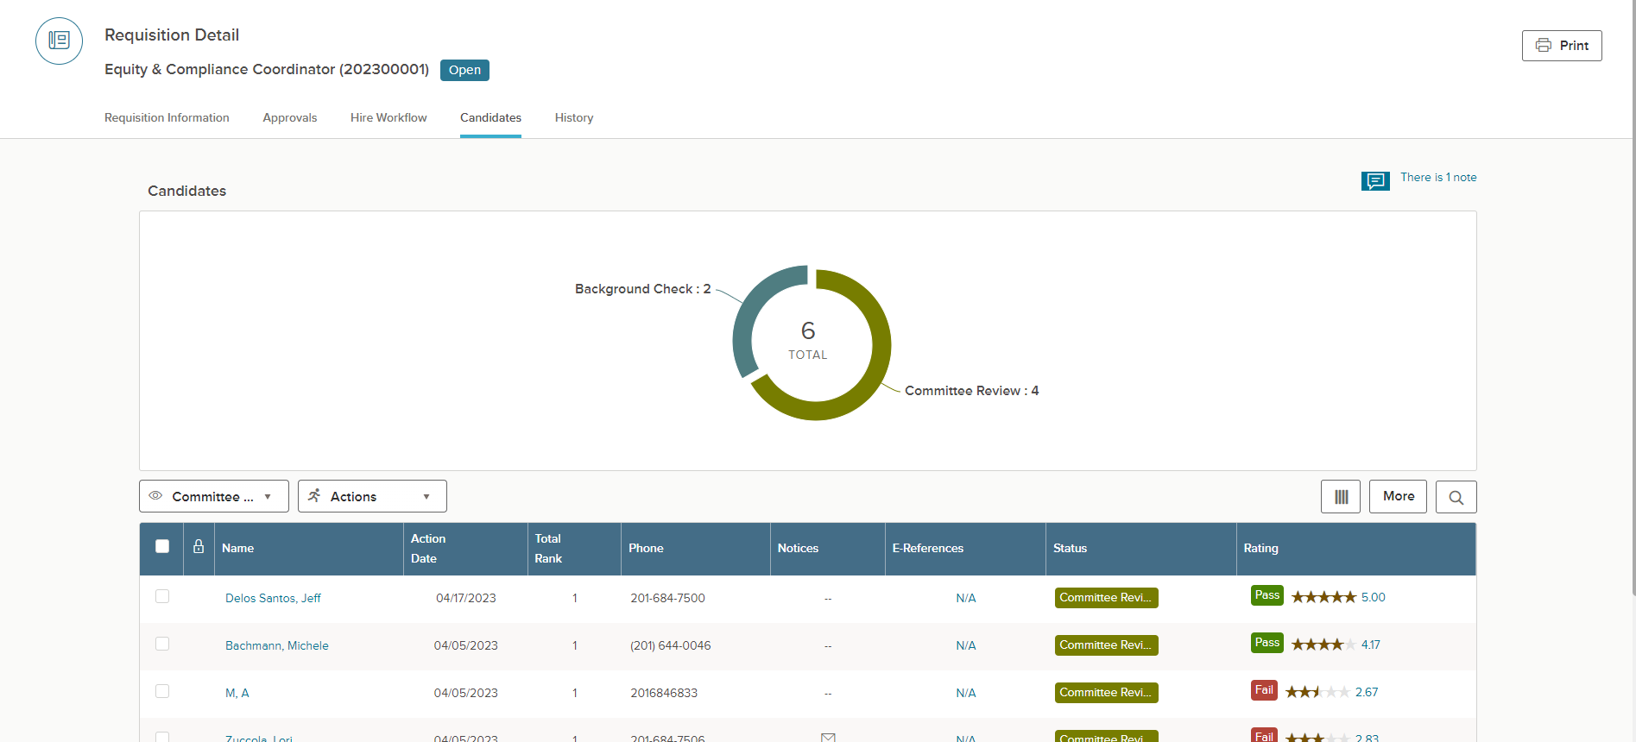
Click on Action you want

Requisition Information View
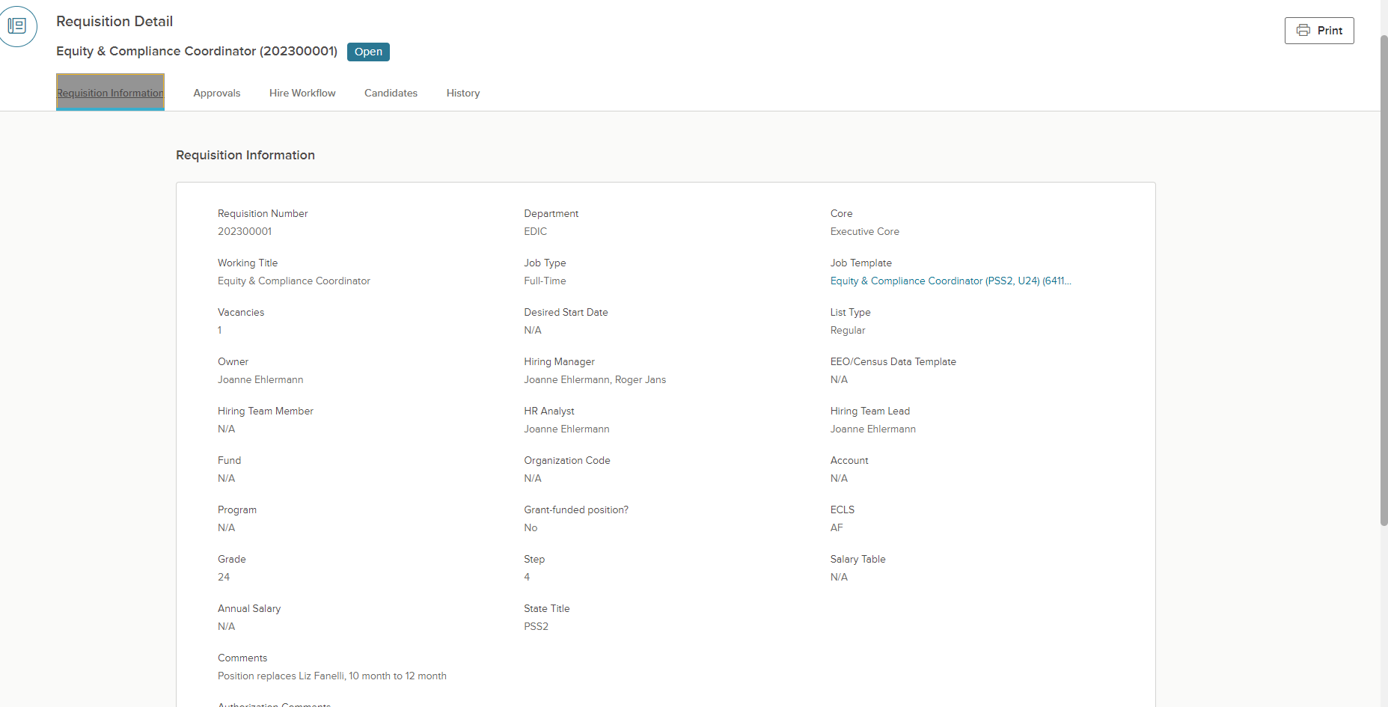

Candidates View

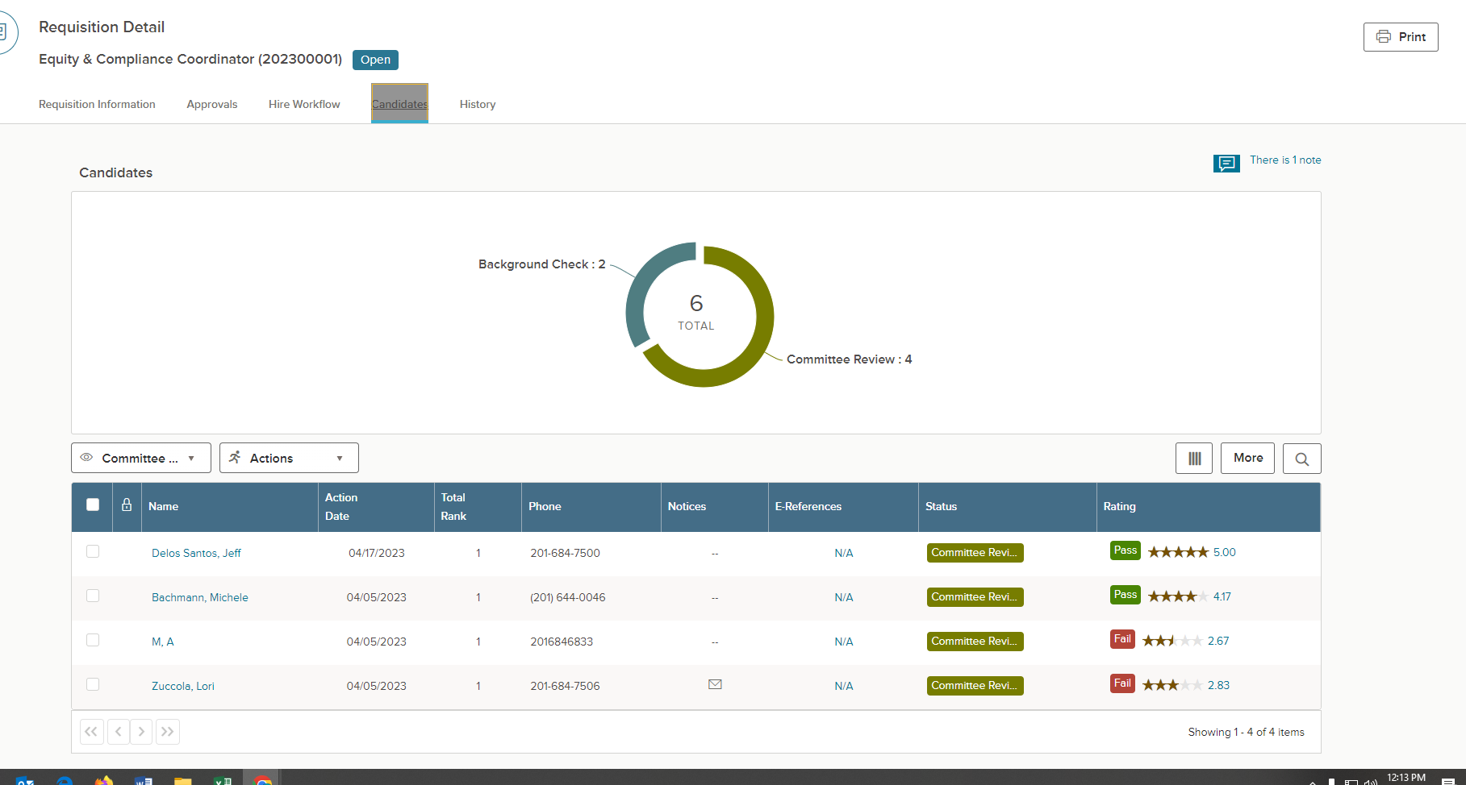
Click to change status and move applicants

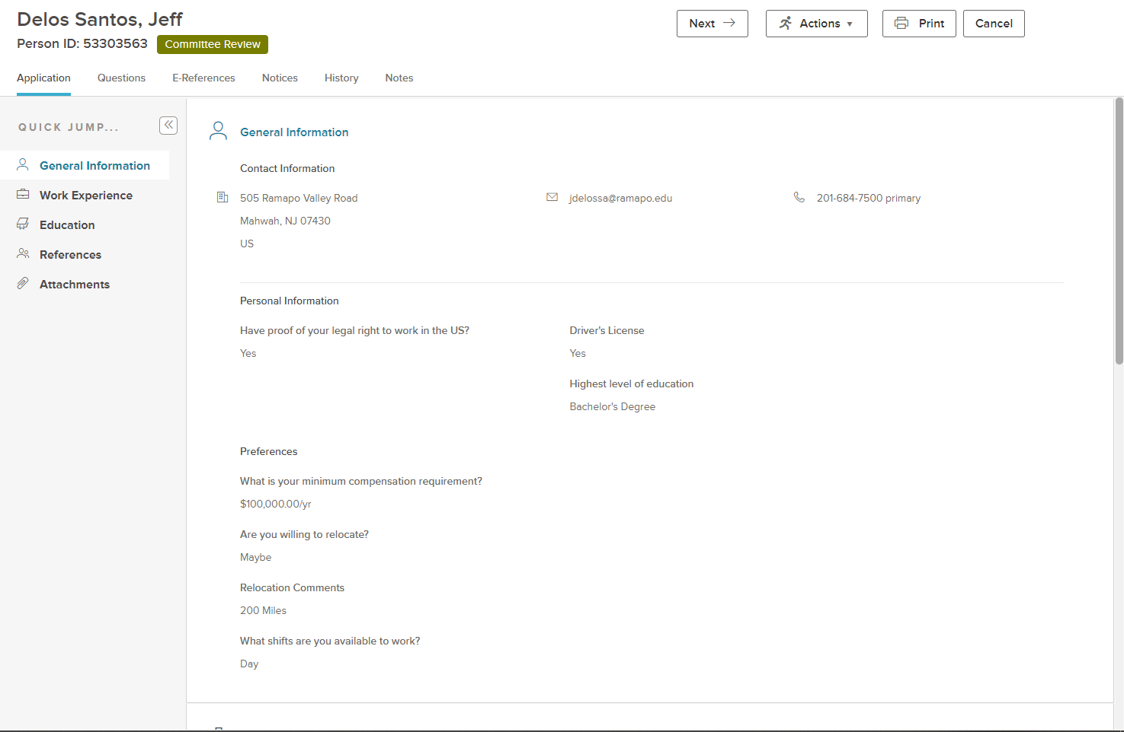
Click and select change status of applicant

