NEOED
Logging on to the System

Link: https://login.neoed.com/authentication/saml/login/ramapo
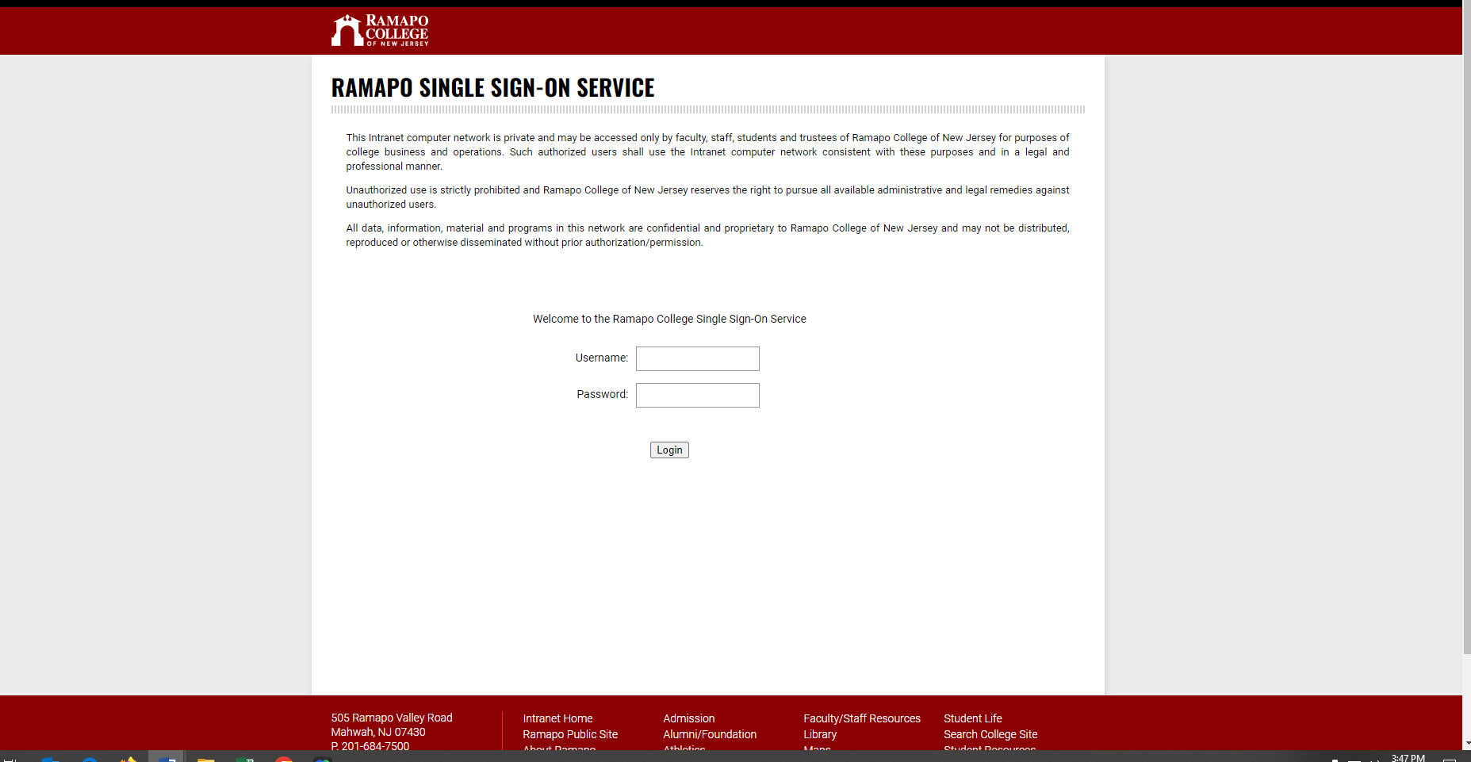
Use your RCNJ Login
Dashboard will appear
