NEOED TRAINING
Cheat Sheet for Creating a New Job Template (Job Description)
Step 1) Click Dashboard to get drop down box – Click Insight
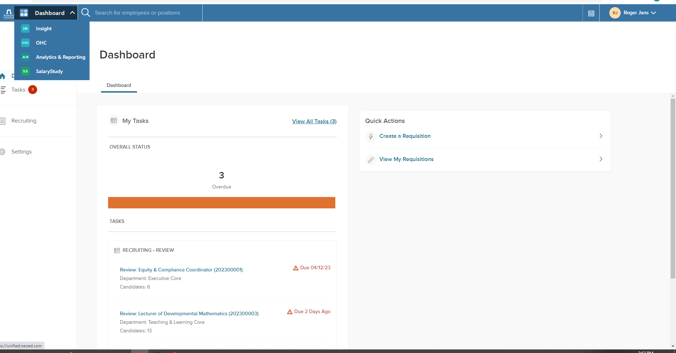
Click Insight

Step 2) Select jobs dropdown and select Job Templates
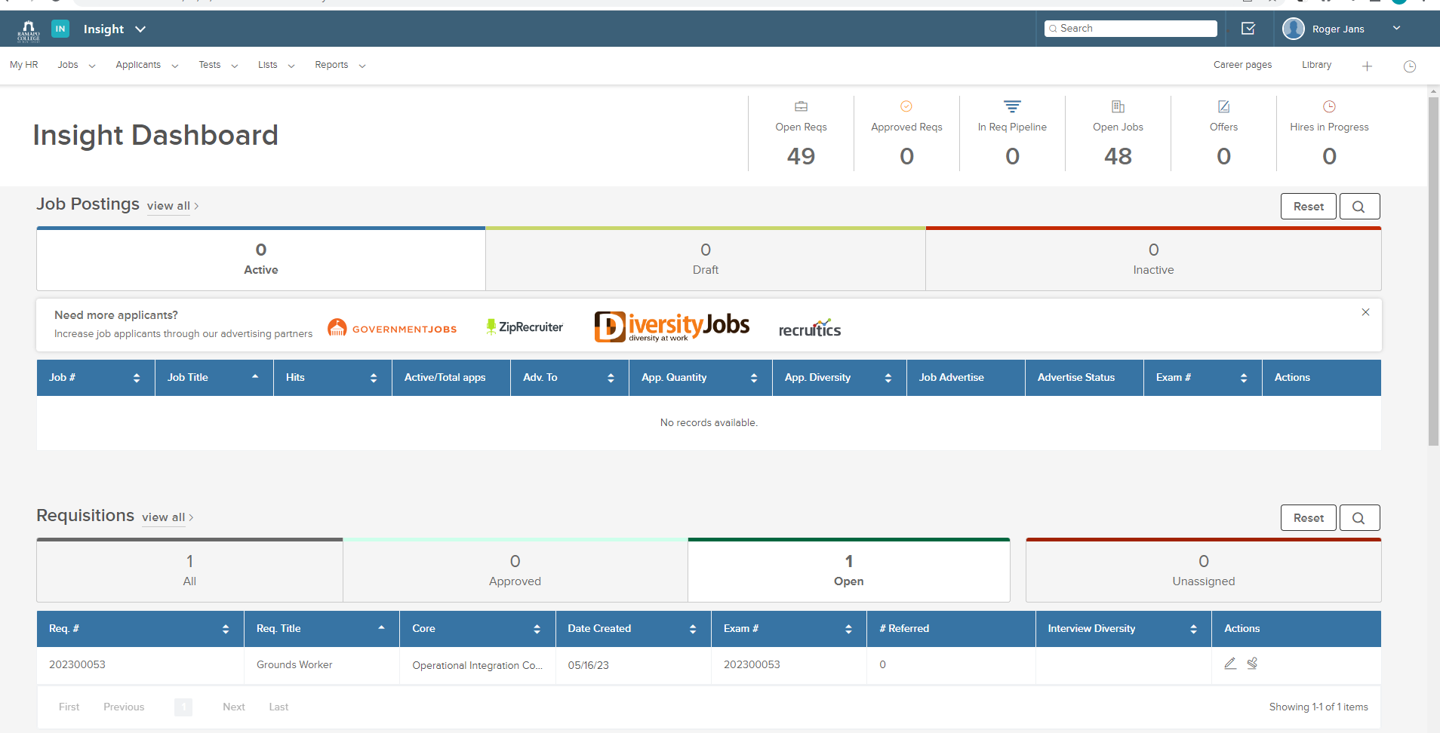
Click for dropdown

Step 3) – Select Job Templates
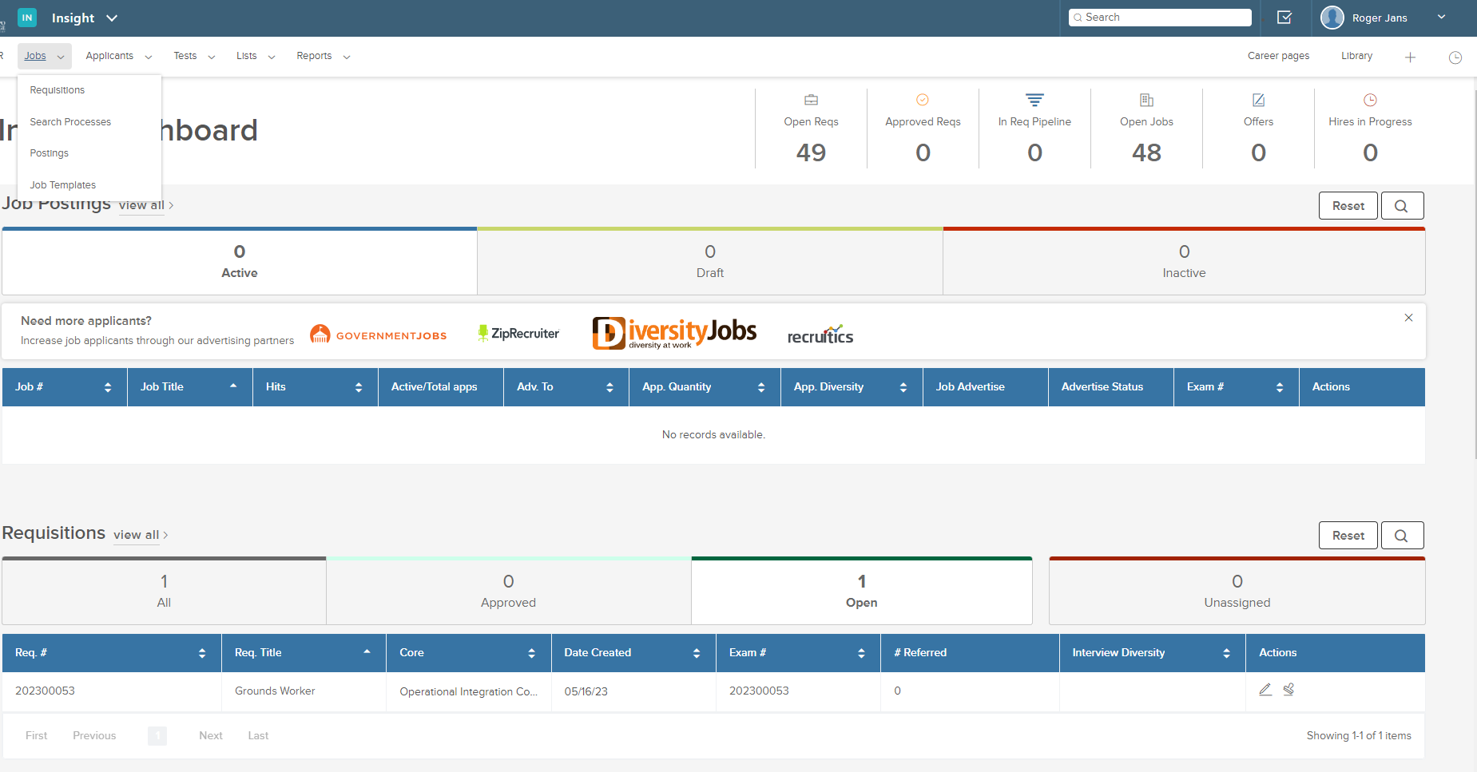

4) Click Plus Sign

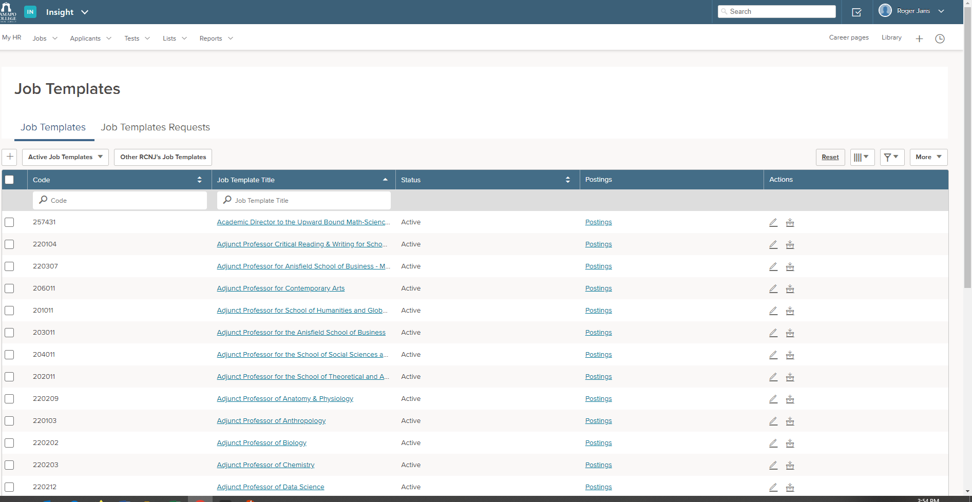

Step 5) Complete the required data
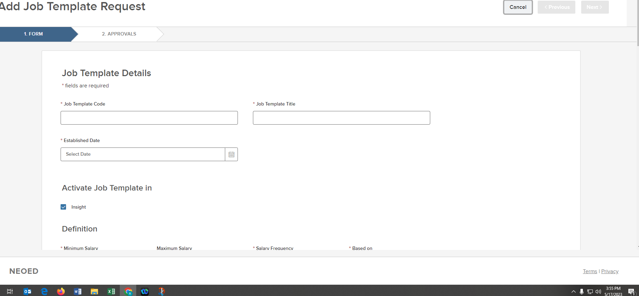

Step 6) – Click Next
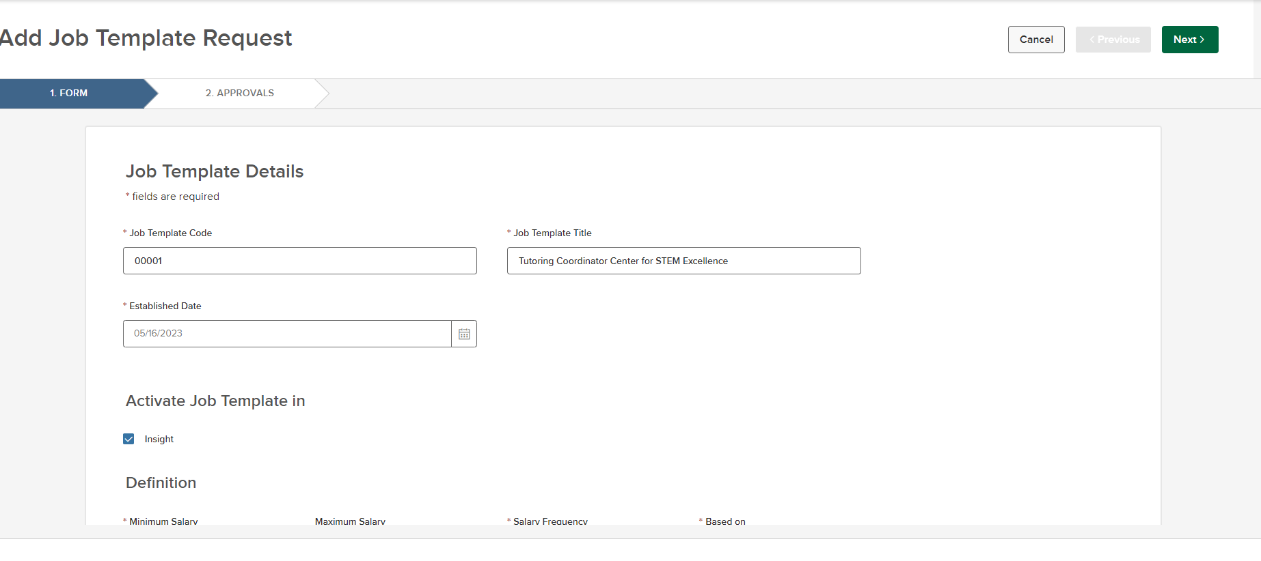

Step 7) – Click Add Approval Group

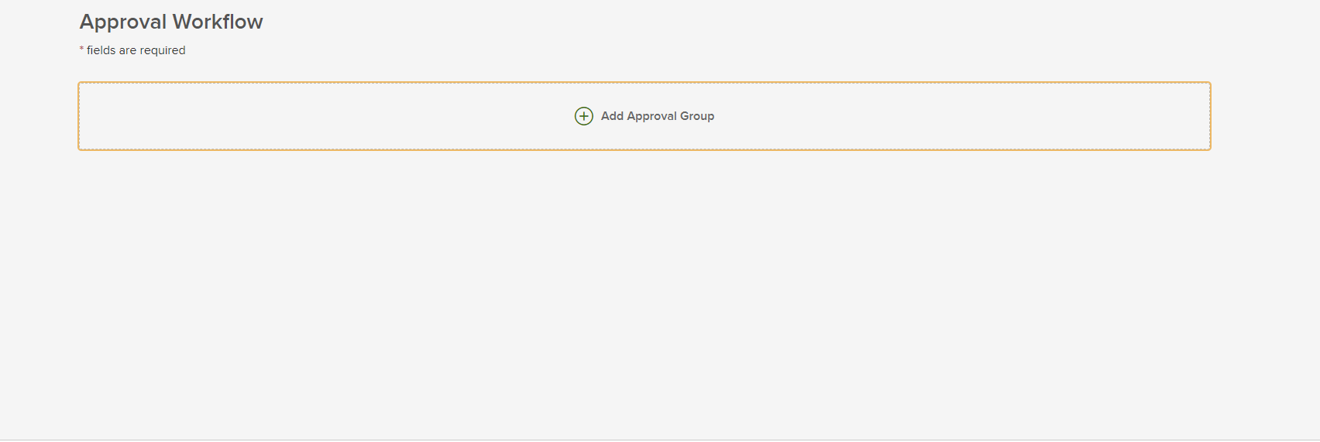
Click Add Approval Group

Step 8) – Click Search button
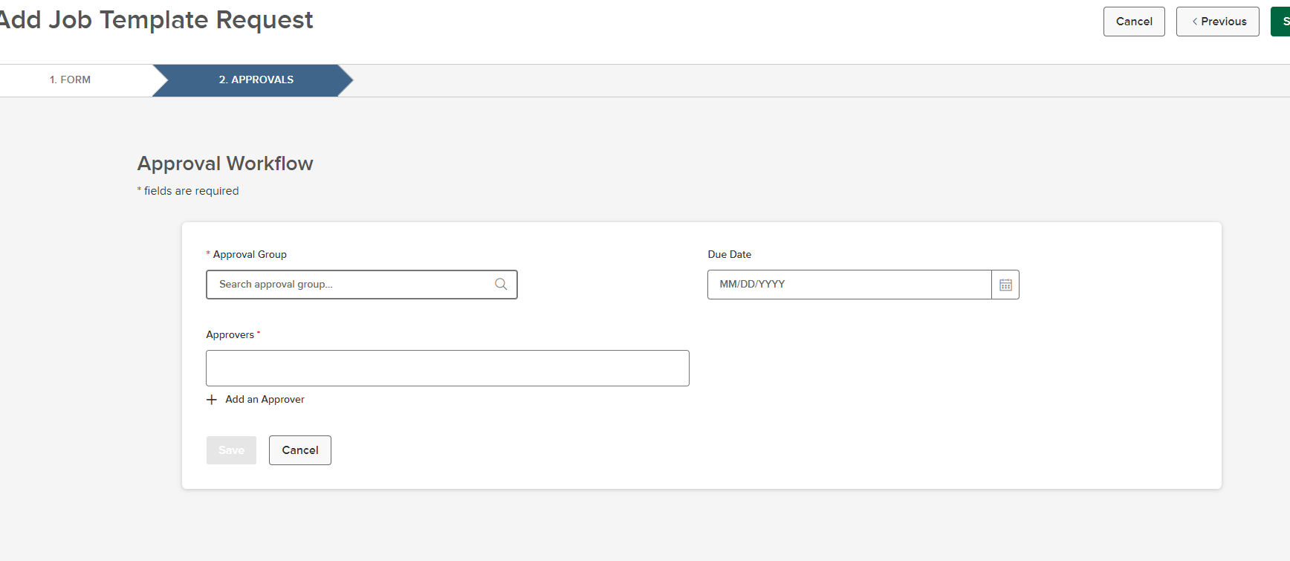
Click Add Search Button

9) – Select OEC and SAVE
Click OEC
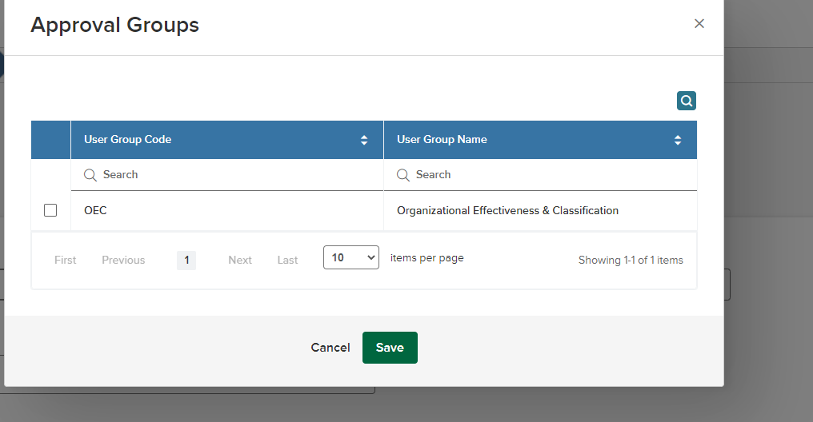
Click SAVE

10) – Enter date
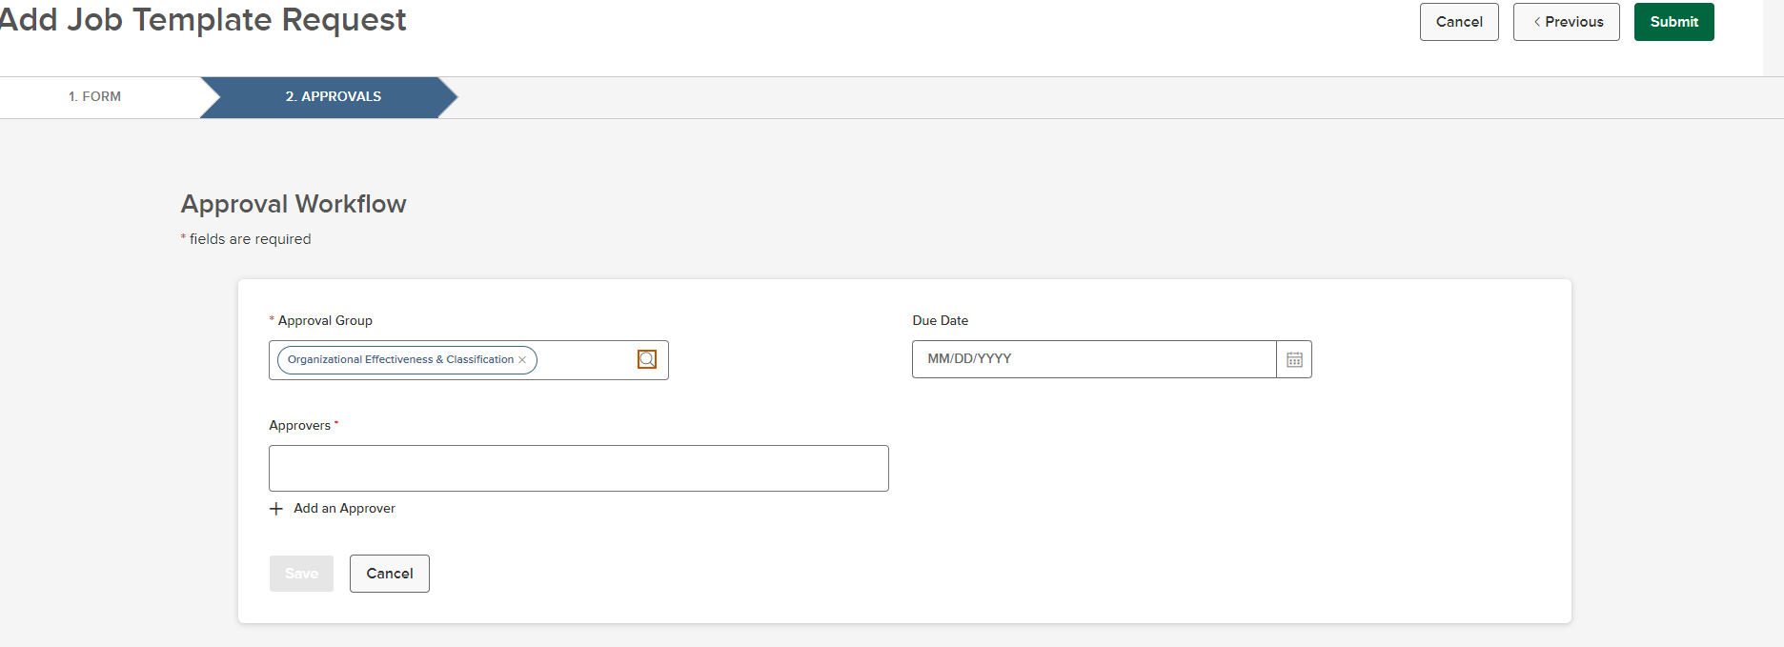
Enter Date

Step 11) – Click ad an Approver
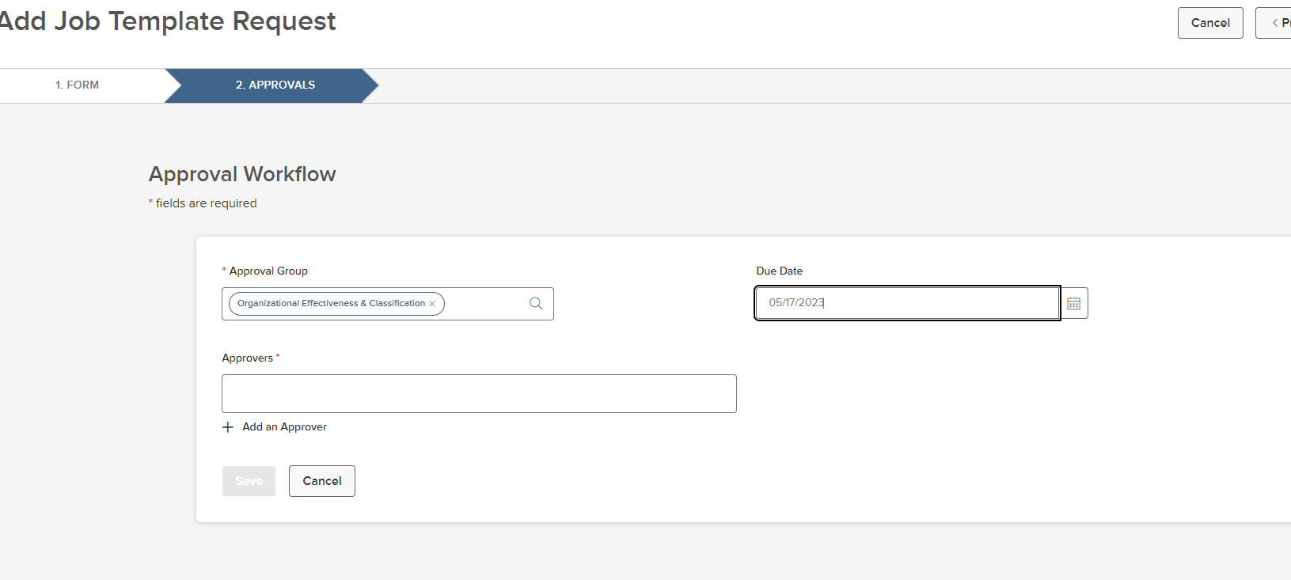
Clcik Ad an Approver

Step 12) – Select a name AND Click Add an Approver again
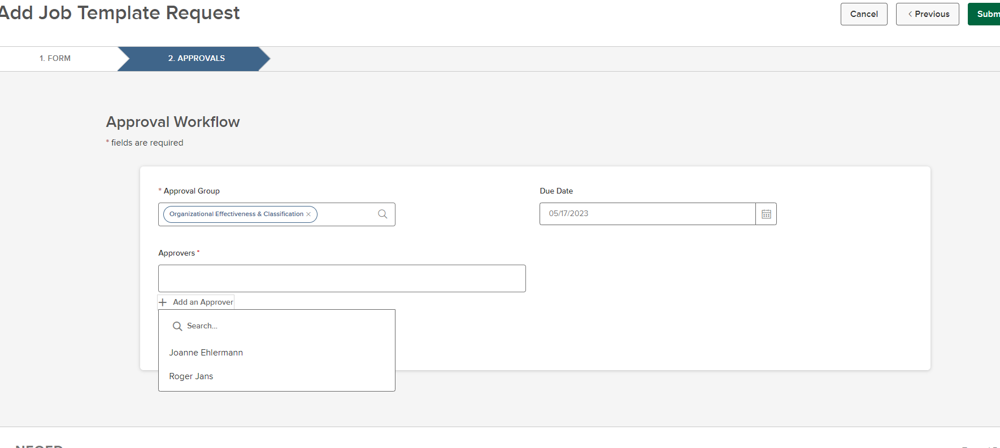
Click Ad an Approver
&
Click Add an Approver again

Step 13) – Click Save
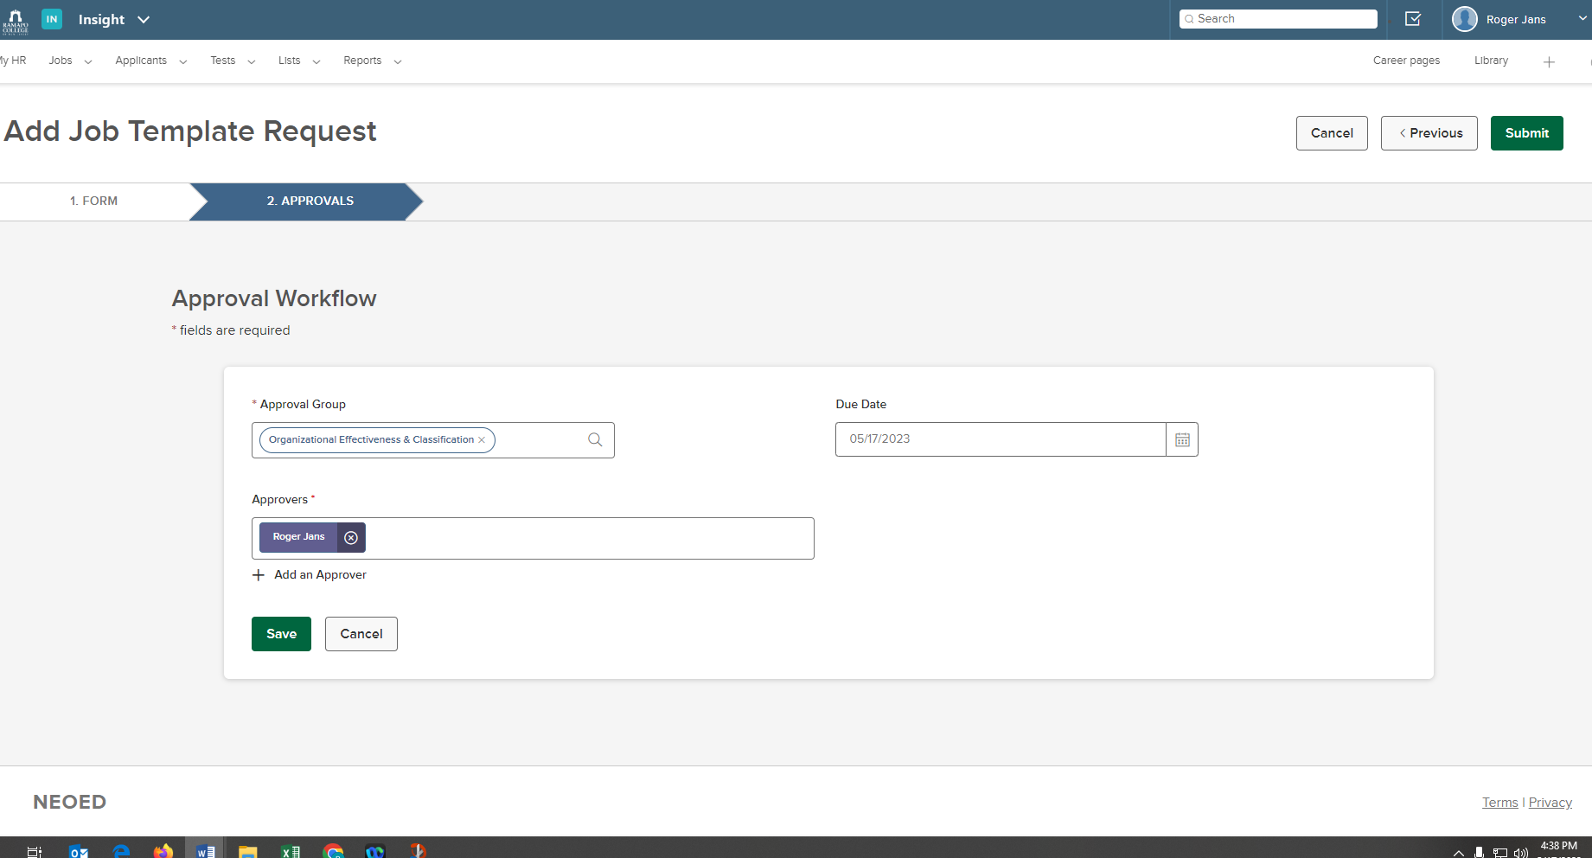
Click save

Step 14) – Click Submit
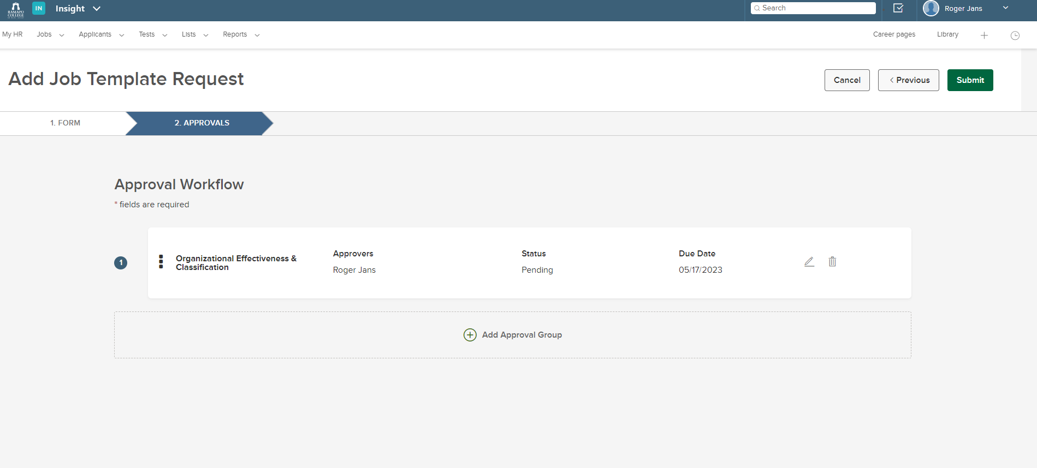
Click submit

END OF PROCESS

