Applicant Tracking System
NEOED
Hiring Manager Training Manual
Dashboard View
May 2023

- Dashboard View – Starting point for all actions and landing page for all Tasks the are Due or Over Due

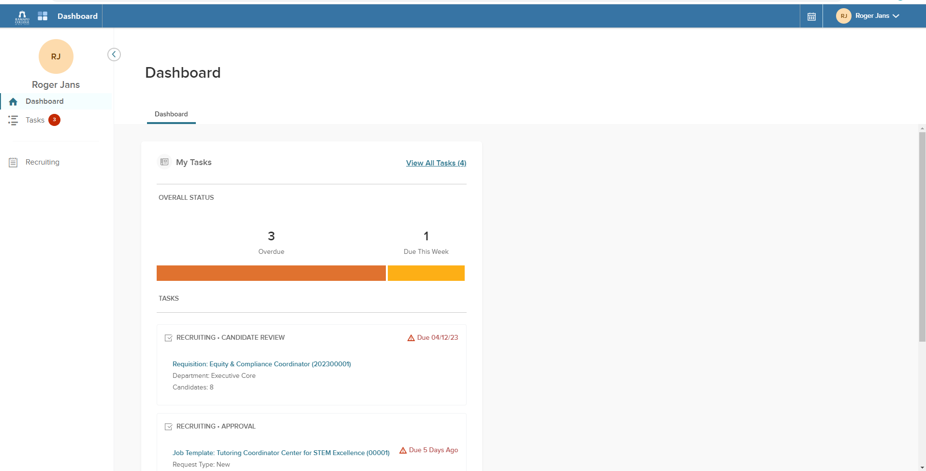
Select Recruiting Tab to see all actions
Tasks that are due

Step 2) Select Tabs to move within the System

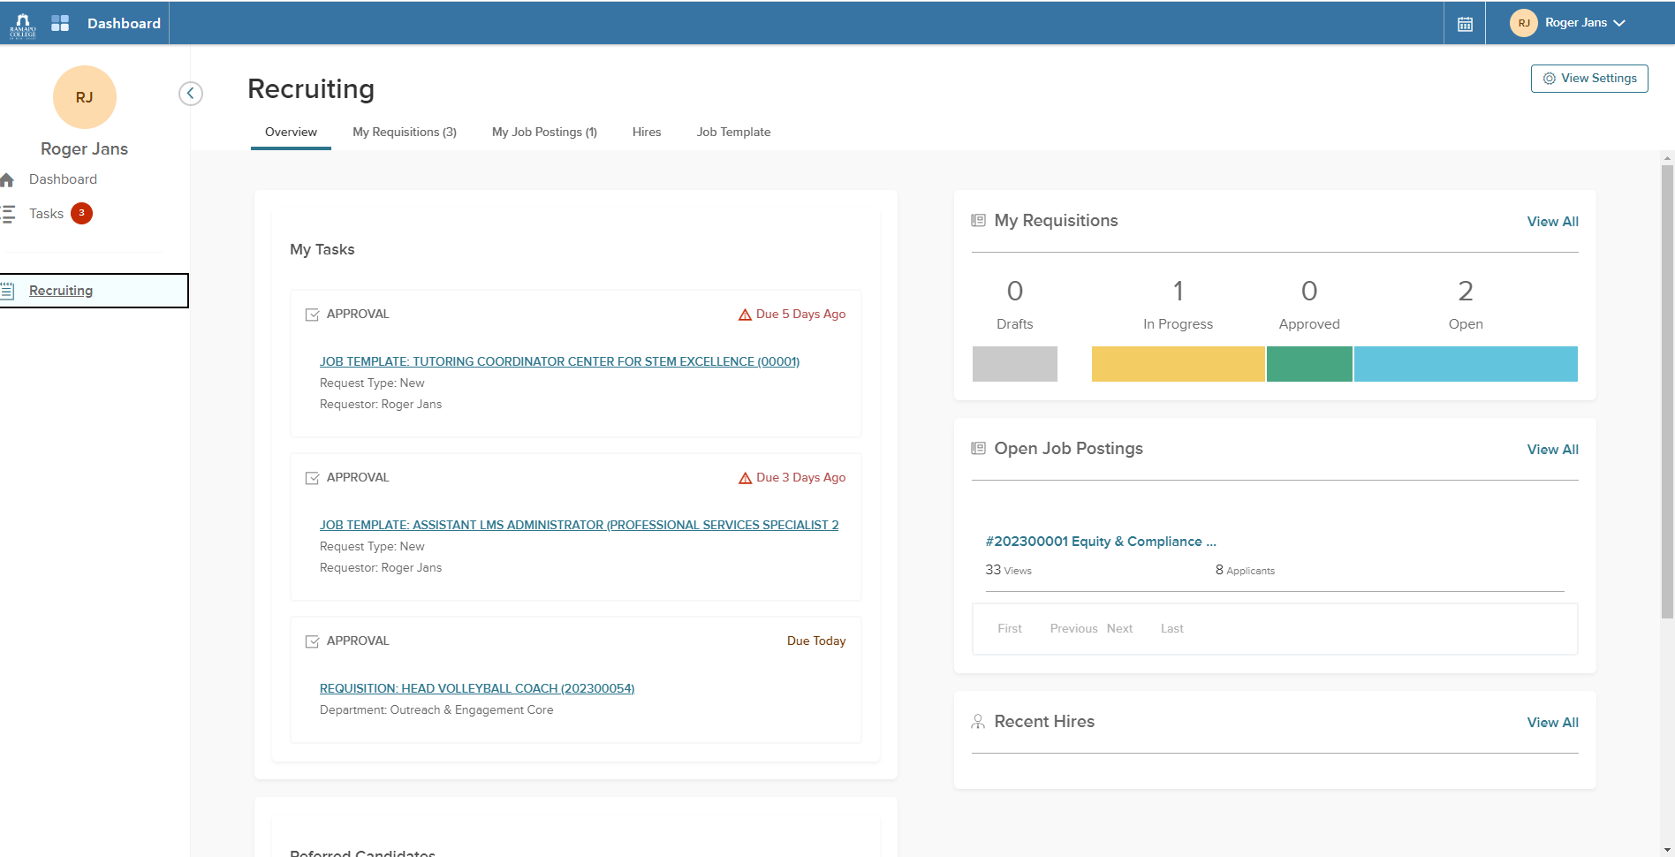
Step 3) Each tab will have specific actions related to the Tab title

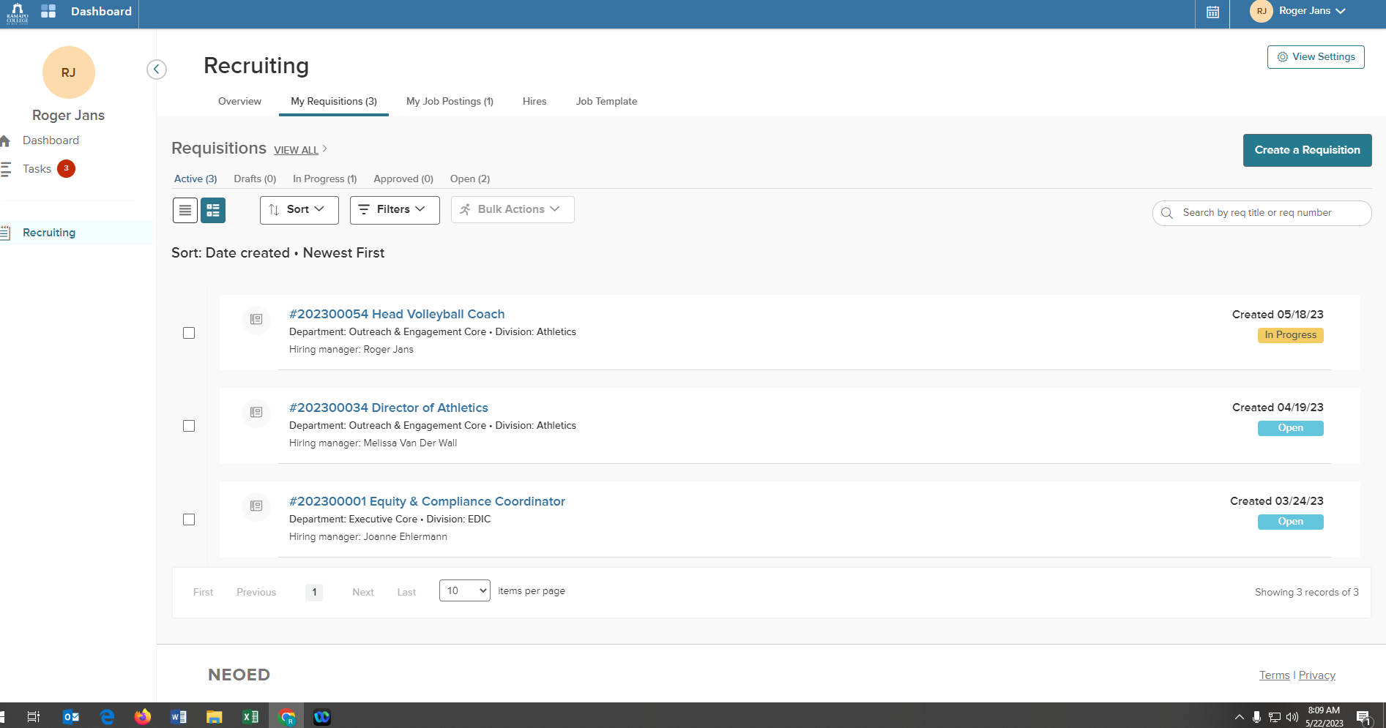
Create a Position Request

Step 4 – View a Posting

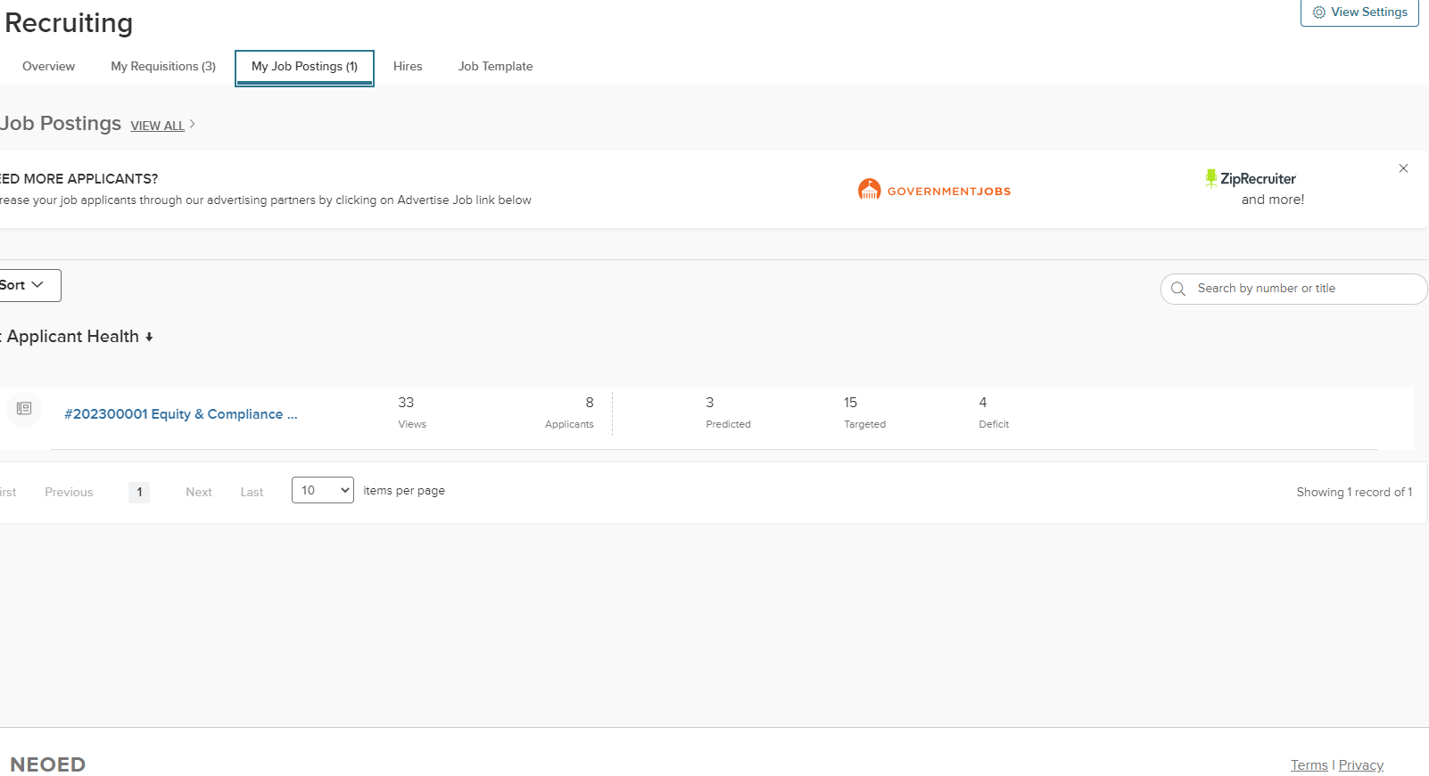
Select Your Posting you would like

Step 5) -

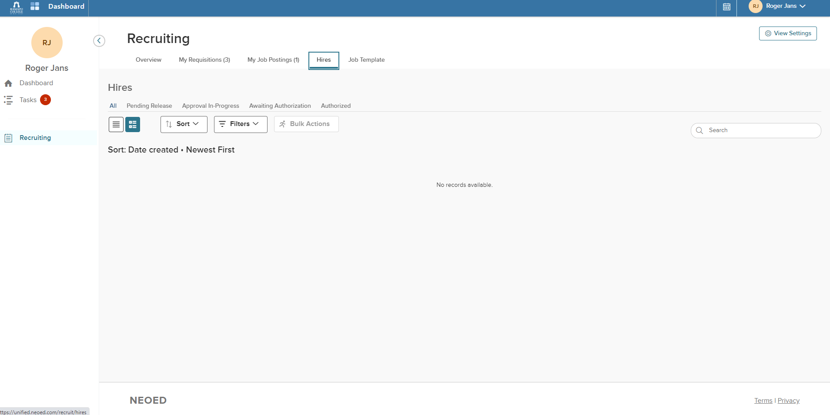

Step 6) Job Template (Job Posting) View

