- Please log into the Instructor Portal (Please note the screenshots are slightly different from your view).
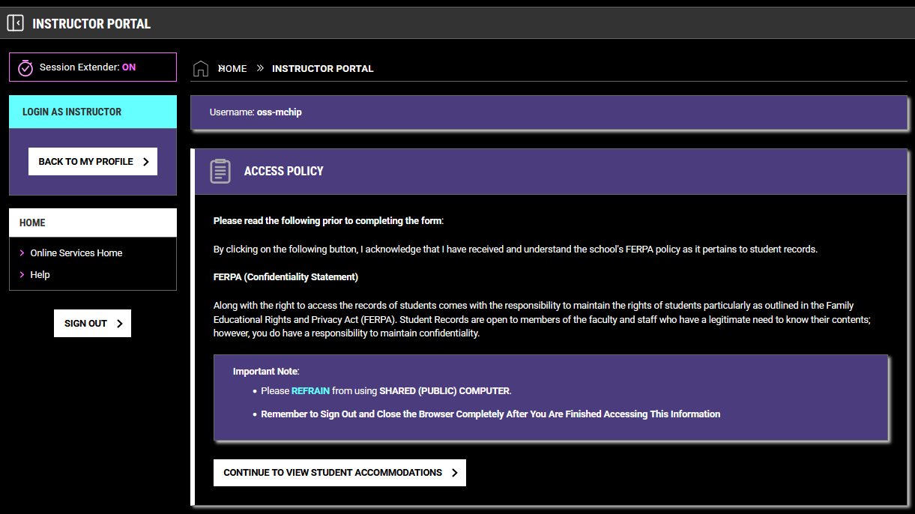
- Click on “Continue to View Student Accommodations”.
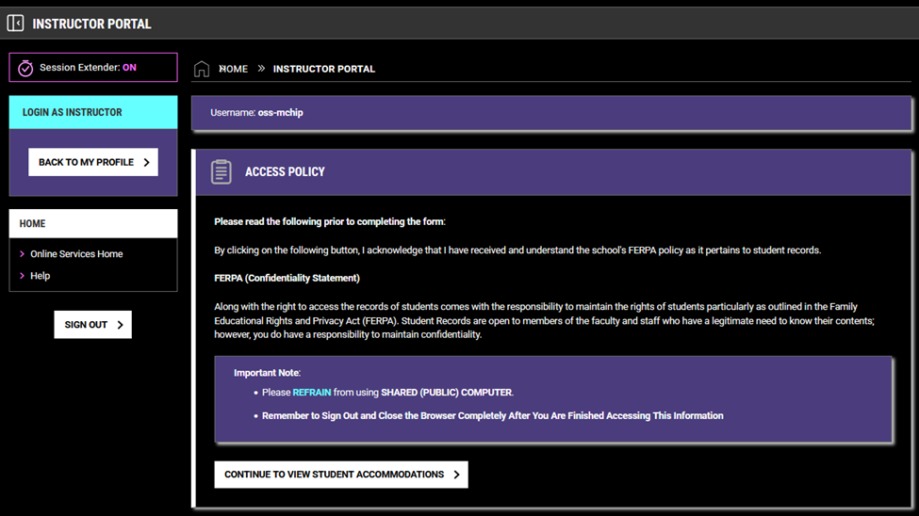

- Next, click on “Alternative Testing”. You’ll be able to see which students requested testing accommodations and the courses they requested accommodations for.
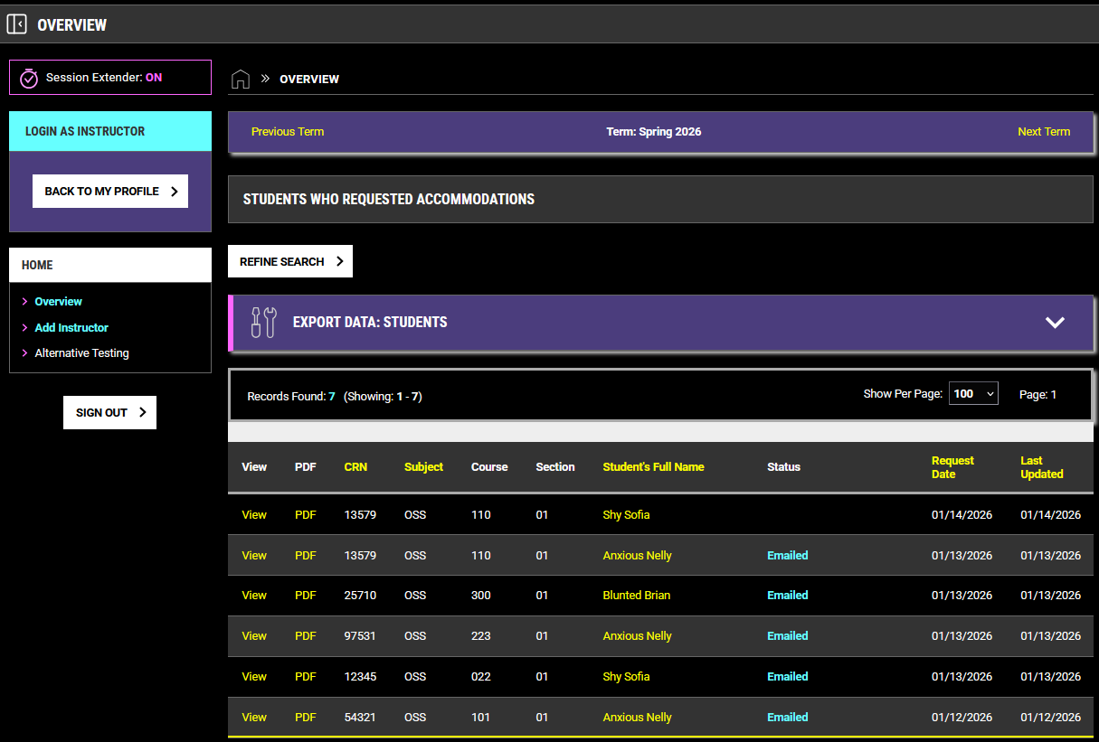

- Next, click on “Faculty Alternative Testing Agreement (FATA)” to complete the form for each course section.
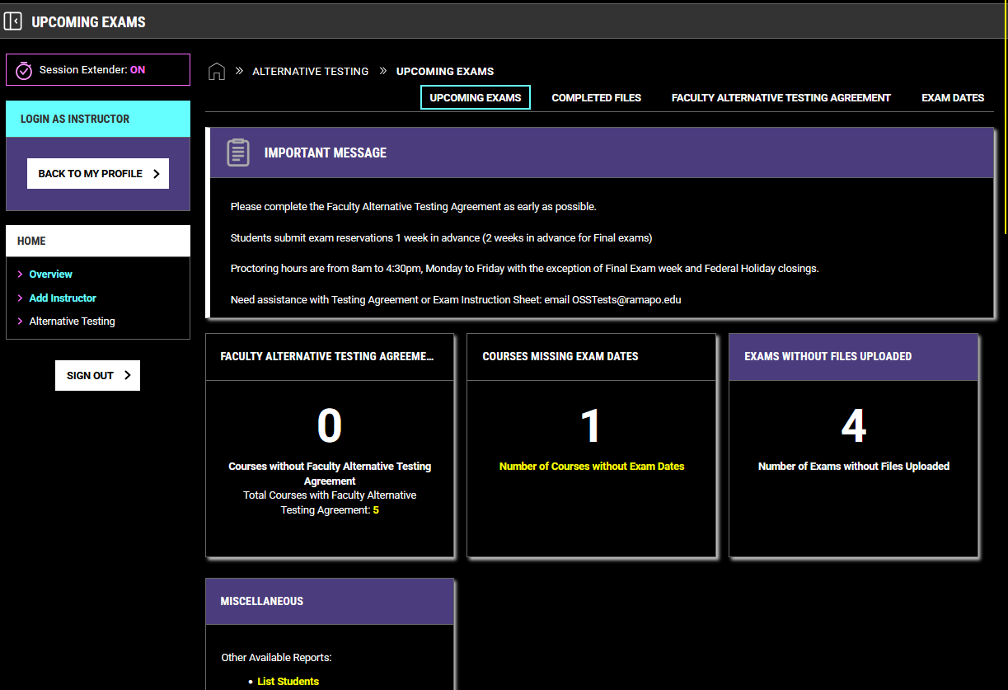

- Next click “View All Courses”, then “Courses without Faculty Alternative Testing Agreement”, and “Go”.
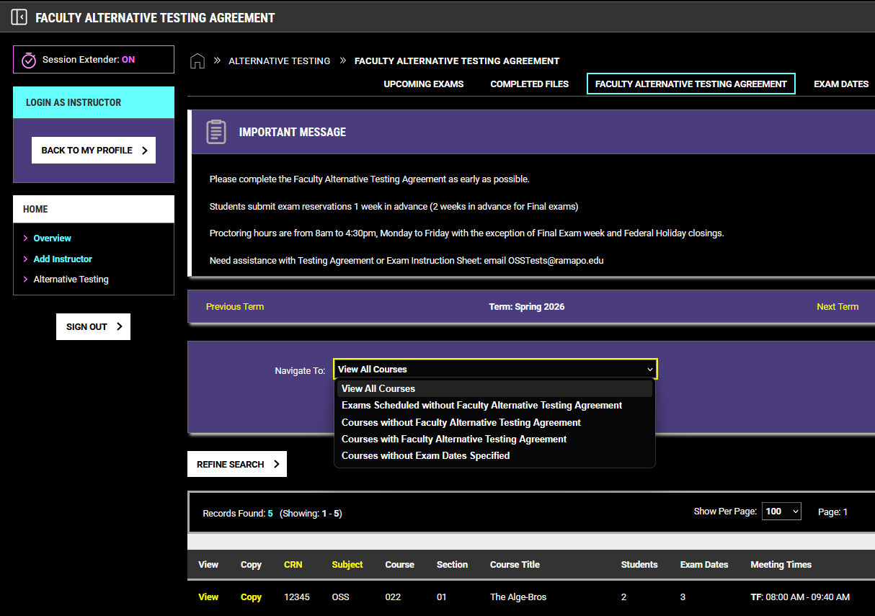

- This is the FATA landing page.
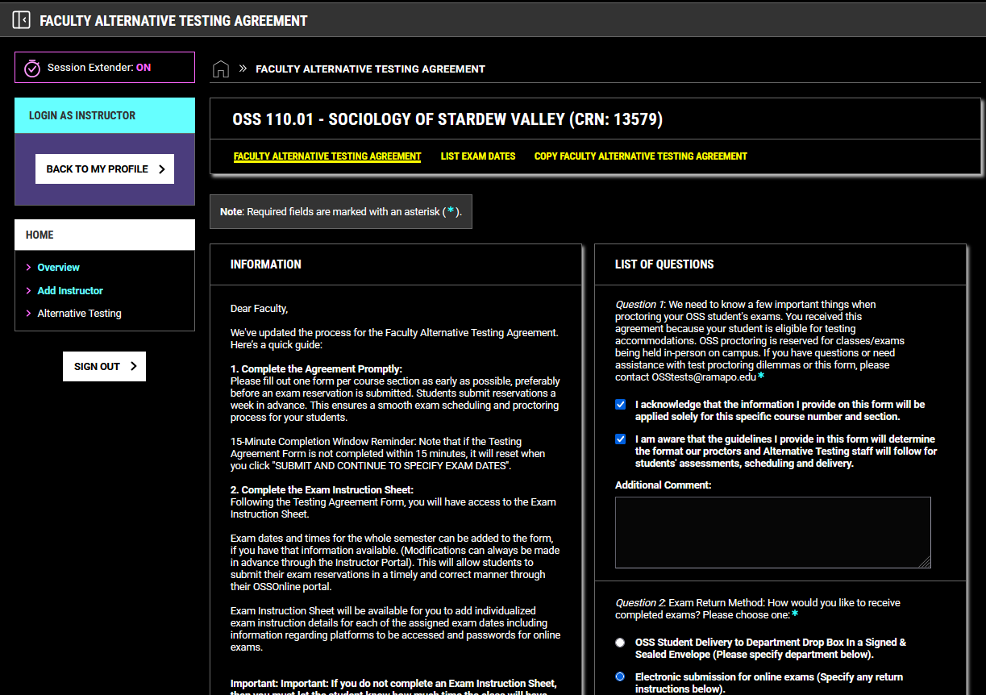

  - Please check out the quick guide beneath “Information” and enter your contact information.
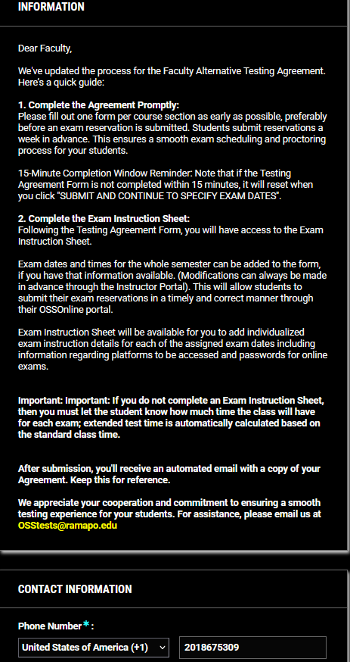

  - Next complete the FATA; there are 9 questions in total.
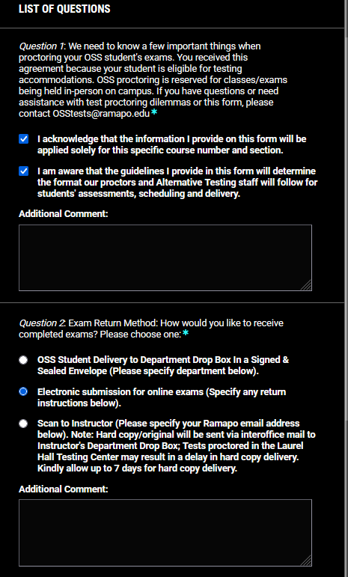

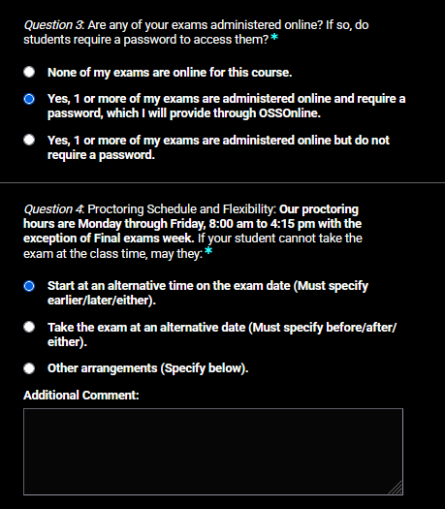

  - Please note the best email and phone number to reach you.
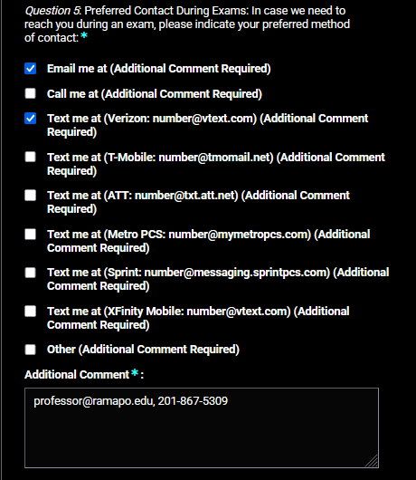

  - Please note that Question 6 is asking about parameters for quizzes. If there are no quizzes in your course, select “No quizzes” and move on to question number 7.
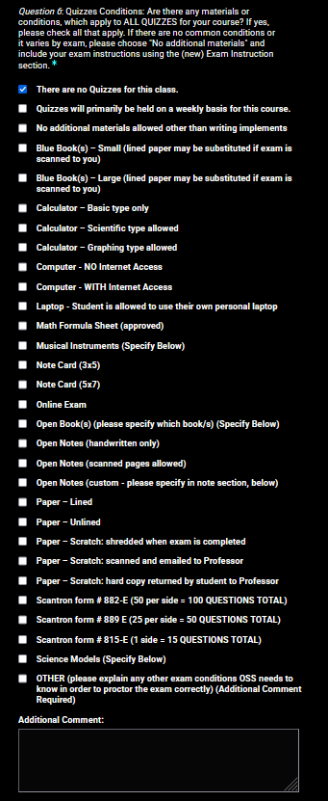

  - Please note question 7 is asking about parameters for exams.
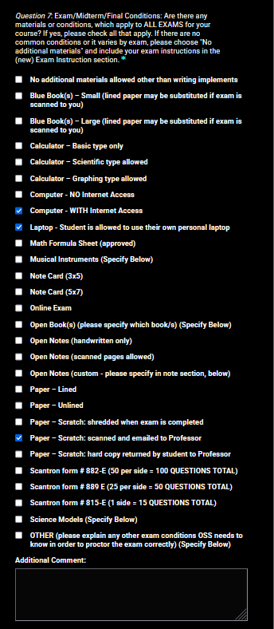

  - Once all questions are completed, please click “Update and View Exam Dates”.
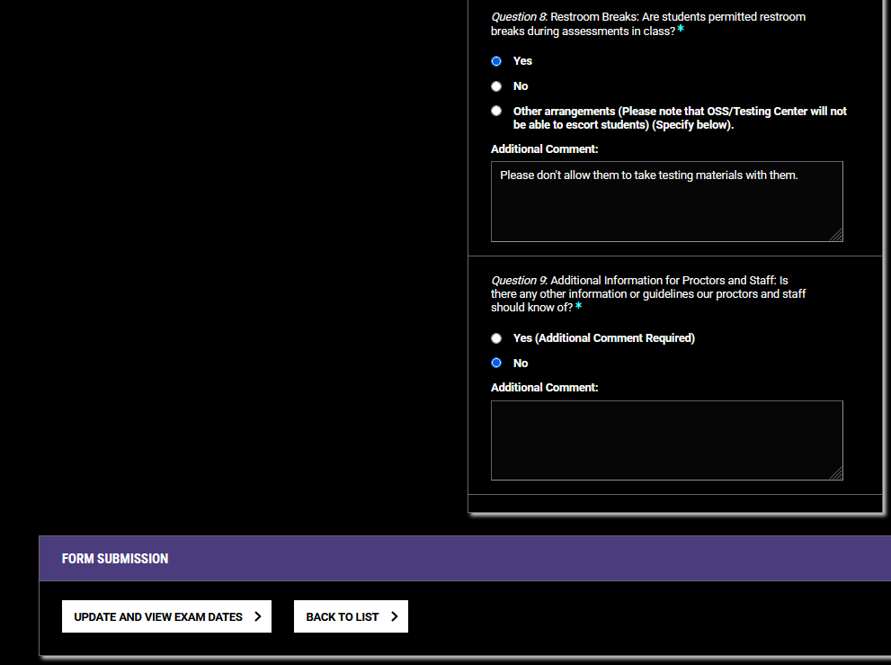

- This is where you’ll land.
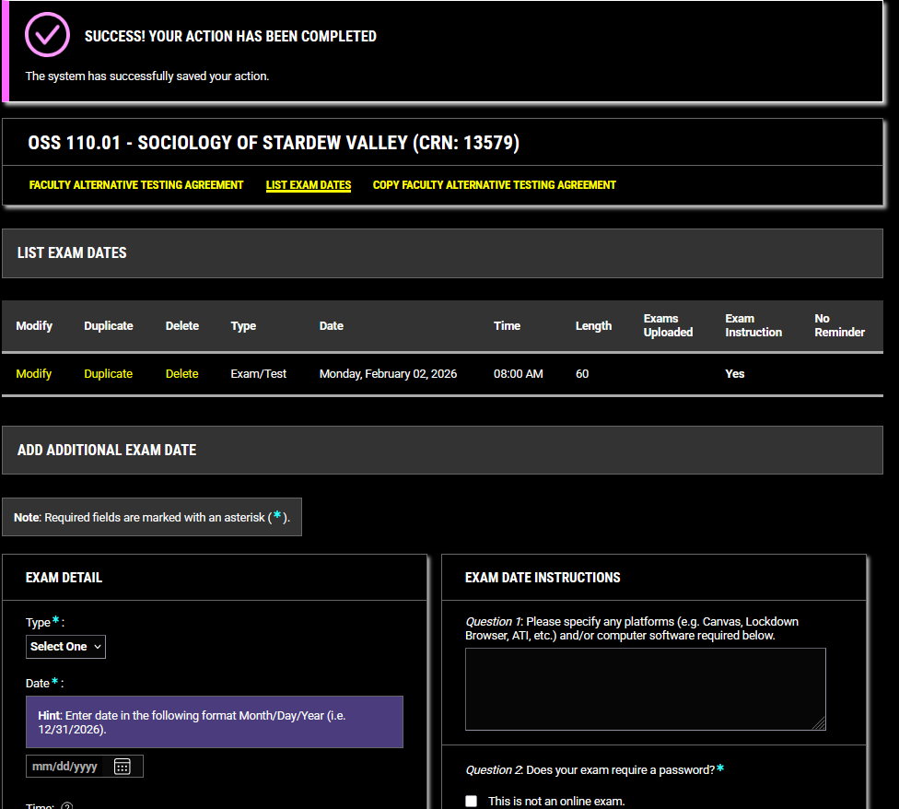
- Complete the information:
  - Under “Type”, you can choose “Exam/Test”, “Midterm”, “Final”, or “Quiz” from the dropdown menu.
  - Choose the exam date and time you’ve approved the student for.
  - For exam time, enter the amount of time the class will receive for the exam. Extended time will be calculated based on the student’s approved accommodation, if they are approved for extended test time.
  - Then click “Save Exam Date”.
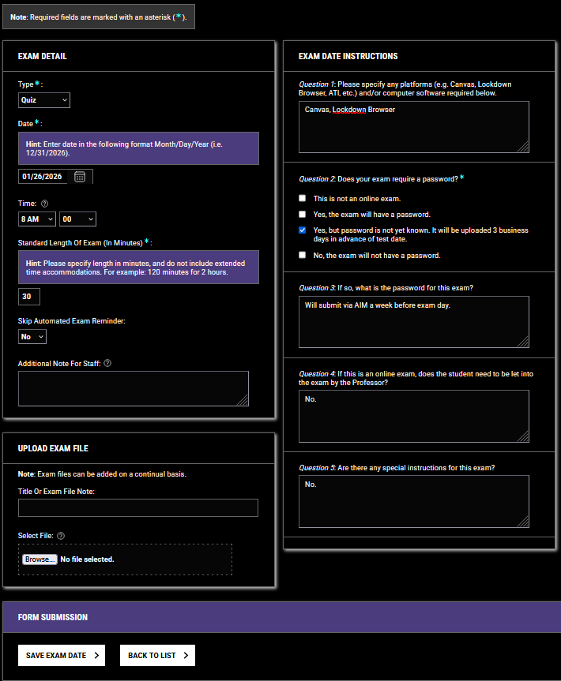

- You can now view the exam date you entered. If this is a weekly quiz or an exam/midtern/final that has similar parameters to upcoming quizzes/exams/midterm/final, you can click on “Duplicate”.

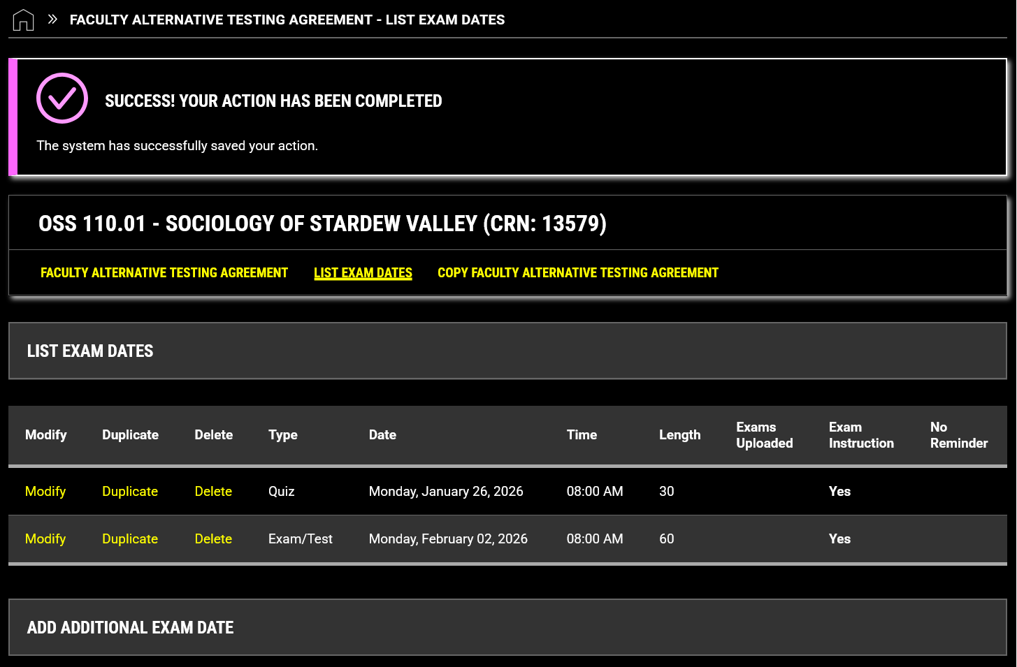

- Parameters from the selected quiz/exam/midterm/final will be copied; you will need to enter the new date. You can make adjustments, if needed.
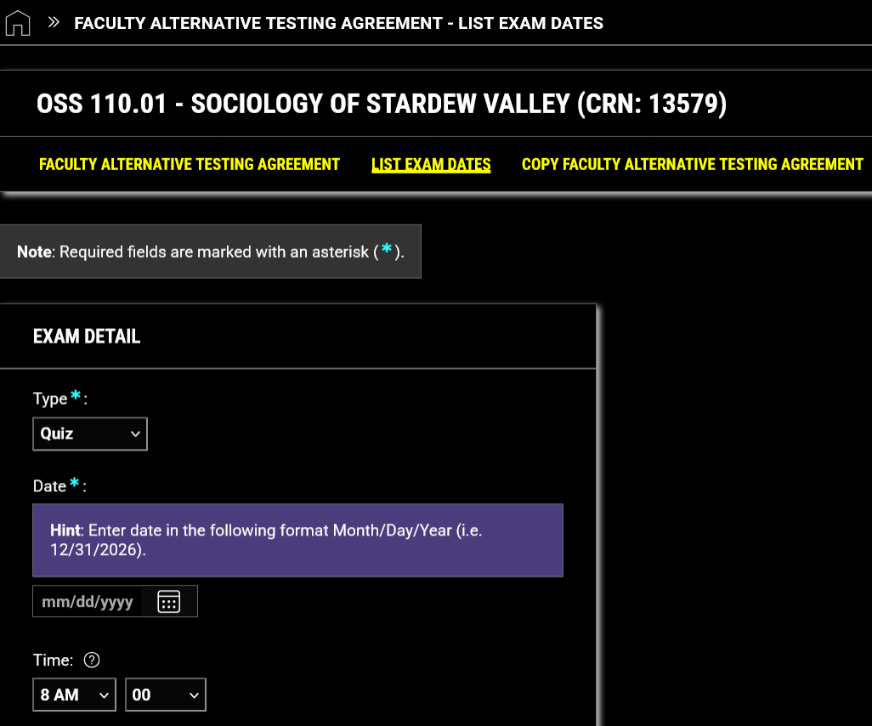

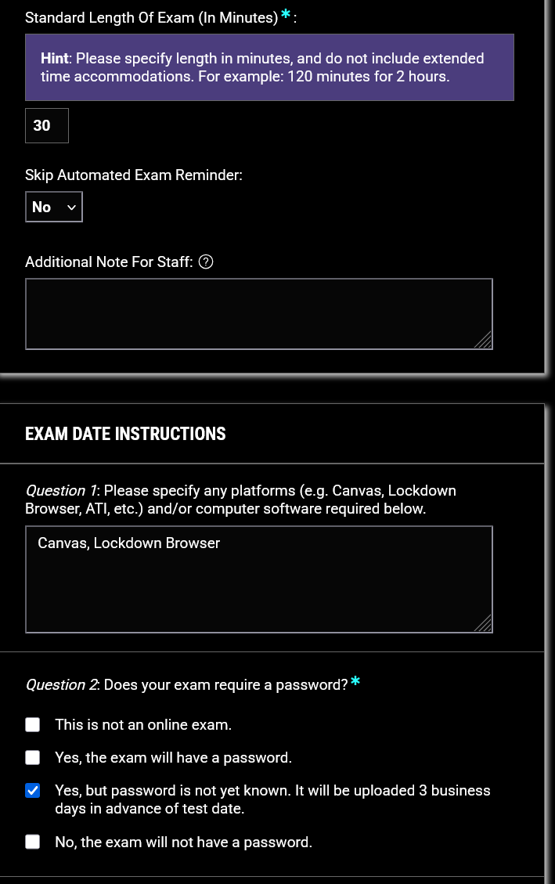

- After completing the request, click “Save Exam Date”.
