**OSSOnline Instructor Portal**

Through the OSSOnline Instructor Portal, you can:

* View a list of all students with requested accommodations in your course(s)
* Search and sort students by course
* View the **Academic Accommodations Notice** for students
* Complete and view the **Faculty Alternative Testing Agreements** for exams proctored at the Testing Center and OSS
* View a list of exam requests made by your OSS student(s) with the ability to upload the exam through a secure and encrypted platform.
* Upload an exam in advance--- By completing the Exam Instruction Sheet, NOW you can upload in advance. No need to wait for the reservation!

**Important!:** *You will still receive students’* ***Academic Accommodations Notice*** *via email and the Notices will continue to contain a link for the corresponding* ***Faculty Alternative Testing Agreement****.*

**To Access the Instructor Portal:** Log into the portal through the OSSOnline Login – Instructors button on the OSS website <https://www.ramapo.edu/oss/>

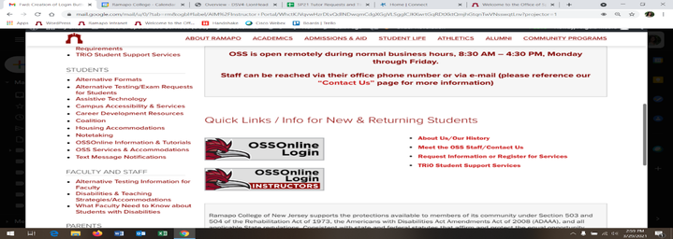

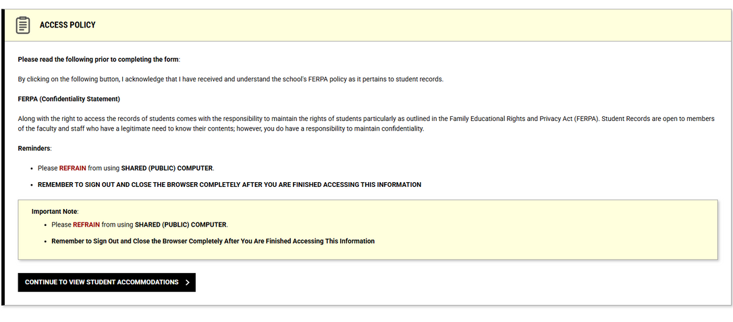**Next:** Review the Instructor Authentication page and click *Continue to View Student Accommodations*

**ACADEMIC ACCOMMODATIONS**

**Academic Accommodations:** You will see the List of Students who requested accommodations for all of your current semester courses. Click View to access the ***Academic Accommodations Notice*** for an individual student. **Reminder**: The notice will list the assigned OSS Advisor and contain the Faculty Alternative Testing Agreement Link (if not yet completed for the course section)↓.

**Alternatively,** you may export an excel spreadsheet of the list of students with their approved accommodations and other pertinent information.

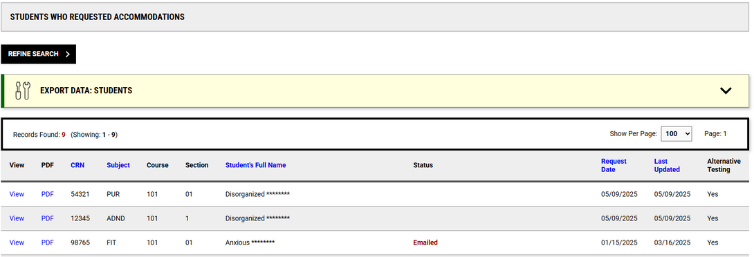

**Want to view the list by course?** Click ***REFINE SEARCH***, enter your course info and click search.

**ALTERNATIVE TESTING**

**Alternative Testing:** This section of the portal will allow you to complete, review and/or update the **Faculty Alternative Testing Agreement**(s) for each of your course. If you have more than 1 course section, you may copy the content of a completed agreement to the other course section.

You will also be able to view any approved exam reservations, completed exams and have the ability to upload your exam securely through the portal.

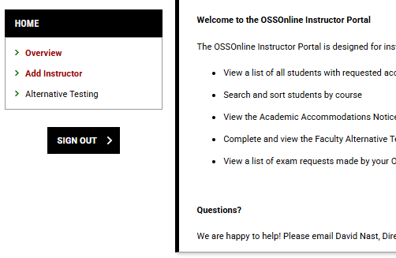**Click** *Alternative Testing* to enter the portal’s alt testing page.

**For On Campus Exams that need OSS Proctoring**: Select the blue *Courses without Faculty Alternative Testing Agreement* text within the FACULTY ALTERNATIVE TESTING AGREEMENT box.

↓

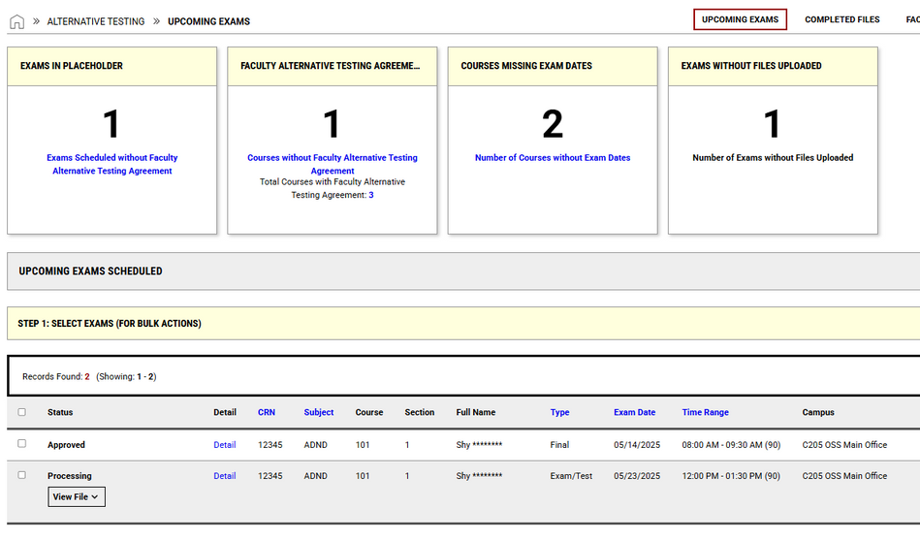

*T*his will bring you to a list of your classes that need their testing agreement specified. Please select either **the GO tab** to vie all Courses without the Faculty Alternative Testing Agreement or the *Specify* tab on the left hand side next to CRN of each listed course*.* This will bring you directly to the **Faculty Alternative Testing Agreement Form**.

*You may modify this selection and complete the Testing Agreement through the Instructor Portal at any point in the semester*

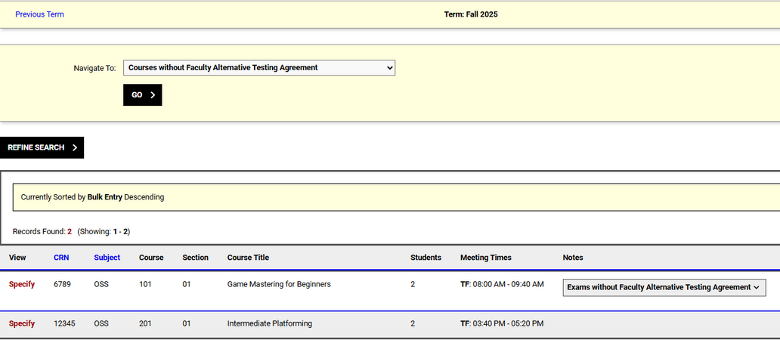

**If you Plan to Proctor the OSS student directly, have a virtual/online class or if you have no exams**, then make the corresponding selection within the drop down option under **Exam Management Method** for your corresponding class in the AVAILABLE OPTIONS FOR [CLASS] box. Then use the second drop down menu under **Confirm Task** and select Confirm to Proceed. Finally select SUBMIT YOUR SELECTION. You and the OSS student(s) will receive an utomated email regarding this. 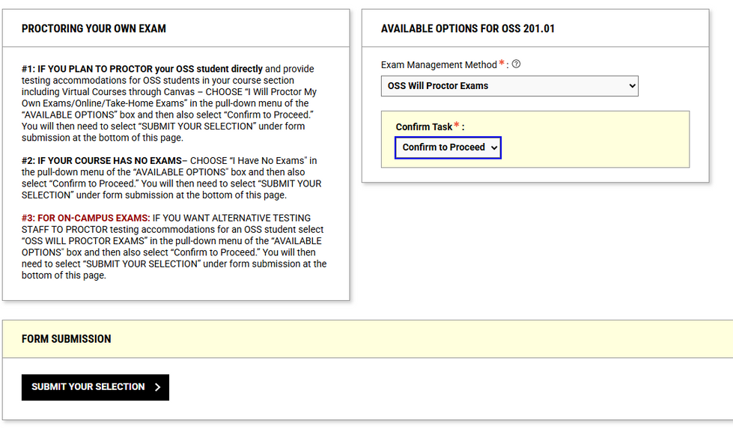

**NEW FEATURES**

**Adding an Instructor: I**f you are teaching a class with another professor, you can now add them to your course independently. To do this you must log into OSSOnline and select “ADD Instructor” on the left-hand side.

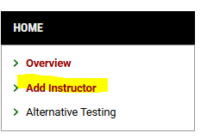

Once you have selected this, all you need to do is select the class and add in all of the additional professors’ information. Once this is done select ADD INSTRUCTOR to allow them access to the class’s information.

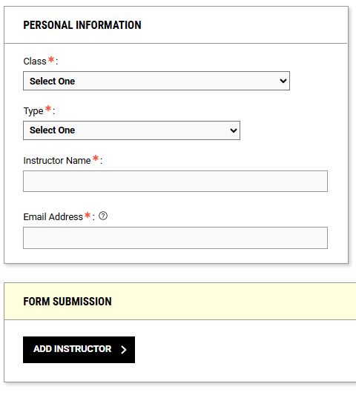

**FACULTY ALTERNATIVE TESTING AGREEMENT:**

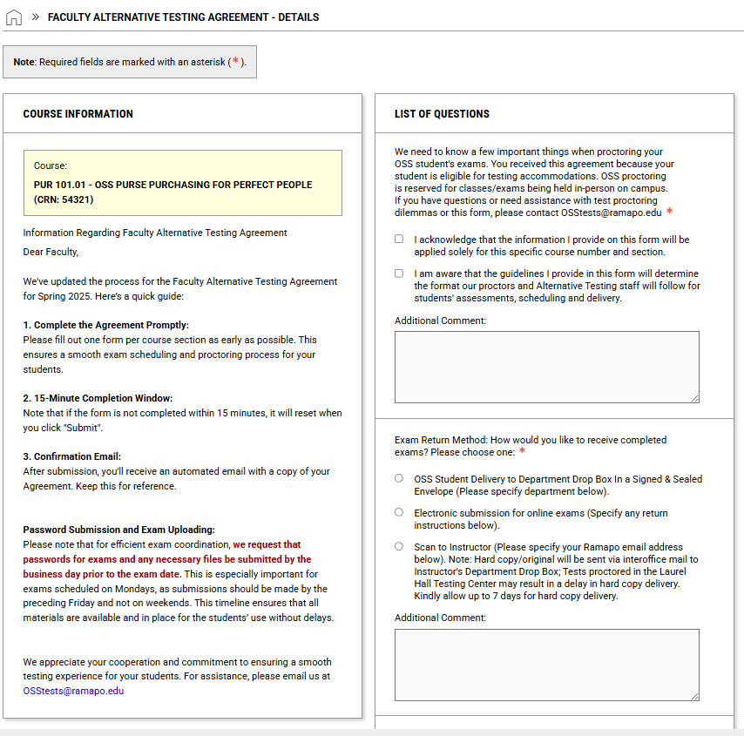**Reminder:** The form consists of different areas specifying testing conditions for your exam and how Alternative Testing Staff can contact you. Once you have filled this out click *Submit* and continue to *Specify Exam Dates* at the end of the form.

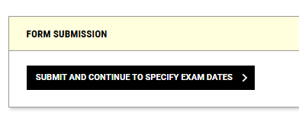

**EXAM INSTRUCTION SHEET**:

Upon completing the Faculty Alternative Testing Agreement Form, you will receive access to an Exam Instruction Sheet. For those who have this semester's exam dates and times, you may complete one form per date and specify individualized instructions and parameters for the exam. This feature will be helpful for those who have exams with different class times, different passwords and/or different conditions (e.g., one quiz is 20 minutes with scrap, another is 10 minutes on Canvas, etc.)

When identifying a date, if you have your exam ready, you can upload directly through the secure and encrypted portal in advance. Instructors will no longer need to wait for an exam reservation to be submitted. However, this option will not be available if no date is submitted through the Exam Instruction Sheet.

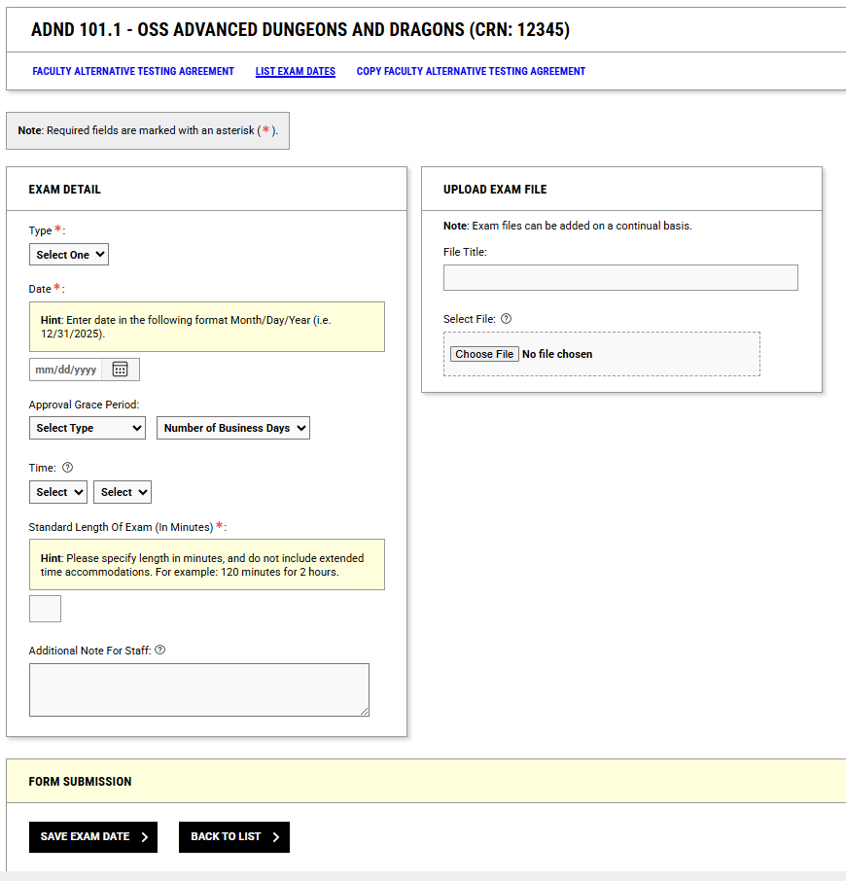**TIP**: You can add an approval grace period to allow your students to make those exam reservations a few days before or after the main testing date.

**TIP:** You can make modifications to the dates through OSSOnline and selecting List Exam Dates.

**PASSWORD FOR EXAM(S):**

The Exam Instruction Sheet allows you to provide the password in advance; You no longer need to upload through the portal. This allows Alternative Testing Staff at both testing locations, Laurel Testing Center and OSS access.

**TIP:** If you know your exam will be password protected but do not yet know what that password will be you can select *Yes, but password is not yet known*. You can modify this through OSSOnline Instructor Portal and add the password at a later date (minimum 48 hours prior to the exam).

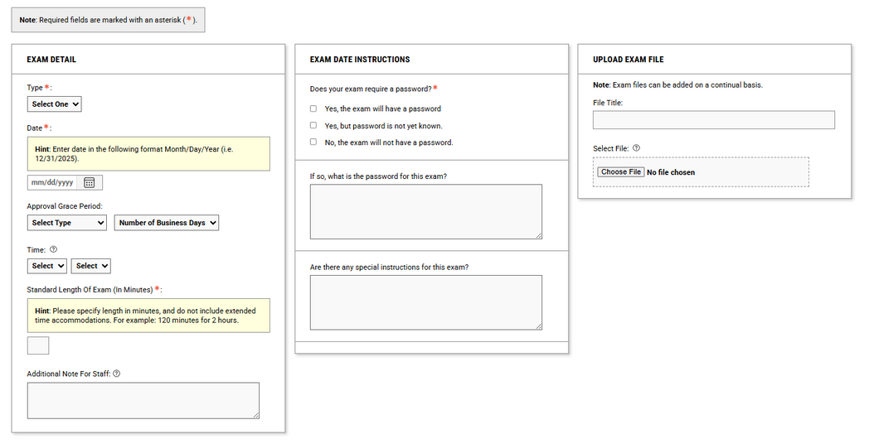

To do this you must select Faculty Alternative Testing Agreement in the top right corner of the alternative testing page.

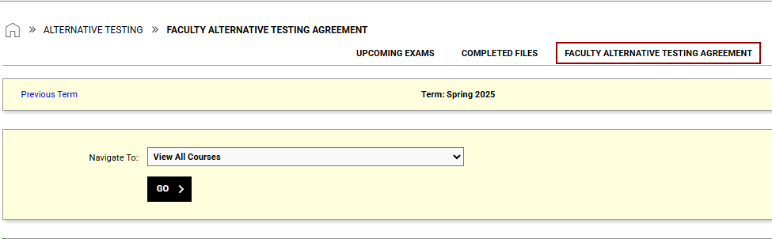

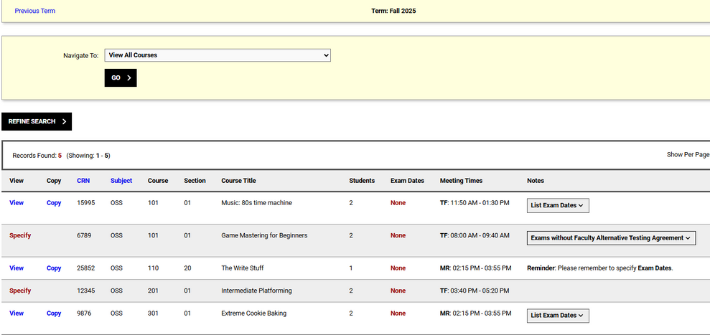Then select View/Modify Faculty Alternative Testing Agreement

And then **LIST EXAM DATES**

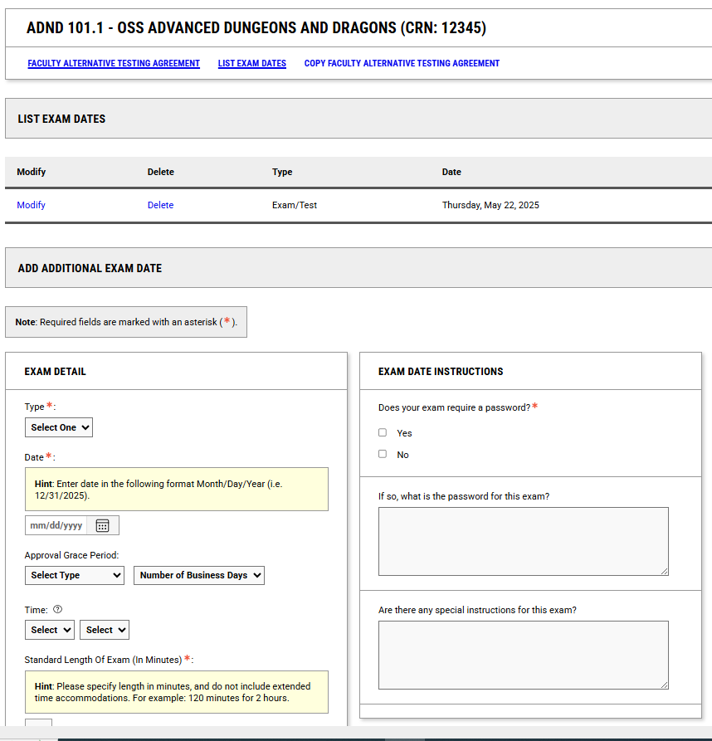

This will take you to a section where you can modify previously specified exams and add additional exam dates.

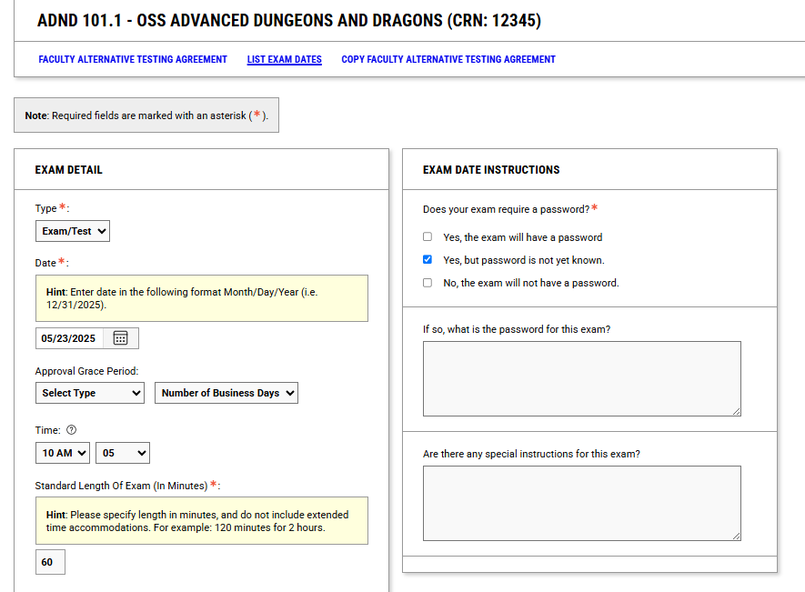

**Student Exam Submissions**: Students will be able to submit their exam reservation through OSSOnline based on the date and time submitted in the Exam Instruction Sheet.  The exam reservation will be processed by Alternative Testing Staff based on that.  **If no date is identified, then students should be made aware of the amount of time the class will be provided for the exam as they will be required to fill out that information when submitting their exam reservation through OSSOnline**.  The exam reservation will automatically be approved by Alternative Testing Staff as in past terms.

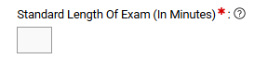

**Looking to complete the Faculty Alternative Testing Agreement and don’t see your class listed in the drop down option?** If your course is not listed, check to see if an exam reservation was already submitted with no testing agreement in place – there will be a section highlighting the student, exam reservation and the status of the Testing Agreement from which you can access and update the form directly.

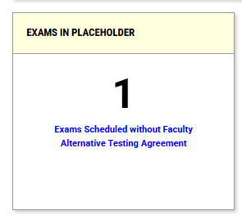

**Wish to view your completed Testing Agreement?** Within the Alternative Testing page, you can view the completed testing agreement, make updates and/or revise Exams Proctored by Instructor etc.



**Alternative Testing – Exam Feature:** You will be able to view exam reservations received by OSS that are being processed or approved for all your courses. [You will still receive an automated email when an exam reservation has been approved by OSS with the secure exam upload link]. To view the details of the exam reservation and the student’s approved accommodations, click *Detail.*

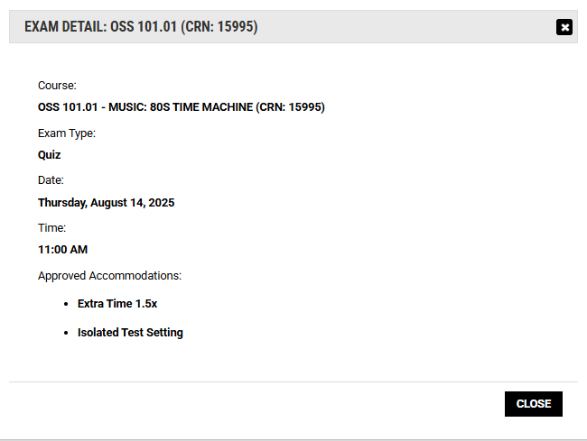

**Exam Upload:** You may upload your exam securely through the Instructor Portal. Step 1 will indicate the number of student exam reservations you would like to attach the file too. Step 2 is where you will upload the file. Then, click *Upload File.*

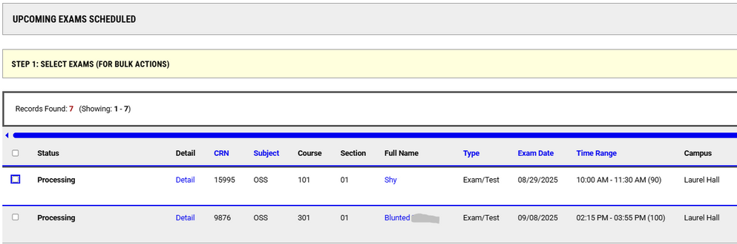

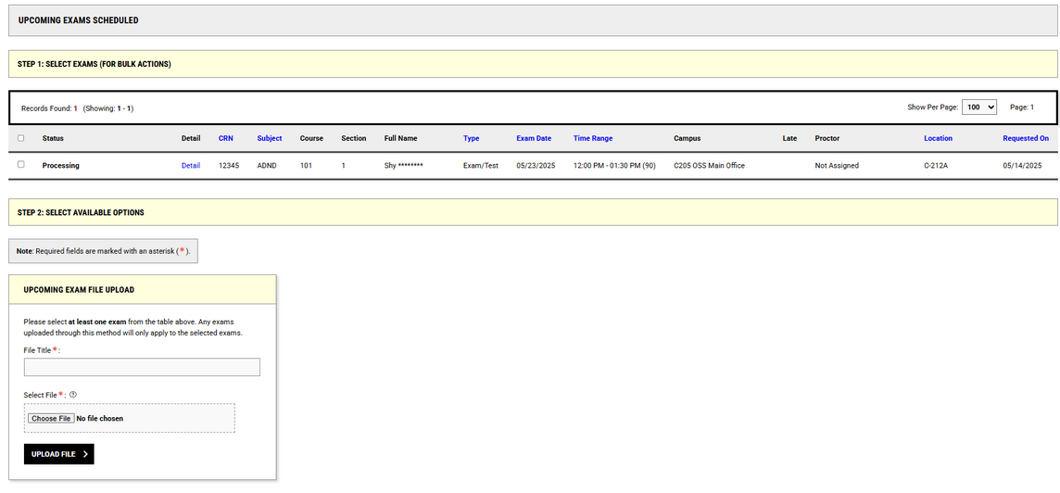

Green Checkmark = Successful Upload

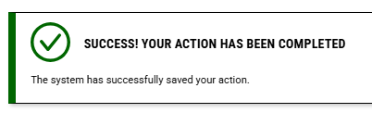

**Exam Campus Location:** There are multiple testing locations on campus. When looking in the same place as where you uploaded exams you can also see the where your student will be testing. The two options are Laurel Hall and C205 OSS Main Office. If there is a last minute change with your exam, please double check the location before sending an email. This makes sure that your email is being relayed to the testing staff working with your student as soon as possible.

**Laurel Hall: LaurelProctors@ramapo.edu**

**C205 Main Office: OSStests@ramapo.edu**



**Tip:** If you click Alternative Testing tab (on the left hand side), you will return to the Alternative Testing page and view the upload. You can make any modifications if needed.

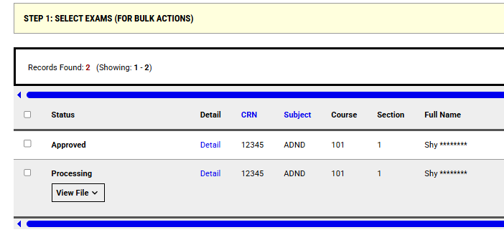

**Alternative Testing – Additional Feature**: You may view completed exams within the Alternative Testing section of OSS Online. Students’ Upcoming Exams Scheduled will list students who have requested accommodations and who have completed exams with OSS.

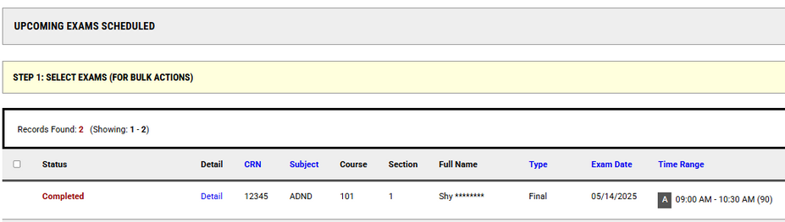

**Questions?** We are happy to help! Please email David Nast, Director at dnast@ramapo.edu to coordinate a demo with one of our team members.