How To Use OSSOnline to Make an Exam Reservation
In this tutorial, you will learn how to use OSSOnline to make exam reservations for your classes at Ramapo College. Before you can request alternative testing, you must be eligible for this accommodation, and your instructor must have already received notification of your approved academic accommodations. Please reach out to your OSS Advisor if this step was not completed.
- Log into OSSOnline (found on the OSS Website: https://www.ramapo.edu/oss/ )
Each semester you will review and complete the Action Required - Alternative Testing: Student Agreement. You must click the link and sign the form. The agreement highlights your responsibilities for alternative testing. Once you sign and submit the form, Please move to Step #2 below. You will not be able to access any of the steps below if you have not completed the Action Required - Alternative Testing: Student Agreement

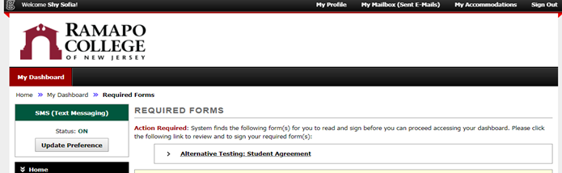

- You can check to see if your instructor has received notification by clicking on List Accommodations under the My Accommodations section of the left sidebar:
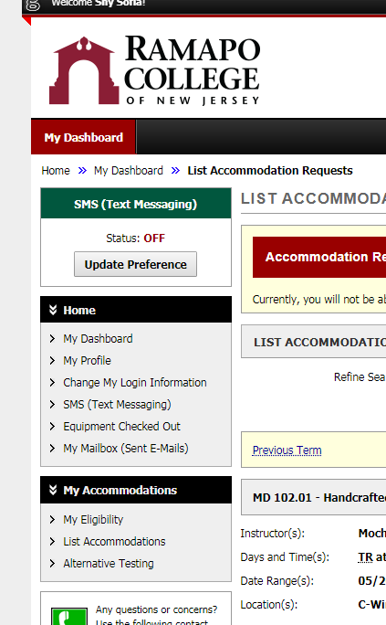

- The status of instructor notification is listed under the Notification Letter heading for each class:
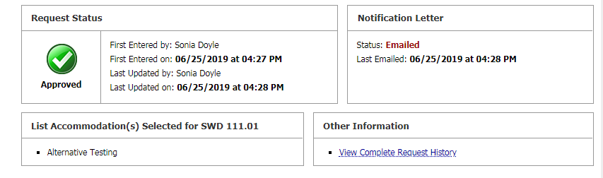

*If you are unable to see the accommodations for a specific course or if the Notification Letter Status does not say Emailed, please contact your assigned OSS Advisor*
- To schedule alternative testing, click on Alternative Testing under My Accommodations in the left sidebar:

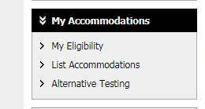

- If the instructor has completed an Alternative Testing Agreement for your class, you will see the class listed in the drop-down menu under Faculty Alternative Testing Agreement(s).

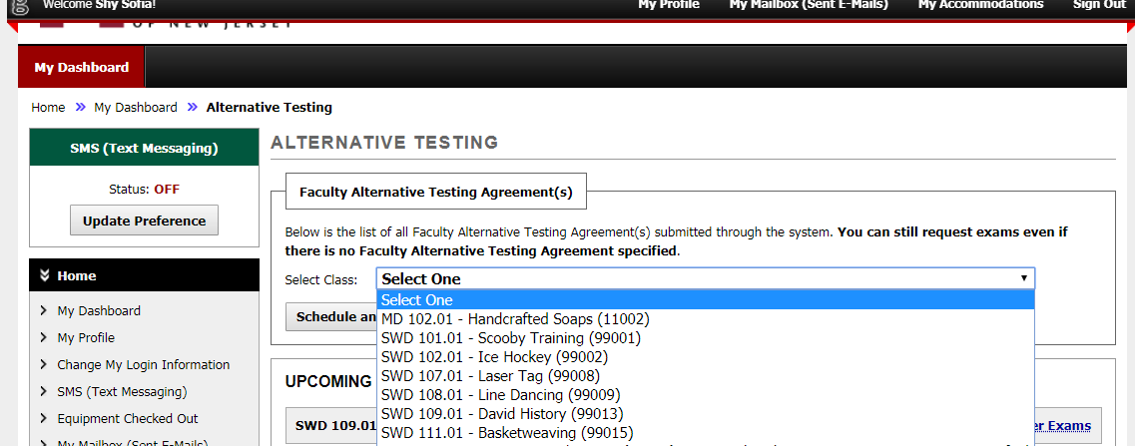

- Select the class that you want to schedule testing for and click Schedule an Exam.

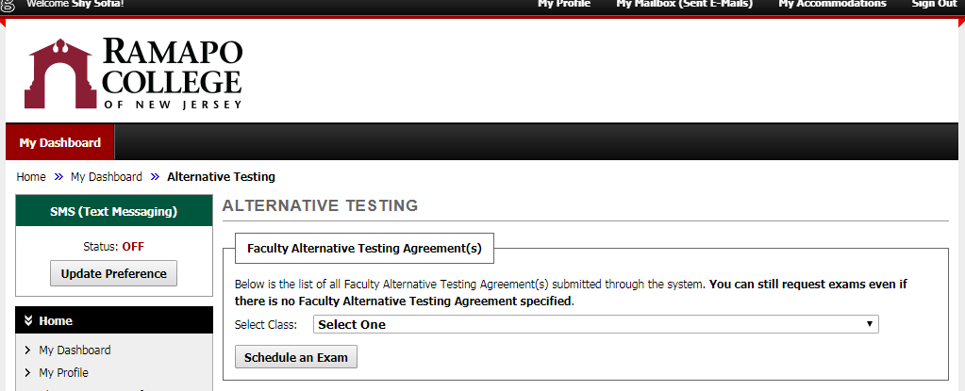

- Next, choose the type of testing you wish to schedule: Exam/Test, Final, or Quiz. Select where you take your exam and the date and time you'd like to take it. Check the boxes for the services you are requesting for this exam and click the Add Exam Request button

[TIP: Check with your Professor the type of exam and the length of time that the class will be receiving. This will help you when scheduling for your exam so that there is no overlapping exams or interference with any other of your courses]
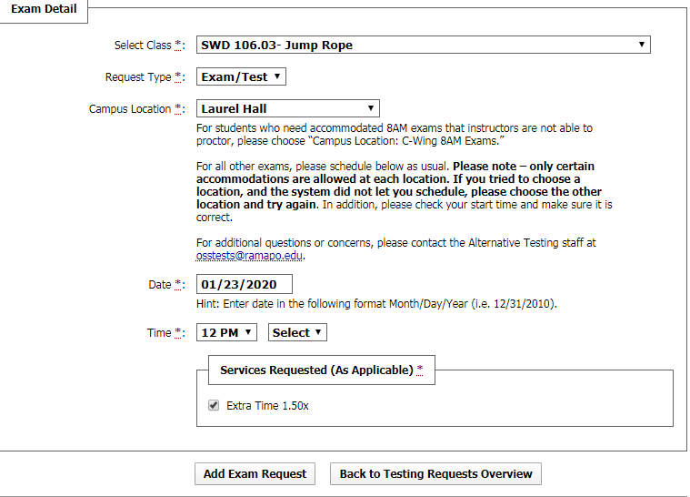
- You will receive an automated email confirmation that your request has been submitted and is being processed by Alternative Testing Staff. If you do not receive an automated email, then your exam request was not successful and you will need to redo it. [TIP: You can view your exam request on your OSSOnline account]

- You can view and check the status, modify or cancel your exam request at any time by logging into the OSS Online Services portal and clicking Alternative Testing under My Accommodations [TIP: Please modify and/or cancel any exam requests in advance - preferably several business days in advance of your testing reservation]

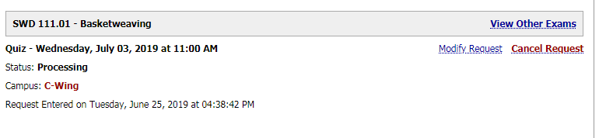

- For more information and help with alternative testing accommodations, please check out our website, or e-mail us at osstests@ramapo.edu . Sending a screen shot of any exam request problems are extremely helpful and allow OSS to offer the best guidance to you.

