**Requesting Your Accommodation Letters through OSSOnline**

**NEW:** You can now make an electronic request for your accommodations letter through OSSOnline. This is a good idea if you have a testing accommodation you plan to use early in the semester.

**Important!:** *You should* ***still set up an appointment*** *with your OSS Advisor as certain accommodations require an in person/phone consultation and additional forms before being processed.*

To request your accommodation letter through OSSOnline, please complete the tasks below:

**Step 1:** Log into OSSOnline (found on the OSS Website: [https://www.ramapo.edu/oss/)](https://www.ramapo.edu/oss/)

**Step 2:** If you see *Action Required* - **Alternative Testing: Student Agreement.** You must click the link and sign the form. The agreement highlights your responsibilities for alternative testing.  Once you sign and submit the form, Please move to Step #3 below. You **will not** be able to access any of the steps below if you have not completed the Action Required - Alternative Testing: Student Agreement]

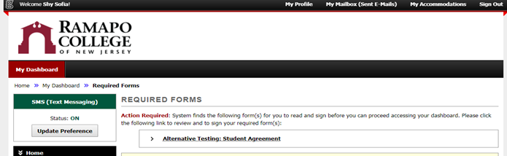

**Step 3:** Next, you will see your classes for the current semester. Select **only** the Class(es) for which you will need your approved accommodations for and then click the Continue button.

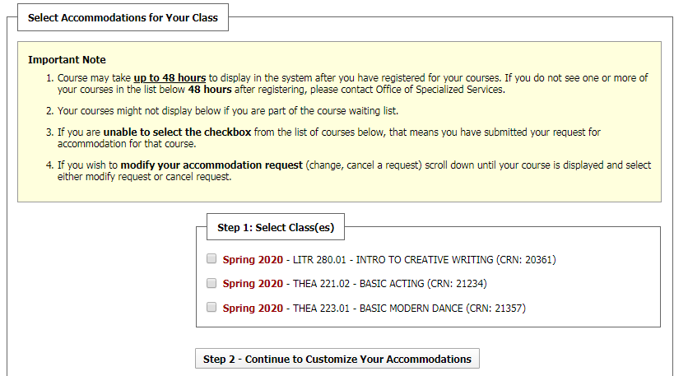

**Step 4:** Each selected class will be listed with the available accommodations. Click each box for the accommodation that you wish to apply for that course and **Click “Submit”**.

[Note: If you are not sure that you will need a certain accommodation as it is too early in the semester or if you have not attended class yet, then don’t select it. You can always select that accommodation later after meeting with your OSS Advisor.]

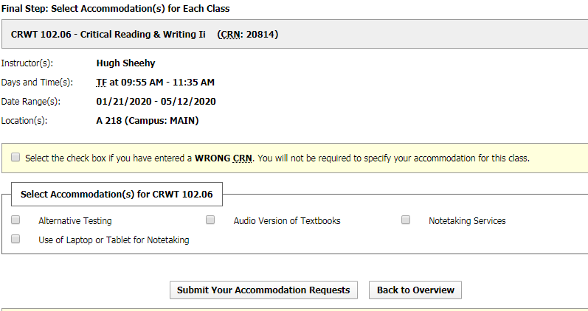

**Note:** Once you submit your accommodation request, it will be reviewed and processed by your assigned OSS Advisor during regular business hours.

***For certain accommodations*** (i.e. notetaking), a meeting or phone consultation with your OSS Advisor needs to take place prior to approval – so set up those appointments through Connect.

Once your accommodation letter is processed, you will be able to print a PDF copy from OSSOnline.

**For assistance with your accommodation letter**: Please meet with your OSS Advisor.