OSSOnline Instructor Portal
NEW: Through the OSSOnline Instructor Portal, you can now:
- View a list of all students with requested accommodations in your course(s)
- Search and sort students by course
- View the Academic Accommodations Notice for students
- Complete and view the Faculty Alternative Testing Agreements for exams proctored at the Testing Center and OSS
- View a list of exam requests made by your OSS student(s) with the ability to upload the exam through a secure and encrypted platform.
Important!: You will still receive students’ Academic Accommodations Notice via email and the Notices will continue to contain a link for the corresponding Faculty Alternative Testing Agreement.
To Access the Instructor Portal: Log into the portal through the OSSOnline Login – Instructors button on the OSS website https://www.ramapo.edu/oss/
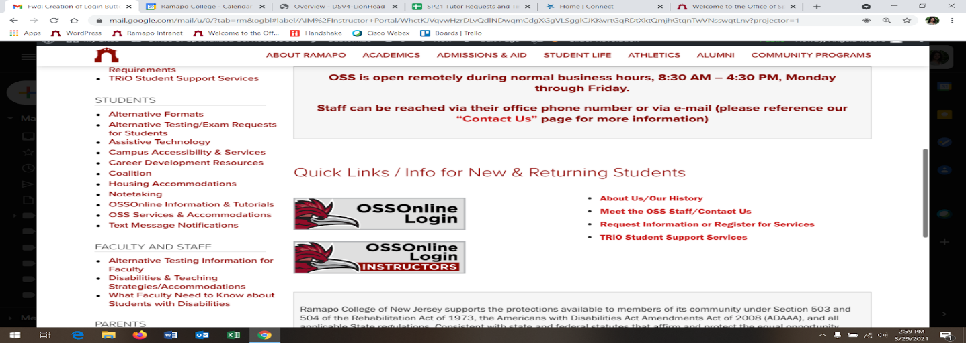

Next: Review the Instructor Authentication page and click Continue to View Student Accommodations
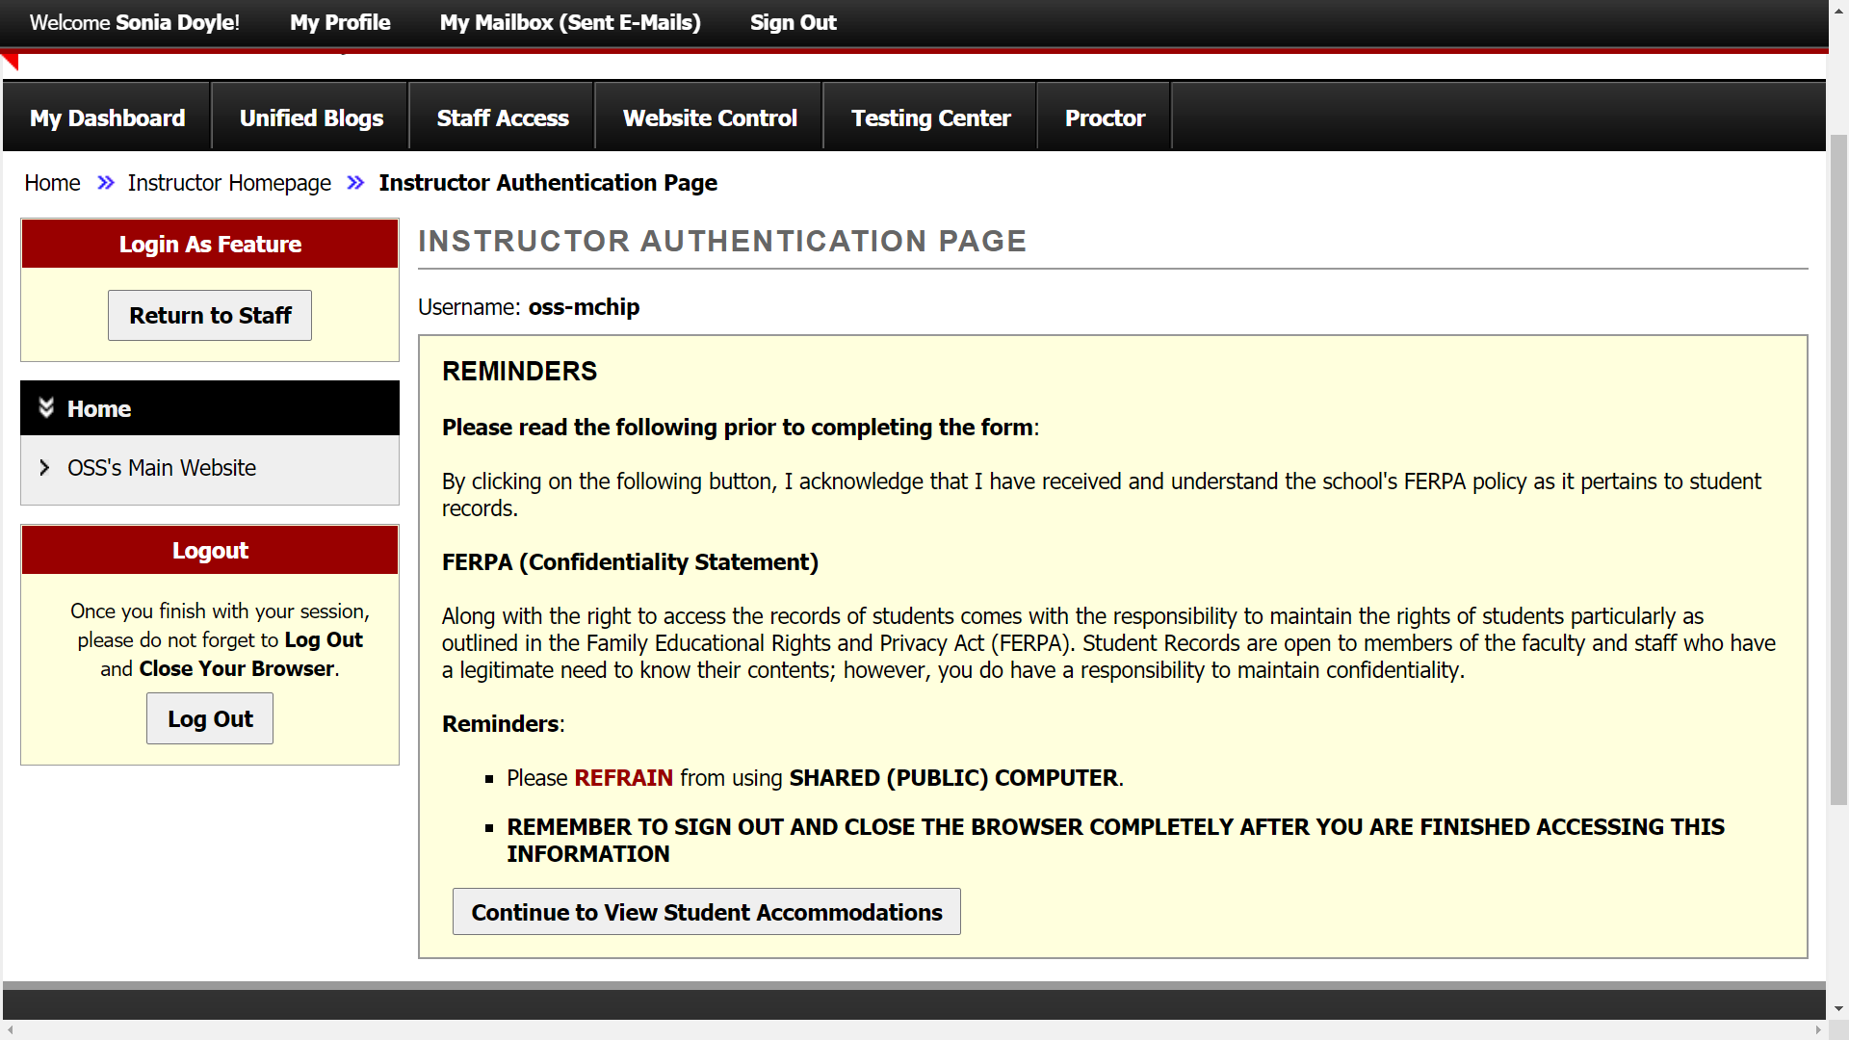

Academic Accommodations: You will see the List of Students who requested accommodations for all of your current semester courses. Click View to access the Academic Accommodations Notice for an individual student. Reminder: The notice will list the assigned OSS Advisor and contain the Faculty Alternative Testing Agreement Link.

Alternatively, you may export an excel spreadsheet of the list of students with their approved accommodations and other pertinent information.
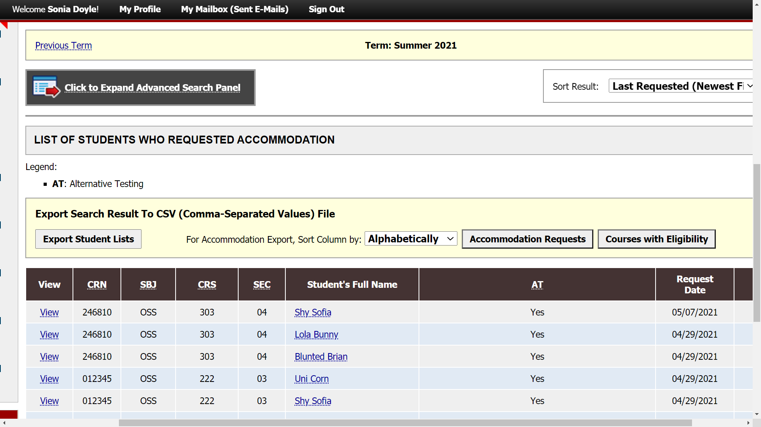

Want to view the list by course? Click to Expand Advanced Search Panel, enter your course info and click search.
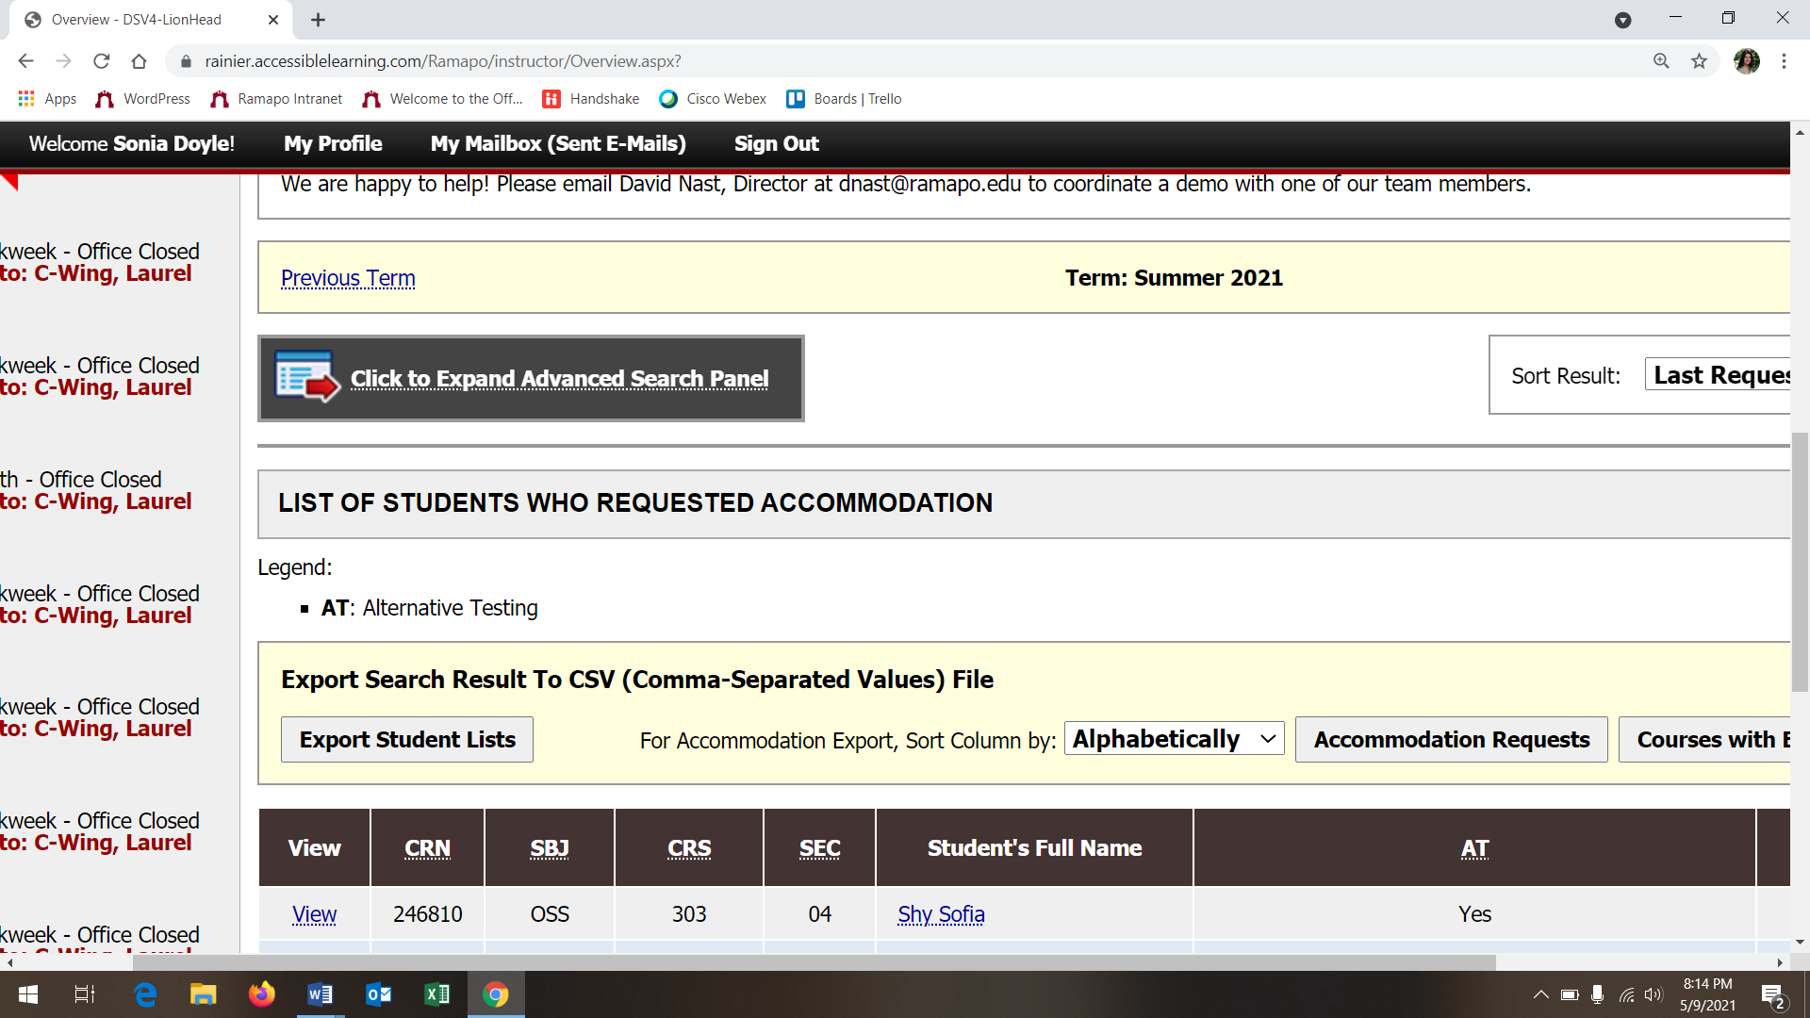

Alternative Testing: This section of the portal will allow you to complete, review and/or update the Faculty Alternative Testing Agreement(s) for each of your course. If you have more than 1 course section, you may copy the content of a completed agreement to the other course section.
You will also be able to view any approved exam reservations, completed exams and have the ability to upload your exam securely through the portal.
Click Alternative Testing to enter the portal’s alt testing page.
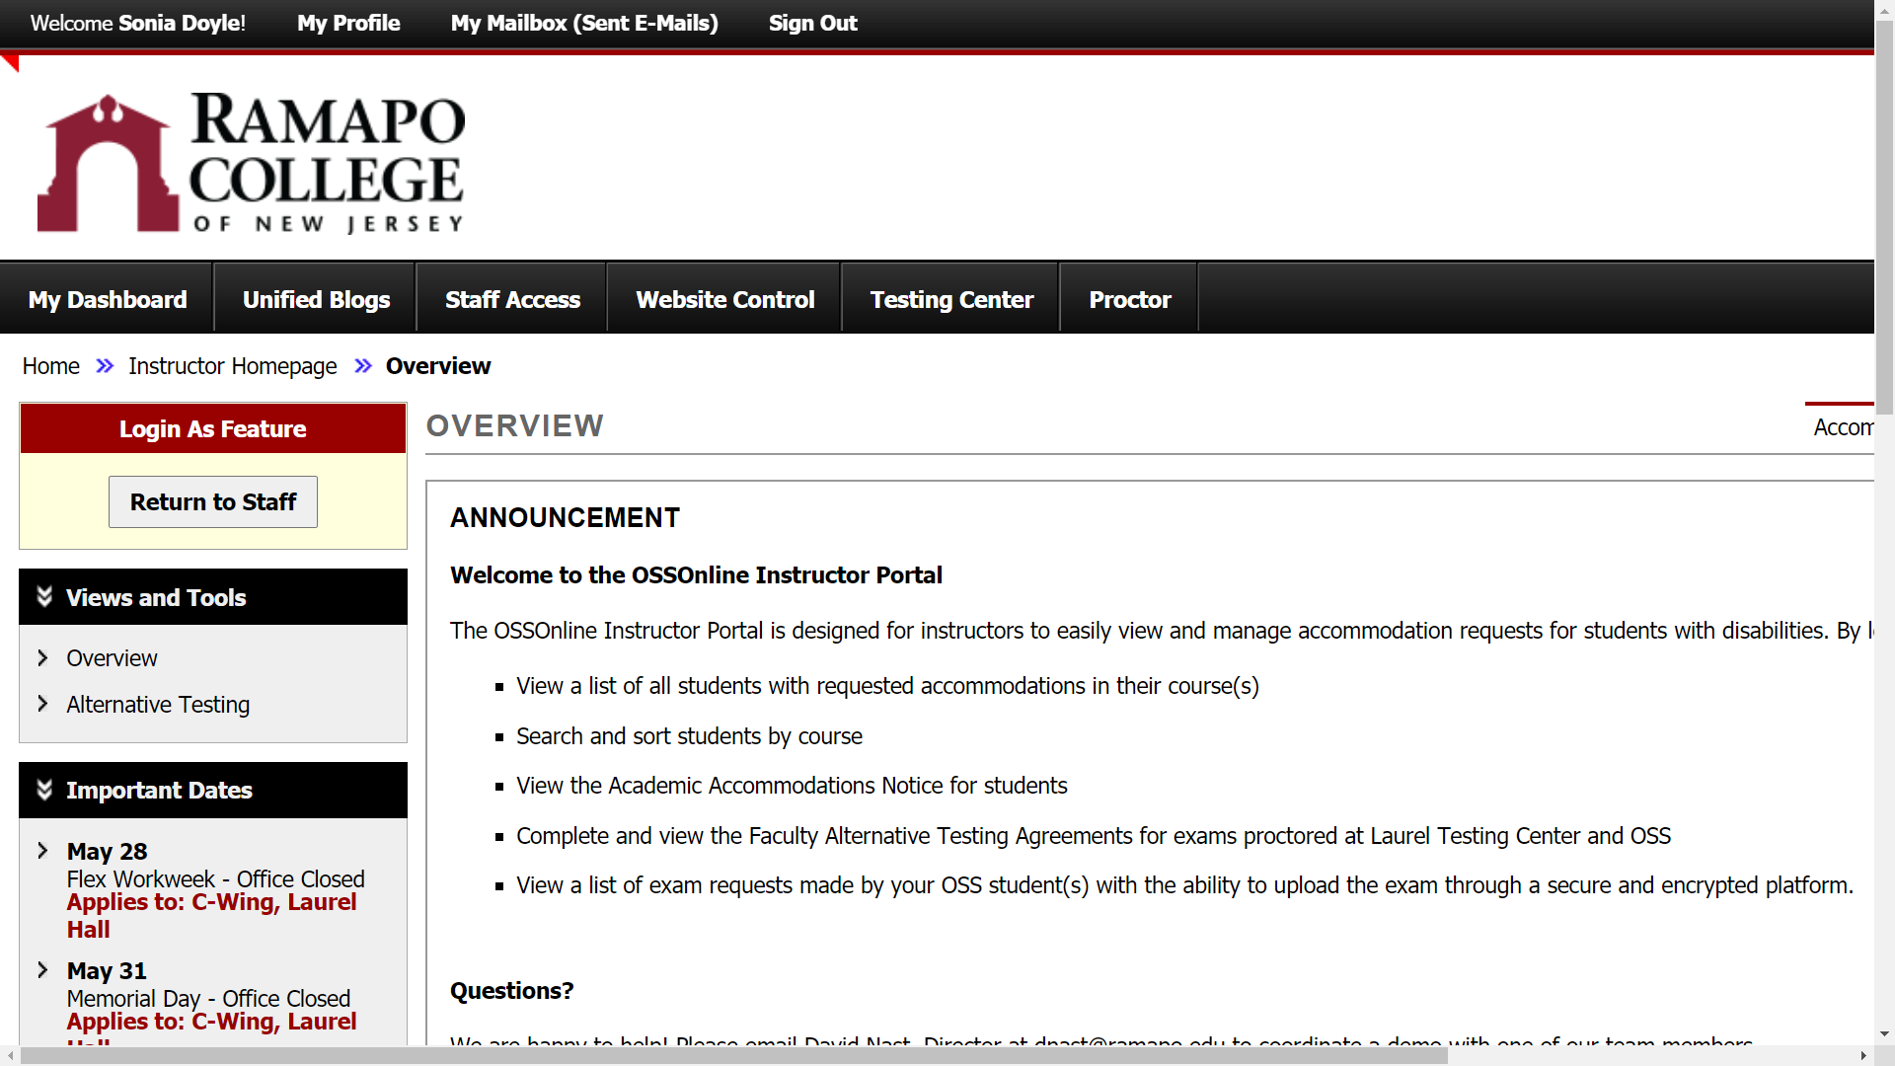
For On Campus Exams that need OSS Proctoring: Select the class and click Continue to Specify Alternative Testing Agreement. This will bring you directly to the Faculty Alternative Testing Agreement Form.
If you Plan to Proctor the OSS student directly, have a virtual/online class or if you have no exams, then select the course and make the corresponding selection within the drop down option under Type for your corresponding class in the Proctoring Your Own Exam Box and click Confirm. You and the OSS student(s) will receive an automated email regarding this.
*You may modify this selection and complete the Testing Agreement through the Instructor Portal at any point in the semester*
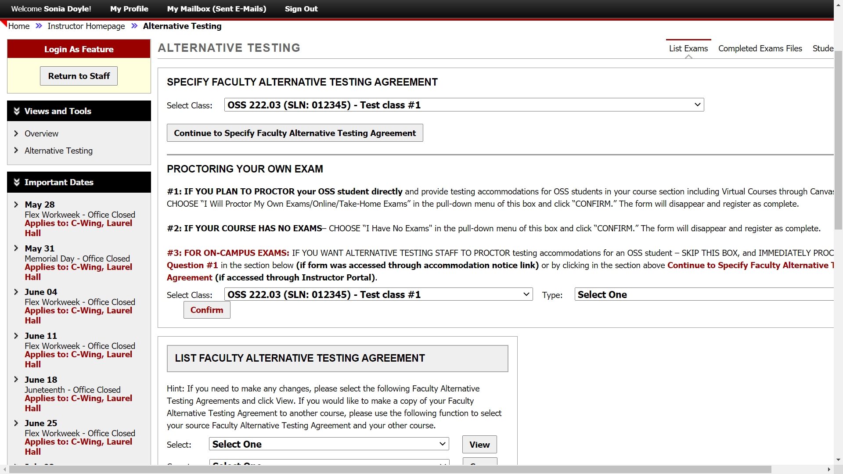
Faculty Alternative Testing Agreement: The form consists of different areas specifying testing conditions for your exam, dates and length of class time for your exams and how OSS can contact you. Upon clicking Submit at the end of the form, you will receive an automated email with a copy of the agreement. Any errors or future updates can easily be made through the Instructor Portal.
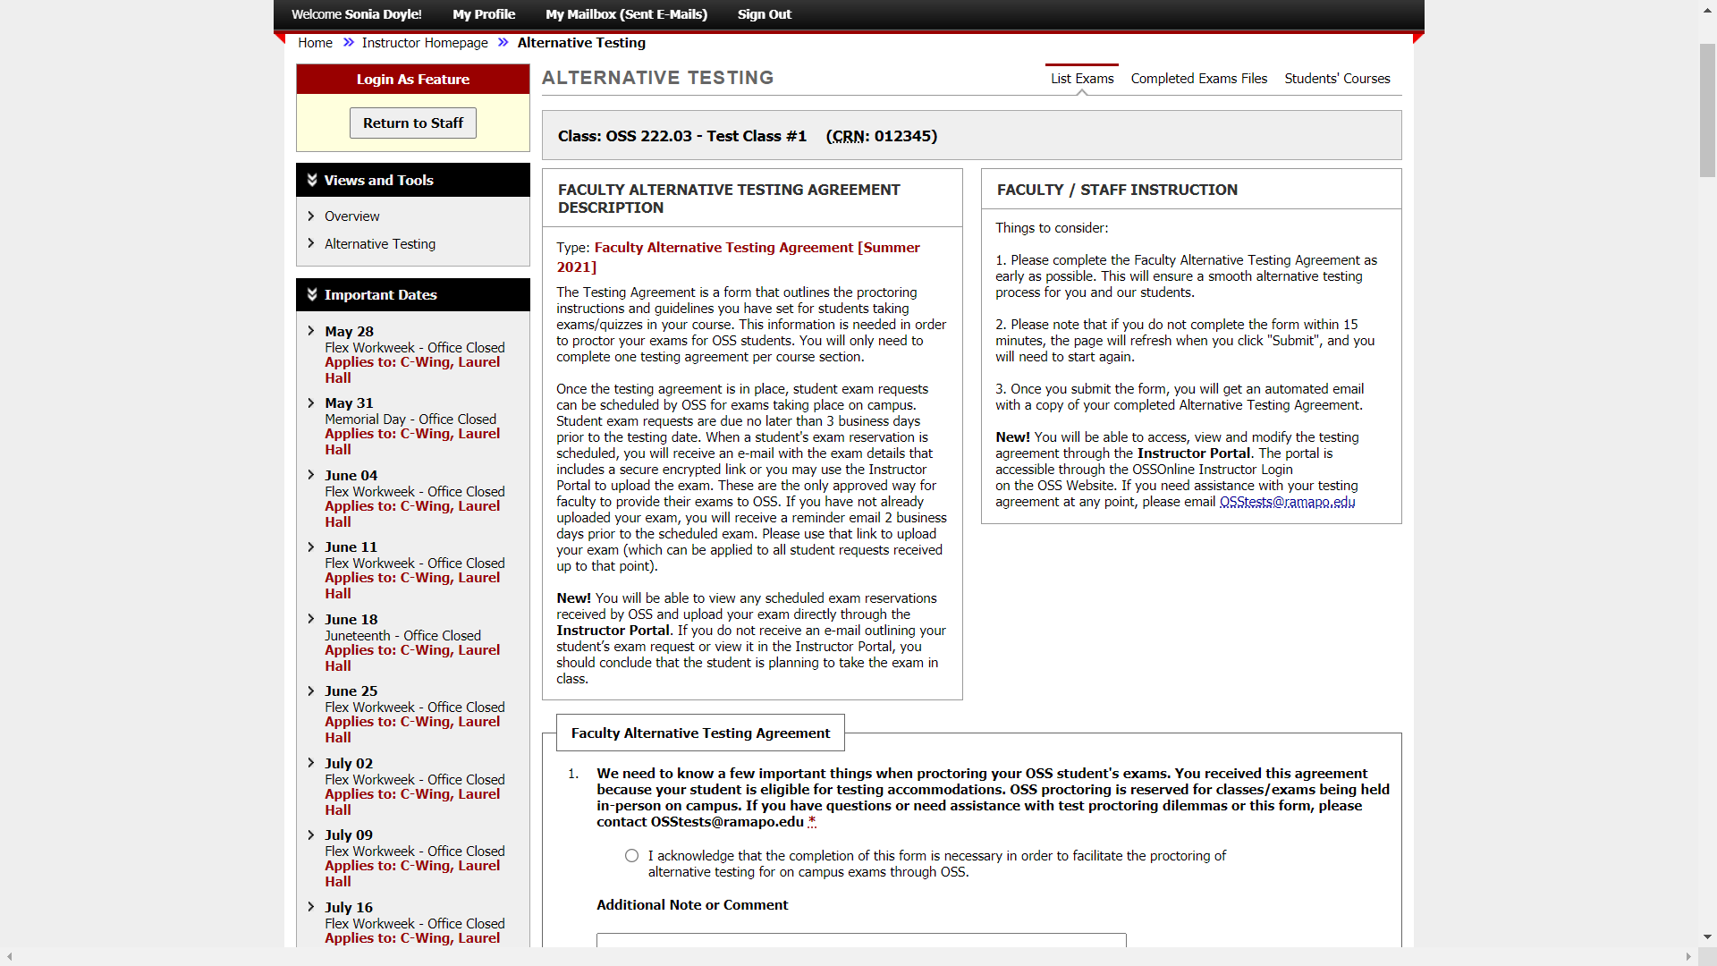
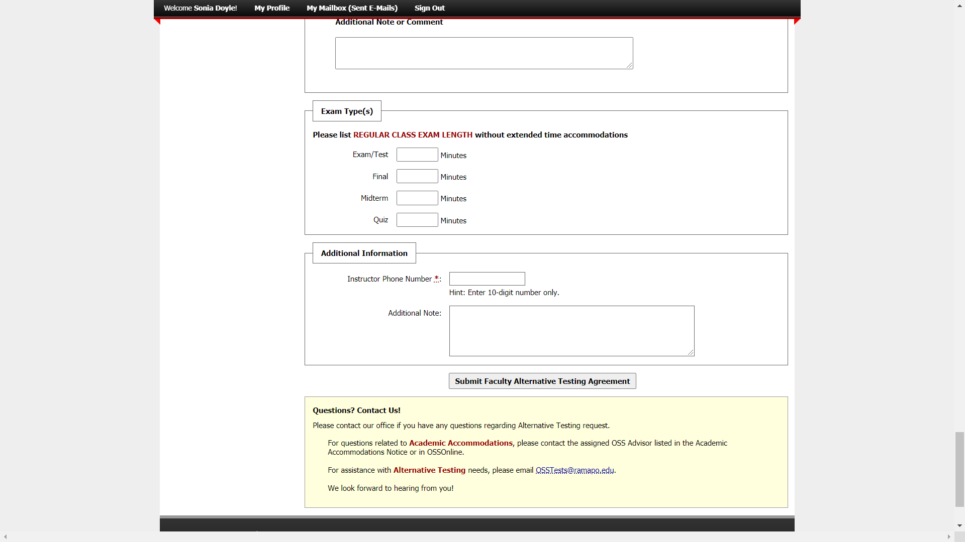

Looking to complete the Faculty Alternative Testing Agreement and don’t see your class listed in the drop down option? If your course is not listed, scroll down to see if an exam reservation was already submitted with no testing agreement in place – there will be a section highlighting the student, exam reservation and the status of the Testing Agreement from which you can access and update the form directly.
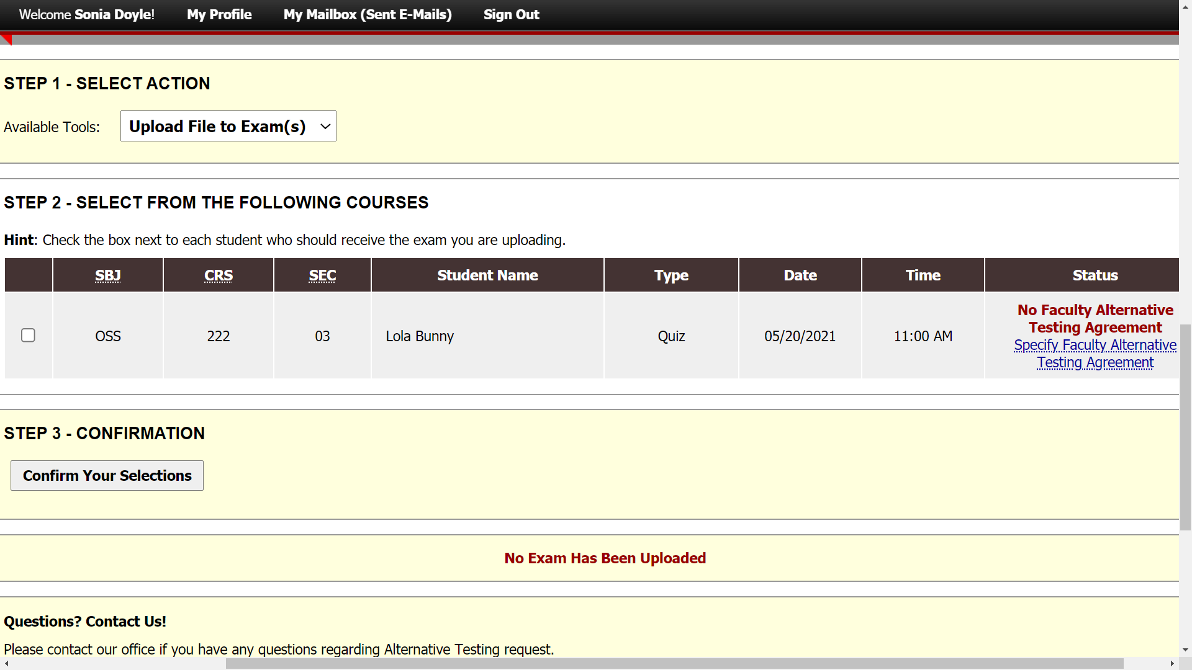

Wish to view your completed Testing Agreement? Within the Alternative Testing page, you can view the completed testing agreement, make updates and/or revise Exams Proctored by Instructor etc.
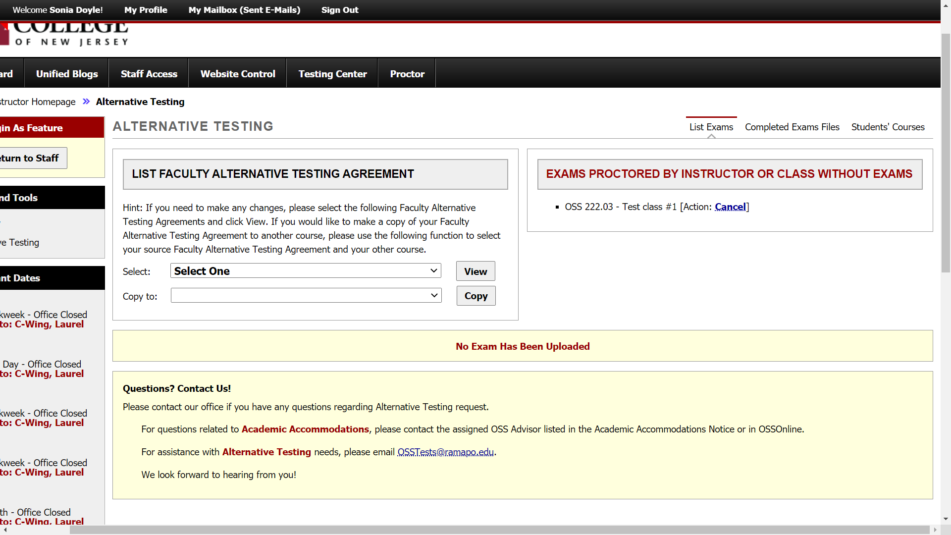

Alternative Testing – Exam Feature: You will be able to view exam reservations received by OSS that are being processed or approved for all your courses. [You will still receive an automated email when an exam reservation has been approved by OSS with the secure exam upload link]. To view the details of the exam reservation and the student’s approved accommodations, click View Detail.
Exam Upload: You may upload your exam securely through the Instructor Portal. Step 1 will indicate the available tool for the upload. To apply the same exam to more than 1 student reservation, check each reservation box. Then, click Confirm Your Selection.
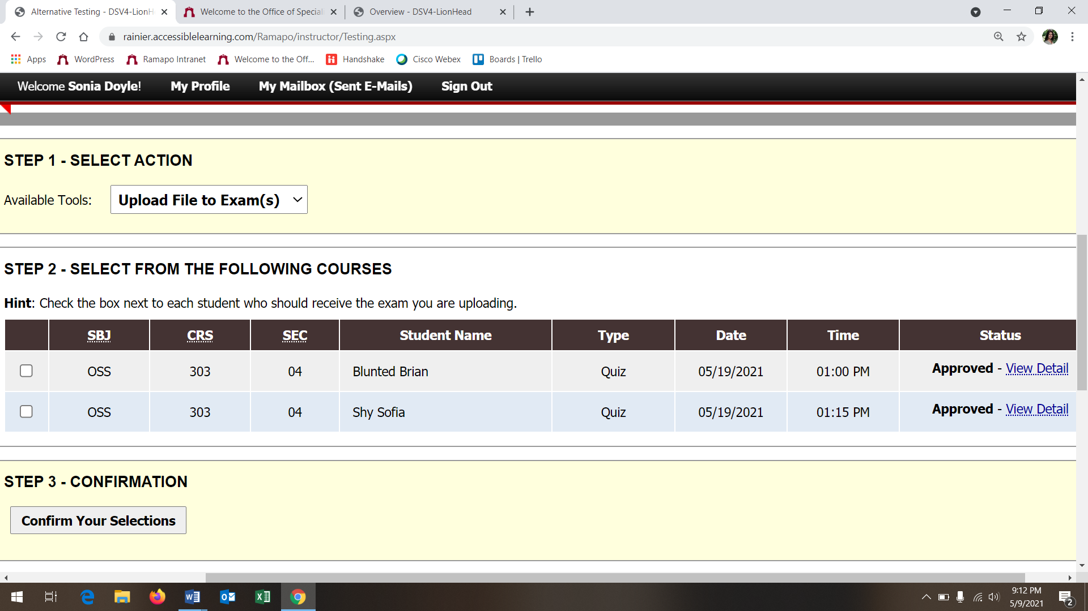
Exam Upload Continued: This will take you to the exam upload page, where you can submit your exam and enter any notes for the Proctor.
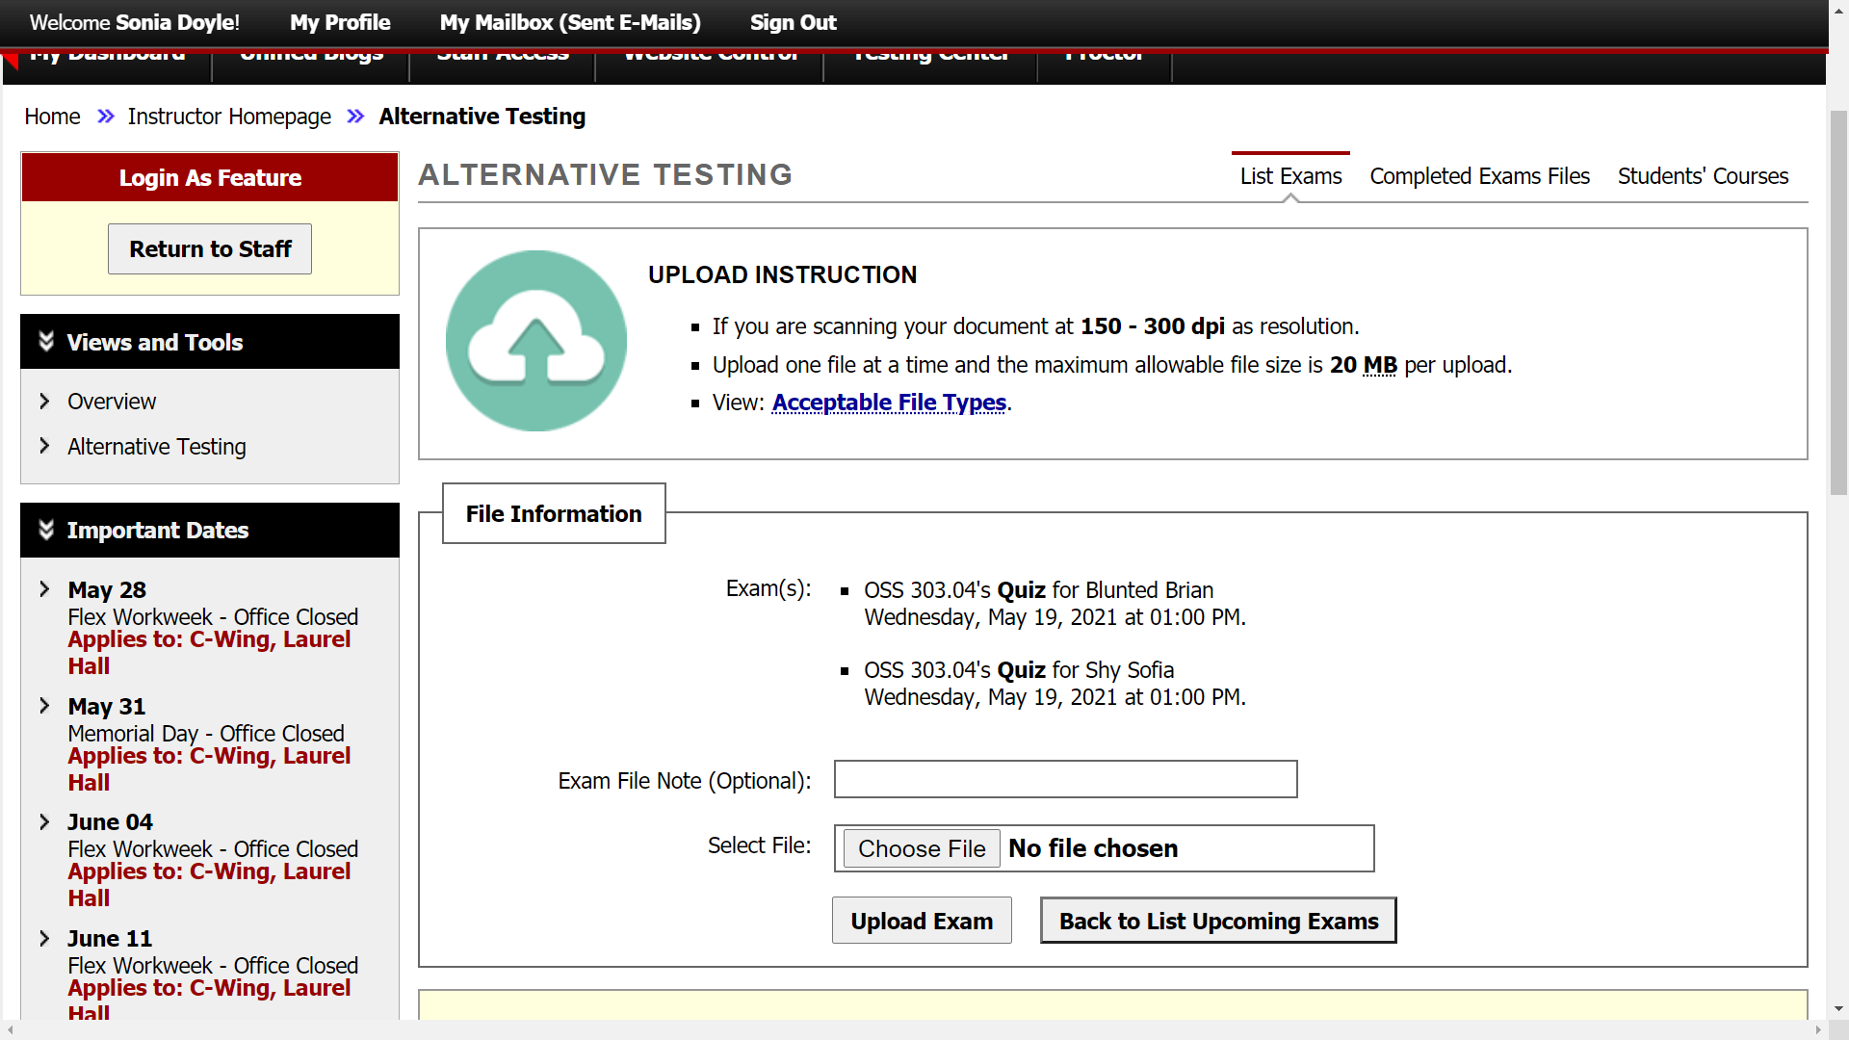
Green Checkmark = Successful Upload
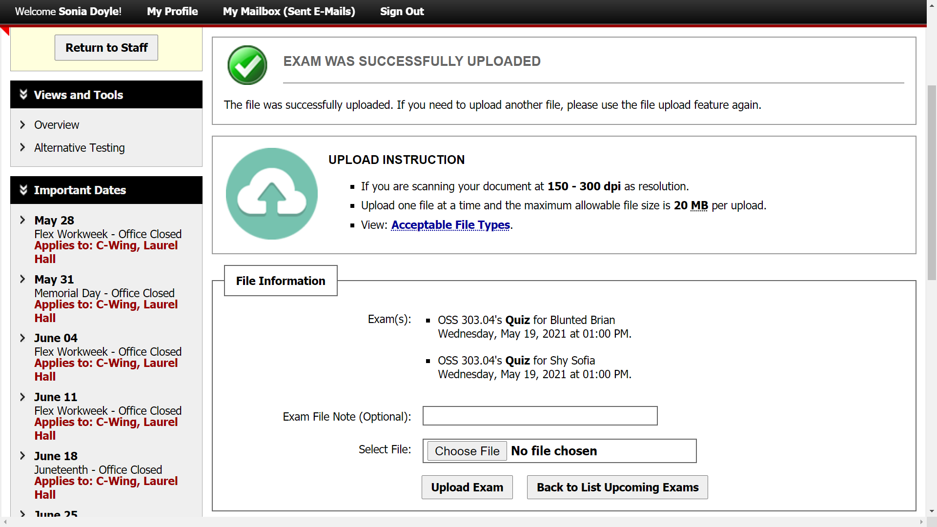

Tip: If you click Alternative Testing tab (on the left hand side), you will return to the Alternative Testing page and view the upload. You can make any modifications if needed.
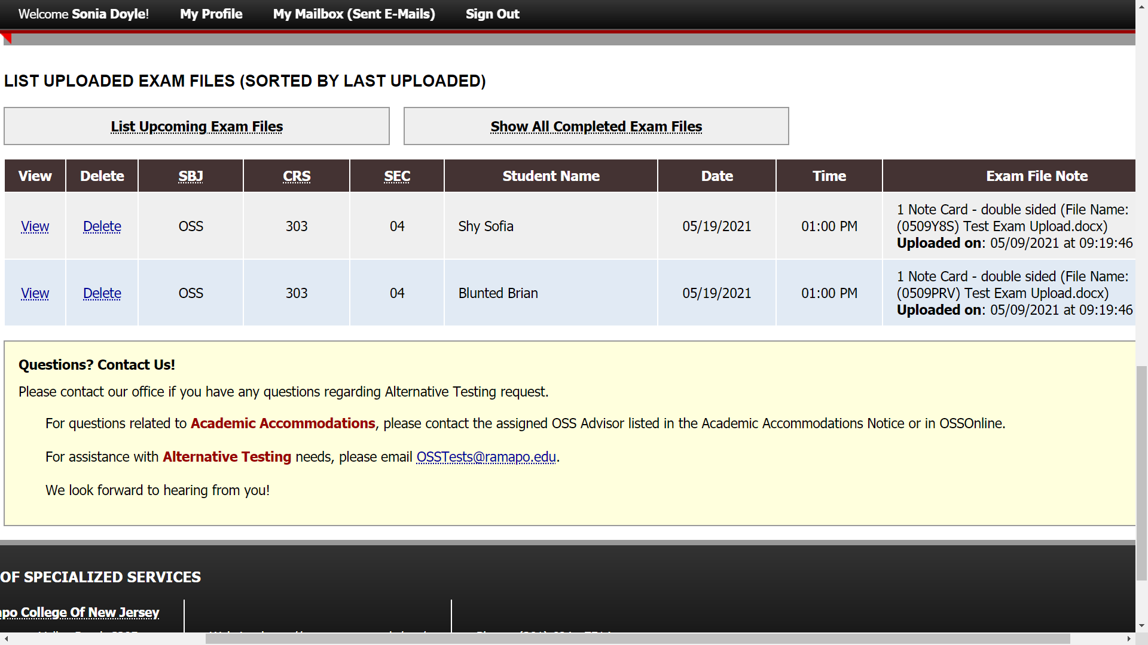

Alternative Testing – Additional Feature: You may view completed exams by clicking Completed Exam Files. Students’ Courses will list students who have requested accommodations and who have completed exams with OSS.
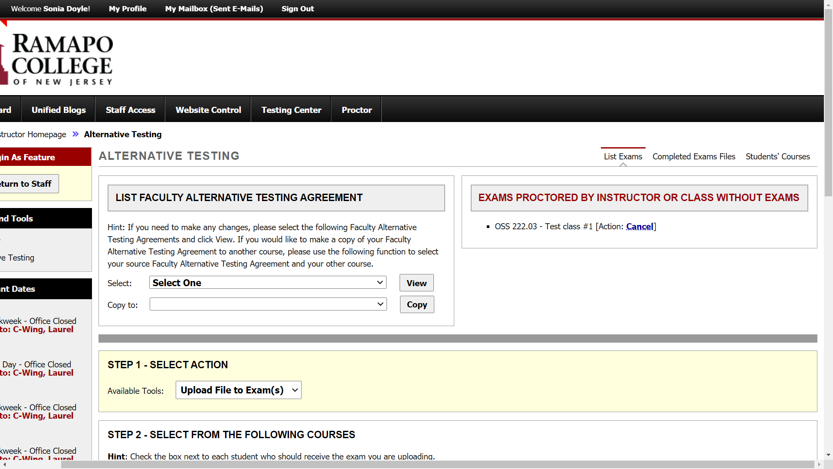

Questions?
We are happy to help! Please email David Nast, Director at dnast@ramapo.edu to coordinate a demo with one of our team members.

