Submitting Timesheets as a Student Employee

Background
This procedure will explain how to submit a timesheet as a Student Aide using the Banner Self‐Service 9 upgraded module. Students enter the hours they worked or sick time used on their time sheets.

Steps
1. Log into RCNJ Experience at https://experience.elluciancloud.com/rconj/

2. Log in using your Ramapo credentials. Note: username does not include @ramapo.edu

3. On the Home screen click the OPEN EMPLOYEE DASHBOARD in the Employee Self-Service card

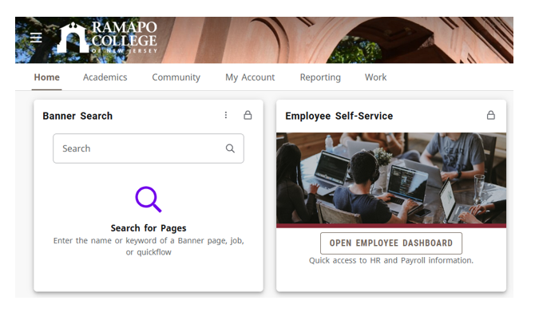

4. From the Employee Dashboard, locate the Enter Time box on the right side of your screen

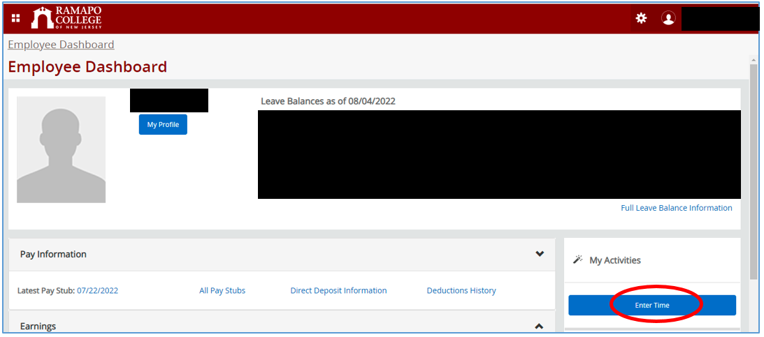

5. Locate the position for which you need to enter time. Click the Start Timesheet button to begin.

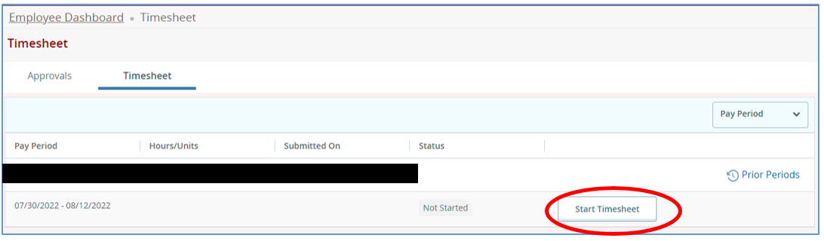

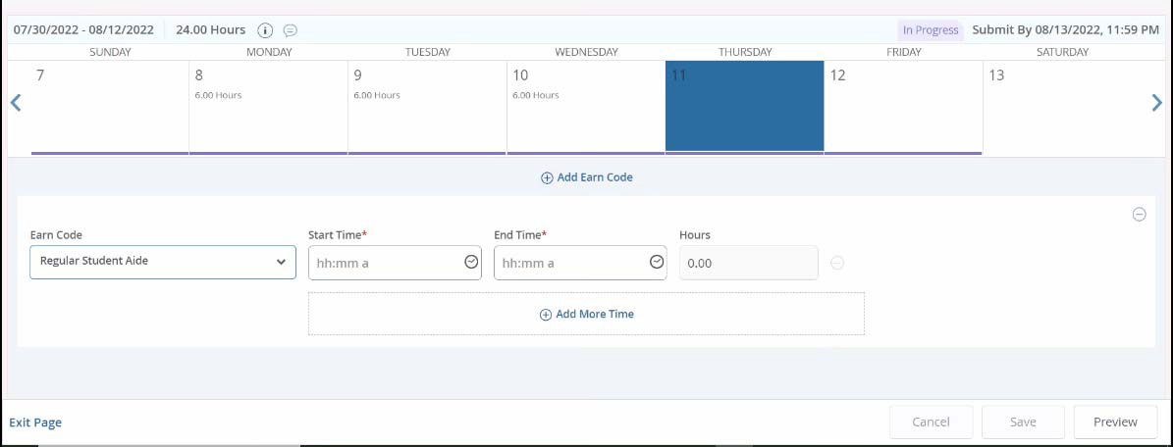


6. Click on the day for which you need to enter the hours you worked or the hours you took off as sick. The day will turn blue, shown below. Make sure the correct day is highlighted before entering hours. Note: to go to a different week within the pay period, use the arrow keys on either side of the calendar.

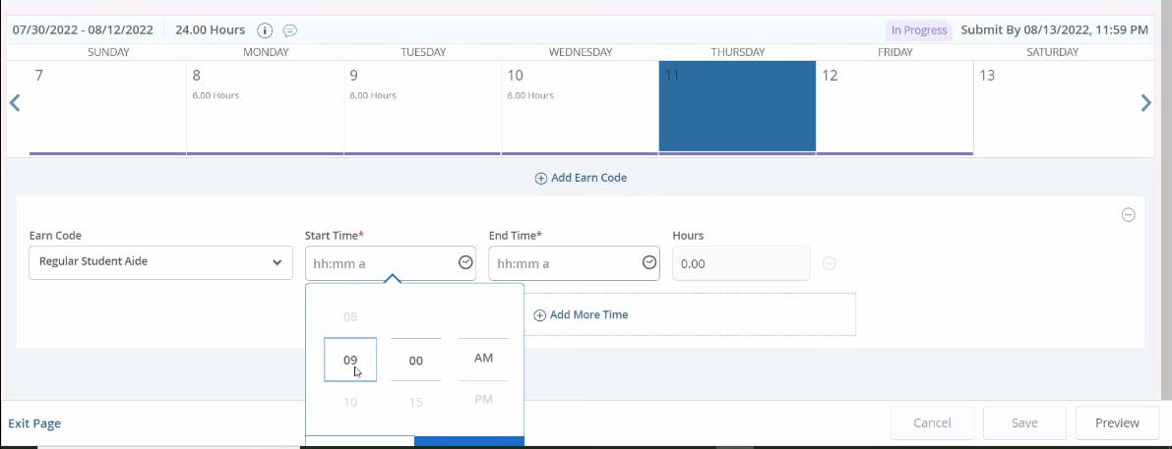


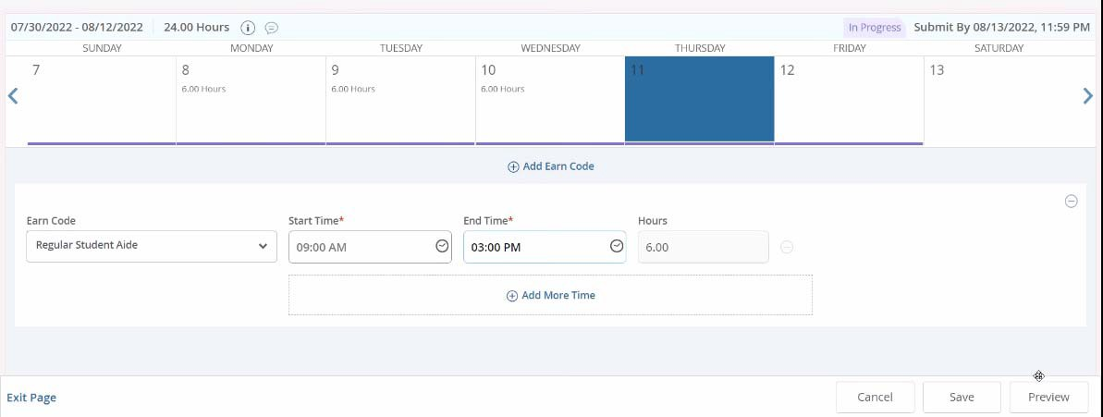
7. The Earn Code for entering normal hours worked is Regular Student Aide. Click on the clock to begin entering your start time for the day. Be sure to choose the correct AM/PM indicator! Then, click Set to set the time. Do the same for the End Time. The Hours field will populate automatically.

a. Note: If you need to split the hours (to express a break within the day, ex: 9 am to 12 pm and 1 pm to
3pm), click Add More Time and add the hours.

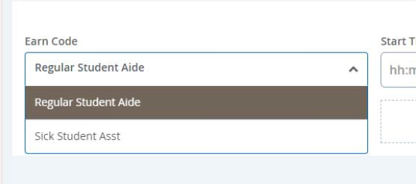
b. To enter sick time, change the Earn Code drop down menu to Sick Student Asst. Be sure you have enough hours earned to put in sick time.

8. Click Save after each day for which you enter hours. You should not move onto another day until you have clicked Save on days for which you have added time. Otherwise, your changes will not be saved.

9. Repeat steps 7‐9 until you have entered all the time you worked/any time you took off sick. You can also copy time from one day to multiple days by selecting the paper icon, choosing the days you want to copy the hours to, and clicking Save. If you select Copy, you will have the option to select "Copy to the end of pay period" or select each day individually. It is recommended you select each day individually to ensure time entry accuracy.

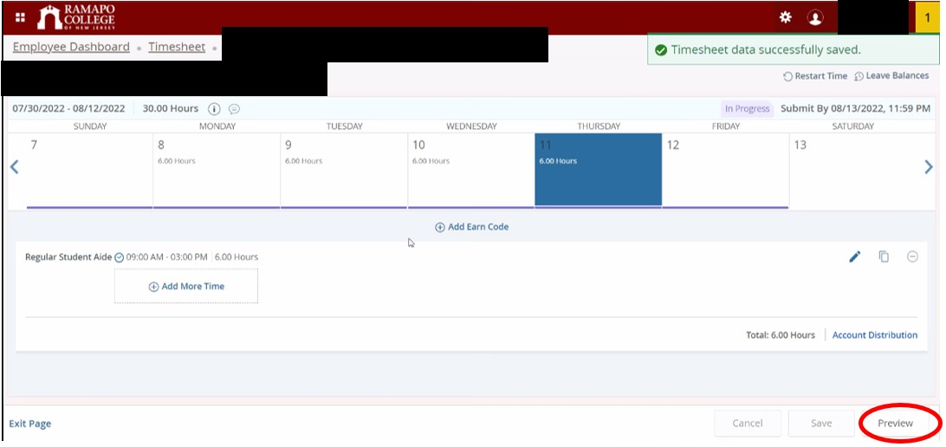
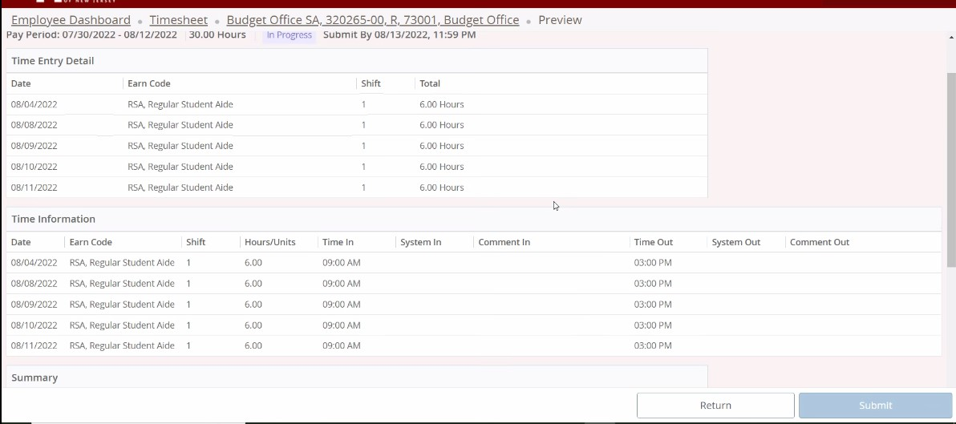
10. Once all the hours have been added & saved, click Preview

11. This will show you a preview/summary of the time you entered. Check everything over and make sure the time you entered is correct/accurate. Note: Your supervisor is not able to edit your timesheet or enter time on your behalf, and it is your responsibility to make sure the time entered is accurate.

12. Once everything has been checked, scroll all the way to the bottom of the Preview page and look for a checkbox that states “I certify that the time entered represents a true and accurate record of my time. I am responsible
for any changes made using my ID.” Without checking this box, you cannot submit your timesheet for approval. Check the box, then click Submit

You have now submitted your timesheet for approval.

Additional Notes:

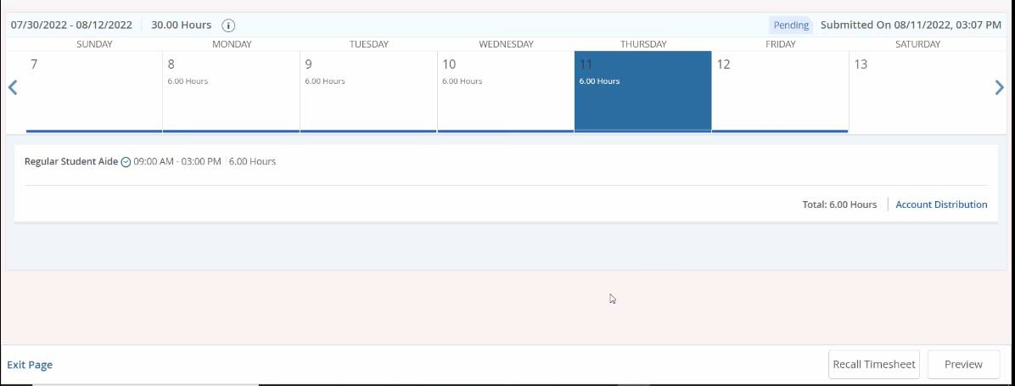
• After submitting your time, your timesheet will now go into a “Pending” state until it is approved. In this state, you are able to recall your timesheet and make changes if necessary until the timesheet is approved. In order to recall your timesheet, go back into the timesheet and click Recall Timesheet. From there, you can make any changes needed. You will need to Preview, Certify & Submit your timesheet again once those changes are made.

• Once the timesheet is approved, no more changes can be made. For any issues regarding time entered & approval on a timesheet, please contact Payroll.

