FOR IMMEDIATE RELEASE
Press Release: February 2, 2023
Contact: Brittany Williams-Goldstein, College Spokesperson
bwillia1@ramapo.edu, (201)684-7609
Follow #RCNJ: Facebook | Twitter | Instagram
Visit ramapo.edu/news for this press release and more Ramapo College news.

Ramapo College and CCM Sign New Jersey’s First
Data Science Transfer Agreement
A Pathway to Earning a Master’s Degree in Five Years at a Reduced Cost

(MAHWAH & RANDOLPH, NEW JERSEY)- 2023 kicked off with the following declaration from Tech Crunch magazine: "Data science is perhaps the most exciting area in all of enterprise technology right now, and it’s evolving at a lightning pace." Recognizing the significance of this dynamic industry, Ramapo College of New Jersey and County College of Morris (CCM) have joined forces to create pathways for aspiring data scientists to earn a master’s in data science in as little as five years.

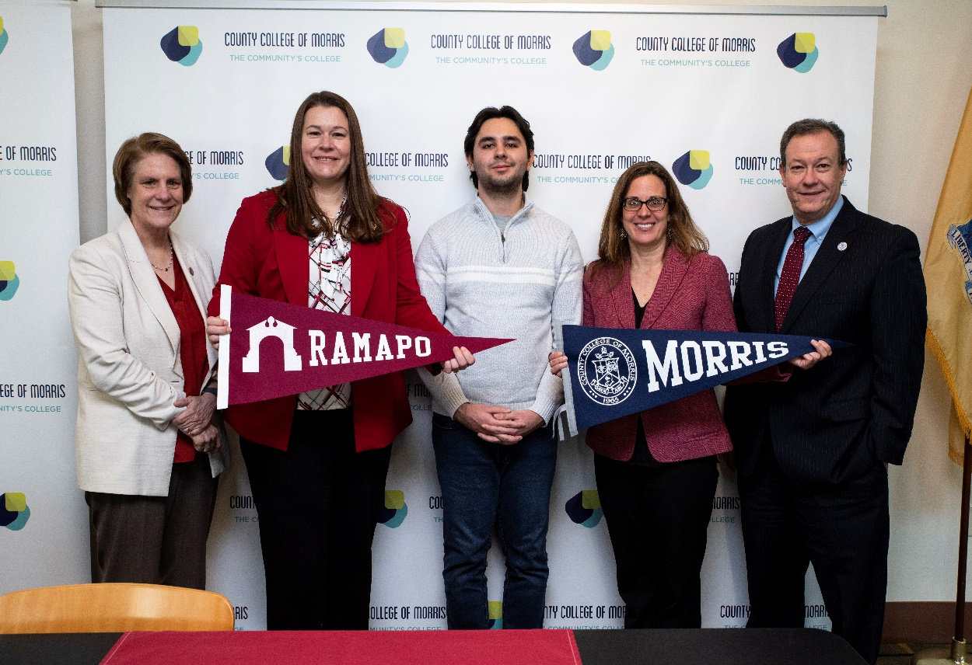

(l-r) Dr. Cindy Jebb, president of Ramapo College; Ramapo Professor of Mathematics Amanda Beecher; Thomas Ortega, Data Science student at Ramapo; CCM Professor of Mathematics Kelly Fitzpatrick; and Dr. Anthony J. Iacono, president of CCM, at the signing of the Data Science Transfer Agreement, the first between a community college and a four-year institution in New Jersey.

The presidents of Ramapo and CCM on February 1 signed a Data Science Transfer Agreement, the first between a community college and a four-year institution in New Jersey. Known as a 2+2+1 agreement, the partnership will allow students to begin their education at CCM to earn their associate degree and then seamlessly transfer to Ramapo to earn their bachelor’s degree and then a master’s in data science if they wish.
Thomas Ortega, of Randolph, NJ, a graduate of Morris Hills High School and CCM, is in his fourth year in the 2+2+1 program. Ortega, who also serves as the founder and President of the Ramapo College Data Science Club, shared, “My pathway between County College of Morris and Ramapo College has been a wonderful experience that has provided me with a great start to my data science career. With an engaging faculty, I always feel that I have the support I need to pursue hands-on data science projects.”
“Ramapo looks forward to welcoming more CCM graduates to our data science programs,” said Ramapo College President Cindy Jebb. “Our Center of Data, Mathematical & Computational Sciences, which is home to our data science programs, is at the cutting edge of preparing undergraduate and graduate students to be highly skilled and ethical problem solvers by teaching them how to apply technical and interdisciplinary concepts to real-world challenges."
By taking a number of graduate courses as an undergraduate at Ramapo, the master’s can be completed in one year. By starting at a community college and then earning a master’s in a year, students can enjoy significant savings on their higher education. Students are not required to earn a master’s and can opt instead to earn a bachelor’s only.
“We’re pleased to be offering this opportunity for CCM students to seamlessly continue their data science higher education at Ramapo College so they can take advantage of a wide range of career opportunities,” said Dr. Anthony J. Iacono, president of CCM. “We’re proud to enhance our relationship with such a great institution that also builds upon our reputation as the best community college in the state for transfer students.”
Among the first institutions in NJ to offer advanced degrees in data science, Ramapo's Master of Science in Data Science program is nationally ranked a Top 30 Master’s program by Fortune Magazine, making it the #1 graduate data science program in New Jersey. According to Fortune’s analysis, data science is one of the fastest growing fields due to the increasing volume of data generated every day, which is “creating a steep demand for workers that can harness, analyze and create value from the data available.”

“The path for students to pursue an associate’s, a bachelor's, and even a master’s degree in data science is now seamless,” said Christopher Romano, vice president for strategic enrollment, outreach, and engagement at Ramapo, adding, "Through this agreement with CCM, we are expanding access, and clearly articulating the pathway to allow individuals to pursue careers, and earn continuous credentials, in a very exciting, high-demand, and high-growth industry.”
The strength of Ramapo combined with the strength of CCM, which is nationally rated the Best for Transfer Students in New Jersey by Intelligent, has created thoughtful, accessible, and seamless pathways for students to pursue their studies in this high demand growth industry. With the addition of this data science 2+2+1 agreement, CCM now has more than 170 transfer agreements to ease the process of earning an associate and then a bachelor’s degree.
To learn about the Data Science program at Ramapo, visit https://www.ramapo.edu/dmc/.
To learn more about the Computer Science Program at CCM, visit https://bit.ly/CCMComputerScience.

Ramapo College Contact: Brittany Williams-Goldstein, bwillia1@ramapo.edu, (201)684-7609
County College of Morris Contact: Kathleen Brunet, kbrunet@ccm.edu, (973)328-5052

###
About Ramapo College
Ramapo College of New Jersey (RCNJ) develops responsible leaders who serve as empathetic problem solvers and ethical change agents across all sectors. The College’s unique interdisciplinary academic structure, its liberal arts core, its size (approximately 5,500 students), and its setting in the foothills of the Ramapo Mountains on the New Jersey/New York border provide an optimal environment for individualized, student-centered learning and leadership development. RCNJ’s designation as “New Jersey’s Public Liberal Arts College” by the State legislature is the foundation from which the College’s commitment to an accessible and transformative undergraduate and graduate education is realized.
Graduation and retention rates of RCNJ students exceed national averages and, as just one of many markers of student success, the superior rates are made possible by the College’s provision of impactful mentorship and student well-being supports, hands-on learning, and a range of opportunities for service and leadership development. In fact, Ramapo is ranked #1 among New Jersey public institutions by College Choice and is recognized as the State’s top college on the list of Best Disability Schools by Great Value Colleges. Further commendations include designation as: a “Military Friendly College” in Viqtory Media’s Guide to Military Friendly Schools, and as a leading college by U.S. News & World Report, Kiplinger’s, Princeton Review, and Money Magazine, among others.
Established in 1969, CondeNast Traveler named Ramapo as one of the 50 Most Beautiful College Campuses in America. The barrier-free campus occupies 300 acres and is home to 52 bachelor’s degree programs spanning the arts, business, data science, humanities, education, nursing, social work, social sciences, and the sciences. In addition, the College offers graduate programs leading to master’s degrees in Accounting, Applied Mathematics, Business Administration, Contemporary Instructional Design, Computer Science, Creative Music Technology, Data Science, Educational Leadership, Nursing, Social Work and Special Education, as well as a Doctor of Nursing Practice. Every degree program is designed and delivered through the collaborative and interdisciplinary efforts of student-centered faculty scholars and staff who are committed to serving the public good through the delivery of an academically rigorous, inclusive, and transformative collegiate experience.
Distinguished as a Career Development College of Distinction by CollegesofDistinction.com, every student at Ramapo is enrolled in the College’s unique and award-winning Pathways Program which equips and empowers students, across the continuum of their student career, to secure internships, pursue graduate/professional school, and/or enter/re-enter the job market. As a result, Ramapo College’s over 40,000 alumni are confident, intellectually curious, self-aware, and humble people who are highly sought after and who make a positive impact at local, national, and global levels. As community leaders, engaged citizens, and professional colleagues, Ramapo College alumni serve as the change agents necessary to innovate, problem solve, and elevate the human condition in NJ and beyond.

