RAMAPO COLLEGE OF NEW JERSEY
Press Release: January 20, 2023
Contact: Brittany Williams-Goldstein, College Spokesperson
bwillia1@ramapo.edu, (201)684-7609
Follow #RCNJ: Facebook | Twitter | Instagram
Visit ramapo.edu/news for this press release and more Ramapo College news.

Ramapo College Serves Up Hunger Relief
MAHWAH, NEW JERSEY – The State of New Jersey recently recognized Ramapo College for its all hands-on-deck approach to meeting the needs of its students. The State awarded the College a $51,000 Hunger-Free Campus Grant in recognition of its demonstrated success in helping to address food insecurity and expand related resources and student relief efforts.
“We are so honored and pleased to use the awarded grant funds to further student well-being at Ramapo," said President Cindy Jebb. Some of the steps the College will take include adding more bus routes to take students to a local farmer’s market, expanding offerings of food and supplies in its Food Pantry, promoting more healthy food options, issuing gift cards to local supermarkets, and increasing the amount of funds available to subsidize meal costs for students in need.

In 2016, Ramapo College was among the first institutions in the state to begin formally exploring and documenting college student health, hunger, and mobility issues as well as homelessness. At that time, the College’s Student Government Association formed a tight-knit working group and took the lead on identifying potential stakeholders, contributors, and the most essential forms of support to meet the needs of their peers who were confronting such hardships. "In addition to providing our students with much needed resources, this grant award also reaffirms the importance of student leadership at Ramapo and our demonstrable success in developing responsible leaders, empathetic problem solvers, and ethical change agents," Jebb added.
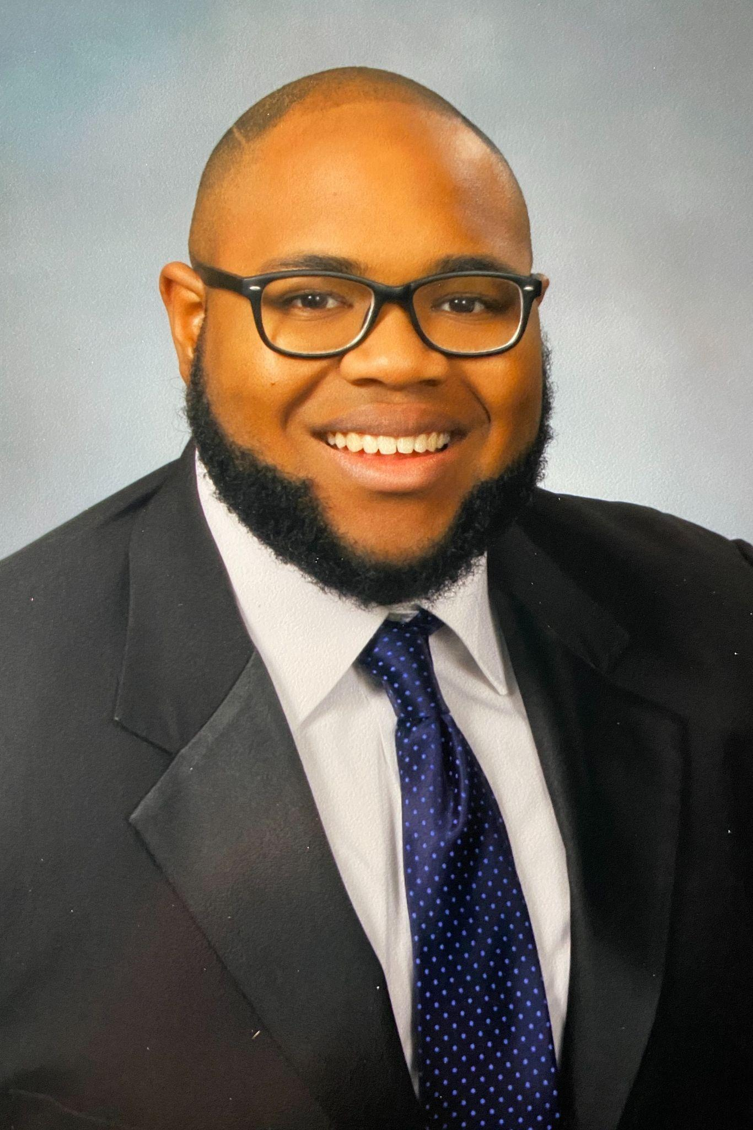
Stephan Lally graduated from Ramapo College in 2020. While a student, Lally served as President of the Student Government Association and was one of the lead architects of the College's student relief efforts during his undergraduate experience. Lally, who now serves as an advisor in the state capital shared, “I am delighted to see Ramapo receive a grant award from the Office of the Secretary of Higher Education’s Hunger-Free Campus Grant Program. This is a product of years of hard work from students, staff, and faculty across the College. The WeCare program is instrumental in helping Roadrunners complete their degrees and this funding will only increase its impact on campus.”

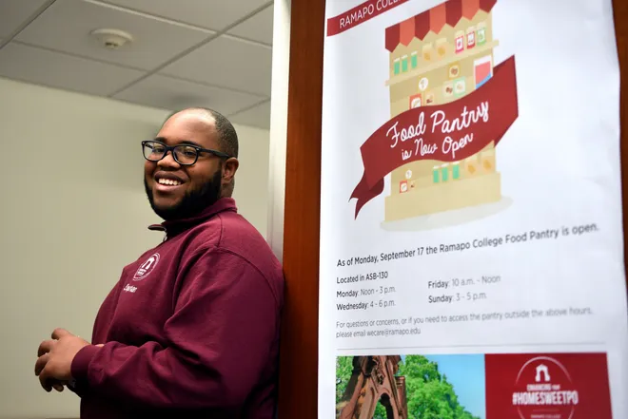
Photo credit: Amy Newman/NorthJersey.com
Stephan Lally ‘20 pictured at the Ramapo College Food Pantry in 2018.

Through an empathetic vision, bold leadership, and broad collaboration with the College’s administration, union leaders, faculty, staff, and donors, the student-led effort quickly attracted the attention of state legislators. In early 2017, Ramapo students were invited to testify as part of the Senate Higher Education Committee and Senate Health, Human Services, and Senior Citizens Committee Joint Hearing to Discuss Hunger Among College Students. Within that same year, the student-led efforts yielded the establishment of the Ramapo College WeCare Program which continues to be an integral part of the College’s holistic approach to addressing student well-being. The WeCare Program is overseen by Melissa Van Der Wall, the College’s Dean of Students/Vice President for Student Well-being, and a team of professionals in the Center for Student Involvement, has grown over the past several years to now include a student financial relief fund, food pantry, clothing closet, and technology/equipment provisions.

“Food insecurity among the college-going population has been on the rise nationally since 2019 and these hardships have only been magnified by the pandemic,” said Van Der Wall. “At Ramapo we know that food insecurity affects the health, well-being, and academic performance of our students, and we are committed to doing all we can to mitigate these challenges by providing our students with the necessary resources and a supportive and safe environment to grow and thrive.”

For more information about how you can support these efforts and Ramapo College students in need, please visit the College’s WeCare Program at www.ramapo.edu/ccec/we-care-program/.

###

About Ramapo College
Ramapo College of New Jersey (RCNJ) develops responsible leaders who serve as empathetic problem solvers and ethical change agents across all sectors. The College’s unique interdisciplinary academic structure, its liberal arts core, its size (approximately 5,500 students), and its setting in the foothills of the Ramapo Mountains on the New Jersey/New York border provide an optimal environment for individualized, student-centered learning and leadership development. RCNJ’s designation as “New Jersey’s Public Liberal Arts College” by the State legislature is the foundation from which the College’s commitment to an accessible and transformative undergraduate and graduate education is realized.
Graduation and retention rates of RCNJ students exceed national averages and, as just one of many markers of student success, the superior rates are made possible by the College’s provision of impactful mentorship and student well-being supports, hands-on learning, and a range of opportunities for service and leadership development. In fact, Ramapo is ranked #1 among New Jersey public institutions by College Choice and is recognized as the State’s top college on the list of Best Disability Schools by Great Value Colleges. Further commendations include designation as: a “Military Friendly College” in Viqtory Media’s Guide to Military Friendly Schools, and as a leading college by U.S. News & World Report, Kiplinger’s, Princeton Review, and Money Magazine, among others.
Established in 1969, CondeNast Traveler named Ramapo as one of the 50 Most Beautiful College Campuses in America. The barrier-free campus occupies 300 acres and is home to 52 bachelor’s degree programs spanning the arts, business, data science, humanities, education, nursing, social work, social sciences, and the sciences. In addition, the College offers graduate programs leading to master’s degrees in Accounting, Applied Mathematics, Business Administration, Contemporary Instructional Design, Computer Science, Creative Music Technology, Data Science, Educational Leadership, Nursing, Social Work and Special Education, as well as a Doctor of Nursing Practice. Every degree program is designed and delivered through the collaborative and interdisciplinary efforts of student-centered faculty scholars and staff who are committed to serving the public good through the delivery of an academically rigorous, inclusive, and transformative collegiate experience.
Distinguished as a Career Development College of Distinction by CollegesofDistinction.com, every student at Ramapo is enrolled in the College’s unique and award-winning Pathways Program which equips and empowers students, across the continuum of their student career, to secure internships, pursue graduate/professional school, and/or enter/re-enter the job market. As a result, Ramapo College’s over 40,000 alumni are confident, intellectually curious, self-aware, and humble people who are highly sought after and who make a positive impact at local, national, and global levels. As community leaders, engaged citizens, and professional colleagues, Ramapo College alumni serve as the change agents necessary to innovate, problem solve, and elevate the human condition in NJ and beyond.

