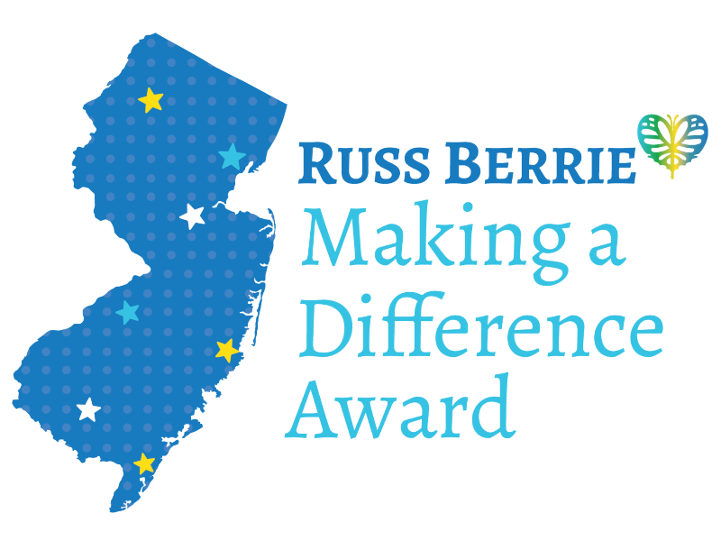

FOR IMMEDIATE RELEASE
Contact: Meredith Lee, Program Director
mlee8@ramapo.edu
(201) 819-3912 (cell)

NOMINATIONS OPEN FOR RUSS BERRIE MAKING A DIFFERENCE AWARD
Nominations for the award for “Unsung NJ Heroes” due February 11, 2022

MAHWAH, NJ – The Russ Berrie Making a Difference Award is accepting nominations for its award for “Unsung NJ Heroes” through February 11, 2022. Established in 1997 by the late Russell Berrie, New Jersey based entrepreneur and CEO of RUSS, the Award is managed by Ramapo College.

“This is a time when our communities need everyday heroes – innovators, pioneers, problem solvers, and social entrepreneurs,” said Angelica Berrie, president of the Board of Trustees of the Russell Berrie Foundation. “These are the people we want to honor.”

A total of 380 of New Jersey’s most dedicated citizens – representing all 21 counties – have been honored with this prestigious award and received $3.75 million in cash awards to recognize their achievements and personal sacrifices they’ve made to serve others.

Ten outstanding individuals will be honored at the 26th Anniversary Award Ceremony in May 2022. There will be one top award of $50,000; two $25,000 awards, and up to seven $7,500 awards.

“It can make a huge difference in the community when you recognize someone for the work they’ve done,” said Liz Corsini, Vice President of Bergen Family Center, who nominated Dionisio Cucuta, Jr. in 2021. “Chef Dion,” a retired military veteran, launched multiple food distribution partnerships in Bergen County to help people struggling during COVID. Cucuta received the top $50,000 award as a result of the nomination.

Nominations can be submitted through February 11, 2022 online at https://www.ramapo.edu/berrie-awards/2022-nomination-form/

“The Russ Berrie Award means raising awareness,” said Fraidy Reiss, who was honored in 2019 for founding Unchained At Last to help other women in New Jersey - and across the U.S. - resist or escape forced marriages and rebuild their lives. “I am here and I’m going to continue fighting for women and girls and helping make people aware of this issue.”

More information available at: https://www.ramapo.edu/berrie-awards/
Visual images available upon request
###

