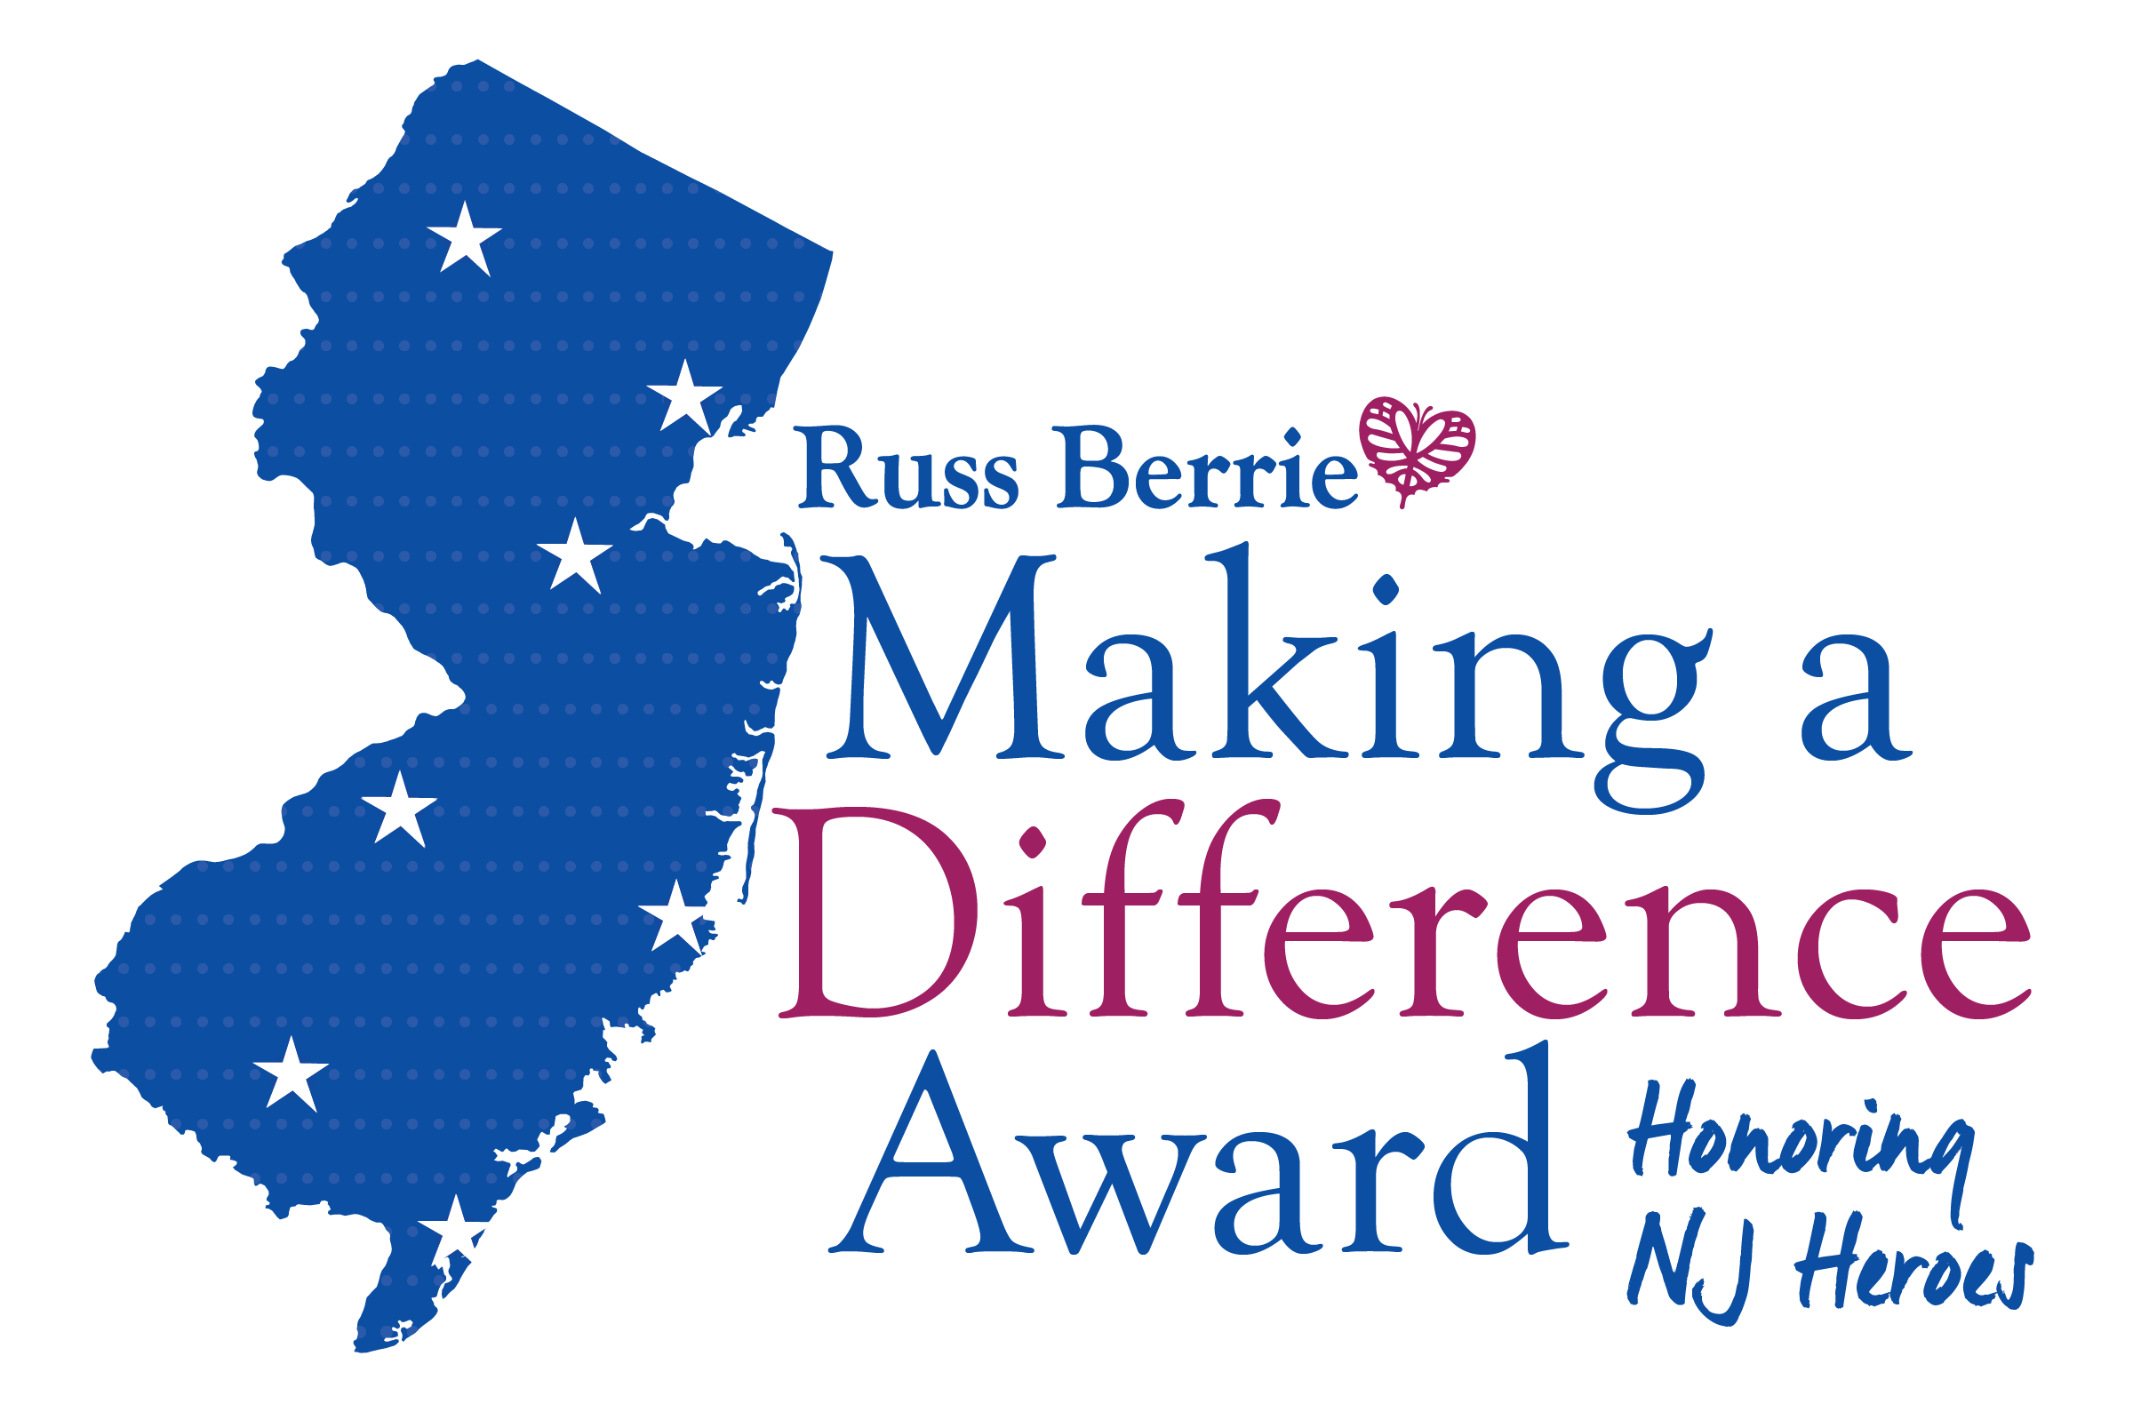
Call for Nominations of Unsung New Jersey Heroes for the
24th Russ Berrie Making a Difference Award
Honoring Extraordinary Individuals Who Make New Jersey a Better Place
Deadline for Nominations Is February 21, 2020
MAHWAH, N.J. – Nominations are now being accepted through February 21, 2020 for the 24th Russ Berrie Making a Difference Award. New Jerseyans who have made a significant difference in their communities through a lifetime of service or a single heroic act are eligible for cash awards. Members of the community are invited to nominate New Jersey residents whose deeds, carried out in the state, make them worthy of the honor. The Russell Berrie Foundation sponsors the program.
Established in 1997 by the late Russell Berrie, founder of Russ Berrie and Company, Inc. and the Russell Berrie Foundation, and Ramapo College of New Jersey, the awards honor “unsung heroes” statewide. Individuals will be recognized for making a significant difference to the well-being of their community during the annual spring award ceremony at Ramapo College in Mahwah. In 2020, more than $150,000 in cash awards will be presented: a top award of $50,000; two awards of $25,000, and up to seven $7,500 awards.
“Through this award, we honor the contributions of people who don’t seek recognition for what they do, yet generously give of themselves to make New Jersey a better place,” said Angelica Berrie, president of The Russell Berrie Foundation.
Nominees will be reviewed by an Advisory Board, which is co-chaired by Josh S. Weston, honorary chairman, Automatic Data Processing, Inc., and Dr. Peter P. Mercer, president of Ramapo College of New Jersey. The Board, comprised of prominent New Jersey business and nonprofit leaders, will evaluate nominations submitted by individuals, community groups, houses of worship, educators, representatives of the media and others. Following this evaluation, based on criteria refined by the Board, awards will be presented at a ceremony on Friday, May 8, 2020 at Ramapo College of New Jersey.
More honoree stories from 23 years are available online at: berrieawards.ramapo.edu and on Facebook.
Nomination forms are also available online at berrieawards.ramapo.edu. Deadline for entries is February 21, 2020. Nominations and/or inquiries may also be sent to madaawards@ramapo.edu
For more information on The Russ Berrie Making a Difference Award or to nominate someone, please contact:
- Meredith Lee, Program Director, Russ Berrie Making a Difference Award
- Phone: 201.684.7458
- Or email: madaawards@ramapo.edu
About The Russell Berrie Foundation
The Russell Berrie Foundation was established in 1985 by Russell Berrie, an American entrepreneur and philanthropist. Russell Berrie had a passion for giving that was grounded in his deep belief in humanity, the importance of touching the lives of ordinary people, the importance of strengthening the local community in New Jersey and the power of using philanthropy to help achieve transformational change. The Russell Berrie Foundation seeks to continue Russ’ mission by providing significant support to strengthen New Jersey’s art, cultural and health care institutions and celebrates everyday people who make a significant difference in the lives of others through the Russ Berrie Making a Difference Award.
About Ramapo College of New Jersey
Ramapo College of New Jersey, established in 1969, is the state’s premier public liberal arts college and is committed to academic excellence through learning, and international and intercultural understanding. The College is ranked #1 among New Jersey public institutions by College Choice, and is recognized as a top college by U.S. New s & World Report, Kiplinger’s, Princeton Review and Money magazine, among others. The campus center for performing and visual arts is named in honor of Angelica and Russ Berrie.

