RAMAPO COLLEGE OF NEW JERSEY
Office of Marketing and Communications
Press Release
November 30, 2018

Contact: Angela Daidone
201-684-7477
news@ramapo.edu

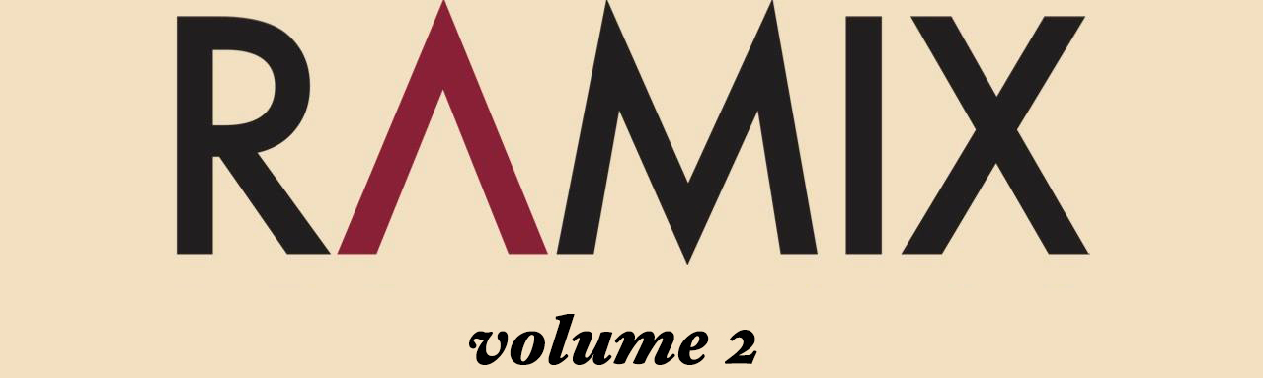

Ramapo College Music Program Launches Ramix Volume 2
Collection of Music by Ramapo Students and Alumni

MAHWAH, N.J. -- The Ramapo College Music Program is proud to announce the launch of RAMIX Volume 2, the second compilation on the college-based independent record label. Ramix is dedicated to developing and promoting Ramapo student talent and providing Music majors with hands-on, real world experience. Ramix Volume 2 will be released on Friday, November 30. This edition features 10 Ramapo artists and bands who are either current students or alumni of the Music Program.

On Friday, December 14, the label artists will perform in the Adler Theater at 7 p.m. to celebrate the launch of the new recording. Current members of the DJ Culture class will be presenting DJ and VJ sets beginning at 5 p.m. and throughout the evening, and free food and drinks will be provided.

Ramix Volume 2 features 10 songs by current Ramapo Music majors and recent Music Program graduates. The recording will be released through all major digital outlets. The wide-ranging genres represented on the second release include hip-hop, indie rock, and EDM, reflecting the Music Program’s diverse student interests. A new set of label branded merchandise will also be available through the Ramix website, www.ramixrecordings.com

Ramix is an important component of Ramapo’s contemporary-focused Music Program. Recent graduates have found great success in the popular music and entertainment industries, and the label is designed to help students start building their careers as performing/recording artists and music industry professionals while still in school. The College’s state-of-the-art Les Paul Studio, created thanks to a grant from the Les Paul Foundation, opened in 2016 and serves as the primary production and mastering facility for Ramix releases. Ramix Volume 2 features hip hop/R&B tracks from Omiette, Brendan G and Empty Matrix, EDM by JRIFTR, and indie rock from solo artists Hadar Baron, Brady Bock, and Dani Zanoni. Three rock bands are represented, including Callout, This Year’s Comeback, and Pink Lemonade, a group from the UK whose members are currently exchange students at Ramapo from Anglia Ruskin University. All of the music was written and performed by the student artists, and many of the recordings were produced in Ramapo’s on-campus recording and production facilities.

For more information, contact Hadar Baron, Label Manager, at hbaron1@ramapo.edu or Professor Ben Neill, Executive Producer, at bneill@ramapo.edu or 201-684-6283.

###
Ramapo College of New Jersey is the state’s premier public liberal arts college and is committed to academic excellence through interdisciplinary and experiential learning, and international and intercultural understanding. The College is ranked #1 among New Jersey public institutions by College Choice, and is recognized as a top college by U.S. News & World Report, Kiplinger’s, Princeton Review and Money magazine, among others. Ramapo College is also distinguished as a Career Development College of Distinction by CollegesofDistinction.com, boasts the best campus housing in New Jersey on Niche.com, and is designated a “Military Friendly College” in Victoria Media’s Guide to Military Friendly Schools.
Established in 1969, Ramapo College offers bachelor’s degrees in the arts, business, humanities, social sciences and the sciences, as well as in professional studies, which include business, education, nursing and social work. In addition, the College offers courses leading to teacher certification at the elementary and secondary levels, and offers graduate programs leading to master’s degrees in Accounting, Business Administration, Educational Technology, Educational Leadership, Nursing, Social Work and Special Education.

