
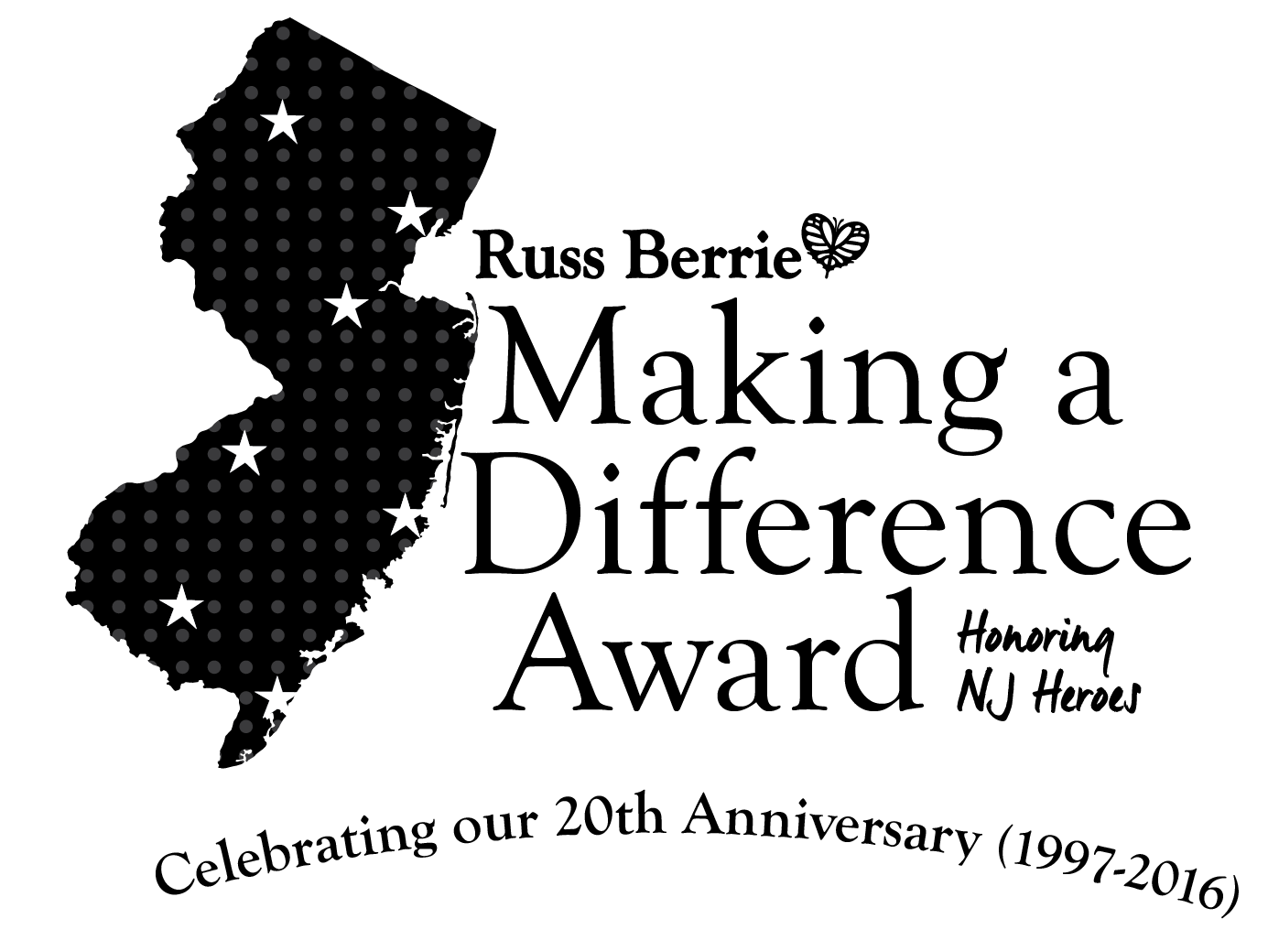
RAMAPO COLLEGE OF NEW JERSEY
Office of Communications and Public Relations
Press Release
January 4, 2016

Press contact: Angela Daidone 201-684-7477
adaidon1@ramapo.edu
For inquiries: madaawards@ramapo.edu

Nominations Open for Unsung NJ Heroes

for the 20th Russ Berrie Making a Difference Award

Uncommon Acts for the Common Good Earn Everyday Heroes Extraordinary Honor
Deadline for Nominations is February 19, 2016
MAHWAH, N.J. – Nominations are now being accepted through February 19, 2016, for the 20th Russ Berrie Making a Difference Award. New Jerseyans who have made a significant difference in their communities through a lifetime of service or a single heroic act are eligible for cash awards of up to $50,000. Members of the community are invited to nominate New Jersey residents whose deeds, carried out in the state, make them worthy of the honor. The Russell Berrie Foundation sponsors the program.
Established in 1996 by the late Russell Berrie, founder of Russ Berrie and Company, Inc. and the Russell Berrie Foundation, and Ramapo College of New Jersey, the awards honor “unsung heroes” statewide. Up to 11 individuals will be recognized for making a significant difference to the well-being of their community during the annual spring award ceremony at Ramapo College in Mahwah. The Russell Berrie Foundation will provide three major monetary awards of $50,000, $35,000 and $25,000, and up to eight runners-up receive $5,000 each.
“Through this award, we honor the contributions of people who don’t seek recognition for what they do, yet generously give of themselves to make New Jersey a better place,” said Angelica Berrie of Englewood, president of The Russell Berrie Foundation.
Nominees will be reviewed by an Advisory Board, which is co-chaired by Josh S. Weston, honorary chairman, Automatic Data Processing, Inc., and Dr. Peter P. Mercer, president of Ramapo College of New Jersey. The Board, comprised of prominent New Jersey business leaders and professionals, will evaluate nominations submitted by individuals, community groups, houses of worship, educators, representatives of the media and others. Following this evaluation, based on criteria defined by the Board, the group will present the awards at a ceremony on Friday, May 6, 2016.
Last year, the top honorees included an inner-city teacher who established an innovative school management program which brings needed resources, such as health and social services to children and their families in the poorest sections of the city; a woman whose personal crusade led to funding of research and forced cleanup of polluted waterways discovered to be the sites of high cancer incidence; and a retired businessman who single-handedly collected thousands of coats, linens and other essential items for shelters and other charitable organizations.
“I never expected or thought doing what was necessary would earn me the honor of the Russ Berrie Making a Difference Award,” said Linda Gillick, founder of Ocean of Love in Toms River, a nonprofit organization dedicated to helping local families struggling with cancer. “This award showed me that when you believe in something and you try to safeguard the life of your community, others are watching and paying attention.”
More honoree stories from 20 years are available online at:
http://www.ramapo.edu/berrie-awards/
For more information on The Russ Berrie Making a Difference Award or to nominate someone, please contact:
The Russ Berrie Making a Difference Award
c/o Office of the President
Ramapo College of New Jersey
505 Ramapo Valley Road
Mahwah, New Jersey 07430
Phone: 201.684.7179
Or email: madaawards@ramapo.edu
Nomination forms are also available online at http://www.ramapo.edu/berrie-awards/ Deadline for entries is February 19, 2016. Nominations and/or inquiries may also be sent to madaawards@ramapo.edu
About The Russell Berrie Foundation
The Russell Berrie Foundation was established in 1985 by Russell Berrie, an American entrepreneur and philanthropist. Russell Berrie had a passion for giving that was grounded in his deep belief in humanity, the importance of touching the lives of ordinary people, the importance of strengthening the local community in New Jersey and the power of using philanthropy to help achieve transformational change. The Russell Berrie Foundation seeks to continue Russ’ mission by providing significant support to strengthen New Jersey’s art, cultural and health care institutions and celebrates everyday people who make a significant difference in the lives of others through the Russ Berrie Making a Difference Award.
About Ramapo College of New Jersey
Ramapo College of New Jersey is ranked by U.S. News & World Report as fifth in the Best Regional Public Universities North category for public institutions. It is sometimes viewed as a private college. This is, in part, due to its unique interdisciplinary academic structure, its size of approximately 6,000 students and its pastoral setting in the foothills of the Ramapo Mountains on the New Jersey/New York border.
Established in 1969, Ramapo College offers bachelor's degrees in the arts, business, humanities, social sciences and the sciences, as well as in professional studies, which include nursing and social work. In addition, Ramapo College offers courses leading to teacher certification at the elementary and secondary levels. The College also offers seven graduate programs as well as articulated programs with Rutgers, The State University of New Jersey, New York Chiropractic College, New York University College of Dentistry, SUNY State College of Optometry and New York College of Podiatric Medicine.
The campus center for performing and visual arts – the site of the Russ Berrie Making a Difference Award ceremony – is named in honor of both Mr. Berrie and his wife, Angelica.

More honoree quotes, photos and infographics available upon request.

###

