20th Annual Ramapo River Watershed Conference Friday, April 24, 2015 Ramapo College of New Jersey 505 Ramapo Valley Road, Mahwah, N.J. 07430, In the Trustee’s Pavilion
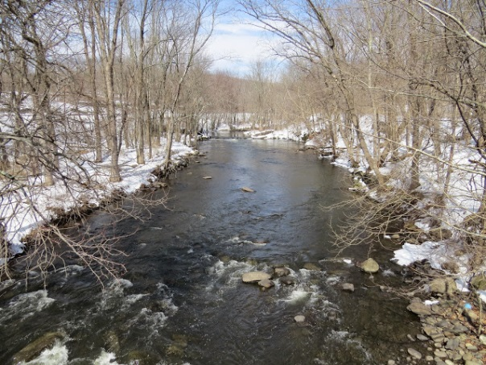 Dater’s Crossing in Sloatsburg, NY
Morning
9:30 am - Coffee and Bagels

10:00 - Greetings: Ramapo College President Peter Mercer

10:10 - 20 Years along the Ramapo, A Retrospective: Geoff Welch and Howard Horowitz

10:30 - Sterling Forest vs. the Genting Casino: Rodger Friedman Co-chair, Sterling Forest Partnership

11:00 - The Proposed Pilgrim Pipeline: Threats to the Ramapo River and Aquifer: Matt Smith
Regional Organizer, Food & Water Watch

11:25 - The Controversial Case of a Proposed 204-Unit Ridge-Top Housing Complex near the Oakland-Wayne Border: Jeff Tittel: Executive Director of the NJ Chapter of the Sierra Club

11:45 - The Rockland County Water Resources Management Task Force: How it was formed, its mission, composition, committee work and where we are with regard to meeting Public Service Commission goals: Harriet Cornell, Chair of the Environmental Committee of the Rockland County Legislature

12:15 pm - The Ramapo is changing from a freshwater stream to a wastewater-dominant stream, with an emphasis on how the Ramapo Valley Well Field and downstream well fields in NJ and reservoirs are impacted: Robert Kecskes, Retired from the NJDEP where he was Responsible for state and regional water supply planning in New Jersey

1 pm –2:15 pm LUNCH

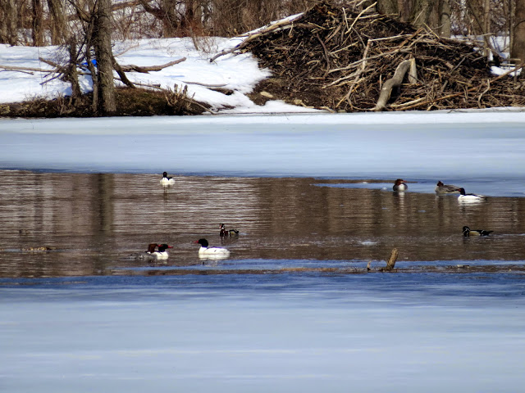
Merganser and Wood Ducks on the Ramapo River with a Beaver Lodge
Afternoon

2:15 - Torne Brook, Phase two of the Ford Motor Company Paint Sludge Remediation in Torne Valley, NY: Dr. Chuck Stead Adjunct Professor, Ramapo College

2:45 - Ramapough Mountain Indians People, Places and Cultural Traditions: Edward Lenik is a past president of the Archaeological Society of New Jersey and author of many books including a series on Indian Rock Art in the northeast and the well-known "Iron Mine Trails" from the NY/NJ Trails Conference.

3:30 What’s at Stake with The NJ EXXON Deal? An update from investigative journalist Bob Hennelly on the controversial settlement by the Christie Administration with Exxon-Mobil to settle close to $9 billion dollars in natural resource damage claims for less than 3 cents on the dollar: Bob Hennelly is the political analyst for WBGO, NPR in Newark and a regular contributor to Salon, City and State and City Limits.

4:00 - 5:00 - Reception

Presented by the Ramapo River Committee
And the Institute for Environmental Studies at Ramapo College
Kindly Sponsored by:
ROCKLAND COUNTY, TOWN of RAMAPO
Free Event - Registration requested at geoffwelch@gmail.com (845) 712-5220

