Creating A Requisition

Starting A Requisition
Go to FPAREQN
Type NEXT and click GO

Enter in Delivery date – T for today or another date.
Comment field – you can add comments here if you need to.
Click Next Block with the arrows on the bottom left or Alt – Page Down
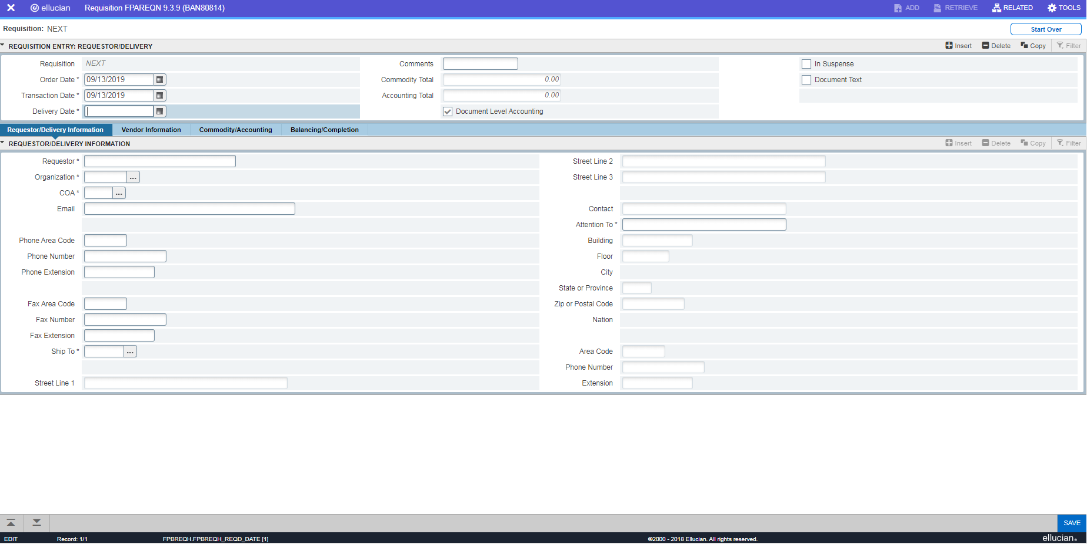

Enter Requestor Name or Department (Required)
Enter or Search Organization (Required)
Enter COA – Chart of Accounts – R or 1 (Required)
Enter email and Phone Fax number(s) (Optional)
(Required)Enter or Search Ship To – RAM1 (generally) The address is automatically populated
(Required) Enter Attention To – Name
Then Next Block
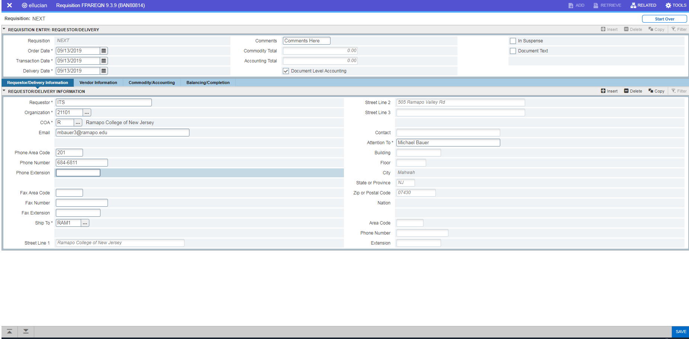
Vendor Information
Enter Vendor R# or search Vendor by name
You can change the Address Type for the Vendor if needed. Example instead of the PO address that came in when you double clicked on the R# in the search you can choose the AP address.
Vendor address populates.
Contact and Email are optional fields
Next Block gets you to the Commodity Tab
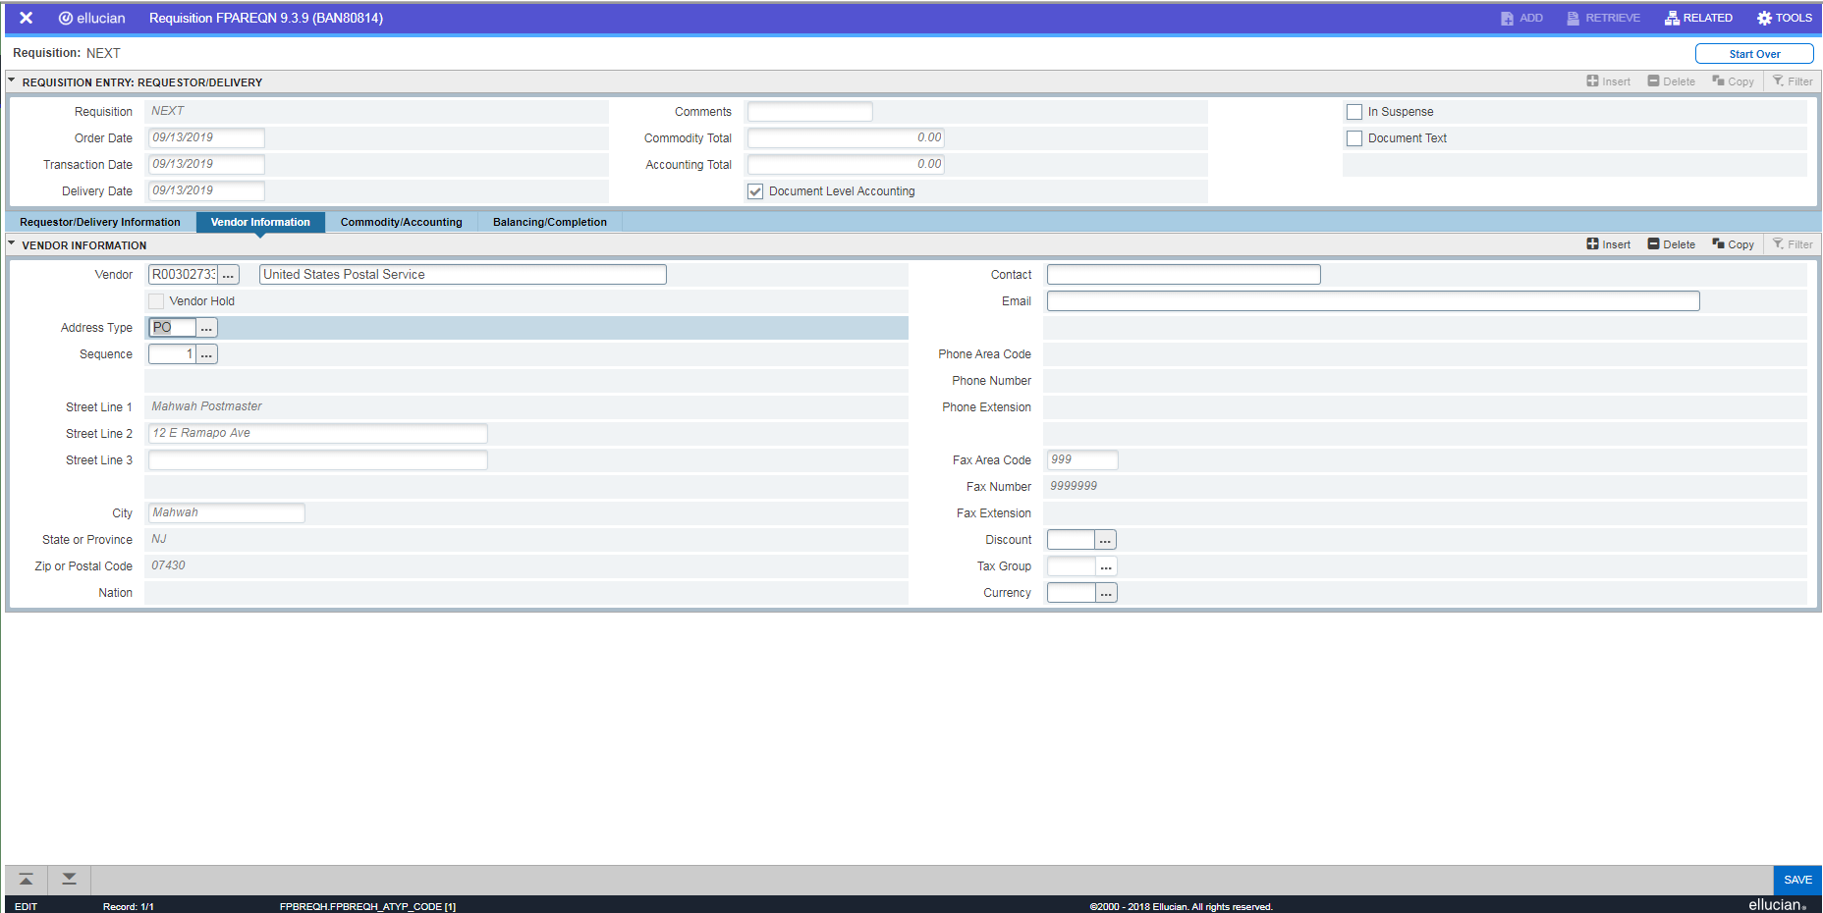
The Commodity Tab
Click into the box.
Item and Commodity – remain blank
Description – add
UM (Unit Measure) – enter N/A or select a unit of measure used for the commodity
Tax Group – blank
Quantity – enter quantity
Unit Price – Enter the Unit Price
Rest of the items stay blank.
Click on the down arrow to enter the next line if adding more than one item.
Once all items in, click next block to get to the Accounting tab.
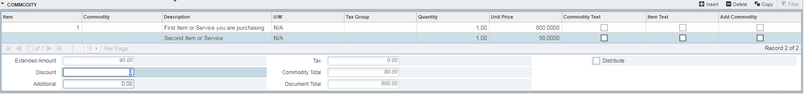
The Accounting block
The sequence number, COA and Year, Fund, Org and Prog should be automatically populated
Just add in Acct (account) OR you can overwrite the FOAP if needed
You can enter more than one item. Different line items for different amounts and with different FOAPs maybe added here. Just use the down arrow to add a line and go to the next line to enter information.
Each Accounting line has it’s own ‘Extended amount’ field that shows when you click on that line. This is how much will be coming from that account. Do not put more in that field than exists in that account.
The lines on the commodity section do not have to have matching lines on the accounting section. You can have multiple commodity lines and only one accounting line (one account paying for multiple things from a single vendor) or one commodity line and multiple accounting lines (multiple accounts paying for one thing). Additionally you can have multiple commodity lines and multiple accounting lines. The important thing to remember is that the commodity lines are how much something costs, while the accounting lines are which accounts are paying for those commodities and how much per account. As long as the total extended amount of the accounting lines adds up to the total amount of the cost of the commodities, and the extended amounts of the accounting lines do not exceed what is in the account, the requisition can be completed. If these two totals do not match up, you will get an error message and will not be able to complete the requisition.
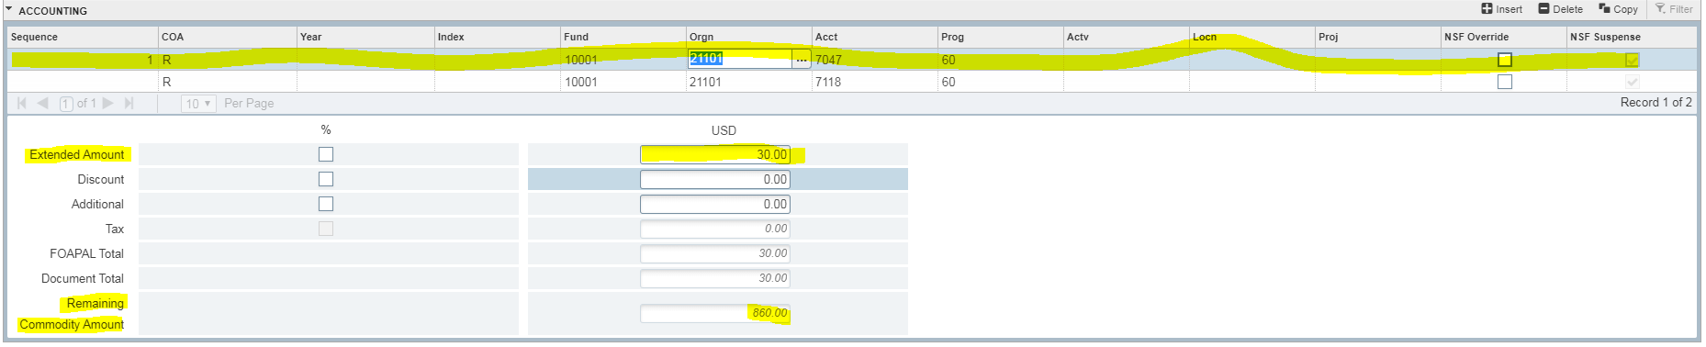
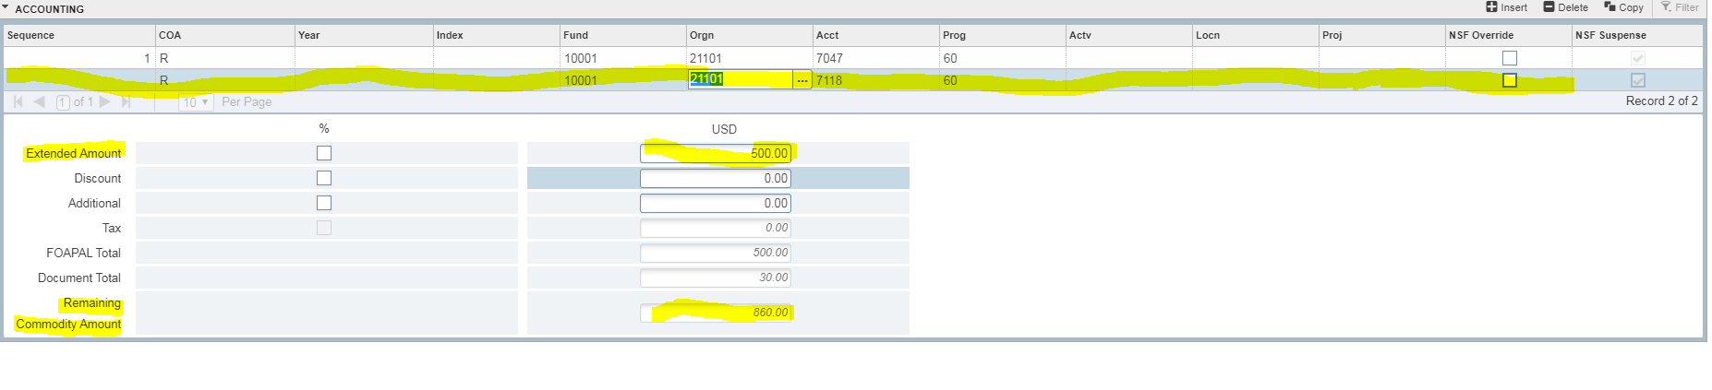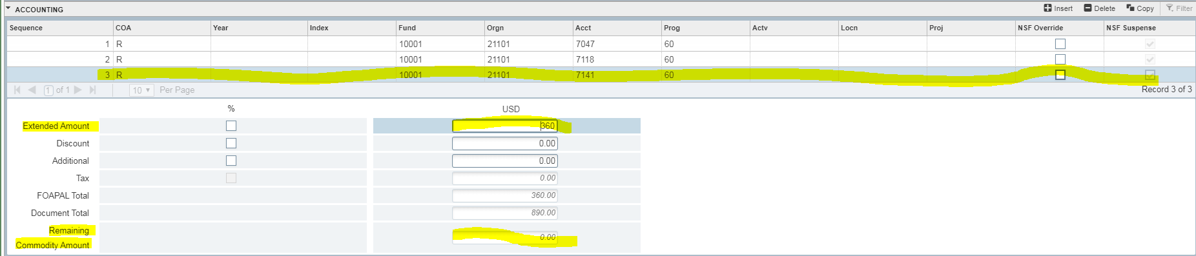
Balancing and Completion Tab
Once you review everything you can click on Complete on the center left of the screen.
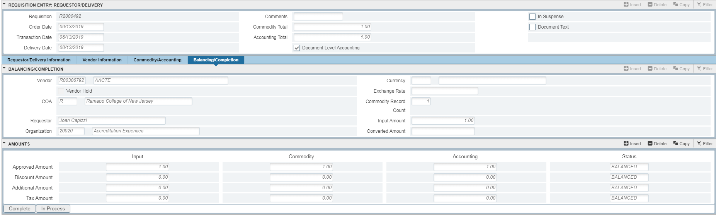
After you click complete you will see on the top right of the screen a confirmation that the requisition was created and a requisition number.
If needed, make note of the requisition number for your purposes.

