RAMAPO COLLEGE
HONORS PROGRAM
Student Handbook

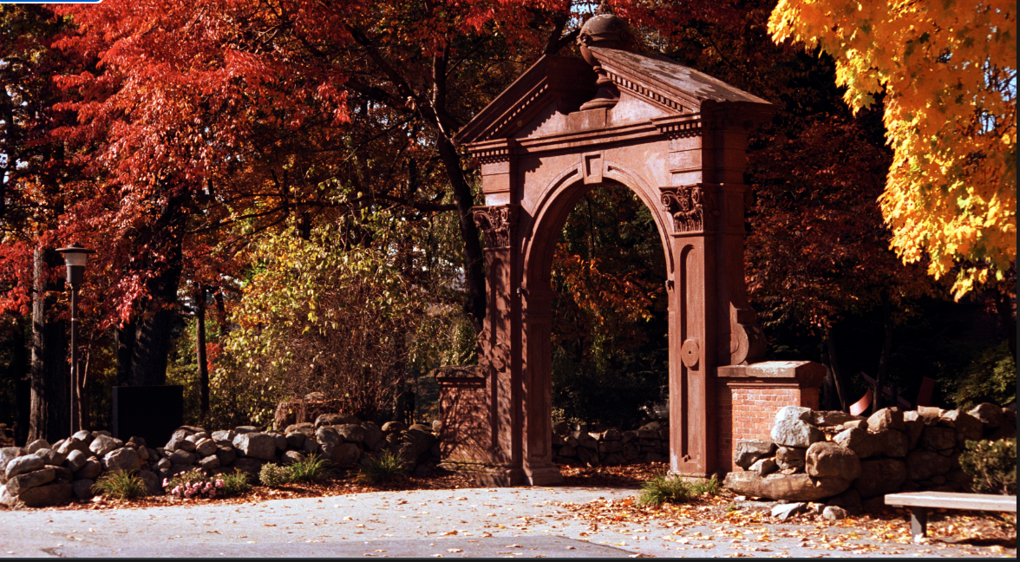

2026-2027

Introductions



Dr. Erin Augis, Professor of Sociology, Director of the College Honors Program. Professor Augis holds a Bachelor's in Political Science from The Ohio State University, and a Master's and Doctorate in Sociology from the University of Chicago. She is a recipient of Fulbright, National Science Foundation, Social Science Research Council, and Council of American Overseas Research Centers Awards, and has been a fellow at Princeton University's Institute for the Transregional Study of the Contemporary Middle East, North Africa, and Central Asia. She has published in the field of American race relations, as well as in West African and Islamic studies. She is currently writing the biography of an abolitionist minister, the Reverend John Mahan of Ohio, who in the 1830's and early 1840's aided in the escapes of enslaved people from the southern US to Canada. Professor Augis loves teaching and is constantly inspired by the idealism and humor of college students. Her email is eaugis@ramapo.edu.

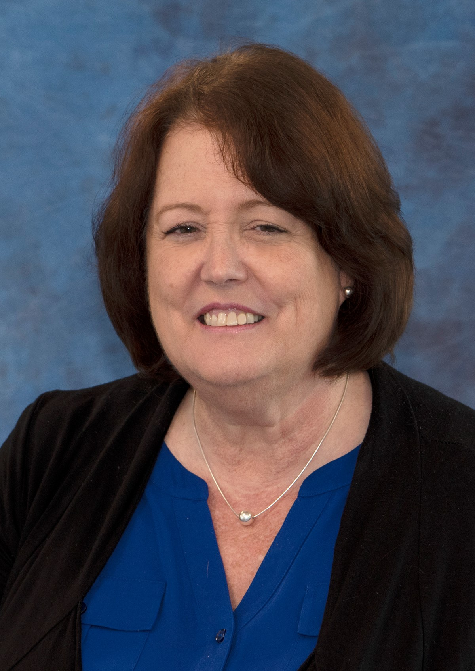

Donna Schweizer, Academic Affairs, Special Programs Coordinator has a cohesive portfolio spanning her professional career. Donna’s college education, certification in “Travel and Tourism” and living abroad, provided her with a multi-faceted foundation that directed her career path. Donna’s track has included: 18 years in the travel industry, six years in pharmaceutical conference event planning, program management, and 11 years in media administrative project coordination. For the past five years, Donna has managed certificate programs at Ramapo College of New Jersey and currently utilizes her specialized talents and experience for the Honors Program and SBDC in an administrative and event/conferences planning role. Donna is dedicated to her work, “the details” customer service, and problem solving. Contact Donna at dschwei1@ramapo.edu or visit her in B-wing, 143a.

Have a question for us? You can email us directly, or reach us at honors@ramapo.edu.

Mission Statement

The Ramapo College Honors Program is a community of faculty and students dedicated to intellectual, creative, and moral engagement. Honors students seek excellence through continual guidance and a distinctive curriculum of critical thinking, intercultural and international understanding, experiential learning, service, and interdisciplinary studies. The end of the program is the beginning of an enriched and accomplished life.

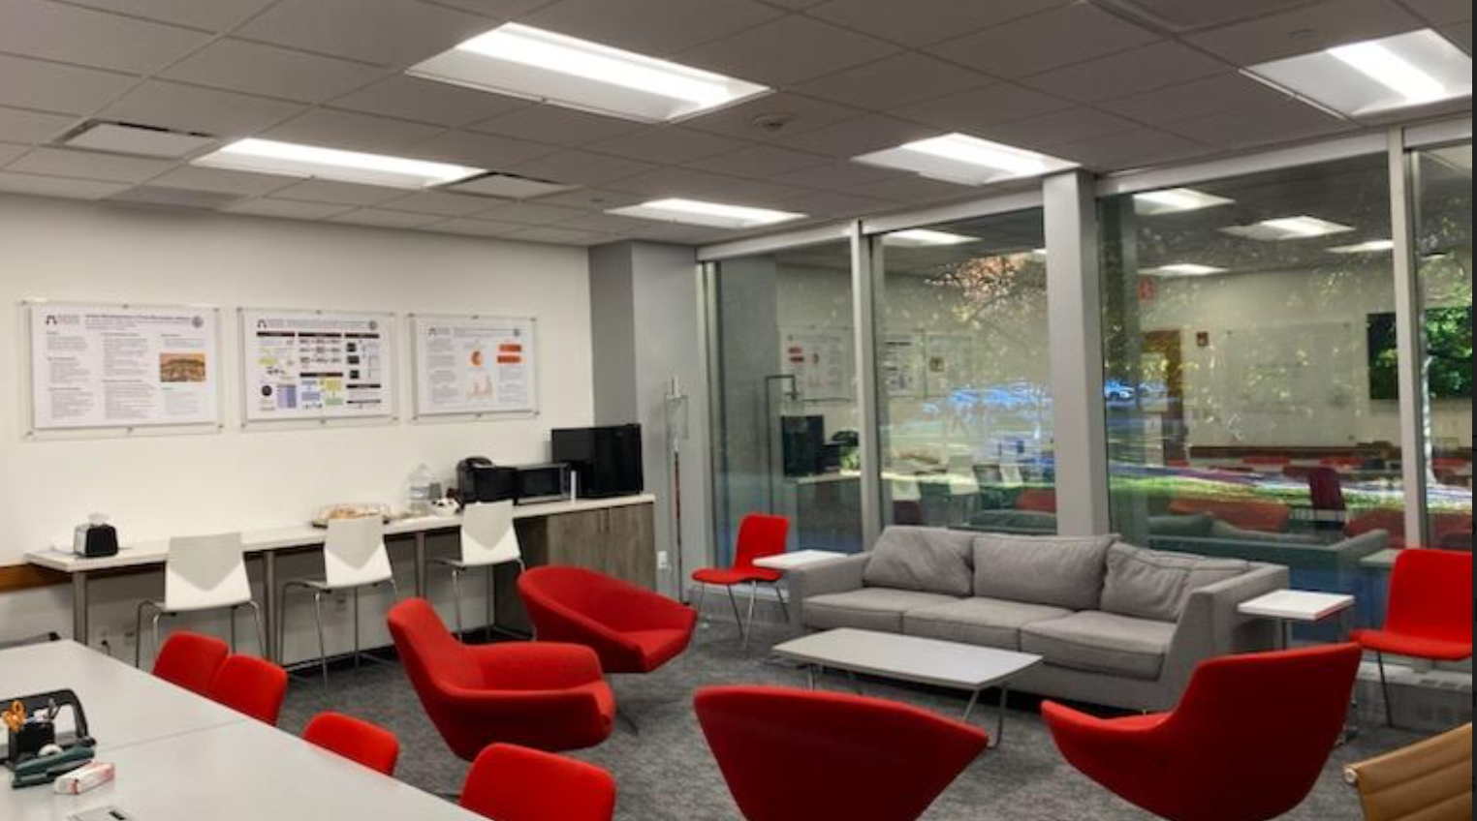

The Honors Lounge

One of the perks a Ramapo Honors student receives is access to the Honors Lounge and Quiet Study Room. Located in Room A-110 of the A-Wing, the Honors Lounge can be accessed 24/7 with your Student ID. Many students utilize the Lounge to study, do homework, eat lunch, and spend time with other honors students. Many Honors Mentoring Team meetings take place in the lounge as well. The room includes computers, a black and white printer, a television with basic cable, a mini-refrigerator, a microwave, and a variety of board games.

While the Lounge is considered your space to use as you wish, there are a few simple guidelines that should be followed:

- Any rules related to public health measures apply to this space as well. Hand sanitizer and disinfecting wipes will be available in the lounge.

- Be respectful of others in the Lounge. If you see students studying, participating in Honors Mentoring Teams, etc., please keep noise to a minimum. Please only play music through headphones.

- Clean up after yourself. Try to always leave the Lounge cleaner than you found it. Clean up any food, garbage, or crumbs you may leave behind. Put back any furniture you have moved. If you see that someone else left a mess, please consider spending a few minutes to make the Lounge a cleaner place.

- The printers in the Lounge are capped at 30 pages. If students are found to be printing more than that, printing privileges can be revoked. If ink is running low, please let us know at honors@ramapo.edu

- The mini-refrigerator is cleaned out on a daily basis. Please don’t leave food for more than 24 hours. Also, do not touch or remove any food that does not belong to you.

- Please do not leave items in the Lounge unattended. We are not responsible for lost or stolen items.

Keeping up with Everything Honors

Honors Website

The Honors Program has its own webpage on the Ramapo College Website. To access the Website, you can go to www.ramapo.edu/honors. Much of what you’ll need to know can be found on that site. The Student Resources page includes an archive of documents and important announcements from the past several months. Make sure to take some time to check out the website and become familiar with it throughout the semester.

Honors Instagram

Follow RCNJHonors on Instagram to see photos from recent events, throwback photos, announcements, and more!

LinkedIn

Before you graduate, be sure to develop a LinkedIn profile. Connect with the Honors Director so they can invite you to join the Ramapo Honors Program Alumni group. This is a great way to see what Honors grads are up to, keep in touch with your peers, and network!

Academic Requirements

The GPA requirement for Honors students is a minimum of 3.0 at the end of each semester. The director will review the GPA of continuing students in January and May of each year. Students who fall below this requirement will receive a notification that they will be placed on a probationary period for one semester. Those who do not bring their GPA above a 3.0 after this period may not continue with the Honors Program.

Violations of the Academic Integrity Policy of the college may also result in removal from the program. It appears in every syllabus, so be sure to know it well.

Curriculum

Successful completion of the Honors course curriculum requires that you complete six Honors courses. Students joining the program after the first semester should consult with the Director about which courses they must fulfill. The curriculum of the Honors Program is a critical component to fostering academic excellence and community.

HNRS 101 - Honors First Year Seminar
The Honors First Year Seminar (FYS) provides a comprehensive introduction to Honors-level learning. Seminar courses are developed around an academic theme or topic based on the expertise of each course instructor. The FYS instructor and peer facilitator introduce students to the academic and co-curricular programming of the College Honors Program and to all-college life generally. FYS seminars emphasize critical reading, writing, and discussion and focus on intellectual engagement, experiential learning, the methodology of the discipline being studied, and social responsibility to the larger community. FYS students will also participate in the Ramapo Summer Reading Program. This course fulfills the General Education requirement for Keystone Courses: First-Year Seminar.

HNRS 110 – Honors Social Science Inquiry
This course, an introduction to the social science sequence of general education, familiarizes students to the wide spectrum of social science approaches, methodologies (quantitative, qualitative and combinations between the two) and subject matter. It will use social science methods to examine major problems facing modern society on the local, national, and global levels. Using historical antecedents, it will focus on contemporary issues of inequality and the search for social justice that center on the various forms of social identities and structures of power and domination in society, including, but not limited to racism, ethnocentrism, classism, ableism, sexism, heterosexism, and transphobia. Finally, with attention to “welcoming the other,” this course facilitates understanding the experiences of marginalized peoples. This course fulfills the General Education requirement for Keystone Courses: Social Science Inquiry.

HNRS 201 – Honors Studies in the Arts and Humanities
Studies in the Arts and Humanities is a 4-credit interdisciplinary liberal arts course. It provides students with an introduction to key texts, concepts, and artifacts from different fields in the humanities. (These could include, for instance history, literature, philosophy, music, art history, and others.) Each section of the course covers a range of different cultures, and at least four different periods in human history, which can range from the ancient world to contemporary works. This course is one of the Keystone General Education courses, required for all students. It is also designated Writing Intensive, and will require students to complete at least two different types of writing assignments. This course fulfills the General Education requirement for Keystone Courses: Studies in Arts & Humanities.

HNRS 220 – Honors Global Awareness Seminar
The College Honors Global Awareness Seminar offers an opportunity for students to focus on the international, intercultural and interdisciplinary features of culture in a discipline interesting to them. Possible courses focus on language, business, and contemporary issues such as the concentration of global media ownership, multicultural media within and outside the United States, the international system of communication, alternative journalism, the impact of new technologies on industry, and global and multicultural issues in literature and the arts. Courses will include features such as guest speakers, study abroad – depending on the semester and the topic. This course fulfills the General Education requirement for Keystone Courses: Global Awareness.

HNRS 325 – Honors Values and Ethics Seminar
The College Honors Values and Ethics Seminar offers an opportunity for students to focus on the exploration and development of personal values, civic engagement, and applied ethics. Courses offered will include an opportunity for students to develop their individual moral identity based on critical analysis of personal background, readings and discussion. Topics covered may include meta-ethics, normative ethics, applied ethics, political philosophy, ethics in the professions, and ethics in art. Ethics will be considered in a social, cultural and historical context. Courses will include experiential components designed to assist students in becoming responsible members of the local and wider communities as contributing members. This course fulfills the General Education requirement for Distribution Category: Values and Ethics.

HNRS 400: Independent Study (Your last year on campus only)
You are required to complete a minimum of 2 and maximum of 4 credits of HNRS independent study with a faculty member. The purpose of the independent study is to make significant progress or even complete your Senior Project. These credits must begin to be fulfilled during your fall semester of senior year, or in your last year on campus if you are in a program where you will study off campus your senior year.
Co-Curricular Requirements

For successful completion of the Ramapo College Honors Program, along with the academic requirements outlined above, students are required to demonstrate:
- Engaged citizenship in the learning community of students and faculty in the College Honors Program
- Engaged citizenship in the Ramapo College community, the wider local community or socially engaged projects generally

The Ramapo College Honors Program is intentionally designed to be a supportive, active, and engaged community. A significant part of any community is participation and engagement. The Ramapo College Honors Program requires this engagement to maintain membership. Each year, Honors students are required to attend vital events in the life of the community and a number of other significant events within that community. This participation leads to the development of the community and strengthens and supports it. Students who do not fulfill these requirements will not be permitted to participate in conferences, continue the Honors Program, or graduate from the Program.

All of your Honors activity should be recorded for your personal records. In addition, you should complete sign-in requirements at every Honors event so that we can keep accurate records.

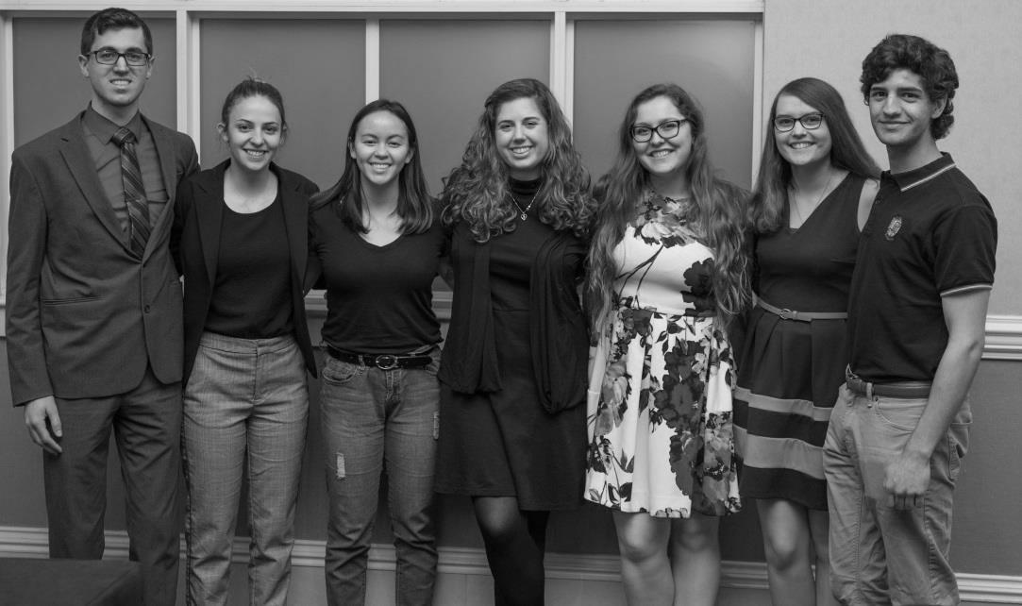
Students attending the NRHC Conference in Providence, RI

- General Meetings: Each student is required to attend the General Meeting at the beginning of each semester. These are not just vital for information, but are a chance for us to convene as a community near the beginning of each semester. Students must attend in order to sign up for early registration privileges for the following semester.

- Academic Events: These events emphasize the principles of the Honors Program and develop and express the intellectual lives of the students associated with them.

  - You are required to attend a minimum of three Honors Academic Events per year (below are some examples). If you do not complete three events, you will not be permitted to continue with the program the following school year or to graduate from Honors.

    - Lunch with a Professor
    - Honors Symposium (required of all Seniors, strongly recommended for all others)
    - Alumni Panel
    - Mental Health Awareness Panel
    - Prestigious Scholarships & Fellowships Workshop
    - National Collegiate Honors Council Conference
    - Northeast Regional Honors Council Conference
    - Professor Talks
    - Documentary Films
    - Book Club events

- Special Events: These optional social events are planned by the (student) Executive Board to strengthen the relationship among Honors students and develop the community aspect of the program. These are great ways to meet other Honors students and have a great time in the process. Examples from recent years include:

    - Honors Banquet
    - Extreme Team-Building
    - Halloween Party
    - Relay for Life
    - Talent Show
    - Honors Olympics

Descriptions of Important Academic Events

Honors Symposium

We host an annual Honors Symposium each April to recognize the outstanding work done within the College Honors Program. Students present their Senior Project at this all-college event celebrating the work of students with their faculty mentors, family, and friends. All Honors students are invited and encouraged to attend. This is a great way to get a sense of what completed projects and presentations look like.

Lunch with a Professor

This casual event gives students the chance to meet with professors of their choice through an informal lunch session. All students can invite a professor and spend some time one-on-one over a catered lunch to discuss the details of their major, their field of study, or the details of their Senior Project. Students are expected to read a piece of the professor’s research in advance.

Conferences

One of the best ways for you to get to see the world while networking and strengthening your presentation skills is to attend an Honors Conference. Every year we take students to the National Collegiate Honors Council Conference in the fall and the Northeast Regional Honors Council Conference in the spring where they spend 2-4 days exploring a new city, meeting other Honors students, and presenting to students and professors from across the country. Conferences are competitive, and you are required to submit proposals to the Directors as well as a signed attendance policy if your proposal has been selected. The Honors Program pays for transportation (including flights), hotel rooms, food, and registration.

International Study

Participating in a Study Abroad program during your time at Ramapo College will allow you to become a global citizen. Experiencing life in other countries and cultures, developing foreign language skills, broadening your worldview, and making lifelong friends while earning college credit are just some of the ways students benefit from their time abroad. Many students use Study Abroad to prepare for graduate school and future employment. Most importantly, students remember and value their study abroad experiences for the rest of their lives.
Students in the College Honors Program who enroll in a study abroad program may request that they be waived from taking an Honors course that fulfills a Gen Ed.
Students who study abroad may apply for the Hiden Family College Honors Scholarship or the Century 21 Scholarship. These scholarships can pay for part of the costs of an international trip. Students should indicate their interest in being considered for this scholarship when they apply to Study Abroad through the Roukema Center for International Education Website. These scholarships are only open to College Honors students.
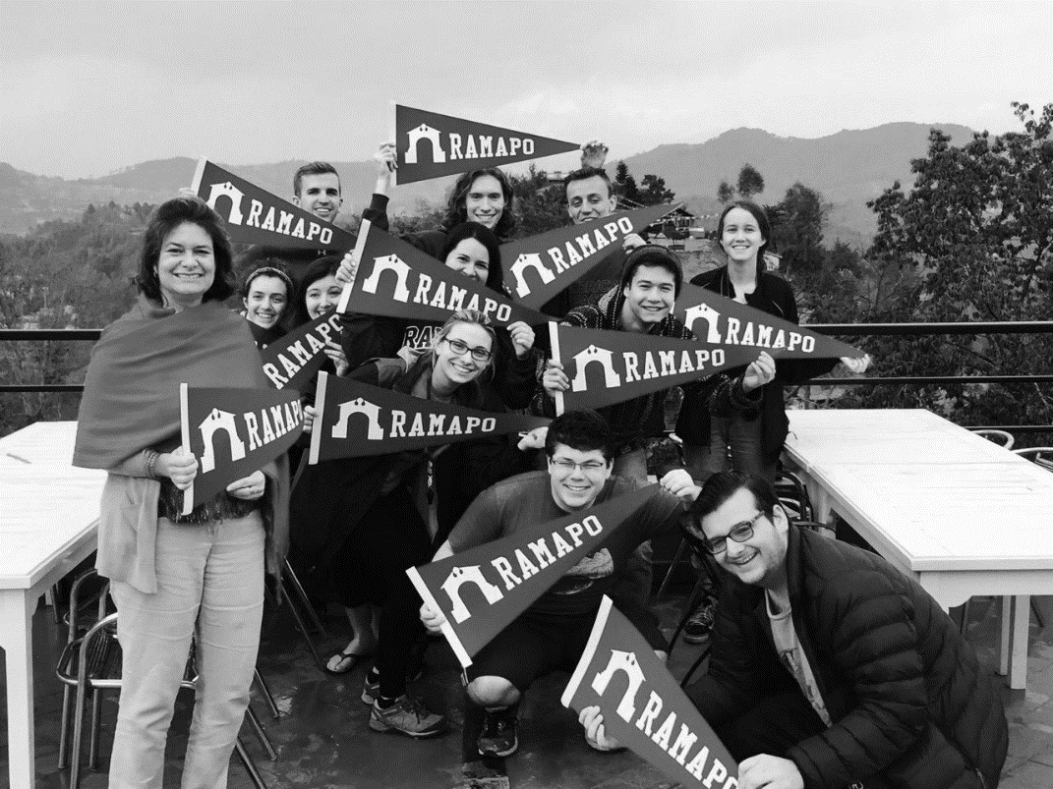

Getting Involved

Honors Mentoring Team Leadership

Student Executive Board

The purpose of the Student Executive Board is to provide assistance to the Director pertaining to the development of co-curricular resources and events. The E-Board is responsible for a great deal of the legwork and behind-the-scenes planning for the Honors Program. Goals of the Executive Board include promoting the College Honors Program, strengthening the program’s learning and social community, and creating, promoting, and maintaining College Honors programming which supports co-curricular development within the community. New members are chosen each year. Consider applying if you feel you would enjoy having a serious leadership role within the program.

Scholarships

Honors students are eligible for scholarships in addition to the study abroad ones mentioned above. The deadline is early in Fall semester. Please consult the Ramapo scholarships website and select “College Honors Program” on the scholarship search engine: https://www.ramapo.edu/scholarships/scholarships-students-can-apply/ Honors students are also strong contenders for scholarships that are not specific to the Honors Program, so be sure to explore what you are eligible for and apply!

Graduation
Graduation from the Honors Program is noted on your diploma, academic transcripts, the graduation ceremony program, and at the Academic Achievement Ceremony.

Honors Senior Project

What is the Senior Project?
Students will complete a Senior Project during the last 2 semesters of their program, though planning begins in Spring of junior year. The Fall Senior semester includes research, preparation, and a first draft completed as part of an Honors Independent Study (HNS 400), while the Spring senior semester is completion of the work, preparation of a poster or oral presentation, and presentation at the Ramapo College Honors Symposium. At a minimum, your Honors Independent Study should advance you to the point where you are 50% done with your senior project, but more is better!
Students must enroll in their Independent Study class (HNRS 400) in the Fall semester of Senior year. They can continue credits in the Independent Study in Spring. Students must complete a total of 2, 3, or 4 credits their senior year. HNRS 400 is not offered in the summer.
The Honors director will notify you in Spring semester of your junior year when it is time to submit the Honors Project Application form and when you must register for HNRS 400. The Honors Director will provide you with the requisite forms.
Each student will select their own Faculty Sponsor who will guide the work. Students should consult with the Honors Director and their faculty advisors during their Junior year in order to discuss selection of a Faculty Sponsor and the project proposal.
Senior Projects require the completion of an Honors Independent Study (HNRS 400), which is a graded course. In addition, your graduation with Honors depends upon the approval of your project by your Sponsor and the Honors Director. Having a well-developed idea before the end of your junior year ensures you have time during the summer and your senior year to complete the project.
Students in 3 +1 programs will do their Senior Projects in their junior year.
A strong Senior Project represents the culmination of your college career, in which you have developed the skills to carry out advanced research or creative work in your discipline(s). It often makes an excellent writing sample to submit for publication or alongside graduate school applications, or a compelling example of your skills to discuss during job interviews.
What is required for an Honors Project?
The goal of the project is developing in students the recognition of the value of intellectual mentorship and collaboration and the experience of initiating their own research or experiential work. Students have the opportunity to critically share their work and produce work of publishable quality. Ideally, students will have been narrowing and defining their project ideas within the curriculum and mentoring of the Honors Program, as well as integrating ideas with their major and/or minor studies.
Projects that take the form of a research paper (approximately 20 double-spaced pages) in a professional format in line with the standards of your discipline, with a minimum of 10 scholarly sources.
Other projects might not be traditional research papers. Perhaps you wish to complete a photography exhibit, write a book of poetry, stage a performance piece, develop a business plan, design a web application, or put many hours into the research lab instead. In these cases (the “creative project” or “lab report” option, we expect a minimum of 10 double-spaced pages in a professional format in line with the standards of your discipline, plus evidence of at least 50 hours of additional research or creative labor. Your faculty sponsor will determine whether you have met this minimum. In no cases will a Senior Project that does not include a minimum 10-page written component be accepted.
All projects will be held to the highest standards of academic integrity, according to the guidelines of the College. Additionally, you may not submit as your Honors Senior Project a paper you have submitted for a course other than your Honors Independent Study. It is not a problem if your work stems from or expands upon something you explored in a course or capstone project elsewhere, but it cannot be the same paper. Consult the Honors Director in any such cases. Similarly, you may not submit your Senior Project to a course (like a senior capstone course in your major).
If your project relates to work you have collaborated on or co-authored with other students, professors, or others, consult the Honors Director about how to proceed.

Who are Faculty Sponsors?
For completion of the Senior Project, one Sponsor is required to assist in mentoring the work of each student. The student selects the Sponsor (consulting with the Honors Director if necessary). The sponsor will be the faculty member who oversees the Honors Independent Study. Do not choose a Sponsor who is going on sabbatical during your senior year.
You should plan to meet with your Sponsor once a month during the year in which you complete your Senior Project, with more frequent meetings (perhaps every week or every other week) during your Honors Independent Study. You must to share a final draft of your senior project with them and incorporate feedback before you submit the project to the Honors Program.
Do I need IRB approval?
If your research involves collecting data from live human subjects, you may require approval in advance by the Ramapo College Institutional Review Board (IRB). For guidelines and application, go to https://www.ramapo.edu/provost/research-and-scholarship/institutional-review-board/ You will need to provide evidence that you have applied for IRB approval when you complete your first check-in (October 30 of Senior year); and provide evidence of your IRB approval along with your final project (March of Senior year).
What is HNRS 400: Honors Independent Study?
An independent study is a course in which you are the only student. You and the faculty sponsor must develop a syllabus with deadlines, a grading system, meeting times, assigned readings and writing assignments, etc. That syllabus must meet with the approval of your faculty sponsor’s Dean and the Director of the Honors Program. This requires planning and preparation well in advance of the end of add/drop at the very start of the semester. You and your instructor should review the requirements and deadlines for the Senior Project as you develop the syllabus.
You can choose whether to complete 2, 3, or 4 credit hours for the Independent Study. Discuss with your faculty sponsor which is the best option for you. A 4-credit course is twice as much work as a 2-credit course. A 2-credit independent study should have a syllabus indicating approximately 75 hours of work, while a 4-credit one is 150 hours of work. If you need more time and space to complete your project, opt for 4 credits; if you don’t, or are building on work you already completed, opt for 2 credits. Also consider which option best fits your schedule.
How does the Honors Independent Study work with my Honors Senior Project?
The Honors I.S. (HNRS 400) is not an additional project or course on top of your Senior Project. Instead, it provides the framework within which to complete your project, or at least the majority of it. The Honors Independent Study makes the project an official graded part of your course schedule and transcript.

How will the Honors Independent Study fit into my schedule?
You have a great deal of flexibility with how you add HNRS 400 to your schedule. You can:
· Add HNRS 400 as a 2-credit course on top of your typical 16 credits schedule during Fall Senior Year. This would allow you to take 18 credits total (Four 4-credit courses plus the 2-credit I.S.), which does not require paying any additional tuition.
· Take 3 classes worth a total of 12 credits and add a 4-credit HNRS 400 to reach 16 credits total.
· Take it 1 credit at a time, Fall and Spring! (for a total of 2 credits)
· Any combination of 2, 3, or 4 credits will work, as long as you enroll in HNRS 400 in Fall of your Senior year. You may choose to enroll again in Spring of your Senior year.
Am I eligible to begin a Senior Project?
Before beginning your project, check with the Honors Director. They will look at your GPA and the number of Honors courses you have completed.
How often should I meet with my Sponsor?
You should be meeting with your faculty Sponsor a minimum of once per month throughout your senior year. Your Sponsor should be guiding you throughout your research along the entire way.

Who has the final say on whether my project has been approved?
Your Sponsor must sign off on your project in order for you to present at the required Honors Symposium and ultimately graduate with Honors, and the Honors Director will verify that you have met the requirements. It is the student’s job to ensure that they are on the same page with their Sponsor regarding the initial goals and criteria of the project.
What are the requirements for a poster presentation?
Each student presenting a poster should create it as a 36x48 PowerPoint slide and save it as a pdf. It should include both the Ramapo Honors logo and the Ramapo College logo. Electronic templates will be provided to you. Your slide must be approved by your Sponsor prior to submission.
We will print all posters and they will be at the Symposium and on easels when you arrive. There will be a period of one hour where you are expected to stand beside your poster and answer questions for the audience who will approach you intermittently. You are welcome to walk away for bathroom breaks or to get a drink, but please eat before or after this portion of the event.
What are the requirements for an oral presentation?
Oral presenters have 8-10 minutes per presentation. PowerPoints are encouraged but not required. PowerPoints should be submitted to honors@ramapo.edu with sponsor approval prior to the deadline specified by the Honors Director.
You should not read directly from a paper or PowerPoint. You should present the information in a clear and concise manner directly to the audience. You will be warned when you only have a minute left. If you start to go well over time, you might be cut off, so please rehearse your presentation so that it can be comprehensively covered in the time allotted. Even a great presentation will look bad if it has to be cut short.
Can I change my Sponsor or Reader?
In certain rare circumstances, your Sponsor can be changed. You should meet the Honors Director first to discuss why this is necessary. Do not choose a Sponsor if they are going on sabbatical during the year of your project.
What if my Sponsor fails to communicate with me?
You should choose a professor that you have a good relationship with. However, should any communication issues arise or if you find it difficult to meet with them, you should inform us immediately.
What if I cannot attend the Symposium?
The Symposium should only be missed if you have class or an internship that you are required to attend, if you are studying abroad, or if you graduated in December. If you cannot attend, you will still need to create a poster that we can display in your absence.

What is expected of me on the day of the Symposium if I’m giving an oral presentation?
On the day of the Symposium, you should arrive ahead of time with your PowerPoint and drag it to the desktop of the Pavilion computer with your name in the title. The Director will open the event with some opening remarks and then we’ll move immediately into the first half of poster presentations. PowerPoint presentations will take place in the middle of the event. Students who give PowerPoint presentations must still make a poster and present it as well.
What do I receive at the Symposium?
You will receive your Honors medallion, graduation cord, and Honors Certificate.
Is there a dress code at the Symposium?
You should dress professionally as you will be presenting to faculty, administrators, and parents.
Does completion of my Senior Project appear on my graduation transcript or diploma?
Your transcript and diploma will show that you graduated with Honors, but do not include the title of your project.
Where else should I consider presenting my research?
The Honors Program regularly takes students to the National Collegiate Honors Conference (NCHC) and the Northeast Regional Honors Conference (NRHC). These are great opportunities to present your research. Typically, proposals for NCHC are due in April and then the conference itself is in November, so only research completed in Junior year can be proposed for this conference. NRHC proposals are due in November and the conference is held in April, making it ideal for presenting Senior Project research. The Honors Program covers all expenses for these conference trips.
Sometime between May and September, all Ramapo students are invited to propose papers for a regional COPLAC (Consortium of Public Liberal Arts Colleges) conference held in October. Again, only research completed before the proposal deadline should be submitted. The college covers all expenses for these conference trips.
You should also talk to your Sponsor about conferences in your discipline. Discussing this Junior year is wise, as submission deadlines are often many months before the conference itself. You and your Sponsor should inquire with both your School Dean and the Honors Director about funding for such conference trips.
The college often offers additional opportunities to present your research on campus, such as Scholars Day and research symposia, typically in the latter part of Spring semester.

Where should I consider publishing my research?
Discuss this with your Sponsor, who will be able to point out undergraduate and scholarly journals in your discipline that might be appropriate venues for publication. NCHC, NRHC and COPLAC all have undergraduate journals eager to publish your work. Check out their websites for more details.

Illuminate (the journal if the Northeast Regional Honors Council)

Metamorphosis (the journal of the Council of Public Liberal Arts Colleges)

UReCA (the journal of the National Collegiate Honors Council)

