RAMAPO COLLEGE
HONORS PROGRAM
Senior Project Guidelines

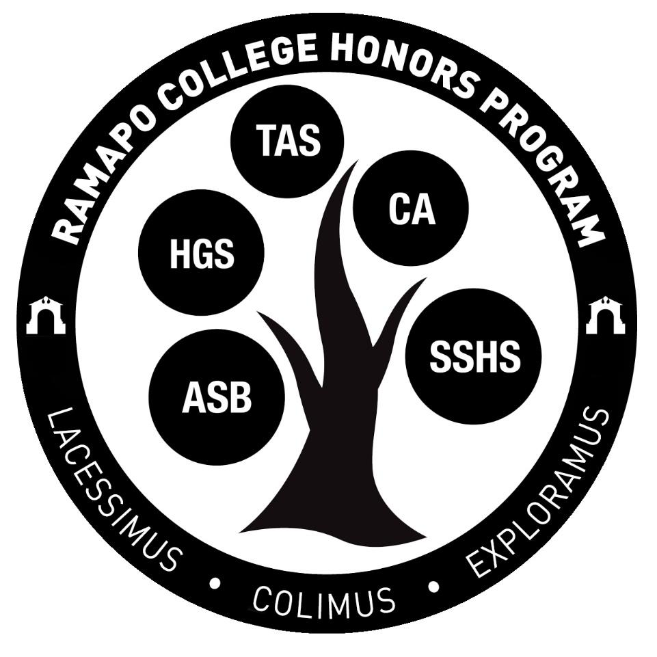

Updated July 2021

What is the Senior Project?
Students will complete a Senior Project most likely during the last two semesters of their program, though planning should begin during Junior year. The Fall Senior semester typically includes research, preparation, and a first draft completed as part of an Honors Independent Study, while the Spring senior semester includes completion of the work, preparation of a poster or oral presentation, and presentation at the Ramapo College Honors Symposium. At a minimum, your Honors Independent Study should advance you to the point where you are 50% done with your senior project, but more is better!
To allow maximum flexibility, students are allowed to complete the Honors Independent Study during the Spring of Junior year or during the summer before Senior year. The final semester of senior year is late to take the Honors Independent Study; this will only be allowed in special circumstances and with the approval of the Honors Director.
Each student will select his/her own Faculty Sponsor who will guide the work. The student and Sponsor will also select one additional faculty Reader whose expertise is complementary to the Project. Students should consult with Honors Director Monen and their faculty advisors during their Junior year in order to discuss selection of a Faculty Sponsor and the project proposal.
Senior Projects require the completion of an Honors Independent Study, which is a graded course. In addition, your graduation with Honors depends upon the approval of your project by your Sponsor, Reader, and the Honors Director. Having a well-developed idea before the end of your Junior year ensures you have time during the summer and school year to complete the project.
A strong Senior Project represents the culmination of your college career, in which you have developed the skills to carry out advanced research or creative work in your discipline(s). It often makes an excellent writing sample to submit for publication or alongside graduate school applications, or a compelling example of your skills to discuss during job interviews.

What is required for an Honors Project?
The goal of the project is developing in students the recognition of the value of intellectual mentorship and collaboration and the experience of initiating their own research or experiential work. Students have the opportunity to critically share their work and produce work of publishable quality. Ideally, students would have been narrowing and defining their project ideas within the curriculum and mentoring of the Program, as well as integrating ideas with their major and/or minor studies.
Projects that take the form of a research paper should be at least 20 double-spaced pages or more in a professional format in line with the standards of your discipline, with a minimum of 10 scholarly sources.
Other projects might not be traditional research papers. Perhaps you wish to complete a photography exhibit, write a book of poetry, stage a performance piece, develop a business plan, design a web application, or put many hours into the research lab instead. In these cases (the “creative project” or “lab report” option, we expect a minimum of 10 double-spaced pages in a professional format in line with the standards of your discipline, plus evidence of at least 50 hours of additional research or creative labor. Your faculty sponsor will determine whether you have met this minimum. In no cases will a Senior Project that does not include a minimum 10 page written component be accepted.
All projects will be held to the highest standards of academic integrity and submitted to turnitin.com to check for plagiarism. You may not submit as your Honors Senior Project a paper you have submitted for a course other than your Honors Independent Study. It is not a problem if your work stems from or expands upon something you explored in a course or capstone project elsewhere, but it cannot be the same paper. Consult the Honors Director in any such cases. Similarly, do not submit your Senior Project to a course (like a senior capstone course in your major); if you do so, you may be considered guilty of plagiarism.
Your Honors Project should be written by you alone: you may not submit co-authored papers. If your project relates to work you have collaborated on with other students, professors, or others, you will need to acknowledge that, but write your own paper. Consult the Honors Director in such cases.

What forms do I need to supplement my Senior Project?
Over the course of your junior and senior year, you should be consistently meeting certain goals in order to ensure that you are on the correct path toward completion of your Senior Project. Accompanying these goals are several forms that must be submitted by strict deadlines.

Form | Due Date | Recipient
Senior Project Idea Form | May 1 of Junior Year | honors@ramapo.edu
Senior Project Proposal Form. At this point, we will provide you with sample syllabi on which you can base your Independent Study syllabus. | August 1 the summer before Senior Year | honors@ramapo.edu
Independent Study Registration Form AND a Syllabus developed by you and the professor (all in one email or in hard copy). | Prior to Add/Drop Date of Semester you intend to enroll in Honors Independent Study | The Independent Study Registration Form needs to be signed by your professor, their dean, and an Honors Director (on the “Graduate Program Director” line). This form then goes to the Registrar’s Office; once approved, they will register you in the Independent Study.

What are Faculty Sponsors and Readers?
For completion of the Senior Project, one Sponsor and one Reader are required to assist in mentoring the work of each student. The student selects the Sponsor (consulting with the Honors Director if necessary); the Reader is selected by the Faculty Sponsor and student in consultation. The sponsor will be the faculty member who oversees the Honors Independent Study. Often the Reader provides competence in disciplines outside the field of the Faculty Sponsor but related to the work of the student, especially in the case of double majors or minors. Do not choose as a Sponsor or Reader a faculty member who is going on sabbatical during your senior year.
You should plan to meet with your Sponsor and Reader once a month during the year in which you complete your Senior Project, with more frequent meetings (perhaps every week or every other week) with your Sponsor during your Honors Independent Study. You need to share a final draft of your senior project with both of them and incorporate feedback before you submit the project to the Honors Program.
Do I need IRB approval?
If your research involves collecting data from live human subjects, you may require approval in advance by the Ramapo College Institutional Review Board (IRB). For guidelines and application, go to https://www.ramapo.edu/provost/irb/ You will need to indicate whether your research requires IRB approval at the time of your Project Proposal (May 1 of Junior year); provide evidence that you have applied for IRB approval when you complete your first check-in (October 30 of Senior year); and provide evidence of your IRB approval along with your final project (March of Senior year).

What is HNRS 499: Honors Independent Study?
An independent study is a course in which you are the only student. You and the faculty sponsor must develop a syllabus with deadlines, a grading system, meeting times, assigned readings and writing assignments, etc. That syllabus must meet with the approval of your school Dean and the Director of the Honors Program. This requires planning and preparation well in advance of the end of add/drop at the very start of the semester. You and your instructor should review the requirements and deadlines for the Senior Project as you develop the syllabus and make your Faculty Reader aware of your plan.
You can choose whether to complete 2 or 4 credit hours for the Independent Study. Discuss with your faculty sponsor which is the best option for you. A 4-credit course is twice as much work as a 2-credit course. A 2-credit independent study should have a syllabus indicating approximately 75 hours of work, while a 4-credit one is 150 hours of work. If you need more time and space to complete your project, opt for 4 credits; if you don’t, or are building on work you already completed, opt for 2 credits. Also consider which option best fits your schedule.

How does the Honors Independent Study work with my Senior Project?
The Honors I.S. is not an additional project or course on top of your Senior Project. Instead, it provides the framework within which to complete your project, or at least the majority of it. The Honors Independent Study makes the project an official graded part of your course schedule and transcript.

How will the Honors Independent Study fit into my schedule?
You have a great deal of flexibility with how you add HNRS 499 to your schedule. You can:
· Add HNRS 499 as a 2-credit course on top of your typical 16 credits schedule during Spring Junior Year or Fall Senior Year. This would allow you to take 18 credits total (Four 4-credit courses plus the 2-credit I.S.), which does not require paying any additional tuition.
· Take 3 classes worth a total of 12 credits and add a 4-credit HNRS 499 to reach 16 credits total.
· Take it 1 credit at a time!
· Take it during the summer, but this requires paying for tuition for 2 or 4 credits.

Am I eligible to begin a Senior Project?
Before beginning your project, check with the Honors Director. They will look at your GPA and the number of Honors courses you have completed by spring of your Junior year. If you are not on pace to complete all of the Honors courses and/or do not have a 3.0 by this time, you will not be permitted to begin the project.

What are the project deadlines?
August 1 - The Senior Project Proposal Form is due. This form asks you for a brief description of your project, the names of your faculty sponsor and reader, whether your project requires IRB approval, and information on when you plan to take your independent study.
Summer/September - There is a required meeting of all seniors to discuss the project timeline. Others are welcome to attend. The Director will be available to explain any changes to the process and to answer any questions you might have.
September 30th – You and your advisors should have developed a comprehensive timeline of your project from start to completion. Email it to honors@ramapo.edu.
October 30th – This is the first check in with us. We will reach out to you, your sponsor, and your reader to see if you are making progress and/or have questions. Be sure to respond; a non-response indicates you are not making progress on your project. If IRB approval is required for your research, provide evidence that you have applied for it.
January 16th - You should be at least 50% complete with your project. If you require IRB approval, provide evidence you have received that approval by this date. Send your advisors an email explaining where you are in relation to your timeline and detailing your next steps, CC’ing honors@ramapo.edu. We will check in on the status of your project with your Sponsor. If your Sponsor tells us that they have not met with you regularly or have not seen any work or research, we will meet with you to discuss discontinuing your project.
March 28th - All work must be completed and turned in to Turnitin.com. Your sponsor and reader should fill out the online Senior Project Completion Form by this date. Your poster is also due. The Honors Director will then verify that the project has fulfilled the requirements.
April 6 – Present your research at the Symposium.

How often should I meet with my Sponsor and Reader?
You should be meeting with your advisors a minimum of once per month throughout your senior year. Your Sponsor should be guiding you throughout your research along the entire way. Your Reader should not only read your project upon its completion, they should also be reading and critiquing at least two drafts. At least one meeting with both your Sponsor and Reader together sometime in January or February is recommended.

Who has the final say on whether my project has been approved?
Your Sponsor and Reader must sign off on your project in order for you to present at the Symposium and ultimately graduate with Honors, and the Honors Director will verify that you have met the requirements. It is the student’s job to ensure that they are on the same page with their advisors regarding the initial goals and criteria of the project.

Can I complete my Senior Project during my Junior year?
While most students do their projects Senior year, we accept them Junior year as well under special circumstances. Additionally, if you begin the project Junior year and decide midway that you would benefit from additional time, you can postpone it until your Senior year without penalty.

Can I do my research during the summer before my Senior year?
Yes, this is greatly encouraged. Senior year is often busy, so students who complete most or all of their work toward the Senior Project during the summer and/or Fall experience much less stress and have much more time to apply for jobs and/or graduate school.

Where can I find templates and examples of past presentations?
The Honors Program Student Resources page contains templates and past poster examples. Visit https://www.ramapo.edu/honors/archives/ The E-Symposia for 2020 and 2021 are also on the Honors website. Go there to watch recordings of presentations by students in your major and others.

What are the requirements for a poster presentation?
Students presenting posters should create them as a 36x48 document in Microsoft Word or PowerPoint. It should include both the Ramapo Honors logo and the Ramapo College logo. It should also be approved by your Sponsor prior to submission.
Posters should be submitted to Turnitin.com with sponsor approval by the Senior Project Completion Form deadline in March. We will print all posters and they will be at the Symposium and on easels when you arrive. There will be a period of one hour where you are expected to stand beside your poster and answer questions for the audience who will approach you intermittently. You are welcome to walk away for bathroom breaks or to get a drink, but please eat before or after this portion of the event.

What are the requirements for an oral presentation?
Oral presenters have 7-8 minutes per presentation. PowerPoints are encouraged but not required. PowerPoints should be submitted to honors@ramapo.edu with sponsor approval by the Senior Project Completion Form deadline.
You should not read directly from a paper or PowerPoint. You should present the information in a clear and concise manner directly to the audience. You will be warned when you only have a minute left. If you start to go well over time, you might be cut off, so please rehearse your presentation so that it can be comprehensively covered in the time allotted. Even a great presentation will look bad if it has to be cut short.
When do you need my final project title?
We will ask you to complete a questionnaire a month or so before the Symposium including the project title and a short bio. All of these will be printed in the program. If any of these should change, you can let us know before the final research deadline and we can make the changes before printing.

What if my project changes after submitting the Proposal Form?
You should speak with your Sponsor and Reader to correct the goals and criteria of your project. This should be documented in writing either via email or on paper with their signature so that there is no confusion regarding your end results and expectations.

Can I change my Sponsor or Reader?
In certain circumstances, your Sponsor or Reader can be changed. You should meet with us first to discuss why this is necessary. Do not choose a Sponsor or Reader if they are going on sabbatical during your senior year.

What if my Sponsor or Reader fail to communicate with me?
You should choose advisors that you have a good relationship with. However, should any communication issues arise or if you find it difficult to meet with them, you should inform us immediately.

What is the schedule of the Symposium?
The Symposium is typically on a weekday in April from 2:30-6:00 pm. We have a brief introduction followed by oral presentations from 2:30-3:30. We then break for an hour so our guests can eat while the poster presenters stand by their posters from 3:30-4:30. The remainder of the oral presentations take place from 4:30-5:30. We conclude with the Regalia Ceremony from 5:30-6:00.

What if I cannot attend the Symposium?
The Symposium should only be missed if you have class or an internship that you are required to attend, if you are studying abroad, or if you graduated in December. If you cannot attend, you will still need to create a poster that we can display in your absence.

What is expected of me on the day of the Symposium if I’m giving an oral presentation?
On the day of the Symposium, you should arrive ahead of time with your PowerPoint and drag it to the desktop of the Pavilion computer with your name in the title. The Director will open the event with some opening remarks and then we’ll move immediately into the first half of presentations.

What is the regalia ceremony?
The Regalia ceremony is the presentation of your medal, graduate cords, and Honors Graduation Certificate. The cords and medal are provided to you for free and they will be there at the Symposium, so you don’t need to pick them up ahead of time. After the final presentations, there will be a five minute intermission where we’ll get set up for the ceremony. You will line up in alphabetical order in front of the stage toward the right. The Director will put your medal and regalia over your head, and you will pose for a picture. You will then be handed your certificate by your Sponsor if they are there. If they are not and your Reader is, they can do this. Please approach the Sponsor or Reader ahead of time and let them know that they will be the one handing you the certificate. You will pose for a picture with them as well.
After receiving all three items, you will stand off to the side of the stage until the ceremony is over. We will then pose for a group picture before you are dismissed.

Is there a dress code at the Symposium?
You should dress professionally as you will be presenting to faculty, administrators, and parents.

Does completion of my Senior Project appear on my graduation transcript or diploma?
Your transcript and diploma will show that you graduated with Honors, but do not include the title of your project.

Where else should I consider presenting my research?
The Honors Program regularly takes students to the National Collegiate Honors Conference (NCHC) and the Northeast Regional Honors Conference (NRHC). These are great opportunities to present your research. Typically, proposals for NCHC are due in April and then the conference itself is in November, so only research completed in Junior year can be proposed for this conference. NRHC proposals are due in November and the conference is held in April, making it ideal for presenting Senior Project research. The Honors Program covers all expenses for these conference trips.
Sometime between May and September, all Ramapo students are invited to propose papers for a regional COPLAC (Consortium of Public Liberal Arts Colleges) conference held in October. Again, only research completed before the proposal deadline should be submitted. The college covers all expenses for these conference trips.
You should also talk to your Sponsor about conferences in your discipline. Discussing this Junior year is wise, as submission deadlines are often many months before the conference itself. You and your Sponsor should inquire with both your School Dean and the Honors Director about funding for such conference trips.
The college often offers additional opportunities to present your research on campus, such as Scholars Day and research symposia, typically in the latter part of Spring semester.

Where should I consider publishing my research?
Discuss this with your Sponsor, who will be able to point out undergraduate and scholarly journals in your discipline that might be appropriate venues for publication. NCHC, NRHC and COPLAC all have undergraduate journals eager to publish your work. Check out their websites for more details.
https://www.illuminatenrhc.com/submit-your-work
http://metamorphosis.coplac.org/index.php/metamorphosis/about/submissions
https://nchcureca.com/

