# Understanding a Degree Audit

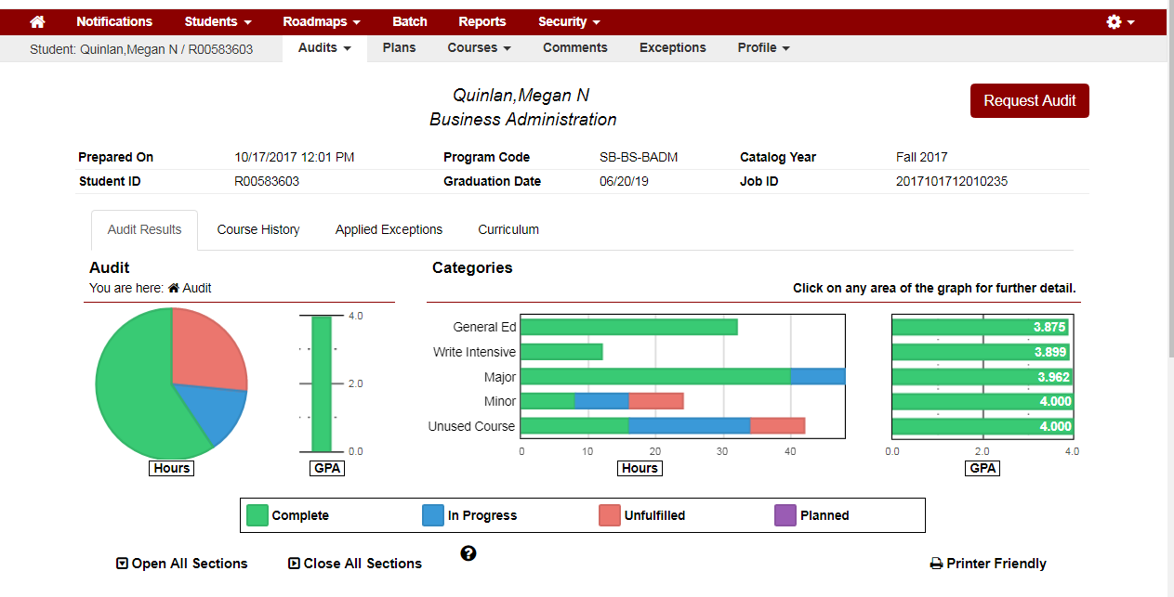

Student name (Last Name, First Name)

General Student Information

The **Categories** bar graph shows the status of some of the specific requirements in the audit.

**Pie Chart:**   
 Visual representation of the minimum credit hours required to graduate, including completed, in progress and unfulfilled courses

Click on **this question mark** to get a pop-up legend to display with an explanation on items in the audit

**Expand/Collapse Options**  
Open all sections to view more details about each requirement.

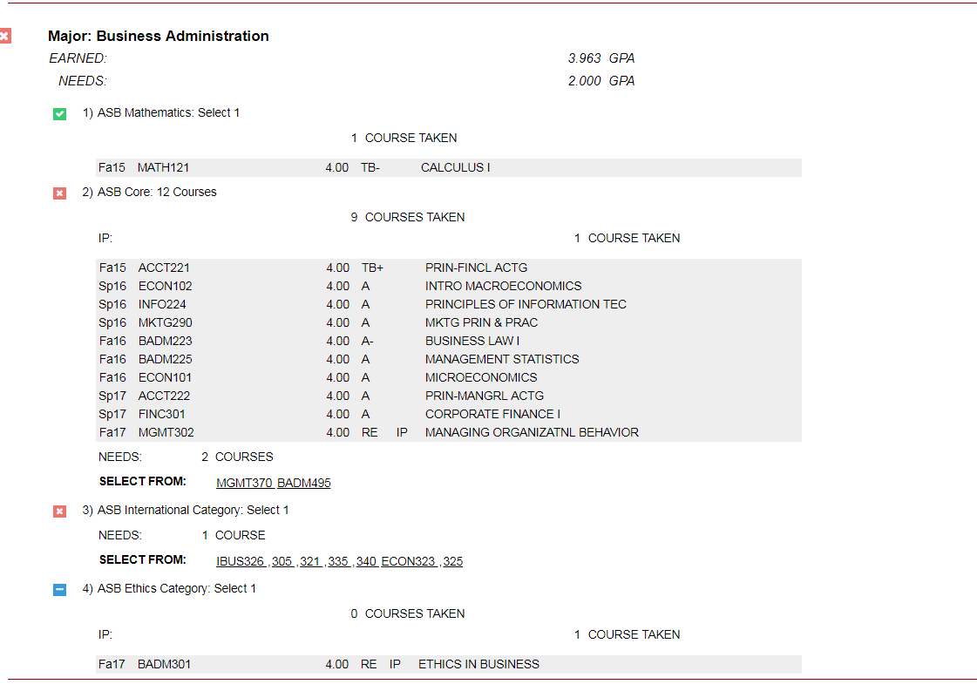

**Degree Requirements**  
Required courses for a student’s degree, are broken down into requirements varying by degree. Requirements can be further broken down into sub-requirements. Each sub-requirement must be fulfilled in order to complete the whole requirement.

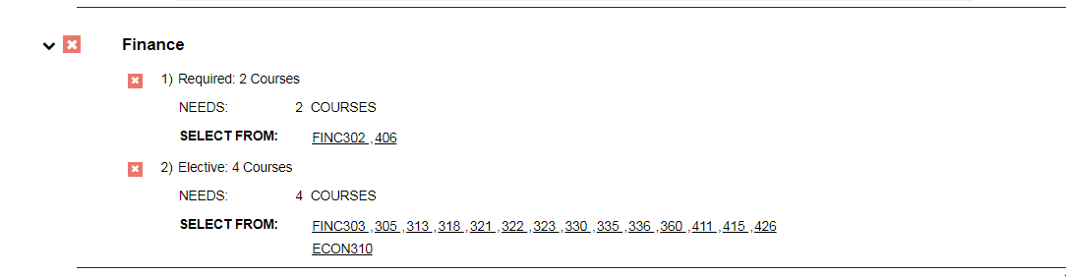

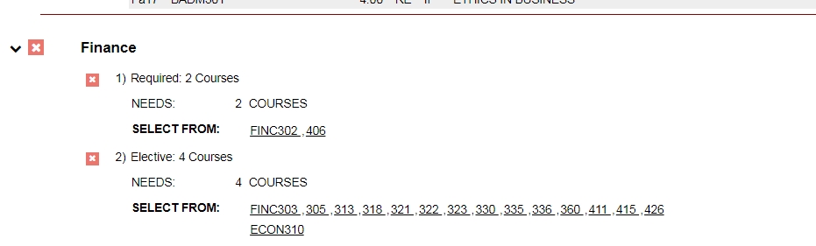  
  
  
  
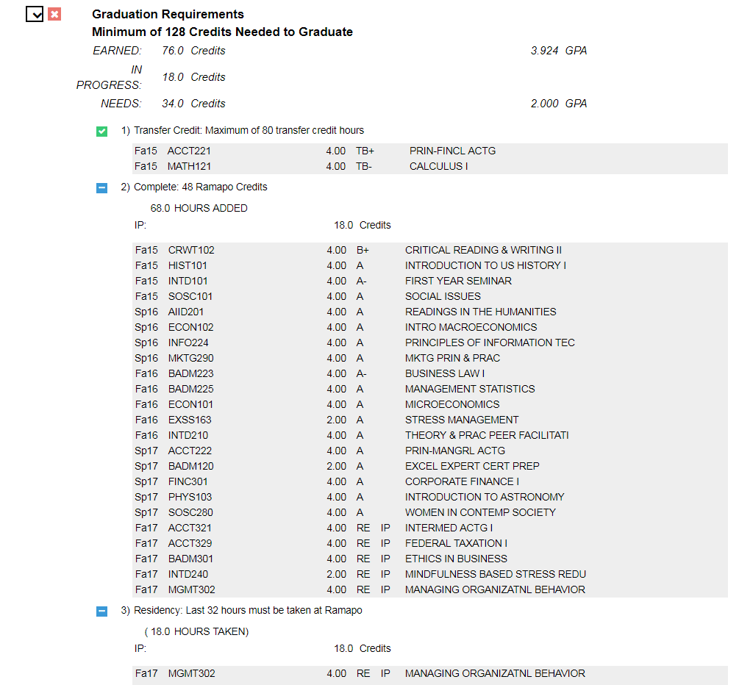

Do **NOT** click on course number part of the planner piece.

**Graduation Requirement (All Majors):**

Min. 128 Credits

Min GPA 2.0 (For Most Programs)

Complete: 48 Credits at Ramapo

Residency: Last 32 Credits taken at Ramapo

Courses that will fulfill the sub-requirements

**Requirements that have not been completed:**   
If you have a requirement or sub-requirement that is not complete, there will be information below the requirement/sub-requirement. It will list either the number of hours, number of courses, or number of credits needed to be complete the requirement or sub-requirement.

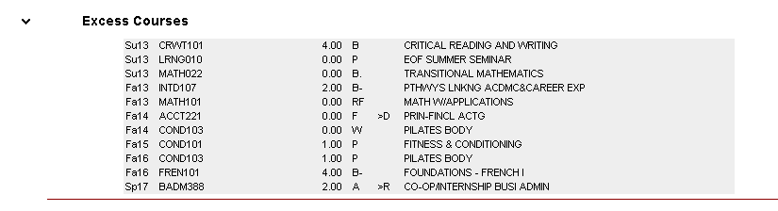

**Excess Courses:**Any course that do not satisfy degree requirements will be in this section of the degree audit.

This section will contain courses that students have taken in excess of their degree audits as well as

Repeat Courses  
Withdrawn Courses  
Failed Courses

**Legend—Course Codes**

IP In Progress  
TX Transfer Course (TA, TB etc.)  
W Withdrawal  
RF Repeat Failed  
>D Duplicate Courses  
>R Repeat Courses

## **Other Information on the Audi**t

There are three tabs that can be found on the audit itself. These are the Audit Results, Course History, and Applied Exceptions tab. You can find an explanation of each below.

Audit Results

**The Audit Results Page displays a student’s audit result.**

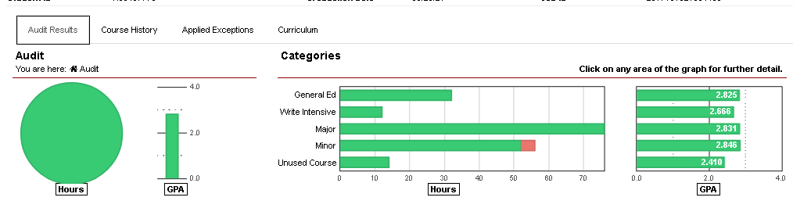Course History

The **Course History Tab** includes information such as completed, in-progress, and transfer courses as well as the term GPA. Course History can be sorted or filtered by grade and/or term.

* To sort the table, click on the header for the column by which you would like to sort.
  + Example: Click on the *Course* header, the table will be sorted by course A-Z
* To filter the table for a grade or term, use drop down list in the “Filter by” section and click on the arrow.

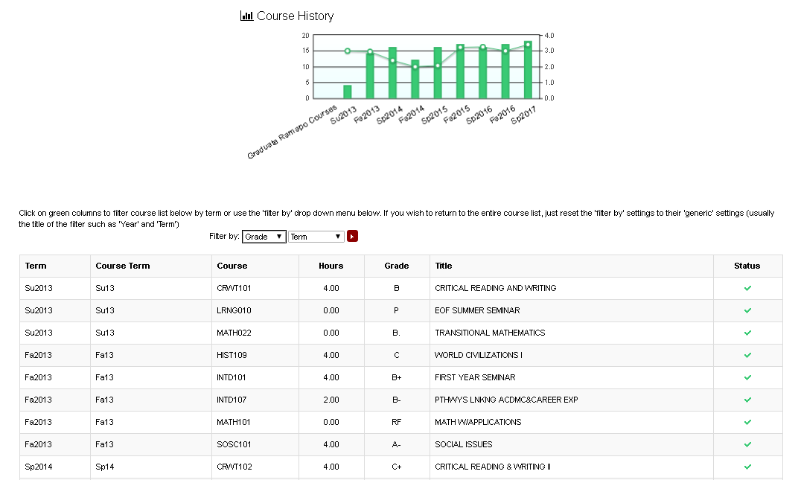

Lists   
Filter for the grade and the quantity of grades in the audit.

Applied Exceptions

This section of the audit would show any exceptions that have been applied to a student’s audit.

## Important Notes to Remember

* U.Achieve is integrated with Banner TST8. The system reads Banner and populates student information into the audit.

Running Declared Program

* When an audit is run for the student’s declared program, U.Achieve will look at Banner and pick up any courses that are checked/marked SHACRSE/SHADEGR record.

Running What-If Audits

* When an audit is run for a student in a What-if scenario, U.Achieve will look at Banner and pick all courses in a student’s history regardless of whether it is checked on a SHADEGR record, will fall into excess.

Questions/Assistance

Please contact the U.Achieve Degree Au