# Obtaining a Class List in Web Self Service 9

Log on to Web Self Service

**Click on Faculty Service** 

**Finding the Student**

* Click on Faculty Detail Schedule
* Select the Term from the Pull Down Menu
* Select the CRN
* Click on Class List (Located under Roster) [Blue Circle]

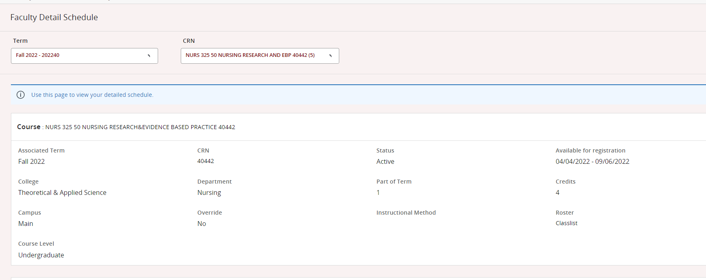

* The Class List will appear. (You can click on the student’s name for additional information.)

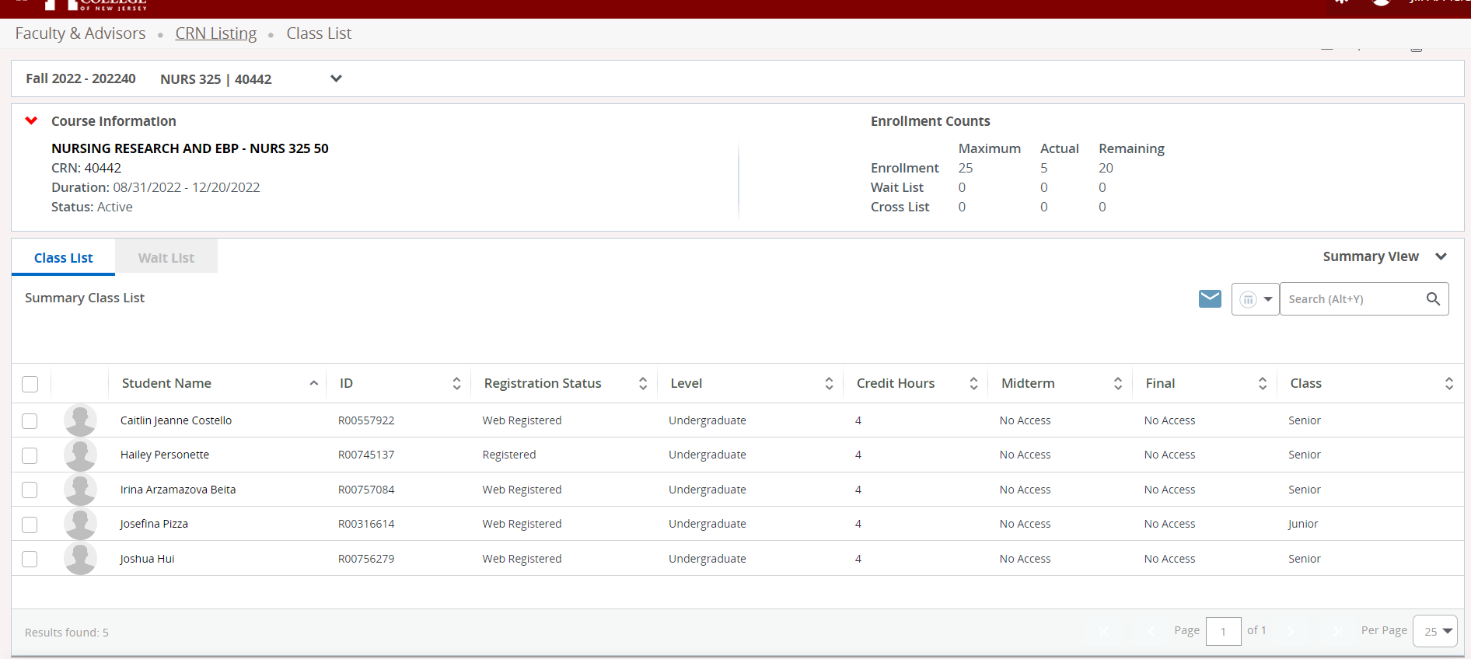

Checks All Students

Checking only one box or multiple boxes will check only those individual students

Email Link. Will ask you to confirm your email provider.

Enrollment Information

Course Information

If you have a larger class, the students may not all be viewable on the screen. Check the page numbers. (Blue Circle) You can increase the number entries on the page by using the pull down menu. (Yellow Circle)