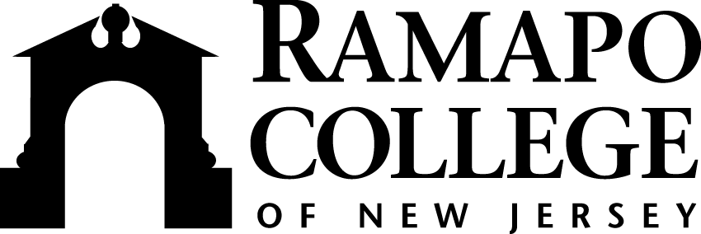 | Center for Student Success  505 Ramapo Valley Road, Mahwah, NJ 07430-1680  Main Office: Room D 207 Phone (201) 684-7441 Fax (201) 684-7599 Email success@ramapo.edu  www.ramapo.edu/studentsuccess/
Student Success (Advisement, Career Development, Center for Reading & Writing, Connect, EOF, New Student Experience & the Testing Center)

Vision Statement
Student Success guides students throughout their first year and beyond by providing services, resources and experiences that facilitate a student’s acclimation into the Ramapo College community. Collectively, these services and resources provide students a foundation to advance their learning and progression towards graduation. Student Success provides the campus and surrounding community with the resources to foster student engagement and create a culture of academic advisement and success.

Student Success Unit Responsibilities Related to Faculty
Academic Advisement
- Implements and updates the Academic Advisement Plan for the College
  - Current plan follows:
    - First-Year students are advised by Student Success’s professional advisors prior to and throughout their first-year (all advisement is mandatory)
    - Upper-class students are advised by faculty advisors (advisement is mandatory in the third and sixth semesters)
  - Coordinates the Academic Advisement Council, which includes faculty from every School
- Advises students on an individual basis for matters relating to academic planning, graduation requirements, off-campus study, personal matters that affect academic planning, etc.
- Web sites:
  - http://www.ramapo.edu/myadvisor/
  - http://www.ramapo.edu/myadvisees/
- Upcoming Trainings:
  - Unit Council Meetings
  - Email your School Liaison for immediate needs/questions:
    - ASB – Diana Benavides, dbenavid@ramapo.edu
    - CA – Paula Ihne, pihne@ramapo.edu
    - SSHGS – Nicole Pedoto, npedoto@ramapo.edu
    - SSHS – Kevin Brenfo-Agyeman, kbrenfoa@ramapo.edu
    - TAS – Jessica Steinheimer, jsteinhe@ramapo.edu
    - Associate Director –John Yao, jyao@ramapo.edu

Cahill Career Development Center
- Advising for career planning, graduate school, job/internship search, resumes, cover letters, networking, interviewing, LinkedIn Profile, etc.
- Pathways program - required for all students
  - https://www.ramapo.edu/careercenter/exploration/
- Cooperative Education - Students work at a relevant internship and earn academic credit
  - Faculty oversee academic requirements
- Student Assistant Program - Over 800 student employees
- Website: https://www.ramapo.edu/careercenter/
- Unit Council/School Liaisons:
    - ASB-Cynthia Michalewski, cmichale@ramapo.edu
    - CA-Debra Stark, dstark@ramapo.edu
    - SSHGS-Debra Stark, dstark@ramapo.edu
    - SSHS-Danielle Graziani, dgrazian@ramapo.edu
    - TAS-Asal Salah, asalah@ramapo.edu
    - Associate Director-LaQuan Norman, lnorman@ramapo.edu

Connect Resources – Academic Progress Survey Software
- Provides a convenient way to support your student’s learning and progress by raising academic progress items when you observe excellent work or performance that concerns you, ensuring that the professional staff on campus who can intervene are aware.
- Accessible through web.ramapo.edu, Connect will automatically display students that are enrolled in your courses. From there, you can begin raising academic progress items about students, review items that have been raised about your students, provide additional information and close the loop with other faculty and advisors in your student’s available Success Network.
- Web site: http://www.ramapo.edu/connect/
- Assistant Director-Tracey Bender, tpastori@ramapo.edu

Educational Opportunity Fund Program
- The mission is to provide access to higher education and support for highly motivated students who exhibit the potential for success, but who come from families/communities disadvantaged by low income and a lack of access to quality educational preparation necessary to attend college. The EOF program provides such students full-time admission to the college, and the support needed to maintain their continued enrollment through graduation.
- Program Highlights:
  - Career Development, Faculty Mentorship, Financial Support, Leadership,
Student Development Specialists
- Website: https://www.ramapo.edu/eof-program/
- Director-Nicole Videla, nvidela@ramapo.edu
- Associate Director-Dee Foreman, dforeman@ramapo.edu

New Student Experience
- Provides transitional programming for first-year and transfer students. These programs include:
  - Orientation: separate programs for First-Year and Transfer students and their families
  - Welcome Week: extended orientation programming right before students start classes
- Coordinates Peer Facilitator Program, which facilitates weekly mentoring from upper-class students, through the General Education First-Year Seminar course (each course of approximately 25 students has 2 peer facilitators)
- Transfer Center and Veterans Lounge
- Web sites:
  - http://www.ramapo.edu/orientation/
  - http://www.ramapo.edu/welcome/
- Assistant Director-Meghan Gregory, mgregory@ramapo.edu

Testing Center
- Provides placement testing in writing/critical reading, mathematics and languages
- Administers CLEP testing through the College Board, which allows students to earn academic credit for prior knowledge through testing
- Proctors accommodated testing in collaboration with the Office of Specialized Services (OSS)
- Web site: http://www.ramapo.edu/testing/
- Assistant Director-Tracey Bender, tpastori@ramapo.edu

