All-College Sustainability Major (SUST): Proposal to ARC
Proposed by Ashwani Vasishth & Sangha Padhy
In consultation with Mike Edelstein, Eric Wiener & Rikki Abzug

FEASIBILITY SECTION

Program Proposal

We propose a thirteen course (52 credit), all-College, trans-disciplinary Major in Sustainability, to be launched in the Fall of 2018. The trans-disciplinary structure of the major effectively supports students to double major, or to minor in some other field.
(The term “trans-disciplinary” is used here with intent, and distinct from the more conventional “inter-disciplinary,” to refer to a very particular humanities-oriented holistic approach. Inter-disciplinarity analyzes, synthesizes and harmonizes links between disciplines into a coordinated and coherent whole. Trans-disciplinarity integrates the natural and social sciences in a humanities context, and transcends their traditional boundaries.)

Many cutting edge organizations have argued that a well-rounded individual is one who has solid depth in some one area of specialization, while simultaneously demonstrating a significant trans-disciplinary breadth of knowledge. In our view, sustainability is not a discipline, in the conventional sense, but rather a field of study, which demands just such a balancing of depth and breadth.

Program Summary

This is a proposal for an trans-disciplinary undergraduate baccalaureate degree in Sustainability to be offered in the School of Social Sciences and Human Services (SSHS), in close collaboration with the Anisfield School of Business (ASB), the School of Communication Arts (CA), the Salameno School of Humanities and Global Studies (SSHGS) and the School of Theoretical and Applied Science (TAS).

The BA in Sustainability requires thirteen courses (52 credits), including a three course (12 credit) disciplinary concentration. Of the thirteen courses, ten courses will be in the field of Sustainability and three courses will draw from foundational courses in a diverse array of majors across the College (negotiated in advance with these majors), which will ground students in foundational knowledge in a disciplinary field of their choice. Of the other ten Sustainability courses, eight courses will provide students a foundational understanding of Sustainability as a trans-disciplinary field, drawing on courses from the School of Business, the School of Theoretical and Applied Sciences and the School of Social Science and Human Services (four of the courses offered are preexisting courses, and the rest are built with a focus on trans-disciplinary methods of inquiry). The additional two courses are capstone courses, which will showcase trans-disciplinary engagement with pressing social, ecological and economic issues of our time, at the global, national and local levels.

Contemporary ecological, economic, and social crises represent unprecedented challenges and opportunities for the ways in which we interact with the ecosphere. Driven by increases in population, coupled with rapidly increasing per capita consumption rates, and the consequent contamination and degradation of natural capital and a disproportionate distribution of the burden on vulnerable communities, our current path is clearly unsustainable. As local governments, civic society, organizations and businesses increasingly recognize the need for alternative practices, individuals who can implement trans-disciplinary and integrative approaches are sorely needed to grapple with the problems of the Anthropocene (the term coined to describe our current geological age, the metaphor of our times; representing the environmental, economic, and cultural transformations wrought by humans on the ecosphere since the start of the industrial revolution).

This requires practitioners with substantial depth in some area of specialization and also, broadly trained in trans-disciplinary methodologies and with the habits of mind grounded in a systems approach, to address the intersection of human activities that are generating sustainability crises at unprecedented scales, and develop solutions that integrate across normally siloed domains. The Sustainability Major takes an approach to Education for Sustainability (EfS) that clearly transcends disciplinary boundaries, while being grounded in a systems approach to an equity-based nested-Triple Bottom Line model.
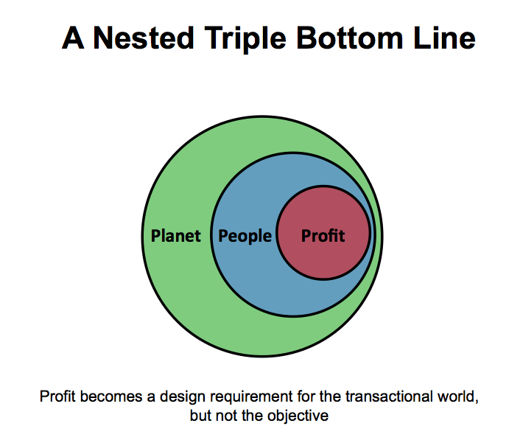
Program Impact On the College’s Other Programs

In general, the impact of this proposed Sustainability Major is expected to be entirely positive. It is expected that the creation of this major will make the College more attractive to Millennial generation students, who are clearly more conscious of the exacerbating adverse impact of human actions upon planetary processes. A rapidly growing movement to formalize this current geological period as the Anthropocene—an epoch in which humans have come to rival geology as a force that shapes the planet—makes it almost imperative that the ways in which we teach and learn keep up with the ways in which we come to know our world and the ways in which it happens.

There is also a growing movement across our catchment area, in which colleges and Universities are working to find ways to teach majors dedicated to the growing field of Sustainability—whether from a science- or social science-perspective. For example, both Rutgers New Brunswick and the New Jersey City University are currently in the process of figuring out how they might establish and launch their own majors in Sustainability.

In addition, the Center for Sustainability at Ramapo College of New Jersey has just been designated as a regional Center for Sustainability Across the Curriculum, by the Association for the Advancement of Sustainability in Higher Education (AASHE). This designation, competitively attained in collaboration with the New Jersey Higher Education Partnership for Sustainability (NJHEPS), makes it particularly beneficial to the College to have a dedicated Sustainability Major.

With regard to most programs within the College, there will be no adverse impact. However, the case of the Environmental Studies program is somewhat different. Here, at least on the face of it, there appear to be substantial risks of overlap and duplication—particularly from within a conventional disciplinary view. But, after extensive discussion with the ENST Faculty, we collectively feel that establishing the SUST program at RCNJ will have a wholly positive effect for the college and for both majors. Growing Ramapo’s sustainability brand will allow both ENST and SUST to attract more students, one building upon the other.

Conceptually, we (SUST and ENST, collectively) propose that the two majors share four Foundational courses—as outlined below—and then branch out into their own distinct sequence of coursework.
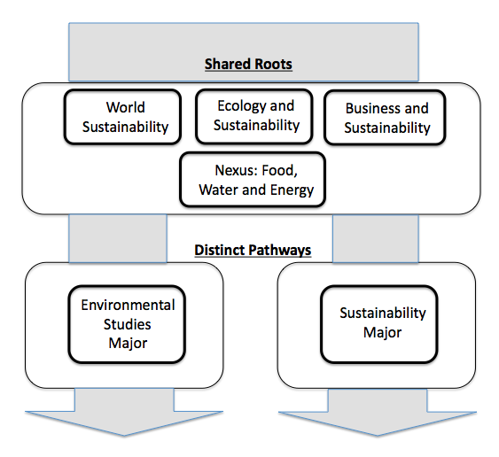

Program’s Need:

Sustainability is integral to Ramapo College’s mission, vision, and values as a Public liberal arts institution with a commitment to prepare students to be responsible citizens of the future. This includes preparing students not only in the traditional liberal arts curriculum of the arts, humanities, social science, mathematics and the natural sciences but also equipping them with the tools to understand and grapple with the complex, interconnected, and ever-changing issues of our times. Sustainability fills this niche in liberal arts curriculum of building the habits of mind, which allow us to explore connections, interdependencies, and practices through a whole systems approach.

In the Chronicle for Higher Education (2006), Frank Rhodes, former Cornell University President, labeled Sustainability as “the ultimate liberal art”. The support for Sustainability in liberal arts institution is a growing movement in Higher Education in the US, evident in shifts in the operational practices of campuses urging sustainability, with sustainable campuses emerging as learning laboratory, and curricular changes to infuse integrated, experiential learning. Some 697 institutions in the country, including Ramapo College, have signed the American College and University Presidents’ Climate Commitment (ACUPCC), which not only focuses on reducing carbon footprints in operations but also introducing sustainability in the academic curriculum. The ACUPCC text reads: “Campuses that address climate change by reducing global warming emissions and by integrating sustainability into their curriculum will better serve students and meet their social mandate to help create a thriving, ethical and civil society” (2012). This also directly ties to the mission of Association of American Colleges and Universities (AAC&U), which asserts the need for a knowledge of human cultures and of the physical and natural world, with skills ranging from critical thinking to problem solving, and to the development of personal and social responsibility.

There is sufficient evidence that Sustainability is both a necessary and promising area of study. Nationally, the programs at Arizona State University, Emory, and Ithaca College have been trendsetters in building sustainability programs at the undergraduate level, and across disciplines. In New Jersey, there has been an increase in commitment to Sustainability studies as well, notable examples being Drew, Montclair, William Patterson, Stockton, Mercer, and Kean, as well as Rowan, and Passaic Community College. However, many of these programs are essentially science based, and hence limited in their ability to build a truly trans-disciplinary focus attending to needs of businesses, organizations, civil society, and governments that increasingly demand practitioners who can grapple with scientific issues while at the same time situating themselves in society’s moral, social, economic, humanistic and policy context.

Ramapo College is well poised to fill this gap, and also, to be a leader. Our strengths are not only in a long tradition and commitment to sustainability but also the wide commitment to inter-disciplinarity and experiential learning, across all disciplines. This enables us to deliver a sustainability curriculum that combines deep expertise with lateral knowledge crossing traditional disciplinary boundaries.

Comparison with Similar Programs in New Jersey

There are a number of programs clustered around the theme of Sustainability, although many of these are focused on Sustainability Science, as opposed to Sustainability Studies, and none of them take the integrative approach to cross-disciplinary education that we are innovating.

Private Liberal Arts Colleges:

Drew University’s Environmental and Sustainability Studies is a twelve course major with environmental studies track or a thirteen course major with environmental science track. Of the required common courses, two provide foundations in ecology and environmental science, one in environment and society, one in GIS methods, and one is a capstone course. The other seven or eight courses are fulfilled in environmental science and environmental studies. The departments website emphasizes multidisciplinary learning in sustainability, and also highlights the importance of environmental and sustainability majors to careers in research, environmental law, non-profit work, consulting, and work with state and federal environmental agency.

Public Liberal Arts Institutions:

Kean University’s undergraduate degree in Sustainability Science is a fourteen course program, with ten required courses in environmental science and law, and four electives in environmental studies and science. The program is heavily geared towards the sciences, with a few studies class. The website does recognize the role of interdisciplinary learning.

Montclair State University’s undergraduate degree in Sustainability science integrates natural and physical science with social science, economics, policy, and project management to prepare sustainability professionals and managers. Their focus is to provide a comprehensive understanding of earth’s systems, organizational processes, and policy although most of the course work draws from the sciences requiring students to take five core and six collateral courses in sciences and two in economics, six electives, and a math course. The program, also, lists a growing number of professions that call for Sustainability professionals and managers such as Alternative energy specialists, Business operations specialists, Chief Sustainability Officer, Energy and water usage auditors and managers, Environmental lawyers, Financial analysts, Project managers, Recycling coordinators.

Stockton University’s undergraduate degree in Sustainability studies is a 64 credit program, which trains students to develop, broad, interdisciplinary education with a focused expertise in a career field. The curriculum integrates natural sciences, technology, economics, policy, and ethics. Students pursue either a BS or a BA degree, and undertake focused study on topics such as alternative energy, pollution, conservation, public policy and law, and sustainability management in business and industry. The curriculum notes the importance of community engagement and experiential learning. Additionally, the program notes the growing need for sustainability professionals in community organizations, government, and businesses.

William Patterson University’s undergraduate degree in Environmental Sustainability is part of the science curriculum and includes thirty credits of core courses, six credits of policy and six credits electives and twelve credits of advanced courses. The program’s focus is on science curriculum and requires students to take policy courses as well.

Anticipated Enrollment

Based on observation across the field, and on experience with the current student population at Ramapo College, we expect an initial enrollment of about 8 to 10 students in the first year, and anticipate about 15 to 25 students per year within five years, with a steady state of about 30 students per year.

Additional Resources Needed

Of the 13 courses being proposed here, seven are existing courses, and six are new courses—that is to say, less than 50% of all courses being deployed for this Major are new courses.
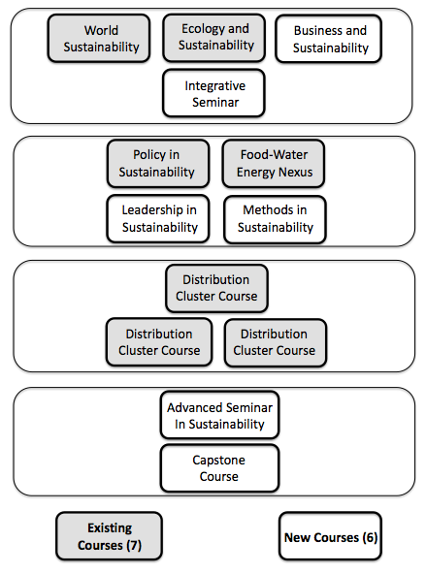
In terms of Institutional Resources, we ask that the Sustainability program be given strong publicity in the Enrollment marketing process, and that the College commit to giving the program a significantly prominent place in the social media streams that support Enrollment Management.

In order to meet the needs of the program, given anticipated growth projections, and the potential for retirement among existing faculty, we would ask for two new lines within three years.

CURRICULUM SECTION

Program Proposal

The Major will comprise of:
- three Foundational Courses
  - Science course- Ecology and Sustainability (SUST 2XX),
  - Business course-Business and Sustainability (SUST 2XX)
  - Social Science course-World Sustainability (ENST 209)
- one Foundational Integrative Seminar,
- four Core Courses
- three thematic Disciplinary Course Clusters (drawn from any one Program on campus that chooses to participate in this arrangement—see detailed list below),
- one trans-disciplinary, pre-Capstone Advanced Seminar, and
- one culminating Capstone Course

The three Foundational Courses will follow the triple-bottom line model, often characterized as People, Planet and Profit. One of these courses will focus on social science for sustainability, broadly speaking. One will focus on the business of sustainability. And the third will be on an ecological approach to sustainability.

The Foundational Integrative Seminar in Sustainability will serve to synthesize across the three Foundational Courses, considering sustainability in its broadest formulation, and serving to position students to choose from the Disciplinary Course clusters. This Seminar Course would be Writing Intensive.

The four distributional Core Courses will ground students in the techniques and issues that make sustainability action trans-disciplinarily substantial and meaningful. These will be:
- Food-Water-Energy Nexus course, Energy and Society, ENST 223, existing course,
- Policy in Sustainability course, Environmental Policy and Regulation, ENST 317, existing course,
- Leadership in Sustainability course, new course and
- Methods in Sustainability course, new course.

The three thematically clustered Disciplinary Courses will allow students to delve more deeply into any one selected field. Some examples of such Majors with which we have arrangements in place are:
- Environmental Studies, School of Social Science and Human Services
Choose Three
  - ENST 338 Sustainable Communities,
  - ENST 313 Appropriate Technology,
  - ENST 335 Ecology, Society and the Sacred
  - ENST 336 Global Ethics
  - ENST 339 Sustainable Agriculture
  - ENST 340 Climate Change,
  - ENST 303 Water Resources,
  - ENST 304 Forest Resources,
  - ENST 390 Native Plants,
  - PSYC 343 Environmental Psychology
- Environmental Science (Earth Science Track), School of Theoretical and Applied Sciences
  - GEOL 105: Fundamentals of Geology lec/lab
Choose Two
  - GEOL 326: Paleontology lec/lab
  - GEOL 333: Environmental Geology
  - GEOL 327: Geology of New Jersey
  - ENSC 305: Climate Change Science
  - GEOG 303: Water Resources
- Food Studies, School of Social Science and Human Services
  - ANTH 220: Food & Culture
Choose Two
  - BIOL 345: Nutrition & Human Metabolism
  - BIOL 346: Food Science
  - ENST 339: Sustainable Agriculture
  - SOCI 309: Food And Population
- Law and Society, School of Social Science and Human Services
  - LAWS 131: Law & Society
  - LAWS 251: Law, Power & Inequality
Choose One:
  - LAWS 206: Human Rights
  - LAWS 220: Law & Economic Thought
  - LAWS 250: Law & Sustainability
  - LAWS 329: Law & Globalization
- Sociology, School of Social Science and Human Services
Choose Three
  - ANTH 225: International Migration
  - SOCI 302: Third World Women
  - SOCI 309: Food and Population
  - SOCI 303: Sociology of Culture, OR
  - SOCI 306: Environmental Sociology
- Psychology, School of Social Science and Human Services
  - PSYC 101: Introduction to Psychology
  - PSYC 226: Social Psychology
Choose One
  - PSYC 220: The Psychology of Yoga
  - PSYC 218: Forensic Psychology
  - PSYC 231: Multicultural Psychology
  - PSYC 227: Cognitive Psychology
  - PSYC 239: Cross Cultural Psychology
  - PSYC 263: Child Psychology
  - PSYC 314: Abnormal Psychology
  - PSYC 345: Industrial & Organizational Psychology
  - PSYC 343: Environmental Psychology
- Contemplative Studies, School of Social Science and Human Services
Choose Three
  - INTD 240: Mind Based Stress Reduction Seminar (2 credits) AND
  - EDUC 205: Contemplative Practices in Education OR
  - EDUC 230: Methods of Contemplative Education for Children and Youth
  - Psych 220: Psychology of Yoga OR
  - Psych 430: Contemplative Psychology
  - Phil 235: Asian Philosophy
- Philosophy, Salameno School of Humanities and Global Studies
Choose Three
  - PHIL 201: World Wisdom Traditions,
  - PHIL 333: Ethics,
  - PHIL 328: Bioethics and
  - POLI 206: Political Theory
- Management, Anisfield School of Business
Choose Three
  - ECON 102 Macroeconomics
  - MKTG 290 Marketing: Principles & Practices
  - BADM 301 Ethics in Business
  - IBUS 326 Fundamental of International Business

These Disciplinary Course Clusters, comprising of three courses each, will be taken from any of the areas of study within the College that choose to participate in this proposed Program, with the caveat that one sustainability-related Student Learning Outcome be infused into each of the three Disciplinary Courses. (The emphasis here is on the word “related.” We are not proposing that the SLO be a sustainability SLO, but rather that it be related in some meaningful way to the theory and practice of sustainability.) This caveat has been part of the negotiation with each of the Program Conveners, and will remain a precondition for including courses from any existing Program into our Major.

The Advanced Seminar in Sustainability will serve to bring back to the center the knowledge students have gained in their foray into the clustered Disciplinary Courses, synthesizing across the chosen disciplines to ground students once more in the supra-disciplinarity of Sustainability as a field of study. Potentially, a 40 hour Experiential Component would be built into this Seminar Course.

The culminating Capstone Course will showcase the learning that each of the students has effected throughout the Major.

We are asking that the first three Foundational Courses within the Sustainability Major be designated as General Education courses, although only two will double-count for any one student. Our purpose in making this request is to a) ensure that a broad range of Ramapo students are exposed to a diverse array of perspectives structured around sustainability; and, b) provide multiple gateways to attract students who might be interested in majoring with the SUST program, or who might be inclined to double Major with us.

Program Assessment

Goals and Student Learning Outcomes

The Sustainability program has three overarching goals, which are formulated into six Student Learning Outcomes, some of which have sub-categories.

- Sustainability Literacy: Students will acquire the knowledge and wisdom to foster a sustainable world, with particular attention to an transdisiciplinary and holistic systems approach.

  - Students will examine the complex and dynamic network of relationships that exist in ecological systems, economic structures, and community dynamics: appreciate that these relationships exist at the national, local and global levels.
  - Students will develop foundational knowledge of theories of sustainability theories and its discourses, from the vantage of a systems approach to solving problems of sustainability.
  - Students will critically analyze public policy settings at the global, national and local level, and apply it to policy making for sustainable communities.
  - Students will gain expertise in understanding the integrative nature of Food, Energy and Water to arrive at an agenda for action through the use of a Nexus approach.
  - Students will learn about leadership models for bringing change in varied and complex organizational settings.
  - Students will explore and develop the complex set of skills and abilities needed for sustainable interventions and assessment.

- Methods and Practice of Sustainability

- Students will engage in systems perspective to address societal problems.
- Students will learn the technique of conducting multi-method research design through training in qualitative and quantitative research methods.
- Students will show the ability to apply diverse methods and techniques to sustainability research so as to guide decision makers toward sustainable solutions.
- Students will practice the methods of participatory decision-making among stakeholders to achieve sustainability.
- Students will address an issue incorporating sustainability research methods and addressing the issue from a triple bottom line perspective.

- Critical Thinking & Communication. Students will demonstrate an ability to critically acquire, analyze, synthesize and communicate information about sustainability—in oral, written and electronic media formats—to diverse audiences, so as to facilitate informed decision making.

  - Develop critical thinking and problem-solving skills.
  - Learn to address decision-making under complex situations and within complex organizations.
  - Learn to apply sustainability to personal, professional and academic living experiences.
Goals | Objectives | Introductory courses:  1) World Sustainability  2) Natural Resources  3) Business and Sustainability | Foundational Integrative Seminar | Methods | Policy | Issues | Leadership | Advanced Seminar | Capstone Course
1. Sustainability Literacy | Students will examine the complex and dynamic network of relationships that exist in ecological systems, economic structures, and community dynamics: appreciate that these relationships exist at the national, local and global levels. | I |  |  | R | R |  | R | R
1. Sustainability Literacy | Students will develop foundational knowledge of theories of sustainability theories and its discourses, from the vantage of a systems approach to solving problems of sustainability. |  | I |  |  |  |  | R | R
1. Sustainability Literacy | Students will critically analyze public policy settings at the global, national and local level, and apply it to policy making for sustainable communities. |  |  |  | I(F)
1. Sustainability Literacy | Students will gain expertise in understanding the integrative nature of Food, Energy and Water to arrive at an agenda for action through the use of a Nexus approach. |  |  |  |  | I(F)
1. Sustainability Literacy | Students will learn about leadership models for bringing change in varied and complex organizational settings. |  |  |  |  |  | I(F)
1. Sustainability Literacy | Students will explore and develop the complex set of skills and abilities needed for sustainable interventions and assessment. |  | I | I (F) | I | I | I(F) | R | R
2. Methods and Practices of Sustainability | Students will engage in systems perspective to address societal problems. |  | I | R |  |  |  | R | R
2. Methods and Practices of Sustainability | Students will learn the technique of conducting multi-method research design through training in qualitative and quantitative research methods. |  |  | I(F) |  |  |  | R | R
2. Methods and Practices of Sustainability | Students will show the ability to apply diverse methods and techniques to sustainability research so as to guide decision makers toward sustainable solutions. |  |  | I(F) |  |  |  | R | R
2. Methods and Practices of Sustainability | Students will practice the methods of participatory decision-making among stakeholders to achieve sustainability. |  |  | I(F) |  | I | I(F) | R | R
2. Methods and Practices of Sustainability | Students will address an issue incorporating sustainability research methods and addressing the issue from a triple bottom line perspective. |  |  | I(F) |  |  |  | R | R
Critical Thinking and Communication | Develop critical thinking and problem-solving skills. | I | I (F) | R | R | R | R | R(F) | F
Critical Thinking and Communication | Learn to address decision-making under complex situations and within complex organizations. |  | I (F) | I | I | I | R | R(F) | F
Critical Thinking and Communication | Learn to apply sustainability to personal, professional and academic living experiences. | I | I (F) | I | I | I | R | R(F) | F
Legend
I = Introduction
R = Reinforcement
F = Focus
Protocol for Program Assessment

Student Learning Outcome:
- Students will examine the complex and dynamic network of relationships that exist in ecological systems, economic structures, and community dynamics: appreciate that these relationships exist at the national, local and global levels.
- Students will develop foundational knowledge of theories of sustainability theories and its discourses, from the vantage of a systems approach to solving problems of sustainability.
- Students will critically analyze public policy settings at the global, national and local level, and apply it to policy making for sustainable communities.
- Students will gain expertise in understanding the integrative nature of Food, Energy and Water to arrive at an agenda for action through the use of a Nexus approach.
- Students will learn about leadership models for bringing change in varied and complex organizational settings.
- Students will explore and develop the complex set of skills and abilities needed for sustainable interventions and assessment.
- Students will engage in systems perspective to address societal problems.
- Students will learn the technique of conducting multi-method research design through training in qualitative and quantitative research methods.
- Students will show the ability to apply diverse methods and techniques to sustainability research so as to guide decision makers toward sustainable solutions.
- Students will practice the methods of participatory decision-making among stakeholders to achieve sustainability.
- Students will address an issue incorporating sustainability research methods and addressing the issue from a triple bottom line perspective.
- Develop critical thinking and problem-solving skills.
- Learn to address decision-making under complex situations and within complex organizations.
- Learn to apply sustainability to living experiences.

- Four year Assessment Plan:
- First year: We will assess introductory courses for Learning outcome I and World Sustainability for Outcome XIV.
- Second Year: We will assess Foundational Integrative Seminar and Methods, for Outcome II and VII.
- Third Year: We will (re)assess Goal 1 for introductory courses and goal III, IV and V respectively for Policy, Issues and Leadership courses.
- Fourth Year: We will assess capstone courses for goals VII, VIII and X.

- Direct and Indirect Assessment: Direct assessment will include student papers, project reports, and presentations. Indirect assessment will include course syllabus.

- Sample Size: We will use a random sample of 25% of all assignments and 100% of all course syllabus for direct assignment.

- Rubrics: Rubrics Course rubrics will be used to assess the assignments. Further, in the first year, since the courses are in the Gen Ed category, we will use GE rubric for assessment.

Objective | Unacceptable  (D) | Acceptable  (C) | Good  (B) | Excellent  (A)
 | 1 | 2 | 3 | 4
- Readers: For each of the specific assessments, two readers will be chosen to apply a rubric to assess the papers and student projects.

- Inter-rater Reliability: Inter-rater reliability sessions will be conducted to ensure there is no strong disagreement amongst the readers, in their respective assessments.

Assessment Plan: (2018-2019)

Outcome 1: Students will examine the complex and dynamic network of relationships that exist in ecological systems, economic structures, and community dynamics: appreciate that these relationships exist at the national, local and global levels.

Outcome 2: Learn to apply sustainability to living experiences.

Measure 1a: Syllabus assessment at the beginning of the semester: we will collect syllabi from World Sustainability taught in the fall and Natural Resources and Business and Sustainability taught in Spring. We will identify the course requirements that require examination of the complex and dynamic network of relationships that exist in ecological systems, economic structures, and community dynamics at the national, local and global levels. The convener will create a rubric identifying types of activities and assess the syllabi based on the rubric.
Measure 1 b: Syllabus assessment at the beginning of the semester: we will collect syllabi from World Sustainability taught in the fall. We will identify the course requirement that focuses on applying sustainability to the living experiences.

Achievement
Target: 90% of syllabi will include a requirement that explicitly asks the students to examine the complex and dynamic network of relationships that exist in ecological systems, economic structures, and community dynamics at the national, local and global levels.

Measure 2: The convener will ask faculty teaching the courses that require these types of activities to send her a products (such as papers, field diaries, etc.) with all identifying markers removed at the end of the semester (approximately 30-percent per class). The convener and another faculty member will evaluate the products using a common rubric and assess whether the students were in fact able to connect law in action with the course concepts.

Achievement
Target: 75% of students will demonstrate the ability to examine the complex and dynamic network of relationships that exist in ecological systems, economic structures, and community dynamics at the national, local and global levels.

Program’s Relationship to the College’s mission:

Sustainability major meets and fulfills the mission of the college to promote a sustainable society through globally engaged student community. The major meets and advances the mission of the college in trans-disciplinarity, inclusiveness, international and intercultural understanding, community involvement and experiential learning..

This all college program is committed to fostering and strengthening:
- transdisiciplinary learning
- diversity/inclusiveness through its focus on questions of equity and justice,
- experiential learning through its emphasis on problem solving skills and decision making
- International and intercultural understanding through its focus on understanding global, national or local issues and the connections
- Community involvement through participatory decision making.

Program’s Relationship to the College’s Strategic Plan

The Guiding Principles of the 2014-2018 Strategic Plan are central to Sustainability Action: Assessment, Accountability, Analysis, Collaboration, and Transparency.

Goal 2, Objective 2.4 calls for actions that move the College toward environmental sustainability. This Objective is surely supportive of this proposed Program.

Program’s Relationship to the New General Education Goals:

The program is well aligned with the goals of the new General Education curriculum.
- Explore the world: Investigate human cultures and the natural world
- Engage the world: think critically and convey new understanding.
- Experience your world: integrate and apply your new learning.
- Expand our world: develop compassion and ethical understanding across cultures and become an engaged global citizen.

Program’s Relationship to School’s Mission and Goals

“The School of Social Science and Human Services creates an transdisiciplinary learning environment grounded in experiential learning and active participation in community experience. Using social science perspectives, we engage our students in critical thinking about enduring and emerging issues of our world, including psychological, social, cultural, economic, political, legal and environmental dimensions based on principles of social justice and sustainability. The values of diversity, inclusiveness and international and intercultural understanding are integral to our process of life-long learning.”

The School’s Mission and Goals are centrally linked to the proposed Sustainability program.

Degree Requirements

Course Titles, Descriptions, and Credits

All courses are four credits each.

The Foundational Courses:

- World Sustainability (Existing Course): ENST 209: The course introduces students to an appreciation of our world through the lens of human domination of the ecosphere, within the current geologic period. The metaphor of the Anthropocene provides a useful analytical lens from within which to narrate the story of our planetary lives, and the complex relationships that link our cultures and our ecosphere. Through a critical analysis of the forces of global transformation—modernity, capitalism, colonialism, neoliberalism, and sustainable development—this course examines questions of resource access, use, distribution, disposal, as well as justice and equity in the world, and their impact on diverse communities within local, national and global contexts.

- Sustainable Natural Resources (Existing Course): ENSC 290. This course presents a broad survey of the foundational concepts related to natural resources and their sustainable management. General areas addressed include the conservation and management of energy, biological, geological and water resources, as well as specific topics of climate change, tipping points, ecosystem services, food production, residential landscapes, forestry, fisheries, wildlife conservation and the reduction and remediation of chemical contaminants.

- Business and Sustainability (New Course, Approved By ARC): BADM 2xx. This course takes up the challenge of working out an ethical and strategic approach to impact analysis from within a sustainability frame. The course covers concepts such as competitive advantage, environment impact and socio-ethical impact.. The purpose of this course is to provide a business rationale for sustainability and show how sustainability impacts organizations and their functioning. Corporate social responsibility (CSR) and Environmental and Social Governance (ESG) as well as sustainability models of for-profit and non-profit organizations will be explored.

- Foundational Integrative Seminar (New Course): SUST 3xx. In this course, students receive a foundational knowledge of core theory in the fields of Sustainability. Sustainability will be defined within different theoretical frameworks, focusing on the contextual differences, dilemmas, contradictions and gray areas, on the points of debate and dispute within the field, as well as the points of universality and consensus. This seminar will build on the foundational understanding of the issues in the introductory classes, to showcase a systems approach to solving problems of sustainability.
The Core Courses: [The Foundational Integrative Seminar, SUST 3xx, is a Prerequisite for these courses]
- Policy in Sustainability (Existing Course): ENST 317. The course focuses on Sustainability Policy inputs to students’ understanding of global and local issues. This course will introduce students to tools of agenda setting, public policy making, implementation, and assessment in the context of policy for a sustainable society. The aim is to familiarize students with major policy debates and legal principles involved in promoting sustainability such as National Environmental Policy Act, Air and Water Pollution, Energy Policy, Climate Change etc.
- The Food-Water-Energy Nexus (Modified Existing Course): Based on ENST 223. The course considers the rising global pressures brought to bear upon our ecosphere by increasing populations, rising standards of living—with the attendant increases in consumption and waste—and growing urbanization, and the effects of these pressures on Food, Water and Energy, all framed by the rapidly escalating threats posed by climate change phenomena. In an effort to arrive at some operational version of a systems approach, the course uses the Nexus Approach to arrive at an agenda for action. One argument of this course is that issues such as food, water and energy cannot be studied in isolation from each other, but must, in fact, be dealt with integratively.
- Leadership in Sustainability (New Course): SUST 3xx. The course will focus on models of leadership for change agents. Leadership skills are necessary for any effective organizational sustainability transformation. To positively influence the transformation, leaders have to be cognizant of the complex systems-based underpinning principles of sustainability. Techniques to measure and monitor the change process across the organizational value chain are presented as a toolkit to equip leaders to effectively carry out change processes. Students will learn how to make the business case for sustainability, how to anticipate and navigate opposition, and also how to mobilize organizational support for their campaigns.
- Methods in Sustainability (New Course): SUST 3xx The course focuses on appropriate means and tools for gathering information to support sustainability analysis, interventions and actions, as well as techniques for using community information to build agreement and consensus. This course trains students in multi method research techniques, integrating both qualitative and quantitative tools. An emphasis is placed on participatory approaches to documentation, discourse, valuing and decision-making and participatory design methods.
The Disciplinary Clusters:
Student will take three courses from any one of a range of pre-specified disciplinary Programs, as discussed earlier in this report, before taking the two Culminating Courses.
The Culminating Courses:
[The Disciplinary Cluster Courses are a Prerequisite to these Culminating Courses]
- Advanced Seminar in Sustainability (New Course): SUST 4xx. This is a capstone-oriented course in Sustainability, designed to develop final capstone projects. The purpose of course is to provide an experiential, project based lecture/lab space where participants can explore and develop the complex set of skills and abilities needed for implementing sustainability. The goal of the course is to equip students to develop an implementation program for their specific projects, especially focusing on defining the problem, designing the project, implementing and evaluating interventions through study of best practices and sustainability assessments.
- Capstone Course (New Course): SUST 4xx. [The Advanced Seminar is a Prerequisite to the Capstone Course] The goal of the Capstone course is to help shape the written document and oral presentation of the Capstone Project work from conceptualization, research and implementation. Participants will develop the final project, and gain experience in making professional presentations.
Course Sequencing:
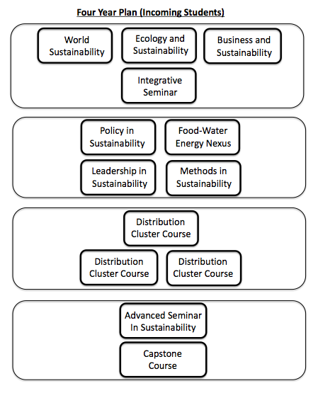

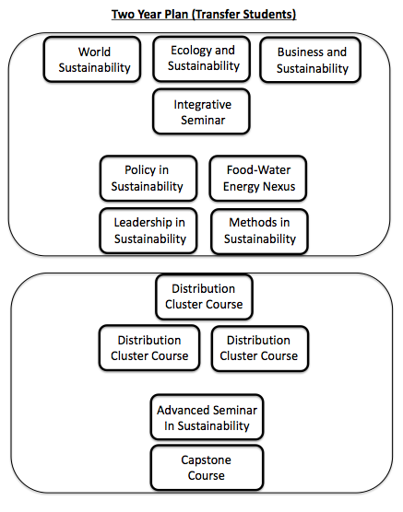
Distinction between Required and Elective Courses

There are no elective courses in this Major. All courses are required and taken in sequence. It may be necessary to make some accommodation with substitutions and equivalencies to accommodate transfer students.

Number of Credits for the Entire Program

The entire program, including the three Disciplinary Cluster Courses, constitutes a total of 52 credits.

Frank H. T Rhodes (2006). “ Sustainability: The Ultimate Liberal Art.” The Chronicle Review 53(9).
Carbon Commitment Charter Signatories. Second Nature. http://secondnature.org/wp-content/uploads/Carbon-Commitment_Charter-Signatories.pdf
It should be noted that not all Majors see themselves as “disciplines.” For instance, Environmental Studies has long held that, like sustainability, it is not a discipline but rather a trans-disciplinary field. No slight is intended to any of the Majors in calling them “disciplines.”

