 Academic Review Committee

Academic and Curricular
Guidelines Manual

Version 1.4, May 2010
Table of Contents

I. Introduction 3
II. General Education Program 4
III. Writing Across the Curriculum (WAC) Program 7
IV. First Year Seminar Description 8
V. Course Level Guidelines 10
VI. Course Enrollment Guidelines 11
VII. Course Enrichment Component Guidelines 12
VIII. Course Proposal Review and Approval Process 13
A. Course Proposal Narrative 13
B. Course Proposal Flowchart 15
C. Course Syllabus Guidelines Checklist 16
E. Course Proposal Request Form 21
F. Instructions for Completing the Course Proposal Request Form 24
IX. Program Proposal Review and Approval Process 26
A. Narrative of Program Proposal Request Process 26
B. Program Proposal Request Process Flowchart 28
C. Instructions for Completing the Program Proposal Request Form 29
X. Miscellaneous Provisions and Notes 31
XI. Record of Changes 32

I. Introduction

Dear Colleague,

The Academic Review Committee (ARC) is the standing committee of the Faculty Assembly charged with reviewing academic policies, evaluating new programs, overseeing the General Education program, and making recommendations on these areas to the Faculty Assembly. It also approves new courses. This Academic & Curricular Guidelines Manual was developed by ARC for your benefit. It is to be used by all faculty as a guide in developing new courses and revising existing ones, by new faculty as an orientation guide, and by ARC in facilitating its review and approval of course and program proposals.

The original version of the Academic & Curricular Guidelines Manual was adopted by the Faculty Assembly on February 18, 2004. This current version, dated Spring 2010, incorporates minor changes from the November 2007 version.. This Manual is available in electronic form on the Faculty Assembly website. It is a work-in-progress and will be updated periodically to reflect changes in academic and curricular policies, procedures, and guidelines.

ARC acknowledges, with appreciation, the dedication and hard work of the former Faculty Assembly Standing Committees – Academic, All-College Curriculum, General Education, and Senior Seminar – in providing baseline information for this Manual.

We greatly appreciate the dedication and contribution of the original members of the ARC: Stephen Klein (SB), Chair, Shalom Gorewitz (CA), Robert Mentore (TAS), Elaine Risch (LIB), Frances Shapiro-Skrobe (SSHS), Ira Spar (AIS), and Martha Ecker (Office of the Provost, ex officio). We also thank Jacquelyn Skrzynski (Office of the Provost, ex officio) who served on ARC for AY 2004/2005, and Linda Padley (Office of the Registrar) (AY 2002-2006) for her support services.

We thank the faculty, administration, and staff for your support of our work and encourage you to email your comments, ideas, questions and/or suggestions to any member of ARC. Current Unit ARC representatives are listed on the Faculty Assembly website; in addition, Cynthia Brennan (Registrar), Eric Daffron (Vice Provost for Curriculum and Assessment) and Michelle Johnson (Associate Director of Academic Advisement) are currently ex-officio members.

II. General Education Program

Goals

The overall goals of the Curriculum Enhancement Plan (CEP) General Education Program courses are to provide students with critical reading, writing, and analytical skills essential to a Liberal Arts education and to help them gain a foundation in academic areas which will prepare them to further develop in their majors.

All General Education Program courses will incorporate the following six information literacy goals, as mandated by Middle States Commission on Higher Education (MSCHE): framing a research question, accessing sources, evaluating sources, evaluating content, using information, and understanding ethical and legal issues affecting the use of information. In addition, all General Education Program courses should be writing intensive, when appropriate, and should be taught by full-time faculty.

The General Education Curriculum Committee (GECCo), reporting to ARC, provides oversight and manages assessment of the General Education curriculum.

Guidelines

- A course may be placed into only one General Education Program category.
- A course description should indicate how the course fits into the specified General Education Program category.
- Where double counting is permitted, a course may satisfy both the specified General Education Program category and a School or major requirement.
- As with all courses, General Education Program courses will adhere to the College course syllabus guidelines as articulated in this Manual.

For additional information, and a list of courses that fulfill each of the General Education Program categories, please refer to the General Education Program section on the College website.
GENERAL EDUCATION PROGRAM REQUIREMENTS (10 COURSES)

FIRST YEAR
100  LEVEL  One Course | INTD 101 First-Year Seminar (FYS) (Also AIID 101 and CNTP 101)  Designed especially for first-year students, First-Year Seminar (FYS) provides a comprehensive introduction to college-level learning. FYS courses are developed around an academic theme or topic based on the expertise of each course instructor, providing students with the opportunity to select a seminar that best suits their interests. FYS encourages new students to participate in a community of learners, to strengthen their critical thinking skills, and to communicate effectively both orally and in writing.
100  LEVEL  One Course | ENGL 180 College English  The objective of this course is to strengthen students' critical reading and writing. The course will include writing a research paper and developing information literacy. Students will participate in revising, peer critiquing, and faculty-student conferences.
100  LEVEL  One Course | SOSC 101 Social Issues  The objective of this course is to provide a forum for the historical, academic and personal exploration of race, class, ethnicity and gender and the ways these categories can benefit or oppress college students and American Society. It will cultivate in-depth conceptual approaches to these key areas.  OR  BADM 115 Perspectives in Business and Society  The objective of this course is to explore modern American business. The course will examine the evolution of our economic system from historical, political, sociological, economic, and cultural perspectives, and will discuss current issues that involve industry within a changing social framework.
100  LEVEL  One Course | History Category  The courses in this category develop an appreciation of change over time, and the often complex forces that have shaped the past. Students gain an understanding not just of content, but of historical process and method as well.  Courses which meet this requirement are:  HIST 101 Introduction to US History I  HIST 102 Introduction to US History II  HIST 105 Western Studies I  HIST 106 Western Studies II  HIST 109 World Civilization I  HIST 110 World Civilization II
100  LEVEL  One Course | Mathematical Reasoning Category  The courses in this category develop a student's mathematical reasoning skills including formulating and solving problems, thinking critically, and reasoning abstractly.
100  LEVEL  One Course | Science with Experiential Component Category  This category contains 100-level science that provide a significant experiential component, which could be a lab or fieldwork. Students in these courses will create and analyze data.

SECOND YEAR
200  LEVEL  One Course | AIID 201 Readings in the Humanities  This course is an introduction to major texts by authors who have produced distinctive statements about the human experience. The common core of readings will include selections from the Bible, Greek literature and philosophy, Shakespearean literature, and modern literature. The course will enhance students' appreciation of the ways historical and philosophical narratives, fiction, poetry, and drama have helped enrich our understanding of human experience through extensive reading and reflective and analytical writing.

SECOND-THIRD YEAR
200-300  LEVEL  One Course | Intercultural North America Category  Students will gain an understanding of different cultures and the relationships among cultures and peoples within North America (i.e., the United States, Canada, Mexico, and the Caribbean.) Students will reflect upon and analyze texts and products which illustrate the symbolic nature of culture and the exchange of meaning. Courses will examine cultural and artistic productions, everyday life, material culture, and other manifestations of culture, as well as how these are linked to heritages and peoples beyond North American boundaries.
200-300  LEVEL  One Course | International Issues Category  The objective of courses in this category is to provide a context through which students learn to interpret and critically analyze recent world events, focusing on the coordination of economic, cultural, social, and political activities. Courses will examine the increasing interconnectedness of nations and peoples throughout the 20th and 21st centuries.
200-300  LEVEL  One Course | Topics Category courses:  - address subject matter in historical context.  - feature readings and/or other "texts," including film and visual arts, where appropriate.  This requirement will be fulfilled by taking one Topics Category course outside of the student's major:  For arts/humanities majors - Topics: Social Science  For business majors - Topics: Arts and Humanities OR  Topics: Social Science  For science majors - Topics: Arts and Humanities OR  Topics: Social Science  For social science majors - Topics: Arts and Humanities  Topics: Arts and Humanities Category  Courses in this category introduce students to the methods of inquiry in the arts and humanities through the critical examination of works (texts, artworks, artifacts, performances, films, media, etc.). This category includes courses which provide the social, cultural, and historical contexts of the field of inquiry.  Topics: Social Sciences Category  These courses provide students with a scientific understanding of the social forces which shape human experience and society over time. Students apply theories and methods to the study of human and social development, group behavior, and the resolution of collective conflicts.

Writing Intensive Requirement
Four writing intensive courses are required: College English, Readings in the Humanities, the Disciplinary or Interdisciplinary capstone course in the student’s first major, and one other Writing Intensive course at the 200/300 level.

III. Writing Across the Curriculum (WAC) Program

The Writing Across the Curriculum (WAC) program consists of four Writing Intensive (WI) courses: (1) College English, (2) Readings in the Humanities, (3) any 200- or 300-level WI course, and (4) the disciplinary or interdisciplinary capstone course in the student’s first major.

WI courses will be capped at 25 students and have the following requirements:
- Writing will be integrated into the life of the course. Students will receive comments, direction, and support as they work on strengthening their writing skills.
- Student writing will be evaluated and returned in a timely fashion, allowing students to incorporate instructor comments into future work. Students must be able to draft, revise, and resubmit a minimum of two papers.
- Students will complete a minimum of ten pages of writing. Courses whose writing is limited to one term paper at the end will not qualify. An exception will be made for 400-level courses in which instructors provide feedback to students during development of the paper.
- Faculty teaching WI sections will be required to attend a Writing Intensive training workshop in May or June.
- The Center for Academic Success (CAS) Room: E-230, x7557 provides support services through professional and peer tutors.

The following is suggested wording to be included in WI course syllabi:

Writing Intensive (WI) Course
Writing will be integrated into the life of this course. You will receive comments, direction, and support as you work on strengthening your writing skills. Your writing will be evaluated and returned in a timely fashion, allowing you to incorporate my comments into your future work. You will be able to draft, revise, and resubmit a minimum of two papers. For help outside the classroom, please see me during my office hours and/or work with a writing tutor in the Center for Academic Success (CAS), Room: E-230, x7557.

For additional information, contact:
Professor James Hoch
Associate Professor, English/Creative Writing
Acting Director, Center for Academic Success; Acting Director, WAC Program
Phone: 201-684-7244; email hoch@ramapo.edu

IV. First Year Seminar Description

First-Year Seminar (FYS) is the first course in the general education curriculum of Ramapo College of New Jersey, and it serves as the introduction to general education and liberal learning. The goal of FYS is to develop students’ critical thinking skills using open discussion, reading, writing, and experiential learning. FYS courses are open only to first-semester, first-year students; they are designed expressly to acclimate new Ramapo College students to the higher academic expectations they will be asked to meet throughout their years of college study.

First-Year Seminar is the home of the Ramapo College Summer Reading Program. All incoming first-year students will be required to read a common book selected by students, faculty, and staff members, which will be used as a discussion topic in the FYS course. Students are expected to read the book during the summer months prior to joining the Ramapo community, and they will be asked to discuss issues raised in the reading and to write thoughtful responses to questions that develop in the course of engaging discussions.

First-Year Seminar Courses

Individual First-Year Seminars are based on themes and topics that are as diverse as the instructors who teach them. Students in all FYS courses will hone their critical reading and writing skills in the context of the course topic.

First-Year Seminar courses are categorized according to their relevance to Ramapo's academic pillars and mission statement. Students may select courses from among the following groupings:
- Experiential Learning
- Intercultural Understanding
- Interdisciplinary Studies
- International Education
- Sustainability

Some courses are specific to only one category, however, most span more than one.

Students can choose a seminar based on their general interests, or their choice can be based on their intended choice of major. Some seminars are designed to appeal to a diverse group of students with different academic and personal interests. These courses will appeal to those students who may wish to explore a variety of majors. Others are more narrowly focused and serve as preparation for those students who already know which major they wish to pursue.

Seminars have limited class sizes (20 – 25) that allow students and instructors to get to know one another in a comfortable setting. A limited class size allows students to feel welcome and to encourage participation in academic discussions that are the hallmark of seminar courses.

Most of the seminars are interdisciplinary: that is, they introduce ideas and ways of thinking from more than one discipline (history and geography, for example, or chemistry and art). Students are encouraged to choose their seminars with topics they find appealing, and to be flexible in their choices.

While First-Year Seminars differ from one another in topic and in the kind of assignments students will complete, they are similar in the following important ways. Each seminar:
- Creates a sense of intellectual community for the students and faculty member involved;
- Uses discussion as the primary basis for classroom learning;
- Emphasizes critical thinking and critical reading;
- Encourages academic growth and development of individual students;
- Uses a variety of writing, research or problem-solving assignments designed to give students the skills and modes of analysis that will serve them well in their other courses at Ramapo.

Experiential Learning

First-Year Seminars encourage students to take part in a variety of special events and to participate in hands-on learning activities. Some seminar groups go on field trips; others attend concerts, films, or campus programs together, as a regular part of the course. Visiting scholars and performing arts events are arranged specifically for First-Year Seminars. Students often prepare for the visit of an author by reading his or her work ahead of time.

Contact

Dr. Robert Mentore
Director of First-Year Seminar
(201) 684-7696
rmentore@ramapo.edu

V. Course Level Guidelines
100 Level:
Open to all college students; with few exceptions, there are no prerequisites. Target audience is first-year students.

200 Level:
General orientation is for major, minor, or program, as well as all-college audience; may have prerequisites. Target audience is sophomores.

300 Level:
General orientation is for the major, minor, or program; ordinarily has a prerequisite. Courses are more focused, requiring critical analysis and development of issues and themes. Courses for concentration of student's interest. Usually requires a term paper or appropriate project. Target audience is juniors to seniors.

400 Level:
Courses designed to demonstrate methodological skills and oriented specifically for students with an advanced level of education in a discipline and with senior-level academic skills; must have a prerequisite. Requires a major paper, project, or other instrument which demonstrates an advanced academic level and represents a significant percentage of the final grade. Target audience is seniors and advanced juniors.

Pending review by Graduate Council and approval by Faculty Assembly:
500 Level:
Courses which bridge undergraduate and graduate programs, intended for students who may not have a background in the graduate program’s content area. Courses are designed to develop methodological skills and content knowledge, to prepare students for a given graduate program. Requires a major paper, project, or other instrument which demonstrates readiness to complete 600 level courses in the program.

600 Level:
This course level is used for the majority of graduate courses, leading up to the capstone experience in the program. Requires a major paper, project, or other instrument which demonstrates graduate level work and represents a significant percentage of the final grade.

700 Level:
This course level is used only for graduate level thesis, practicum and project courses. These courses are the capstone experiences for the graduate programs. Courses ordinarily have 600-level prerequisites. Students must be matriculated in the program in which the course is offered.

VI. Course Enrollment Guidelines

The following guidelines have been developed by the Ramapo College faculty as a guide to maximum student enrollment in courses. Pedagogical practice dictates that course enrollment should be considered in its impact on student learning.

- 100-level: 35 students
- 200-400 level: 30 students
- First Year Seminar: 25 students
- College English: 21 students
- Writing Intensive: 25 students
- Studio, field work, and lab courses: limited by programmatic and/or other considerations
- Online courses 25 students
- Graduate courses 25 students
- Other courses may have specific enrollment caps.

Note: If you are proposing a new course which you believe should have an enrollment cap different from those listed above, please discuss with your convening group and dean. Class size is ultimately the purview of the administration.

Approved by Faculty Assembly, 12/12/2007; online and graduate course caps pending approval.

VII. Course Enrichment Component Guidelines

Each course will include a total of five (5) hours of unmonitored appropriate experience outside of the classroom. These experiences, which enhance student learning, could include visits to museums, guest lectures, library programs, colloquia, assigned TV shows, movies, participation in class projects, service learning, convocations, trips to professional meetings, and a wide range of other activities limited only by the creativity of our faculty and students.

The following is suggested wording to be included in the course syllabi:

Course Enrichment Component
This course will include a minimum of five (5) hours of unmonitored appropriate experience outside of the classroom. [Describe your course enrichment component here].

VIII. Course Proposal Review and Approval Process

A. Course Proposal Narrative

All proposals for new and revised undergraduate, graduate, and pre-college credit-bearing courses undergo this review and approval procedure:

1. The faculty member proposing a new or revised course assembles the following proposal package:
- An Academic Review Committee (ARC) Course Proposal Request Form
- A completed Course Syllabus Guidelines Checklist
- A course syllabus which conforms to the academic and curricular guidelines of the College
- Other supporting documentation
The School ARC representative works with the faculty member until the package is complete.
  - New courses and major revisions (e.g., change in course level, course discipline, General Education category, or significant content or title change) are sent as voting items.
  - Minor revisions (Writing Intensive designation, minor title changes, etc.) are sent as information items only.
  - Changes in prerequisites, course numbers (where course level remains the same), and minor course description changes require the approval of the appropriate Dean(s) but do not require ARC review.

2. Undergraduate Course: The faculty member secures the signed approvals of the following:
1. Convener (if there is a convening group)
2. Chair of the School Curriculum Committee (for Schools that have such a committee)
3. Chair of Study Abroad Committee (for Study Abroad Courses)
4. Director of Writing Across the Curriculum (for Writing Intensive (WI) courses)
5. Dean (not needed for EXSS and COND courses)
6. Vice Provost (for INTD, EXSS, COND and CIPL-offered courses)
Graduate Course: The faculty member secures the signed approvals of the following:
1. Faculty member’s primary undergraduate program Convener
2. Director of the Graduate Program
3. Chair of the School Curriculum Committee (for Schools that have such a committee)
4. Chair of the Graduate Directors’ Committee
5. Dean of the school offering the program
The School ARC representative works with the faculty member until the package is complete.

3. Once the proposal is complete, the faculty member submits the original and four (4) copies of the proposal to the School ARC representative no later than December 1st for the following academic year. The proposal should also be sent electronically.

4. The School ARC representative delivers a copy of the proposal to an ARC subcommittee which consists of the school representative, a second reader, the ARC chair, and the library representative. A copy is also sent to the representative from the Provost’s office.

5. At an ARC meeting, the subcommittee makes a recommendation to the full committee.

6. The ARC reviews the course proposal. If additional information is required, the School ARC representative requests the information from the responsible party or parties.

7. The ARC votes to approve or not approve the course proposal. Courses may be given full approval, approval as a first-time pilot, or not approved. If the course is approved as a first time pilot, it becomes inactive after one year and requires resubmission to ARC for full approval as a new course before it can be offered again. The ARC deadline is stated on the Course Request Form.

8. If the course proposal is not approved, it is referred back to the responsible party or parties through the School ARC representative.

9. If the course proposal is approved, the Chair of ARC notifies, by e-mail, the following:
For an Undergraduate Course:
1. Faculty member(s) proposing the course
2. Convener(s)
3. Chair of the Curriculum Committee (for Schools that have such a committee)
4. Chair of the Gen. Ed. Curriculum Committee (GECCo; if it is a Gen. Ed. course)
5. Director of Writing Across the Curriculum (if it is a Writing Intensive Course)
6. Chair of Study Abroad Committee (if it is a Study Abroad Course)
7. Dean(s)
8. Registrar
9. CAAFYE representative to ARC
10. Provost
For a Graduate Course:
1. Faculty member(s) proposing the course
2. Faculty member’s Convener(s)
3. Director of the Graduate Program
4. Chair of the Curriculum Committee (for Schools that have such a committee)
5. Chair of the Graduate Directors’ Committee
6. Dean(s)
7. Registrar
8. Director of CAAFYE
9. Provost

10. The Chair of ARC delivers the original copy of ARC-approved course proposal to the Provost for approval in a timely manner.

- If approved, Provost forwards the course request package to the Registrar. The Registrar assigns the course number, enters the course in the Course Catalog, and notifies the following:
1. Faculty Member
2. Convener
3. Dean
4. Vice Provost for Curriculum and Assessment
5. ARC chair
6. Unit ARC representative
7. Advisement
8. Transfer Admissions
9. Provost

If not approved, Provost returns course request package to request originator, and notifies by email:
1. Faculty Member
2. Dean
3. ARC Chair
4. Registrar

NOTE: ARC approval of a course indicates that it conforms to the academic and curricular guidelines of Ramapo College. Scheduling and staffing issues remain the purview of the Academic Administration.

B. Course Proposal Flowchart

Step 1: In consultation with ARC representative, faculty member prepares Course Proposal package. For major revisions such as course level change, significant content or title change, course discipline changes, or changes in General Education category, a vote by ARC is required. Minor revisions such as changes in WI designation, or course title (where content is not significantly changed) are sent to ARC as information items only. Changes in prerequisites, course numbers (where course level remains the same), and minor course description changes require the approval of the appropriate Dean(s), but do not require ARC review. A full package consists of (1) Course Proposal Request Form, (2) Course Syllabus Checklist, (3) Course Syllabus..

Step 2: Faculty member submits package for review and approval by appropriate parties, including where appropriate (1) Convener, (2) Chair of School Curriculum Committee, (3) Chair of Study Abroad Committee, (4) Director of WAC, (5) Chair of Graduate Council Curriculum Committee, (6) Dean, (7) VPCA.

Step 3:
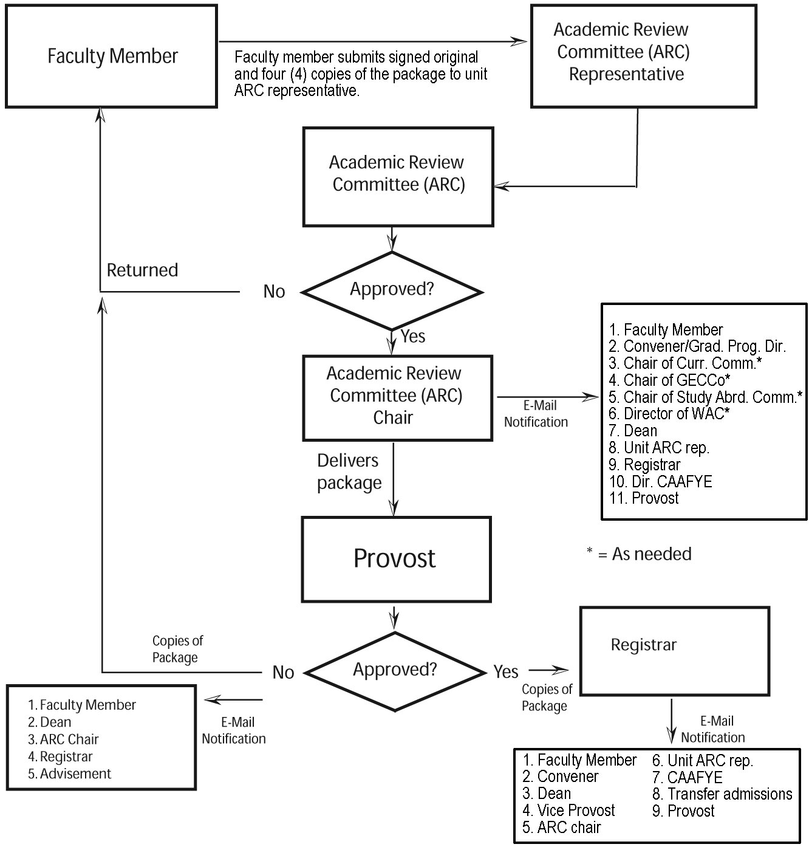

C. Course Syllabus Guidelines Checklist
The Academic Review Committee (ARC) provides the following checklist of required items for inclusion in your course syllabus. It is important that the course syllabus be detailed and comprehensive in describing the content and objectives of the course. The course syllabus constitutes an institutional agreement between the instructor and the students. Please include this completed checklist with your ARC Course Proposal Request Form and course syllabus. This will facilitate the course review and approval process and ensure that all required items are included in your course syllabus.

1. Course Information
College Name and School Name
Course Level (or Course Number, if known) Course Title, Credit Hours
Prerequisites and/or Co-requisites. If none, indicate “None.”
Semester and Year Offered
Class Meeting Day(s) and Time
Where applicable, include the statement “Permission of the Instructor is Required.”

2. Instructor Information
Name, Title
Office Location and Telephone Number
Office Hours
E-mail Address
Mailbox Location, School Office (Location and Telephone Number), and/or Faculty Web Page Address

3. Course Description
Include a course description that provides an overview of the course.

4. Course Goals
Include the general goals of the course.

5. Measurable Student Learning Outcomes
State the measurable student learning outcomes of the course and the assignments to which they correlate.

6. Texts, Readings, Materials
List all readings in the documentation format most appropriate for your discipline. Refer to the Sample Course Syllabus Template for format examples.
Required Readings/Texts – with full bibliographic citations
Required Readings on Library Reserve – where applicable, and with full bibliographic citations
Recommended Additional Readings – where applicable, and with full bibliographic citations. The Library will use this list to obtain materials to support the course and to plan future acquisitions.

7. Course Requirements
List course requirements with due dates where possible, including but not limited to:
Tests
Assignments
Projects
Term paper
Class Participation Policy

8. General Education Program Course
If this is a General Education Program course, identify it as such, identify its category, and describe how this course satisfies the criteria for inclusion in this category. For additional information, please refer to the General Education Program section in this manual.

9. Writing Intensive (WI) Course
If this is a WI course, include this heading and a statement that describes the Writing Intensive requirements. For example:
“Writing will be integrated into the life of this course. You will receive comments, direction, and support as you work on strengthening your writing skills. Your writing will be evaluated and returned in a timely fashion, allowing you to incorporate my comments into your future work. You will be able to draft, revise, and resubmit a minimum of two papers. For help outside the classroom, please see me during my office hours and/or work with a writing tutor in the Center for Academic Success (CAS), Room: E-230, x7557.”

10. Weekly Class Schedule
For each class meeting, indicate date, topic, required readings, and assignments. Where possible, indicate due dates for papers, assignments, quizzes, and exams. The calendar should also include important deadlines such as add/drop, withdrawal, and incomplete requests.

11. Grading Policy
Indicate the percentage of a course grade allocated to each component of the course. Where applicable, include your grading scale, rubrics, and assessment tools. You may also wish to specify your policy on allowing incomplete grades and make-up policy for tests.

12. Attendance Policy
Indicate how many absences are permitted, how they will affect the final grade, and how arriving late or leaving early will be handled.
Include the following statement:
“College policy states that students must notify faculty within the first three weeks of the semester if they anticipate missing any classes due to religious observance.”

13. Course Enrichment Component
Include this heading and the following statement:
“This course will include a minimum of five (5) hours of unmonitored appropriate experience outside of the classroom.”
Include a description of how this course satisfies the criteria. For additional information, please refer to the Course Enrichment Component section in this manual.

14. Electronic Forms of Communication
Include this heading and the following statement:
“In accordance with College policy, I will use your Ramapo College email address (@ramapo.edu) to communicate with you about all course-related matters.”
Faculty will determine how electronic forms of communication (e.g., email, Luminis) will be used in their classes, and will specify their requirements in the course syllabus. Faculty may choose to include additional items, including electronic or Web-based course information, Luminis, and Moodle information.

15. Policy on Academic Integrity
Include a statement consistent with College policy. For example:
“Students are expected to read and understand Ramapo College’s Academic Integrity Policy, which can be found online in the College Catalog (http://www.ramapo.edu/catalog).Members of the Ramapo College community are expected to be honest and forthright in their academic endeavors. Students who are suspected of violating this policy will be required to meet with the faculty member and/or be referred to the Office of the Provost.”

16. Students with Disabilities
Include this heading and the following statement:
“If you need course adaptation or accommodations because of a disability that has been documented with the Office of Specialized Services, please make an appointment with me.”

Note: Items 14, 15 and 16 may be replaced by the statement “This course follows standard Ramapo College policy for Electronic Forms of Communication, Academic Integrity and Students with Disabilities. For details, please refer to the Academic Review Committee Website at http://ww2.ramapo.edu/facultystaff/fa/arc
D. Sample Course Syllabus

Note: this syllabus is provided as a guide only. Faculty should feel free to change the formatting, wording, and other elements to suit their needs, so long as it conforms to the syllabus guidelines.

RAMAPO COLLEGE OF NEW JERSEY
School of _________________

Course Information Instructor Information
Course Number, Course Title, Credit Hours Instructor's Name, Title
Prerequisites and/or Co-requisites Office Location & Phone No.
Semester & Year Offered Office Hours
Class Meeting Day(s), Time, location E-mail Address
Mailbox Location
School Office Location
School Office Phone No.

Course Description
Include a course description that provides an overview of the course. This description should provide students with a capsule summary of the overall intentions of this course. It should match the course description in the college catalog, which is available online at www.ramapo.edu. Courses such as First Year Seminar or 190/290/390/490 Topics courses should include the generic description followed by the specific description for the individual section. (If the course description on the web needs updating, the convener should submit the updated syllabus to the Dean for approval.) If the course is a capstone course, please identify it as such in the course description.

Course Goals
Include the general goals of the course. This entry should provide students with a general understanding of what students will know, do, grasp, or see as a result of taking this course. What are the general skills, aptitudes, or bodies of knowledge which this course seeks to enhance? It is in this area of the course syllabus that instructors have an opportunity to describe how a course would emphasize forms of critical writing, thinking, and reading.

Measurable Student Learning Outcomes
This section will articulate what a student should know or be able to do after taking this course. (SLOs should use specific action verbs such as “calculate”, “write”, “analyze”, etc., and should be measurable within the course. Specific student learning outcomes should be stated and correlated to the assignments in which they will be measured. You may wish to use a matrix to show which assignments address each outcome. For example:
 | Paper | Quizzes | Class discussions | Final exam
Outcome 1: students will … | X | X
Outcome 2: students will … |  | x | x | X

Texts, Readings, Materials
List all readings (i.e., required, Library Reserve, and recommended) in the documentation format most appropriate for your discipline. For example:
APA Good, T. L., & Brophy, J. E. (2002). Looking in classrooms (9th ed.). Boston: Allyn & Bacon.
Chicago Good, Thomas L., and Jere E. Brophy. Looking in Classrooms. 9th ed. Boston: Allyn & Bacon, 2002.
MLA Good, Thomas L., and Jere E. Brophy. Looking in Classrooms. 9th ed. Boston: Allyn & Bacon, 2002.
Turabian Good, Thomas L. and Jere E. Brophy. Looking in Classrooms. 9th ed. Boston: Allyn & Bacon, 2002.

Course Requirements
Students ordinarily give a great deal of attention to this section of a course syllabus since it informs them of their responsibilities. Among the variety of requirements which might apply, the following are important to note:
Classroom Participation – Your expectations regarding students’ involvement in the conduct and tasks of the course should be made clear.
Writing Assignments – You should comment on the kind of writing assignments to be given or offer students guidance on what tasks they must accomplish to receive a passing grade.
Examinations, Laboratory/Studio, Library Research – You should comment on the kind of examinations or assignments to be given or offer students guidance on what tasks they must accomplish to receive a passing grade.

General Education Program Course
If this is a General Education Program course, identify it as such, identify its category, and describe how this course satisfies the criteria for inclusion in this category. This may be included in your course description or in a separate section. For additional information, please refer to the General Education Program section in this Manual.

Writing Intensive (WI) Course
If this is a WI course, include this heading and a statement that gives the Writing Intensive requirements. For example:
“Writing will be integrated into the life of this course. You will receive comments, direction, and support as you work on strengthening your writing skills. Your writing will be evaluated and returned in a timely fashion, allowing you to incorporate my comments into your future work. You will be able to draft, revise, and resubmit a minimum of two papers. For help outside the classroom, please see me during my office hours and/or work with a writing tutor in the Center for Academic Success (CAS), Room: E-230, x7557.”

Weekly Class Schedule
For each class meeting, indicate date, topic and required readings and assignments. Indicate due dates for papers, assignments, quizzes, and exams where possible. With as much detail as possible, a syllabus will provide students with a sense of the course's structure and sequence so that they can perceive a relationship between the goals of the course and the topics of materials to be covered. The calendar should include notice of when exams are to be given, or are due, or conferences to be held. The calendar should also include important deadlines such as add/drop, withdrawal, and incomplete requests. The ARC reminds faculty that tests/quizzes may not be scheduled on days of religious observances, as posted on the Academic Calendar.

Grading Policy
Indicate the percentage of a course grade allocated to each component of the course. Where applicable, include your grading scale, rubrics, and assessment tools. You may also wish to specify your policy on allowing incomplete grades (consistent with the college’s Incomplete policy) and make-ups for tests. This information is essential in the case of a grade dispute. Instructors frequently express such guidelines on grades proportionally, though other methods are certainly available. The issue is not the method used but that the student should have a clear understanding of how you will arrive at a quantitative evaluation of their work.

Attendance Policy - Indicate how many absences are permitted, how they will affect the final grade, and how arriving late or leaving early will be handled. For example, do you limit the number of allowed absences; what policy do you practice in regard to giving make-ups for missed examinations? You must also include the following statement on religious observances:
“College policy states that students must notify faculty within the first three weeks of the semester if they anticipate missing any classes due to religious observance.”

Course Enrichment Component
Include this heading and the following statement:
“Each course will include a minimum of five (5) hours of unmonitored appropriate experience outside of the classroom.”
Faculty should include a description of how this course satisfies the criteria.

Electronic Forms of Communication
Include this heading and the following statement:
“In accordance with College policy, I will use your Ramapo College email address (@ramapo.edu) to communicate with you about all course-related matters.”
Faculty will determine how electronic forms of communication (e.g., email, Luminis) will be used in their classes, and will specify their requirements in the course syllabus. Faculty may choose to include additional items, including electronic or Web-based course information, Luminis, and Moodle information.

Policy on Academic Integrity
Include this heading and the following statement:
“Students are expected to read and understand Ramapo College’s academic integrity policy, which can be found online in the College Catalog. Members of the Ramapo College community are expected to be honest and forthright in their academic endeavors. Students who violate this policy will be required to meet with the faculty member and/or will be referred to the Office of the Provost.”

Students with Disabilities
Include this heading and the following statement:
“If you need course adaptation or accommodations because of a disability that has been documented with the Office of Specialized Services, please make an appointment with me.”
Please note: Students must be registered with the Office of Specialized Services (OSS) to receive accommodations. As you develop or revise your course syllabus, consider ways to make your course material accessible to students with disabilities. For additional information, contact the Office of Specialized Services (OSS) at x7514 or email at oss@ramapo.edu. Please do not place a time limit on when students may request accommodation, as they may not be aware of their need until later in the semester.
You may also replace the above three sections (Electronic Forms of Communication, Academic Integrity, Disabilities) with this statement:
“Additional Information
This course follows standard Ramapo College policy for Electronic Forms of Communication, Academic Integrity and Students with Disabilities. For details, please refer to the Academic Review Committee portion of the Ramapo College Website at http://ww2.ramapo.edu/facultystaff/fa/arc”

Needless to say the above template cannot anticipate all the information or guidelines which could appear in a course syllabus. What is important is that the syllabus be detailed and comprehensive in its interpretation of the content and intentions of the course. The formatting and style of the syllabus is entirely up to the discretion of the instructor.

IMPORTANT NOTES

Information Literacy - Middle States Commission on Higher Education (MSCHE) Requirement
The Middle States Commission on Higher Education (MSCHE) Accreditation has mandated the incorporation of Information Literacy into the college curriculum. Information Literacy, as defined by the American Library Association, is the set of abilities that enables individuals to recognize when information is needed and then to locate, evaluate, and use it effectively. To this end, the library faculty developed guidelines that specify which components of Information Literacy should be infused into specific curricula by course level.
For additional information, contact Susan Kurzmann, Coordinator of Information Literacy, at x7199 or by email to skurzman@ramapo.edu.

ARC-APPROVED COURSE SYLLABI – EXAMPLES
Each School has on file copies of course syllabi that are in the current ARC format. Faculty are encouraged to adapt them to their needs and thereby facilitate the process of creating new and revised course syllabi. The Academic Review Committee (ARC) wishes you success in developing your new or revised course. Your ARC representative is available to assist you. Please call on him/her.

E. Course Proposal Request Form
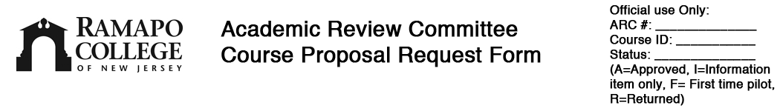

Deadlines: Proposals must be received by DECEMBER 1st for the following academic year. Please submit the SIGNED ORIGINAL and two (2) copies of the full package, which includes this request form, the course syllabus, checklist, and supporting documents, and an electronic copy of the syllabus, to your ARC representative, who will deliver them to ARC. If the new course is a requirement/elective in the major/minor, also include one printout of the current program requirements indicating how the course fits in the program.
SECTION A
Faculty Name: ______________________________ Email: _____________________________
School: _______ Convening Group: ____________________________ Date:______________
Effective Date: Fall: ______ Spring: ______ Summer: ______
New Course Proposal (Complete Sections B and D)
Resubmission of first time pilot for full approval: Course ID ______ (Complete Sections B and D)
Course Revision: Course ID _____________(Complete Sections C and D)

SECTION B - NEW COURSE ONLY
1. Course Discipline: __ __ __ __ Course Credits: 4 Other __ (Attach rationale)
2. Course Level: ___________
3. Full Course Title: ________________________________________________________
4. 32 Character Title: __ __ __ __ __ __ __ __ __ __ __ __ __ __ __ __ __ __ __ __ __ __ __ __ __ __ __ __ __ __ __ __
5. Specific requirements this course will fulfill (for Degree Evaluation):
School Core : ___________________ Subcategory: ____________
General Education – Category: _________________________________
Writing Intensive (Director of Writing Across the Curriculum (WAC) Program signature required)
Study Abroad (Chair of Study Abroad Committee signature required)
Major: _____________________________ Subcategory/Concentration: ______________
Minor: _____________________________ Subcategory: ________________________
Other: ______________________________
6. Are there any FEES for this course? No Yes (please specify)
_______________________________________________________________________
7. Prerequisites: Please specify “and”, “or”: _____________________________________
8. Co-requisites, if any:______________________________________________________
9. Primary Instructor: ____________________________________________________
10. Is this new course replacing or equivalent to an existing course? Yes No If yes:
a. Existing Course I.D.: __________ Course Title: ______________________
b. Effective end date of existing course if it is being replaced (term/year): ______________
c. Is the existing course a prerequisite for another course(s)? If so, please specify: _________
______________________________________________________________________________
SECTION C - COURSE REVISION ONLY
1. Course I.D.: ___________________ Course Title: ______________________________
2. Type of Course Revision (Check ALL that apply):
Discipline From: _________________ To: _____________________
Level From: _________________ To: _____________________
New Prerequisites: ________________________________________________________
New Title: _______________________________________________________________
Major Content Change (describe separately)
Gen. Ed. Category change: From: _________________ To: _____________________
WI designation change: Add WI status Drop WI status
3. Specific requirements this course will fulfill (for Degree Evaluation):
School Core: ________________________________ Subcategory: ____________
General Education – Subcategory: _________________________________
Major: _______________________________ Subcategory/Concentration: ______________
Minor: _______________________________ Subcategory: ________________________
Other: _________________________________________________________________
4. Rationale for change: _______________________________________________________
SECTION D - REVIEW AND APPROVAL (include all that apply)
Convener:____________________________________________ Date: _________
Graduate Program Director: _____________________________ Date: _________
School Curriculum Committee Chair: ______________________ Date: _________
Graduate Directors’ Comm. Chair: ____________________ Date: _________
WAC Director (for WI course): _____________________________ Date: _________
Study Abroad Committee Chair (for Study Abroad course):_____ _____ Date: _________
Dean: _______________________________________________ Date: _________
Vice Provost (for INTD, EXSS, COND & CIPL-offered courses):__________ Date: _________

If course fulfills requirements in more than one program, additional signatures are required:
Convener (second program): _____________________________ Date: _________
Dean (second school or program): ____________________________ Date: _________

ARC disposition:
Information item only - no ARC approval needed
This course request has been reviewed and approved as a “First Time” Pilot course.
This course request has been reviewed, approved and forwarded to the Office of the Provost for final course approval.
This course request has not been approved and is returned to you for the following reason(s):

___________________________________________________________________

Academic Review Committee Chair: _____________________________ Date: __________
Office of the Provost Use Only:
Approved: ____ Not Approved: ____ Cost Center Code (if other than convening group): ________

Provost Signature: ________________________________________ Date:_________________

F. Instructions for Completing the Course Proposal Request Form

SECTION A
Faculty Name: Name of the full-time faculty member proposing the new or revised course.
Date: Enter the date the form was completed.
School: Enter the "home" School of the faculty member.
Convening Group: Enter the convening group of the faculty member.
Effective Date: Enter the effective semester and year; only those courses submitted before December 1 will be effective in the following academic year. Please be mindful of how a course revision may affect students and their degree audits.
Submission type: check one box only:
New course proposal: Check this box if it is a completely new course.
Resubmission of first time pilot or Course revision: check the appropriate box and enter the course identification (e.g. ACCT 100). Minor changes such as changes in prerequisites or course numbers (where course level remains the same), and minor changes to course descriptions require the approval of the appropriate Dean(s) but do not require ARC review.

SECTION B
1. Specify the primary four-character discipline for the course, and the number of credits. If the number of credits is not four, attach rationale for the number of credits.
2. Specify the course level. Refer to the Course Level Guidelines section in this Manual.
3. Enter the full course title as it should appear in the catalog.
4. Enter the short version of the course title for the schedule.
5. Specify requirements:
School Core: Check this box and specify the school and the name of the requirement, e.g., "Upper-Level CA interdisciplinary", "Consciousness and Society", "200-300 Level History", etc.
General Education: Check this box and identify the category you are requesting the course to fulfill. Refer to the General Education Program section in this Manual for additional information. Include in the syllabus a description of how the course fulfills the GE category.
Writing Intensive (WI): Check this box if the course is being designated WI. signature of the Director of the WAC Program is required. Refer to the WI section in this Manual for additional information.
Study Abroad: Check this box if the course will be a Study Abroad course. The signature of the Chair of the Study Abroad Committee is required.
Major/minor: Review the major requirements in the College Catalog for specific requirement names. Specify the name of the requirement, if it is a requirement that has several possibilities. If the new course will become a new requirement for the major, specify the name of the course and provide a copy of the major from the College Catalog with the revisions. Please print out the Requirements of the Major page from the college web site and circle the specific requirements the course fulfills. Staple this to the course request package.
6. Identify if this is a standard lab fee, a modeling fee, a liability insurance fee, etc. Consult the Bursar for the dollar amount of any given fee.
7. Prerequisites: Specify the course ID for the prerequisite(s).
8. Co-requisites: Specify the course ID for the co-requisite. Please note: (1) a co-requisite cannot also be a prerequisite; (2) in the semester schedule, co-requisites can be set up for specific sections of courses.
9. Specify the faculty member who will be the primary instructor of this course.
10. Check the ‘yes’ box if you intend to remove a course from the active inventory of courses, and have the new course replace it in the requirements for the major/minor. This is primarily to update the degree evaluation system and course inventory.
a. Specify the existing course ID and course title
b. Specify semester and year should this course be removed from the catalog and degree audit

SECTION C
1. Specify the course ID and current course title.
2. Check the changes that apply for the type of course revision.
Specify the new title as it will appear in the College Catalog and a 32 character title for the Schedule of Classes.
3. Specify any change in requirements that this course change will cause.
4. Please attach a document to the form if the space allotted for the rationale for the change is not adequate.

SECTION D
1. Convener’s Signature for home Discipline/School (if there is one); for Graduate courses, the Director of the Graduate Program’s signature is required. For INTD, EXSS and COND courses, the Vice Provost’s signature will also (or instead) be required.
2. School Curriculum Committee Chair (for Schools that have such a committee); for graduate courses, the chair of the Graduate Director’s Committee.
3. Director of the Writing Across the Curriculum Program, if the course is a Writing Intensive course
5. Chair of International Education, if the course is a Study Abroad course
7. Dean’s Signature for home discipline/school
If the course fulfills requirements in more than one program, signatures for convener or dean in second program are required.

IX. Program Proposal Review and Approval Process

A. Narrative of Program Proposal Request Process
All proposals for new undergraduate and graduate programs, and major revisions to existing programs (including program name changes) undergo the following review and approval process and procedure; for revisions to programs, consult the Office of the Provost to ascertain the final level of approval required.

Pre-Program Proposal
Interested parties who wish to propose a new or revise an existing program prepare a 1-3 page narrative briefly describing the proposed program and its goals, and stating how the program satisfies the following criteria:
- It is consistent with and appropriate for the mission of the College and the School, as defined by the State of New Jersey Commission on Higher Education. The required documentation in accordance with the Academic Issues Committee Manual of the NJ Presidents’ Council, compiled by the Office of Academic Affairs, New Jersey Commission of Higher Education. The Manual is available in the Office of the Provost.
- An analysis of the resources needed to make the program viable has concluded that the program is feasible in terms of resources and impact on other existing programs at Ramapo and neighboring schools.
- An analysis has been done indicating the level of likely interest among existing students (or potential students) in the particular program.

This pre-program proposal narrative is submitted to the Provost for comment. The Provost’s comments are added to the packet . Note that the Provost’s input at this stage is commentary only; it is not a yes-or-no recommendation step, as that will occur much later in the process.

Program Proposal
- The originators of the proposal assemble the following package:
  - An Academic Review Committee (ARC) Program Proposal Request Form
  - Pre-Program Proposal with Provost’s comments
The School ARC representative works with the faculty member until the package is complete.

- The originators of the proposal submit the package, completed in step 1, to the following groups for review and approval:
  - Convening Group (CG) (if a convening group exists)
  - School Curriculum Committee (CC) (for Schools that have such a committee)
  - Unit Council (UC)
  - Dean of the program’s home school
  - Graduate Council (for graduate programs)

- The originators of the proposal submit the original and six (6) copies of the package to the School’s ARC representative or Chair of ARC. In addition, the package should be provided electronically; ARC will forward information copies to:
  - Faculty Assembly (FA) President
  - Deans’ Council (DC)
  - Provost
  - President
  - Other designated interested parties.

- ARC votes to approve or not approve the proposal.

- The Chair of ARC notifies, by email, the following:
  - Originators of the Program Proposal
  - Convening Group (CG) (if a convening group exists) and Graduate Council (if it is a graduate program)
  - Dean
  - Faculty Assembly (FA) President & Faculty Advisory Council (FAC)
  - Provost
  - President
  - Other designated interested parties

- If approved and where FA approval is necessary, the Chair of ARC requests that the Faculty Assembly (FA) President bring the approval to FA for a vote.

- If the program proposal motion is passed by the Faculty Assembly (FA), the Chair of ARC forwards all documentation to the FA President; and who submits the following documents to the Provost for consideration:
  - Program Proposal Request Package
  - Recommendation made by the Faculty Assembly (FA)
  - Faculty Assembly (FA) minutes

- The Provost may/will review recommendations from the Dean’s Council and Provost’s Council before rendering a decision.

- If the program is approved by the Provost, it is presented to the Board of Trustees for final on-campus approval.

- If the program is approved by the Board of Trustees, the Provost’s Office notifies the Registrar, Enrollment Management, Dean(s), and proposal originator(s), and submits the program to the Academic Affairs Committee (AAC) of the New Jersey Presidents’ Council (NJPC).

  - New minors attached to existing majors of the same name and CIP classification are sent to NJPC as information items only.
  - New stand-alone minors, new majors, and new graduate programs are sent to NJPC for 30-day review by peer institutions, following which additional materials may be required to be submitted before the AAC makes a recommendation on the program to the full NJPC; this step may take 2-3 months beyond the 30-day review. Final approval is granted by the NJPC, except in cases where programs exceed institutional mission (i.e., new graduate programs).
  - If new graduate programs are approved by NJPC, the Provost’s Office submits a Request to Exceed Mission petition to the NJ Commission on Higher Education. The program can not be offered until CHE approval is granted; this step may take up to a year.

B. Program Proposal Request Process Flowchart
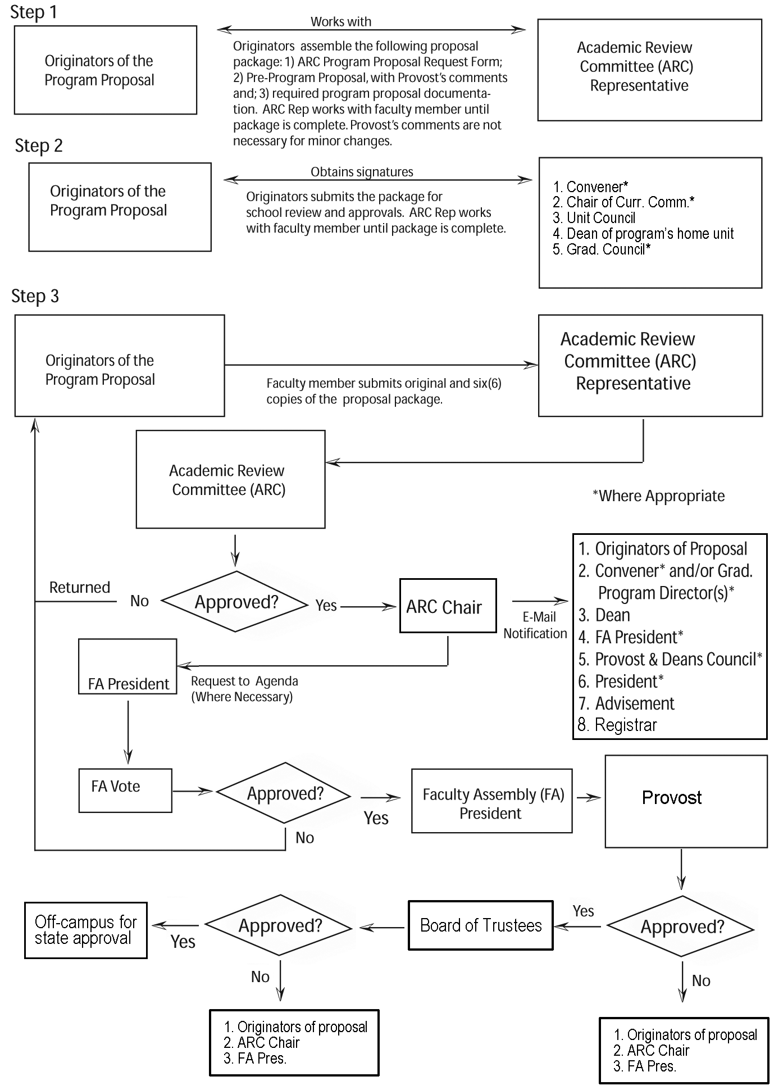

C. Instructions for Completing the Program Proposal Request Form

SECTION A
Program Proposal Title: Title of the new or revised program proposal
Originator(s) of the Proposal: Name or names of originator
Date: Indicate the date the form was completed.
School(s): "Home" School of the proposers of the new program or program revision.
Convening Group(s): Convening group(s) of originator
Effective Date: Date program will begin

SECTION B
New Program Proposal: Secure appropriate signatures
Program Proposal Revision: Secure appropriate signatures

Reviewed and Approved by:
1. Graduate Council (if program proposal is a graduate program)
2. Convener: (if a convening group exists)
3. Dean:
4. School Curriculum Committee (CC) Chair: (for units that have such a committee)

Include in your package the pre-program proposal narrative and the Provost’s comments on that narrative.

ARC approval is not necessary for changes in program requirements. These changes should be sent to ARC as an
information item consisting of a completed Program Proposal form and appropriate documentation.


Please submit the ORIGINAL and six (6) SIGNED copies of this request form and supporting documents to your unit ARC representative, who will deliver them to the Academic Review Committee.
SECTION A
Program Proposal Title: __________________________________________________________
Originator(s) of the Proposal: _____________________________________Date:____________
School(s): _________________________ Convening Group(s): __________________________
SECTION B
New Program Proposal Program Revision. Please attach pertinent materials.
Reviewed and Approved by:
1. Convener: (if a convening group exists): __________________________ Date:_________
2. Graduate Council Chair (for graduate programs): ________________________ Date:_________
3. Dean:______________________________________________________ Date:_________
4. School C.C. Chair:____________________________________________ Date:_________
(for units that have such a committee)
ARC Disposition:
Information item only - no ARC approval necessary
ARC recommends approval by the Faculty Assembly
ARC does NOT recommend approval by the Faculty Assembly
Faculty Assembly approval not needed; ARC approves
Faculty Assembly approval not needed; ARC does not approve
Academic Review Committee Chair: ______________________________ Date:________
The ARC recommends the following:
______________________________________________________________________________
Office of the Provost Use Only:
Approved Not Approved Provost Signature ____________________________ Date:___________

X. Miscellaneous Provisions and Notes

- Courses which have not been offered for five years may be dropped from the catalog. This may be initiated by either the convening group or the Registrar’s office. The change must be approved by the convener of the program and the Dean, and is transmitted directly to the Registrar.

XI. Record of Changes

Record of Changes
1.0 February 18, 2004: Adopted at the meeting of the Faculty Assembly
1.1 September 2004: Updated Introduction, page 5
1.2 March 2006: Revised Manual for Curriculum Enhancement Plan (CEP)
1.3 September 2007: Minor revisions to course and program proposal process, revisions to course level guidelines and course enrollment caps.
1.4 May 2010: Updates to General Education program (including incorporation of GECCo) and First Year Seminar description. Minor revisions to course and program proposal process, and clarification of types of changes that are submitted to ARC as decision items, information items, or not submitted to ARC. Revisions to course level guidelines (500-700 level), ARC course proposal deadlines (both pending approval) and syllabus template.

100-400 level guidelines approved by Faculty Assembly, 12/12/2007.

