How to use the Snipping Tool and Pin to Taskbar

- To open Snipping Tool, select the Search button from the bottom left of your screen.

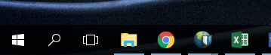

- Type “snipping tool” in the search box, and then select it in the search results. ﻿

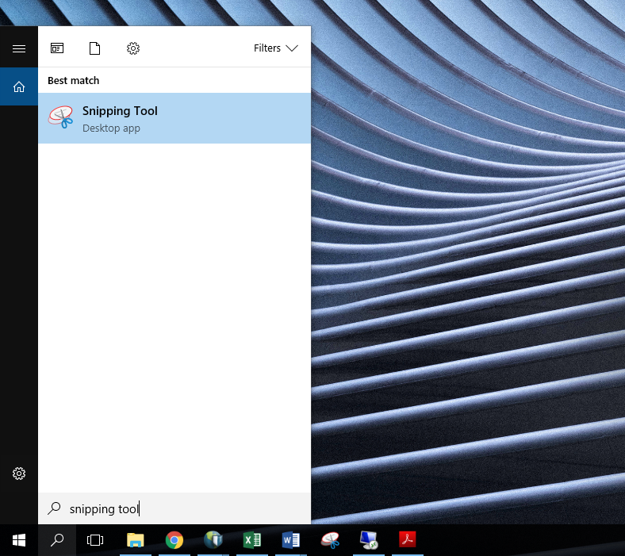

- Press the right mouse button on the Snipping Tool icon from your taskbar, and select Pin to Taskbar.

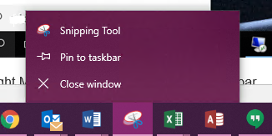

- Click the Snipping Tool icon, and select New

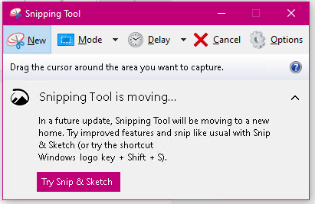

- Hold down the left mouse button and hover over the area to be Snipped. Release the left mouse button once you have covered the desired area to be snipped.

- Use the icons to Save, Copy or Email the Snipping (the Email option works only if your email is already configured with Microsoft Outlook).
