How to convert a Word, Excel, Outlook email, or PowerPoint file to a PDF in Microsoft Office for Windows:

- Open a file in an Office application.
- Go to File from the top left corner of the Quick Access Toolbar:
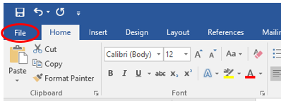
- Click Print.

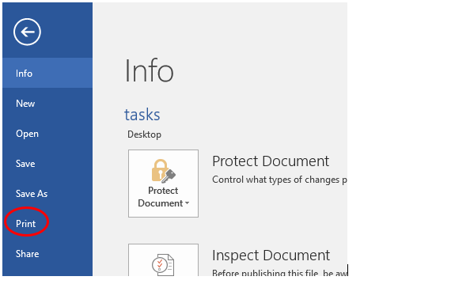

- Select Microsoft Print to PDF (or Adobe PDF if available) in the Printer dialog box.
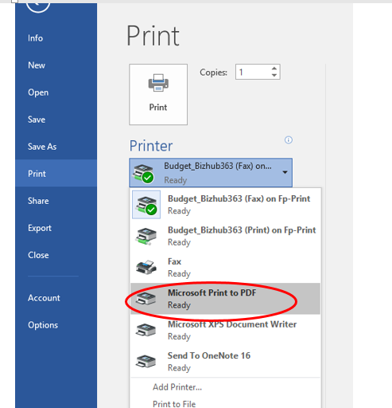
- Click Print, name the PDF file, and save it in a desired location.

